ELECTRO CATALOG
ENTITY RELATIONSHIP DIAGRAMS (ERD)

Document purpose
This document presents the Entity Relationship Diagrams for Electro Catalog, a simple PHP and MySQL electronic-goods catalogue website. It is arranged in separate diagram views so the database relationships are clear and suitable for a college project.
The database supports product categories, product information, member accounts, saved carts, orders and order items. Product image files are stored in the project folder named “item pictures”; the database stores the image filename/path rather than the image itself.

Scope and assumptions
The design covers the planned core features: browsing and searching products, member sign-up/login, guest browsing and cart use, saved carts for logged-in members, simulated checkout, and member purchase history.
Guest carts are assumed to use PHP sessions and therefore do not require a guest record in MySQL. For a logged-in member, the cart is stored in the carts and cart_items tables. Purchase history is derived from orders and order_items; there is no separate purchase_history table.
PK = primary key; FK = foreign key; UQ = unique constraint; 1:N = one-to-many; 1:1 = one-to-one.

ERD views
Five views are included: product catalogue; member accounts and saved carts; cart items and products; orders and order items; and member purchase history.

Figure 1. ERD - Product Catalog
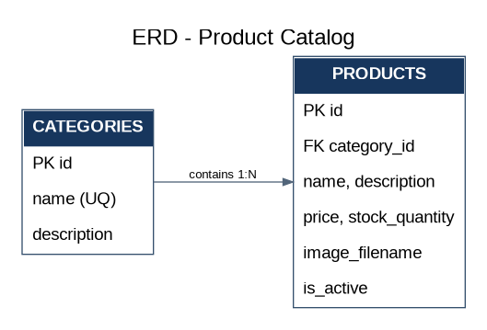
Categories group products. Each product belongs to one category, while a category can contain many products.

Important product fields
image_filename refers to an image file in the “item pictures” folder. Example: headphones.jpg. Keep the actual image files in the project directory and store only their filenames in MySQL.

Figure 2. ERD - Member Accounts and Saved Carts
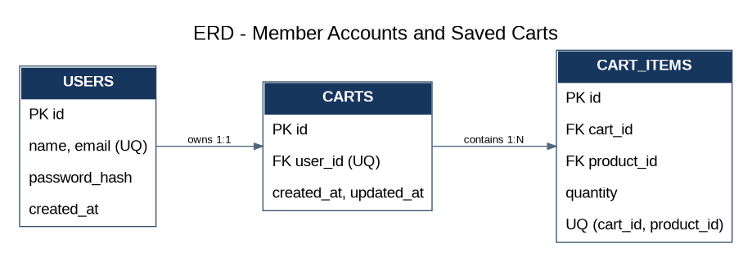
A member can have one saved cart. A cart contains multiple cart items, and each cart item stores a product and quantity.

Figure 3. ERD - Cart Items and Products
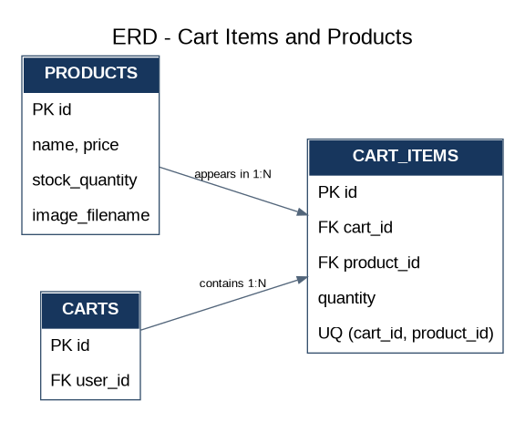
Cart items connect carts and products. The unique cart_id/product_id pair prevents the same product from appearing as duplicate rows in one cart.

Figure 4. ERD - Orders and Order Items
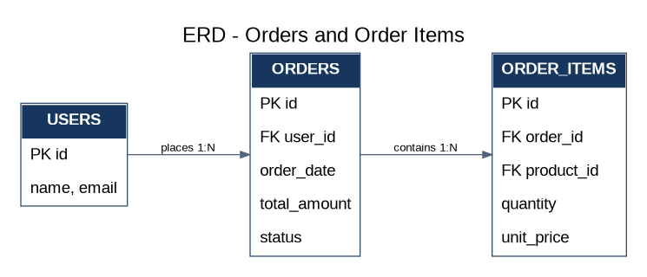
Each order belongs to a member and contains one or more order items. The unit_price records the product price at the time of purchase.

Figure 5. ERD - Member Purchase History
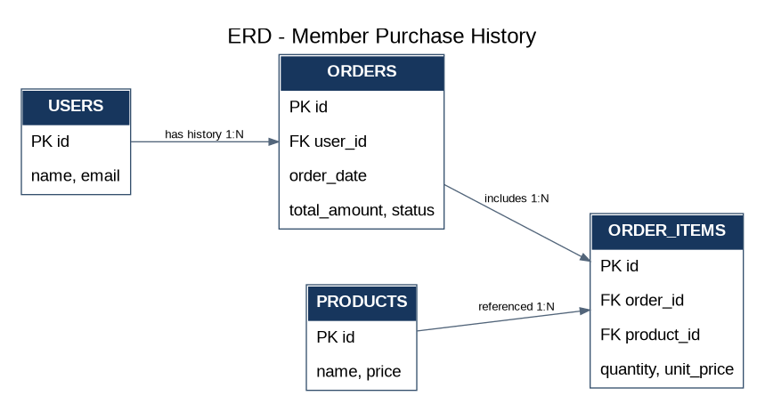
Purchase history is shown by retrieving a member’s orders and their order items, including the purchased product and quantity.

Table inventory and relationships
Table | Purpose | Key relationships
categories | Product grouping | One category to many products
products | Electronic goods and catalogue details | Belongs to a category; referenced by cart_items and order_items
users | Registered member accounts | One member to one saved cart; one member to many orders
carts | Saved cart for a logged-in member | Belongs to a user; contains cart_items
cart_items | Products and quantities in a cart | References one cart and one product
orders | Completed/simulated purchases | Belongs to a user; contains order_items
order_items | Purchased products, quantities and purchase-time prices | References one order and one product

Checkout behaviour
When checkout succeeds, the application creates an orders record and its order_items records before clearing the cart. A member can later view purchase history from those order records.

