ELECTRO CATALOG
SEQUENCE DIAGRAMS

Document purpose
This document presents sequence diagrams for the main Electro Catalog workflows, showing the order of requests and responses between visitors, members, browser pages, PHP services, MySQL and the local product-image folder.

Scope and assumptions
Electro Catalog is a PHP/MySQL electronics catalogue and simulated-shopping website. Visitors can browse and search products and use a temporary guest cart. Registered members can save carts, record simulated purchases and view purchase history. Product images are kept in the local “item pictures” folder, while MySQL stores image filenames. A real payment gateway is outside this project scope.

Sequence diagrams for key modules
The diagrams follow the same documentation approach as the supplied Infinity Blog reference: each workflow has participants, ordered message arrows and a short explanation. The workflows have been adapted to Electro Catalog’s planned features.

Figure 1. Sequence diagram – Product browsing and search
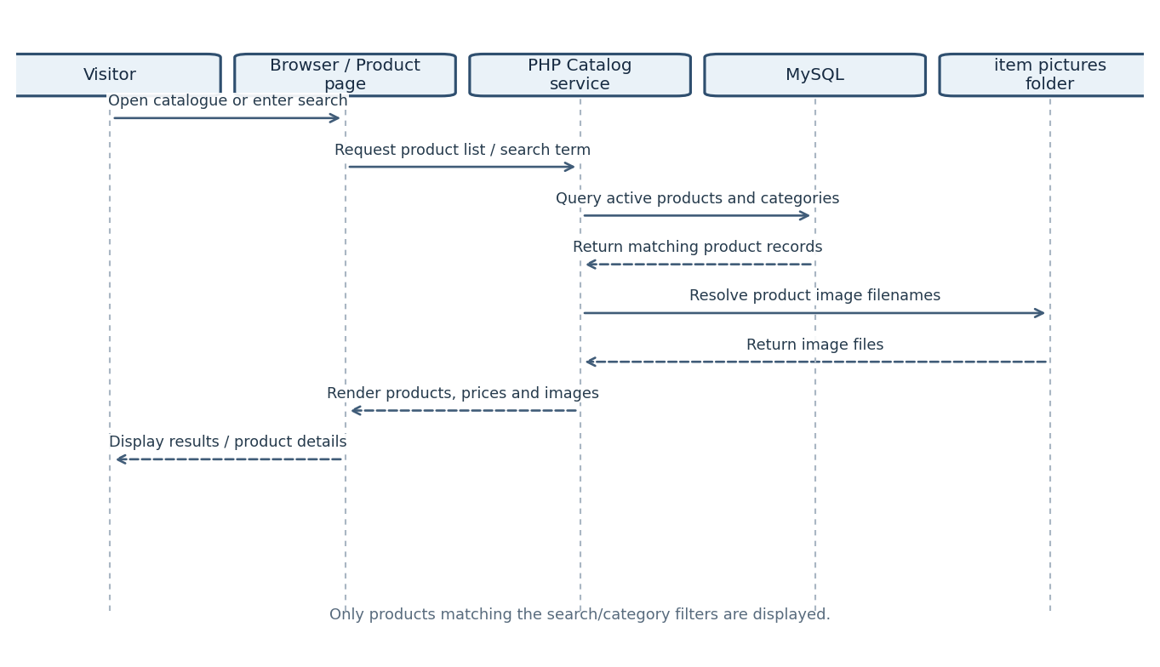
The visitor requests the catalogue or searches by keyword/category. The PHP catalogue service reads matching products and category information from MySQL and resolves each product’s image filename to a local image file before returning the rendered results.

Figure 2. Sequence diagram – Member registration
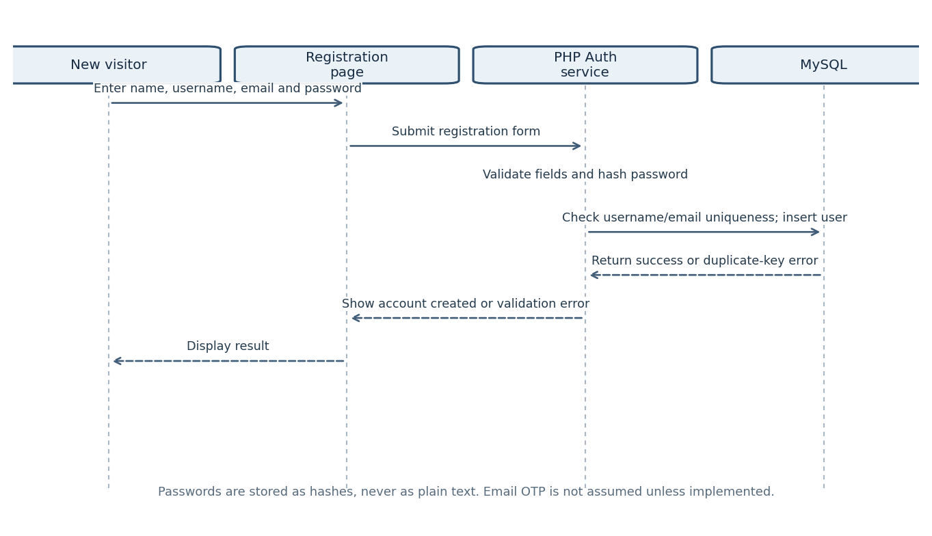
The registration form sends member details to the PHP authentication service. The service validates input, hashes the password, checks uniqueness and creates the user record. The page displays success only when the database insert succeeds.

Figure 3. Sequence diagram – Member login
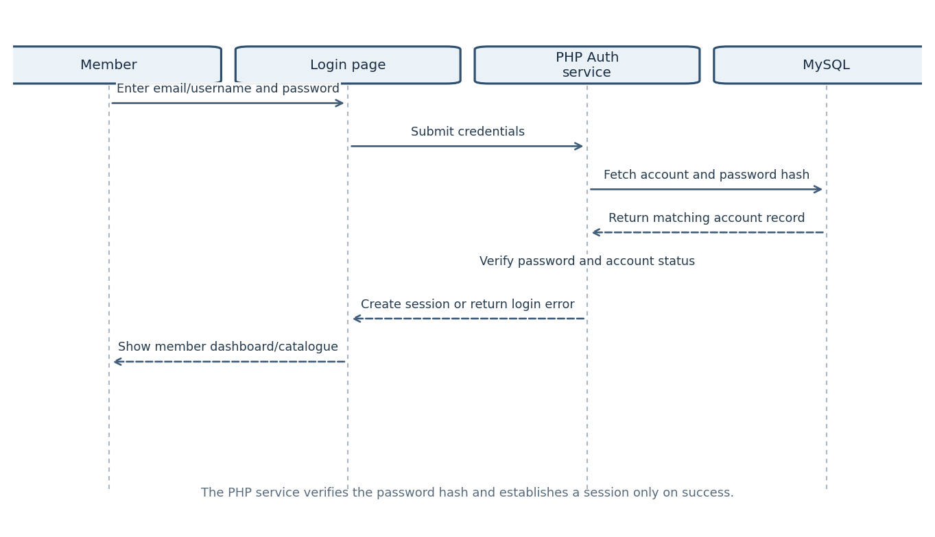
The login service retrieves the matching account, verifies the submitted password against the stored hash and establishes a PHP session only after successful authentication.

Figure 4. Sequence diagram – Add to cart
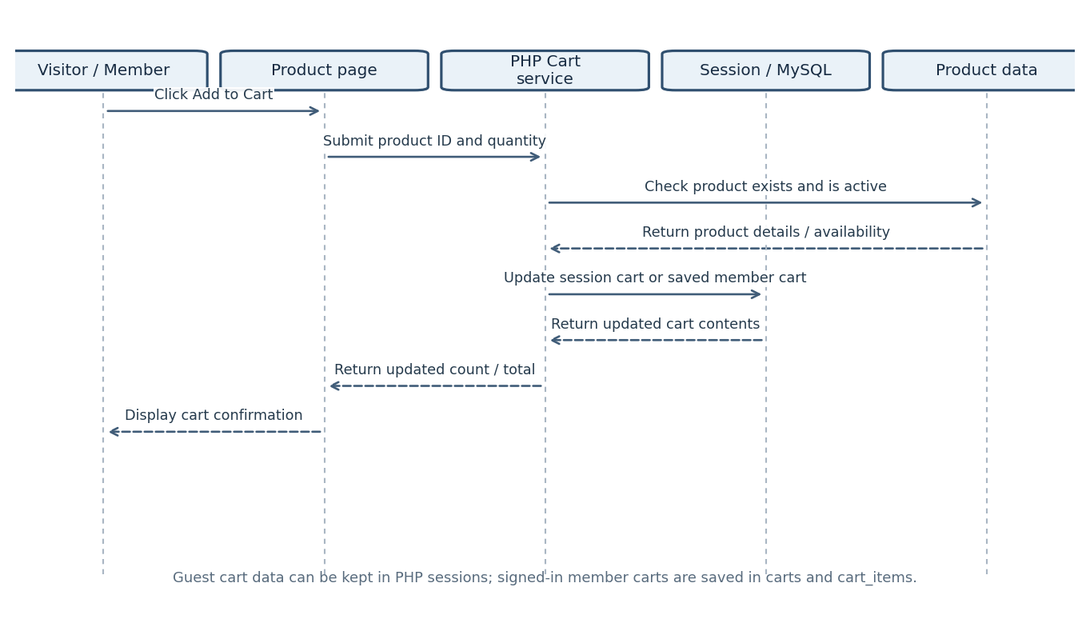
The cart service validates the product and quantity, then updates a PHP session for guests or the saved cart tables for logged-in members. The interface displays confirmation after the update succeeds.

Figure 5. Sequence diagram – Buy / checkout
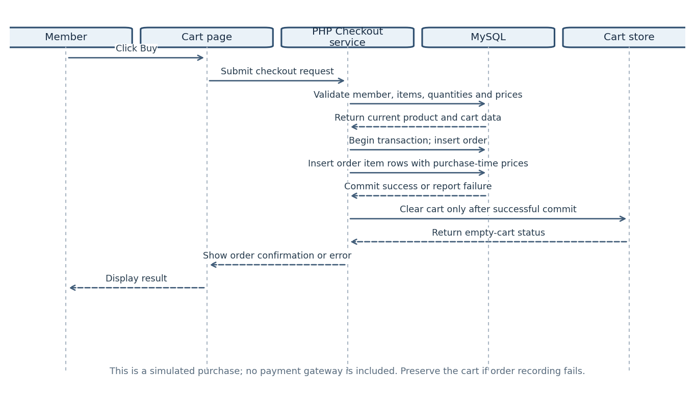
The checkout service validates the cart and records the order and its line items in a database transaction. The cart is cleared only after a successful commit; if recording fails, the cart remains available.

Figure 6. Sequence diagram – View purchase history
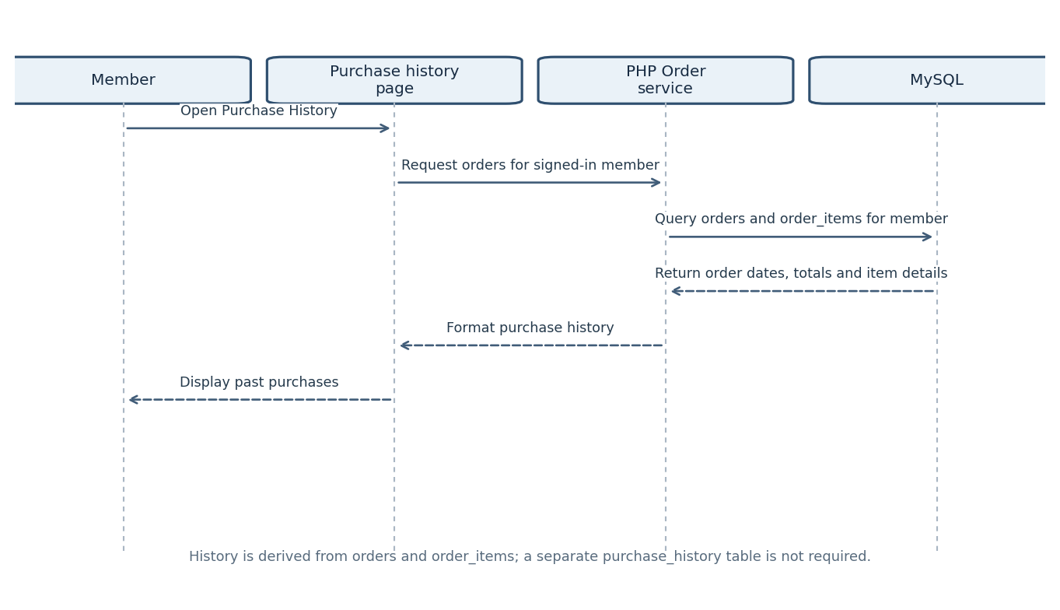
The purchase-history page requests orders for the authenticated member. The service retrieves orders and order_items, then returns a list of previous simulated purchases.

Figure 7. Sequence diagram – Administrator product maintenance
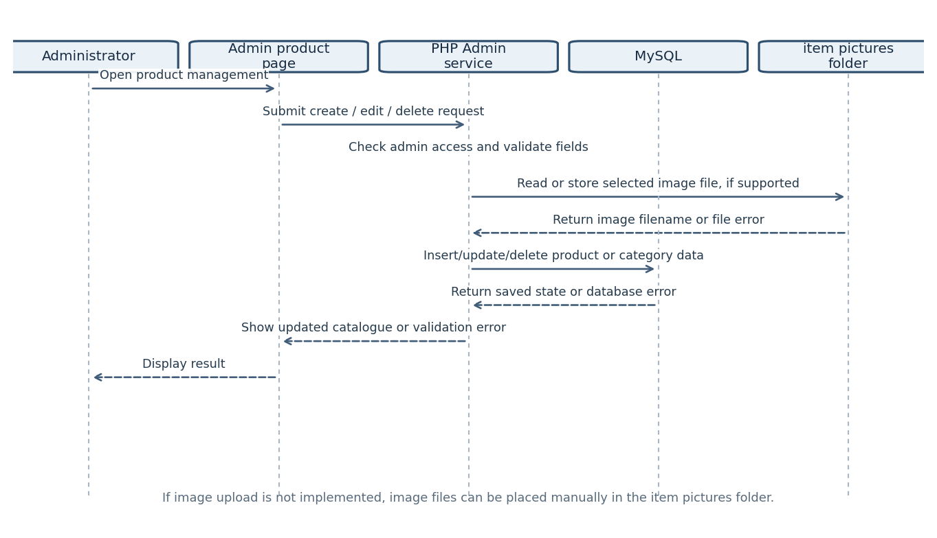
The administrator submits a catalogue change. The service checks authorization and validates input, optionally handles an image file, and then updates the product/category records.

Design notes and verification items
- Guest cart contents may be stored in PHP sessions. They are not permanent member-cart records unless a guest-to-member cart merge is implemented.
- Member cart persistence depends on the carts and cart_items tables and on associating the cart with the authenticated user.
- The Buy operation should record the order and all order items successfully before clearing the cart. Use a database transaction to avoid partial purchases.
- Order item rows should retain the unit price at the time of purchase so later product-price changes do not alter purchase history.
- Product image files are stored in the local “item pictures” folder; MySQL stores their filenames or relative paths.
- Payment processing is simulated and no external payment service is represented.
- The diagrams describe the intended workflow; update them if the implemented PHP pages, database schema or project scope changes.

Abbreviations
Term | Meaning
PHP | Server-side scripting language used by the application.
MySQL | Relational database management system.
PK | Primary key.
FK | Foreign key.
UQ | Unique constraint.

