

**Program: Computer Engineering and Software Systems- CESS**

***Course Code: CSE 227***

***Course Name: Database Systems (1)***

***Examination Committee***

**Prof. Dr. Hoda Korashy Mohamed**

**Ain Shams University**

**Faculty of Engineering**

**Spring Semester – 2020**

RESEARCH & PROJECT SUBMISSIONS

**Student Personal Information for Group Work**

|  |
| --- |
| **Student Names:** |
| Youssef Emad Saad |
| Rana Mostafa Tarek |

|  |
| --- |
| **Student Codes:** |
| 17P8042 |
| 17P8057 |

**Plagiarism Statement**

I certify that this assignment / report is my own work, based on my personal study and/or research and that I have acknowledged all material and sources used in its preparation, whether they are books, articles, reports, lecture notes, and any other kind of document, electronic or personal communication. I also certify that this assignment / report has not been previously been submitted for assessment for another course. I certify that I have not copied in part or whole or otherwise plagiarized the work of other students and / or persons.

**Signature/Student Name:**

**Youssef Emad**

**Rana Mostafa**

**16/6/2020**

**Date:**

**Submission Contents**

**01: Questions**

**02: Project**

Questions

**01**

***First Topic***

Table of Contents:

1. Part1:Questions……………………………………………………..1
2. Part2:Project………………………………………….………………4
3. Introduction 4
4. Important Data and Reports 5
5. Assumptions 6
6. EER Diagram 7
7. Database Schema 8
8. Sample of SQL 11
9. Implementation 17
   1. part1: using ERD tool……………………...…………..17
   2. part2: using SQL tool………..………………………….18

10.References…………………………………………….…………….23

Part 1: Questions:

Question 1:

1 M N

Patient

Ward

Contains

N

Contains

N

Operation Types

Question 2:

Customer

component

supplies

Supplier

N M

M

1

Makes

Contains

M M

order

VGA

RAM

CPU

|  |
| --- |
| Supplier Name  Supplier_Phone  Supplier_address |

|  |
| --- |
| ComponentID |

Supplier Supplies Component

|  |
| --- |
| Supplier Name (FK)  ComponentID (FK) |

|  |
| --- |
| OrderID  CustomerID (FK) |

|  |
| --- |
| ComponentID (FK)  OrderID (FK) |

|  |
| --- |
| CustomerID |

Order Includes Customer

Question 3:

-The schema of this question has the following foreign keys:

-Order# of relation ORDER_ITEM which references to relation Order

-Item# of relation ORDER_ITEM references relation ITEM.

-Cust# of relation ORDER that references relation CUSTOMER

-Order# of relation SHIPMENT references relation ORDER.

-Warehouse# of relation SHIPMENT references relation WAREHOUSE.

Question 4:

PART 1:

Select FNAME, LNAME,ADDR,BDATE

From EMPLOYEE, DEPARTMENT

Where DNAME= “MARKETING” AND EMPLOYEE.DNO =

DEPARTMENT.DNO;

PART 2:

Select DNAME

From DEPARTMENT

Where BUDGET > 5000;

PART 3:

Select FNAME, LNAME

From WORKS-ON w, PROJECT p, EMPLOYEE e

Where w.HOURS >10 AND e.DNO = 5 AND p.PNAME = “PRODUCTX”

AND p.PNO= w.PNO AND w.ESSN = e.ESSN;

Part 2: Project:

1. Introduction
2. Chosen Domain Description:

In this Report we have chosen to work on a restaurant database system. The restaurant assumed has many branches and the staff working there are: Managers, Chefs , Waiters , Cashiers & Cleaning Staff. The customers can go to their preferred branch and choose from the unoccupied tables. The restaurant branches deal daily with one supplier which supplies the branches with semi-prepared meals that only need to get warmed and decorated in dishes, and the restaurant offers four different menus according to each customer’s preference which are: Breakfast , Beverages , Main Dishes & Desserts menus. Finally the customers are kindly asked to submit their reviews, so that the restaurant can improve its overall service and quality.

# Important Data and Reports:

# Basic Requirements:

* Customers’ information.
* Menu Items and Pricing.
* Customers’ orders.
* Employees’ information, shifts and job position.
* Required supplies.
* Supplier’s information.
* Branches’ information.

# Needed Reports:

* Reviews report.
* Supplies report.
* Customer Report.
* Date wise sales report.
* Menu Item Analysis.

### Labor Reports.

# 3. Assumptions:

* Restaurant has employees: waiters, chefs, manager, cleaning staff.
* Items are recorded within the database.
* A branch can be managed by one manager and each manager can only manage one branch at a time.
* Waiters must work for one branch at a time, one branch must have many waiters.
* Waiters must take orders, Orders must be taken by waiters only.
* Chefs must work for one branch at time, one branch must have many Chefs.
* Cleaning staff must work for one branch at time, one branch must have many cleaning staff workers.
* Restaurant may have many branches.
* One supplier must deal with many branches, Many branches must deal with one supplier.
* One branch must be served by many employees, Many employees may serve one branch.
* One employee must only do one job, A job may be done by many employees.
* A customer must make orders, Orders must be made by a customer.
* One customer may give many reviews, Reviews must be given by a customer.
* Customers must select a menu, a menu may be selected by any customer.
* A menu must have many items, Items must exist within a menu.
* Menus types are: Breakfast , Beverages , Main Dishes & Desserts menus.

1. EER Diagram:

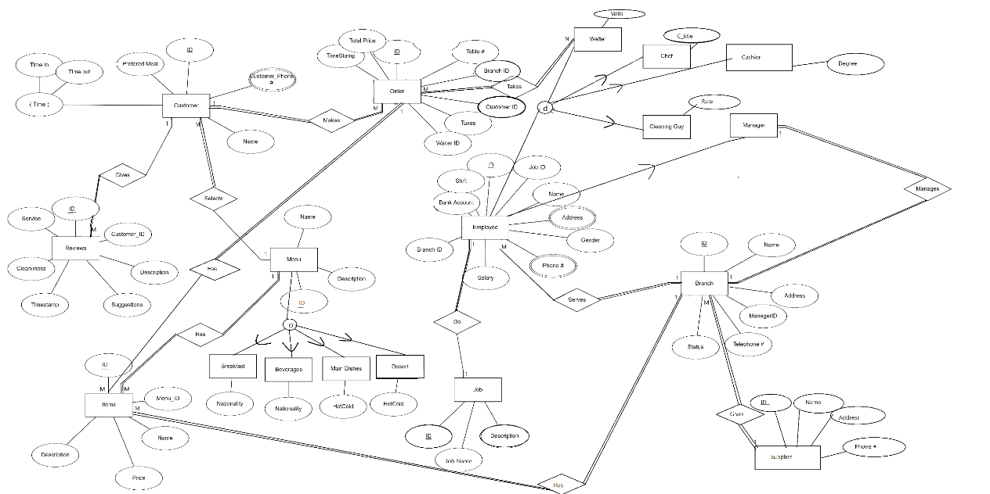

# Database Schema:

# **Employee**

|  |  |  |  |  |  |  |  |
| --- | --- | --- | --- | --- | --- | --- | --- |
| ID | JobID | Name | Gender | Salary | BranchID | BankAccount | Shift |

**JOB**

|  |  |  |
| --- | --- | --- |
| ID | JobName | Description |

**Branch**

|  |  |  |  |  |  |  |
| --- | --- | --- | --- | --- | --- | --- |
| ID | Name | ManagerID | Address | Phone# | Status | SupplierID |

**Supplier**

|  |  |  |  |
| --- | --- | --- | --- |
| ID | Name | Address | Phone# |

**Waiter**

|  |  |
| --- | --- |
| ID | Skills |

**FK**

**Chef**

|  |  |
| --- | --- |
| ID | C_title |

**FK**

**Cashier**

|  |  |
| --- | --- |
| ID | Degree |

**FK**

**CleaningGuy**

|  |  |
| --- | --- |
| ID | Rate |

**FK**

**EmployeeAddress**

|  |  |
| --- | --- |
| EmployeeID | Address |

**FK**

**EmployeePhone#**

|  |  |
| --- | --- |
| EmployeeID | Phone# |

**FK**

**Menu**

|  |  |  |
| --- | --- | --- |
| ID | Name | Description |

**Items**

|  |  |  |  |  |
| --- | --- | --- | --- | --- |
| ID | MenuID | Name | Price | Description |

**MainDishes**

|  |  |
| --- | --- |
| ID | HotCold |

**FK**

**Dessert**

|  |  |
| --- | --- |
| ID | HotCold |

**FK**

**Beverages**

|  |  |
| --- | --- |
| ID | Nationality |

**FK**

**Breakfast**

|  |  |
| --- | --- |
| ID | Nationality |

**FK**

**Customer**

|  |  |  |  |  |
| --- | --- | --- | --- | --- |
| ID | Name | PreferredMeal | TimeIn | TimeOut |

**CustomerPhone#**

|  |  |
| --- | --- |
| CustomerID | Phone# |

**Order**

|  |  |  |  |  |  |  |  |
| --- | --- | --- | --- | --- | --- | --- | --- |
| ID | Table# | TotalPrice | BranchID | CustomerID | WaiterID | Taxes | TimeStamp |

**FK FK**

**Reviews**

|  |  |  |  |  |  |  |
| --- | --- | --- | --- | --- | --- | --- |
| ID | CustomerID | Description | Suggestions | Cleanliness | Service | TimeStamp |

# Sample of SQL:

Example for SQL to create table:

1-CREATE TABLE `items` (

  `ItemID` int(11) NOT NULL,

  `MenuID` int(11),

  `Name` varchar(30) NOT NULL,

  `Price` float,

  `Description` varchar(50),

PRIMARY KEY (ItemID), FOREIGN KEY (MenuID) REFERENCES Menu (ID)

);

2- CREATE TABLE `review` (

`ReviewID` int(11) NOT NULL,

`CustomerID` int(11) NOT NULL ,

`Description` varchar(50) ,

`Suggestions` varchar(50) ,

`Cleanliness` varchar(50) ,

`Service` varchar(50) ,

`TimeStamp` timestamp,

PRIMARY KEY (ReviewID),

FOREIGNKEY (CustomerID) REFERENCES customer(ID)

);

3- CREATE TABLE `menu` (

`ID` int(11) NOT NULL,

`Name` varchar(11) ,

`Description` varchar(255) ,

PRIMARY KEY(ID)

);

Example to insert data

1-INSERT INTO customer

VALUES(‘4’,’omar’,’ChickenBurger’, ‘2020-06-05 02:20:00’);

Example to update Data

1-UPDATE supplier

SET Name=’ramy’

WHERE ID=1 ;

Example to delete Data

1-DELETE FROM supplier

WHERE Name = ‘amr’;

**5 Query Reports:**

1. **Retrieve Reviews given in a specific timestamp**

SELECT customerID, Suggestions,

Cleanliness, Service,

PreferredMeal

FROM review, customer

WHERE review.CustomerID= Customer.ID AND

review.TimeStamp = "2020-05-08 23:20:10.000000"

GROUPBY customerID;

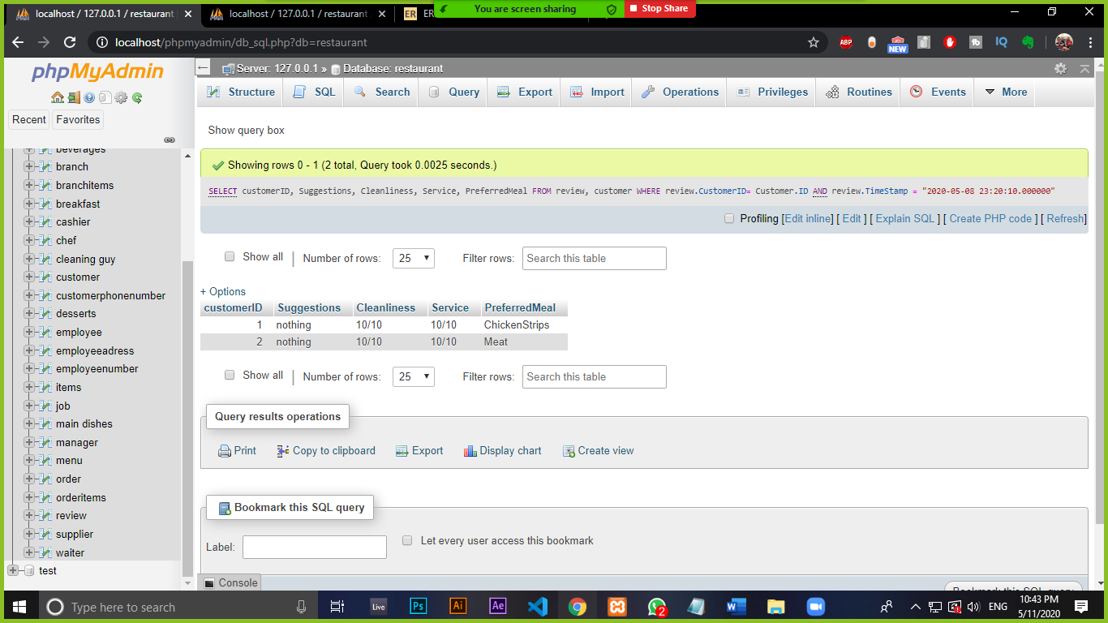

1. **Retrieve Items having a price>5**

SELECT I.ItemID, I.Name, I.Price, M.ID, M.Name

FROM items As I, menu As M

WHERE I.MenuID = M.ID

GROUP BY I.ItemID

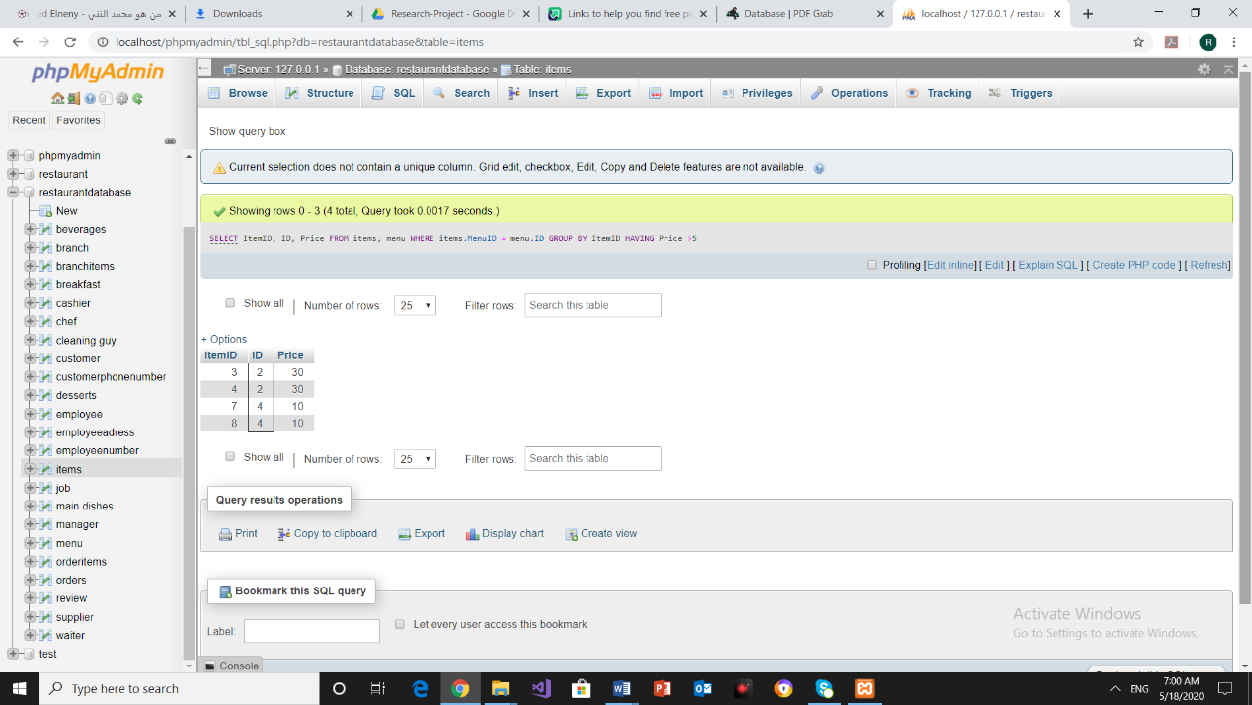HAVING I.Price >5

1. **Report for all the orders total price**

SELECT MAX(TotalPrice), MIN(TotalPrice),AVG(TotalPrice),

Name

FROM Customer, orders

WHERE Customer.ID = orders.CustomerID

ORDER BY TotalPrice

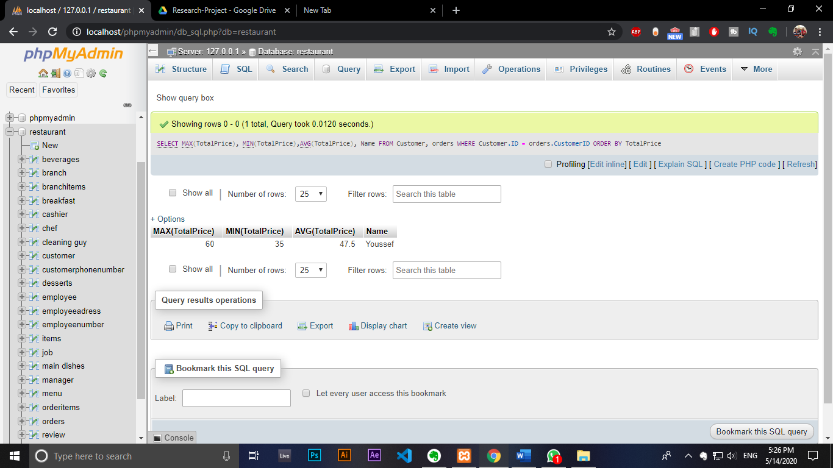

1. **Retrieve Salaries of all Waiters**

SELECT salary, ID, Name

FROM employee

WHERE JobID =

(SELECT ID FROM job WHERE JobName = "Waiter")

Group BY Name;

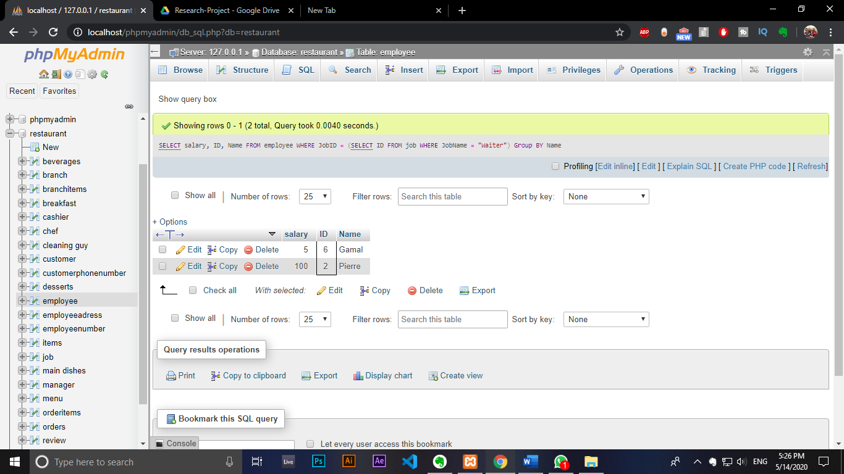

1. **Retrieve data of managers**

SELECT M.ID, M.Name,

B.ID, B.Name

FROM Manager As M,

Branch As B

WHERE M.ID = B.ManagerID

ORDER By M.ID

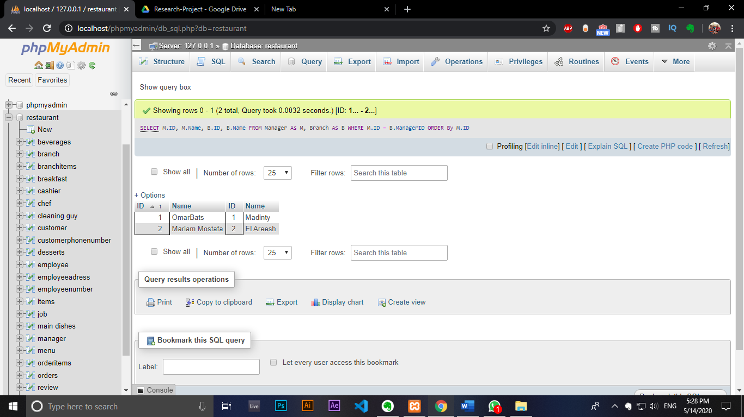

1. **Retrieve data of chefs**

SELECT E.ID, J.ID, E.Name

FROM employee As E,

job As J

WHERE J.JobName="Chef"

AND J.ID = E.JobID

GROUP BY E.ID

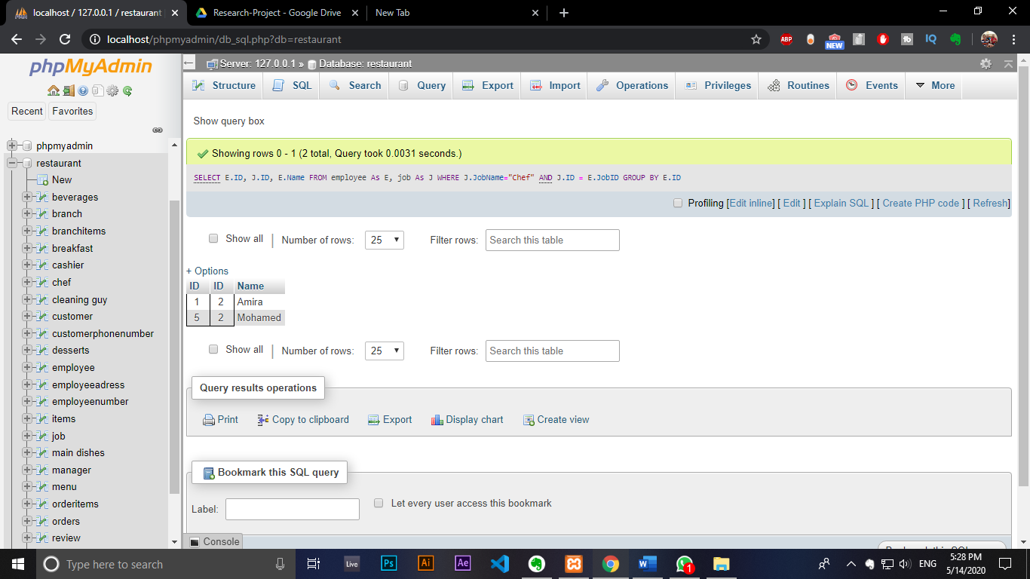

1. **Retrieval of all orders given in a specific time stamp**

SELECT O.ID, O.CustomerID,

C.Name

FROM customer As C, orders As O

WHERE O.CustomerID = C.ID AND

O.TimeStamp= "2020-05-08 22:20:10"

ORDER BY O.ID

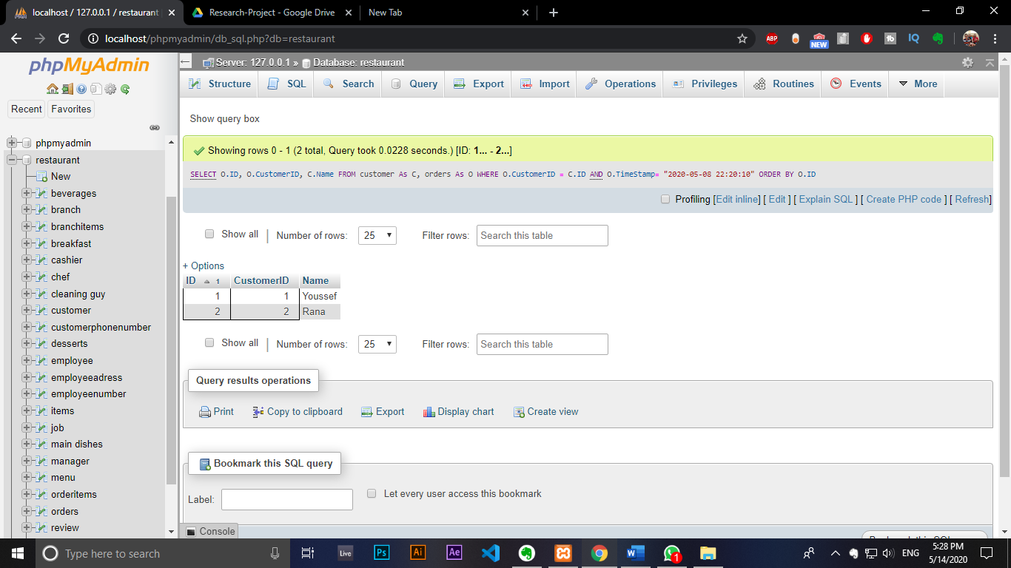

# Implementation:

7.1 Part1: Using ERD Tool: (ERDPlus.com)

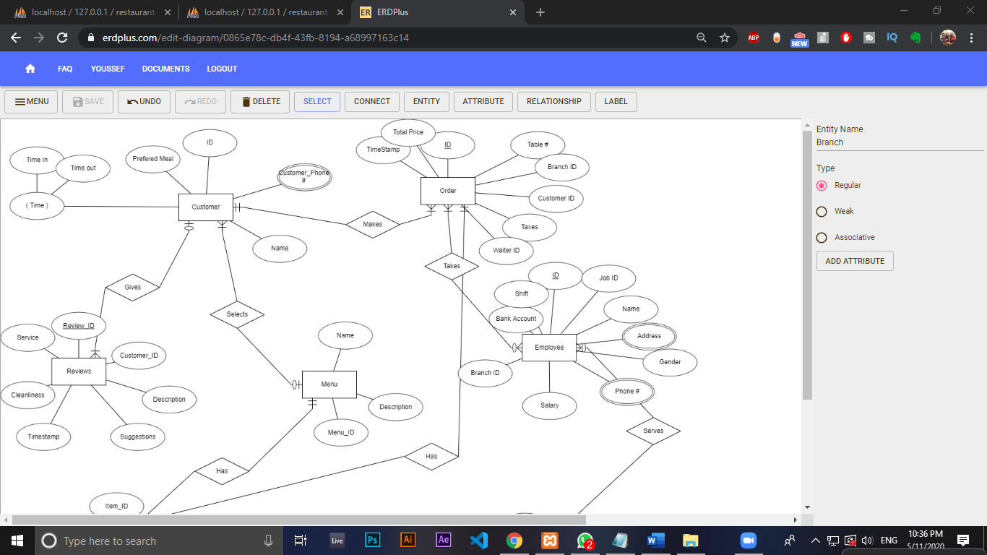

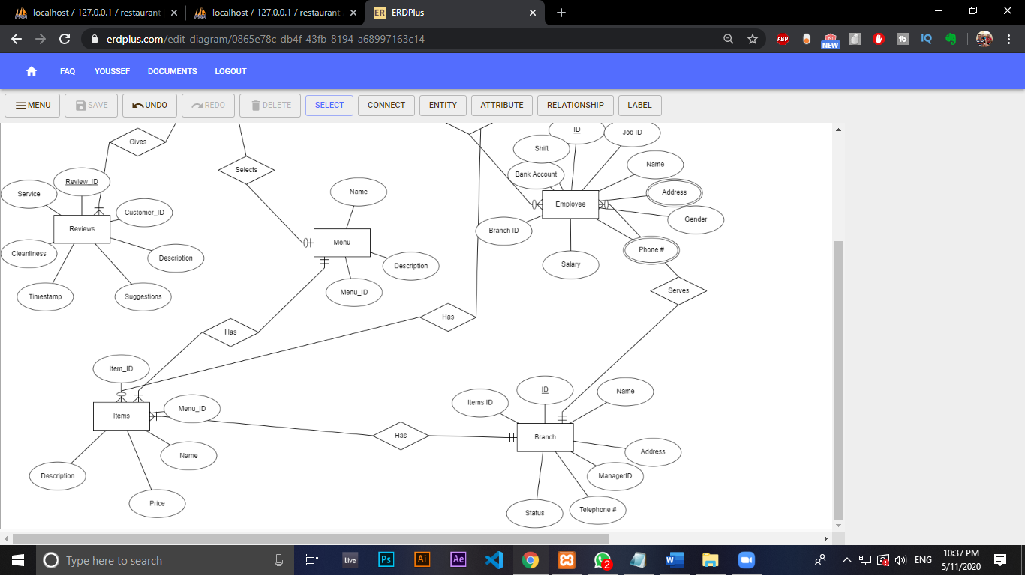

ERDPlus.com is a great tool to create ERD diagrams and convert them to relation schema and SQL automatically. You can also decide whether the relations are mandatory, optional, or between one or many entities. One of the biggest disadvantages of this tool is that it doesn’t have generalization relations.

* 1. Part2: Using SQL Tool:

(Using phpMyAdmin)

Example for SQL to create table:

1-CREATE TABLE `items` (

  `ItemID` int(11) NOT NULL,

  `MenuID` int(11),

  `Name` varchar(30) NOT NULL,

  `Price` float,

  `Description` varchar(50),

PRIMARY KEY (ItemID), FOREIGN KEY (MenuID) REFERENCES Menu (ID)

);

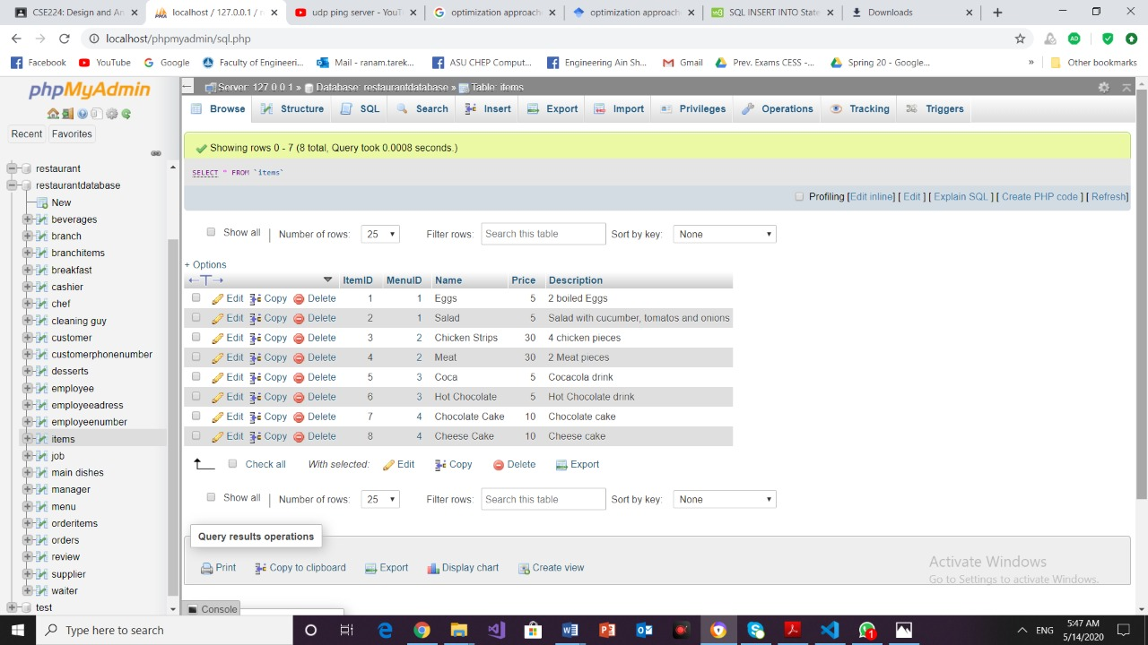

2- CREATE TABLE `review` (

`ReviewID` int(11) NOT NULL,

`CustomerID` int(11) NOT NULL ,

`Description` varchar(50) ,

`Suggestions` varchar(50) ,

`Cleanliness` varchar(50) ,

`Service` varchar(50) ,

`TimeStamp` timestamp,

PRIMARY KEY (ReviewID),

FOREIGNKEY (CustomerID) REFERENCES customer(ID)

);

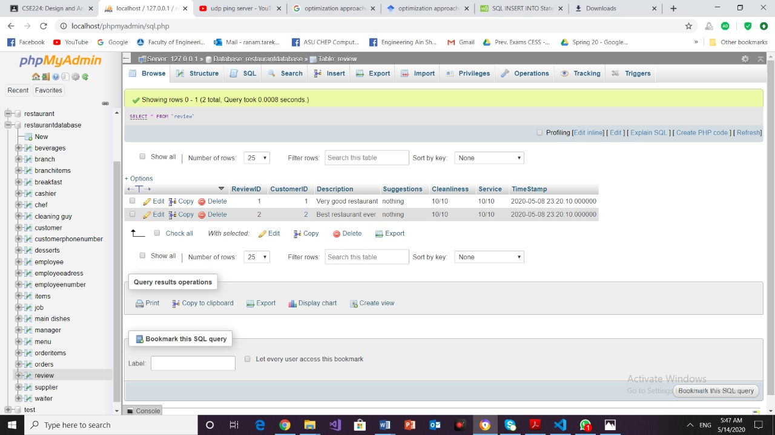

3- CREATE TABLE `menu` (

`ID` int(11) NOT NULL,

`Name` varchar(11) ,

`Description` varchar(255) ,

PRIMARY KEY(ID) );

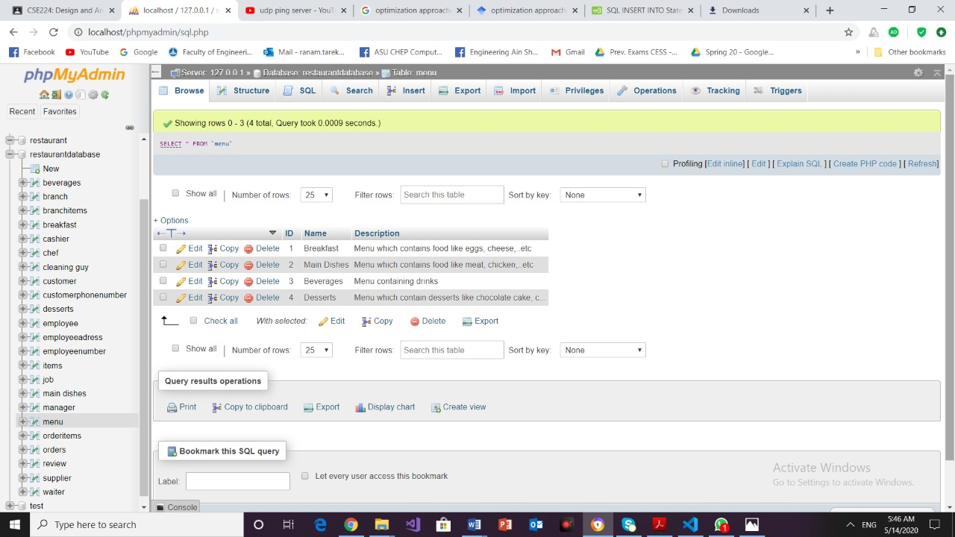

Example to insert data

1-INSERT INTO customer

VALUES(‘4’,’omar’,’ChickenBurger’, ‘2020-06-05 02:20:00’);

Screenshot before insertion: 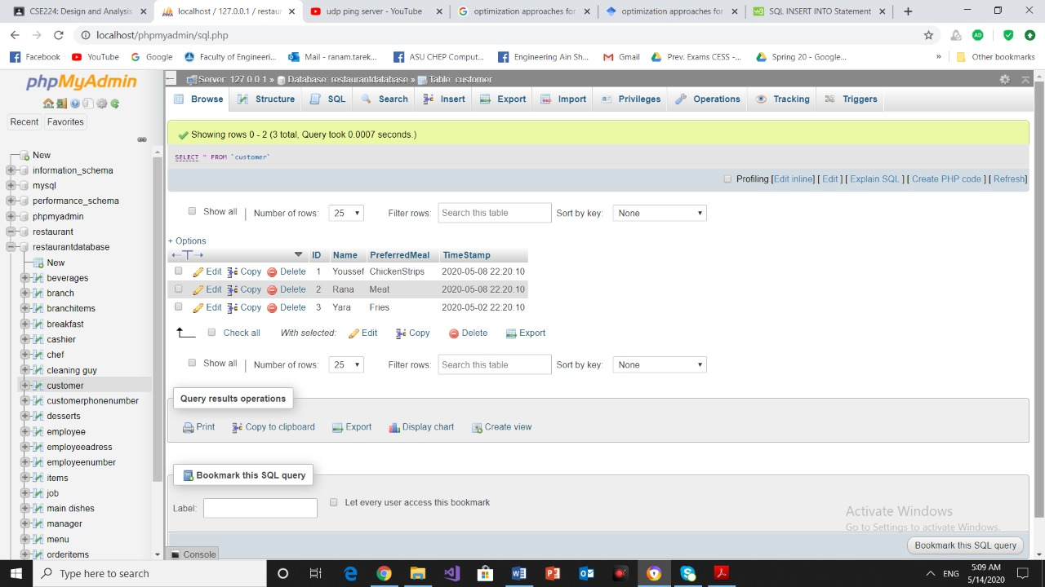

Screenshot after insertion:

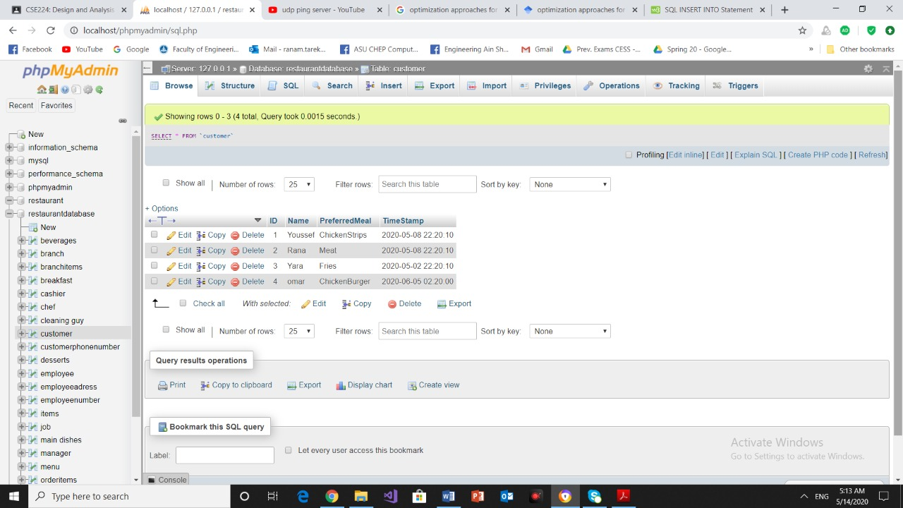

Example to update Data

1-UPDATE supplier

SET Name=’ramy’

WHERE ID=1 ;

Screen shot before update:

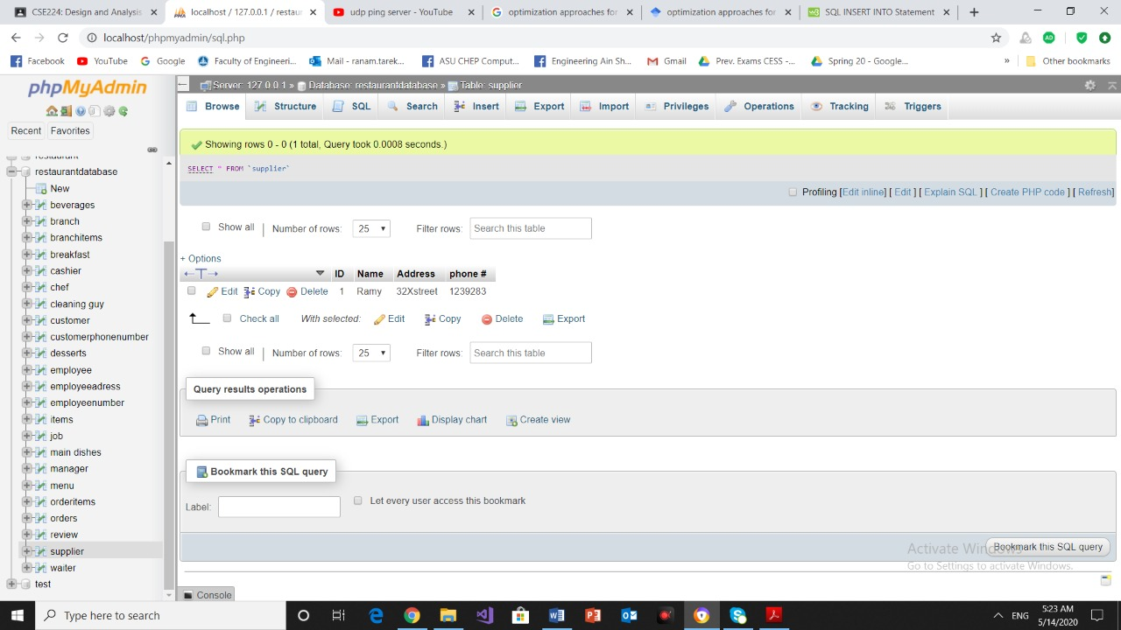

Screen shot after update:

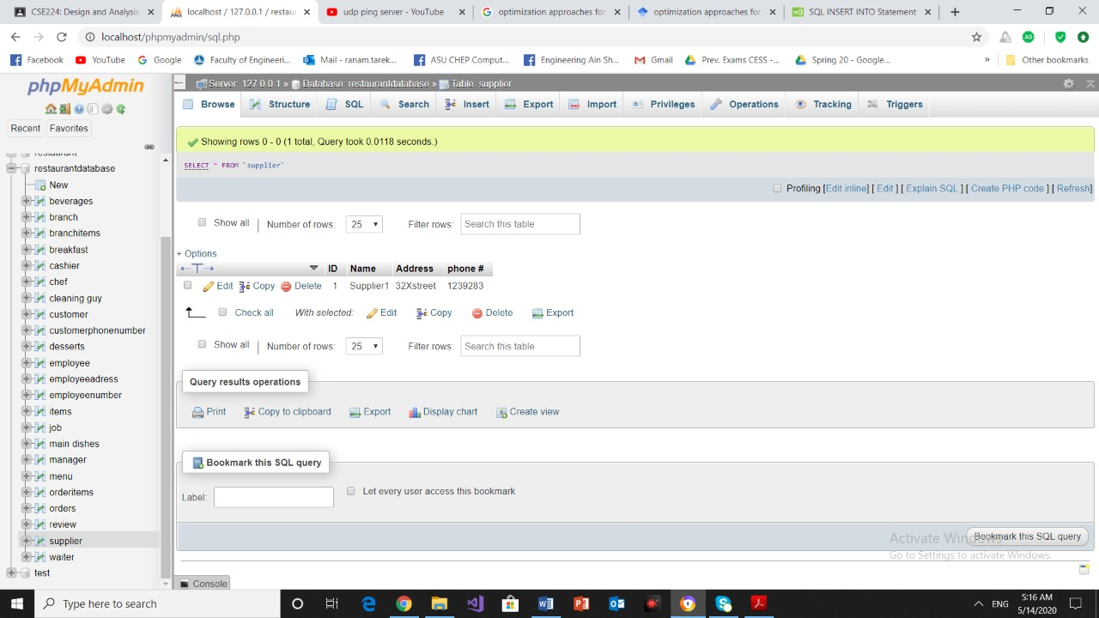

Example to delete Data

1-DELETE FROM supplier

WHERE Name = ‘amr’;

Screenshot Before Deleting Data

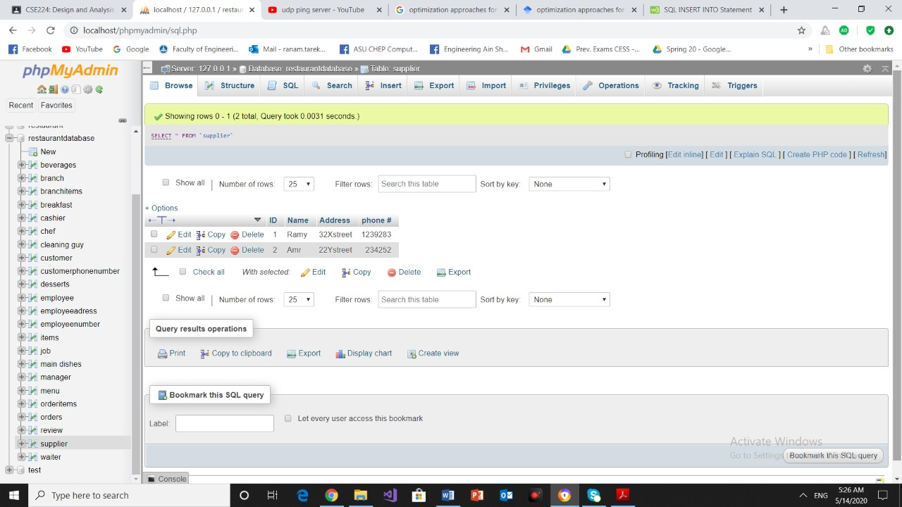

Screenshort After Deleting Data

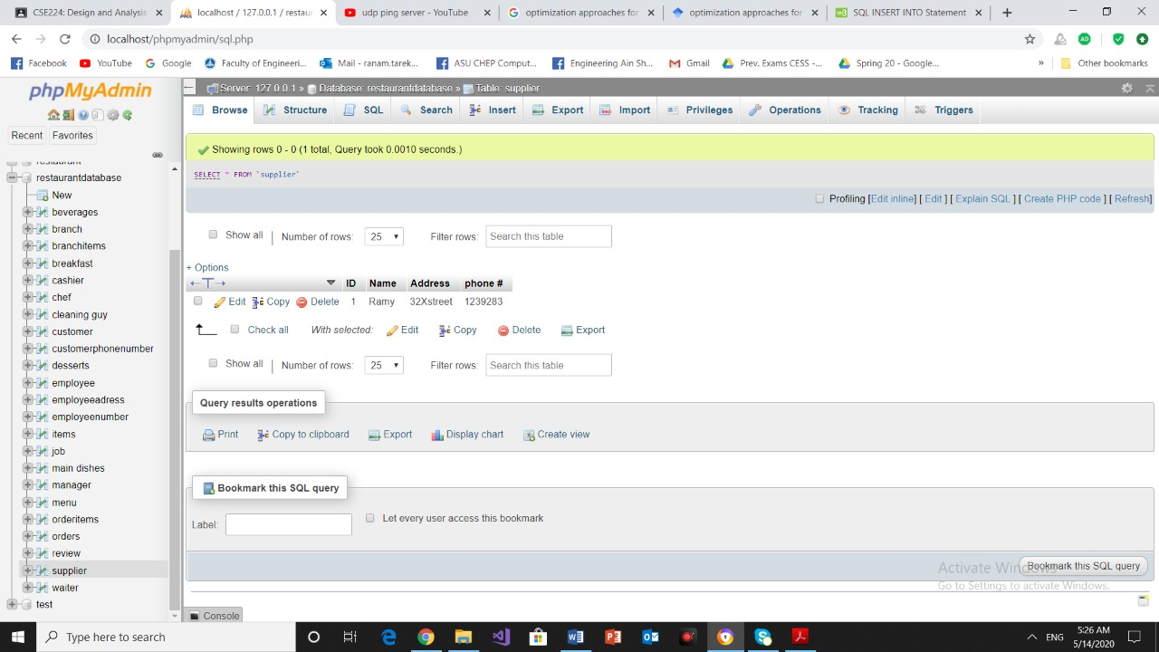

# References:

* Fundamentals of database systems ( 7th edition, 2015) By Ramez elmasri, Shamkant B. Navathe.
* <https://prezi.com/atgo8xhdjzmp/introduction-to-database/>
* <https://erdplus.com/>
* https://www.phpmyadmin.net