National University of Computer & Emerging Sciences
Object Oriented Programming - CS1004
Assignment #1 Documentation
Car Marketplace System (PakWheels Clone)

Student: Tahir Hussain | ID: 25K-0532 | Spring 2026

1. Project Overview
This project implements a Car Marketplace System similar to PakWheels (www.pakwheels.com) using C++ Object-Oriented Programming principles. The system allows sellers to post vehicle listings, buyers to browse, save favorites and send messages, and admins to moderate listings.
- Vehicle listing creation with full specifications
- Search and filter by brand, model, price range, year range
- Buyer favorites / saved listings
- Buyer-to-seller messaging system
- Admin approval / rejection of listings

2. Classes (5 Marks)
The system defines 12 classes. Each class contains 5–6 data members and at least 4 member functions (excluding getters/setters).

# | Class Name | Role | Data Members (5-6) | Key Functions (4+)
1 | Address | Stores location info | street, city, province, postalCode, country (const) | display(), isValidPostalCode(), getFullAddress(), isSameCity()
2 | ContactInfo | Phone/email data | phoneNumber, email, whatsappEnabled, alternatePhone, platformCode (const) | display(), isValidEmail(), isContactable(), getPrimaryContact()
3 | Message | Buyer-seller messages | messageId, senderName, receiverName, content, timestamp, isRead | display(), markAsRead(), containsKeyword(), getSummary()
4 | Vehicle | Core vehicle data | brand, model, year, price, mileage, color | display(), matchesBrand(), matchesModel(), isPriceInRange(), isYearInRange()
5 | CarSpecifications | Technical car specs | engineType, transmission, engineCC, registrationCity, modelYear (const), condition | display(), isAutomatic(), isElectric(), getSummary()
6 | Listing | A single car listing | listingId, vehicle, specs, description, status, postedDate, sellerUsername | display(), isApproved(), isPending(), matchesBrand(), matchesPriceRange()
7 | User | Base user class | username, passwordHash, contact, address, userType, isVerified | displayProfile(), isLoggedIn(), hasValidContact(), getDisplayName()
8 | Seller | Inherits User; posts listings | listings[50]: Listing*, listingCount, totalSales, totalRevenue, sellerRating | addListing(), removeListing(), viewMyListings(), recordSale()
9 | Buyer | Inherits User; browses | favorites[20]: Listing*, favCount, inbox[100]: Message, inboxCount, budget, preferredCity | saveFavorite(), removeFavorite(), sendMessage(), viewInbox()
10 | Admin | Inherits User; moderates | adminLevel, approvedCount, rejectedCount, department, adminCode (const) | approveListing(), rejectListing(), viewStats(), displayProfile()
11 | SearchFilter | Filter query object | brand, model, minPrice, maxPrice, minYear, maxYear, maxMileage, MAX_RESULTS (const) | matches(), display(), resetFilter(), hasAnyFilter()
12 | Marketplace | Main system container | listings[200], sellers[100], buyers[100], listingCount, platformName (const) | addListing(), deleteListing(), searchListings(), displayApprovedListings()

3. Constructors, Setters and Getters (3 Marks)

3.1 Default Constructors
Used when objects are created as part of fixed-size arrays (e.g., Listing listings[200] in Marketplace requires Listing to be default-constructible). Also used when sub-objects are created before full data is available.
- Address() — creates empty address with country='Pakistan'. Needed because User is stored in arrays.
- Listing() — initializes all fields to empty/zero. Required for Marketplace's Listing[200] array.
- SearchFilter() — initializes with widest possible ranges so all listings match by default.

3.2 Parameterized Constructors
Used when creating fully populated objects with all known data. Most common in the program:
- Vehicle(brand, model, year, price, mileage, color) — used when posting a new listing.
- Buyer(username, pwd, contact, address, budget) — captures all buyer info at registration.
- Admin(username, pwd, contact, address, level, code) — adminCode is const so must be set at construction.

3.3 Copy Constructors
Used when creating independent copies of existing objects:
- Vehicle(const Vehicle& v) — demonstrated in main(): Vehicle v1Copy(v1). Changes to the copy don't affect the original.
- Address(const Address& other) — demonstrated in main(). Has a custom assignment operator because const member 'country' cannot be re-assigned.
- CarSpecifications(const CarSpecifications& s) — Listing stores CarSpecifications by value; copy constructor ensures safe copying when Listing objects are assigned.

4. Constants & Constant Functions (2 Marks)
Constant / Feature | Class | Member | Reason
const string country | Address | const string country = "Pakistan" | Country never changes for a local platform
const string platformCode | ContactInfo | const string platformCode = "PW" | Platform identifier is fixed for all contact objects
const int modelYear | CarSpecifications | const int modelYear | Model year of a car is a permanent specification — never changes
const string adminCode | Admin | const string adminCode | Admin code is assigned once at creation and must never be modified
const int MAX_RESULTS | SearchFilter | const int MAX_RESULTS = 50 | Max search results is a fixed system-wide limit
const string platformName | Marketplace | const string platformName | Platform name is fixed and should never change at runtime
Const functions | Multiple classes | display() const, matches() const, viewStats() const, etc. | These functions only read data. Marking them const guarantees no state modification.

5. Static Members (2 Marks)
Static Member | Class | Type | Reason for Making It Static
totalVehiclesListed | Vehicle | static int | Tracks how many vehicle objects have ever been created across ALL instances. Belongs to the class, not any one object.
messageCount | Message | static int | Counts total messages sent platform-wide. Every Message constructor increments it. No single message 'owns' this count.
totalTransactions | Marketplace | static int | Platform-wide transaction counter. Callable via Marketplace::recordTransaction() without needing any instance.
getTotalVehicles() | Vehicle | static function | Returns class-level data. Cannot be an instance method since it doesn't relate to any single vehicle.
getTotalMessages() | Message | static function | Returns platform-wide count. Called without needing a Message instance.
recordTransaction() / getTotalTransactions() | Marketplace | static function | Transaction stats are global data — static allows calling from anywhere without an object.

6. Composition & Aggregation (5 Marks)

6.1 Composition (Filled Diamond — child dies with parent)
Parent | Child | How Implemented | Justification
User | ContactInfo | ContactInfo contact (by value inside User) | A user cannot exist without contact info. ContactInfo is embedded directly — it lives and dies with the user.
User | Address | Address address (by value inside User) | Address is an intrinsic part of a user profile. No independent Address object survives the user.
Listing | Vehicle | Vehicle vehicle (by value inside Listing) | A listing cannot exist without a vehicle. Vehicle is embedded directly in Listing.
Listing | CarSpecifications | CarSpecifications specs (by value inside Listing) | Specs are part of the listing definition. They don't exist independently.
Buyer | Message (inbox) | Message inbox[100] inside Buyer | Inbox messages are owned by and stored inside the buyer object.

6.2 Aggregation (Hollow Diamond — child exists independently)
Parent | Child | How Implemented | Justification
Seller | Listing | Listing* listings[50] (pointer array) | A listing exists independently on the Marketplace. Even if a seller is deleted, the listing still exists. The seller holds only a pointer (reference) to it.
Buyer | Listing (favorites) | Listing* favorites[20] (pointer array) | Saved listings exist independently. Removing a favorite only removes the buyer's pointer — it does NOT delete the listing itself.

7. Array of Objects (5 Marks)
Class | Array Member | Size | Purpose
Marketplace | Listing listings[200] | 200 | Stores all vehicle listings on the platform. Iterated during search, display, delete.
Marketplace | Seller sellers[100] | 100 | Stores all registered sellers for platform-wide management.
Marketplace | Buyer buyers[100] | 100 | Stores all registered buyers on the platform.
Buyer | Message inbox[100] | 100 | Stores full Message objects for a buyer's inbox — each with id, sender, receiver, content, timestamp.
Seller | Listing* listings[50] | 50 (pointers) | Aggregation: pointer array referencing listings this seller has posted.
Buyer | Listing* favorites[20] | 20 (pointers) | Aggregation: pointer array referencing listings saved as favorites.

8. Functionality (12 Marks)

8.1 Add, Update, Delete Vehicle Listings
- Seller::addListing(Listing* l) — adds listing pointer to seller's personal list.
- Marketplace::addListing(const Listing& l) — adds listing to global marketplace array.
- Marketplace::deleteListing(int id) — removes listing by shifting array elements left.
- Marketplace::updateListingStatus(int id, string status) — updates status: Pending/Approved/Rejected/Sold.
- Seller::removeListing(int id) — removes listing reference from seller's personal array.

8.2 Search and Filter by Attributes
- SearchFilter class encapsulates: brand, model, price range, year range, mileage, city.
- Vehicle::matchesBrand(), matchesModel(), isPriceInRange(), isYearInRange() called inside SearchFilter::matches().
- Marketplace::searchListings(const SearchFilter& f) iterates all listings and prints matches.

8.3 Buyer Saves Favorites
- Buyer::saveFavorite(Listing* l) — saves pointer to listing in favorites[20] array.
- Buyer::removeFavorite(int id) — removes pointer without deleting the actual listing.
- Buyer::viewFavorites() — displays all saved favorite listings.

8.4 Buyer Sends Messages to Seller
- Buyer::sendMessage(sellerName, content, timestamp) — creates a Message object in buyer's inbox[100].
- Message tracks: sender, receiver, content, timestamp, isRead status.
- Buyer::viewInbox() — displays all messages. Message::markAsRead() marks a message as read.

8.5 Admin Approves / Removes Listings
- Admin::approveListing(Listing& l) — sets status to Approved, increments approvedCount.
- Admin::rejectListing(Listing& l, reason) — sets status to Rejected with a reason.
- Marketplace::displayApprovedListings() — shows only listings where status == "Approved".
- Admin::viewStats() — const function showing approve/reject counts.

9. Class Diagram (6 Marks)
The diagram below shows all 12 classes with their attributes and methods, and all relationships: Inheritance (solid arrow), Composition (filled red diamond), and Aggregation (hollow green diamond).

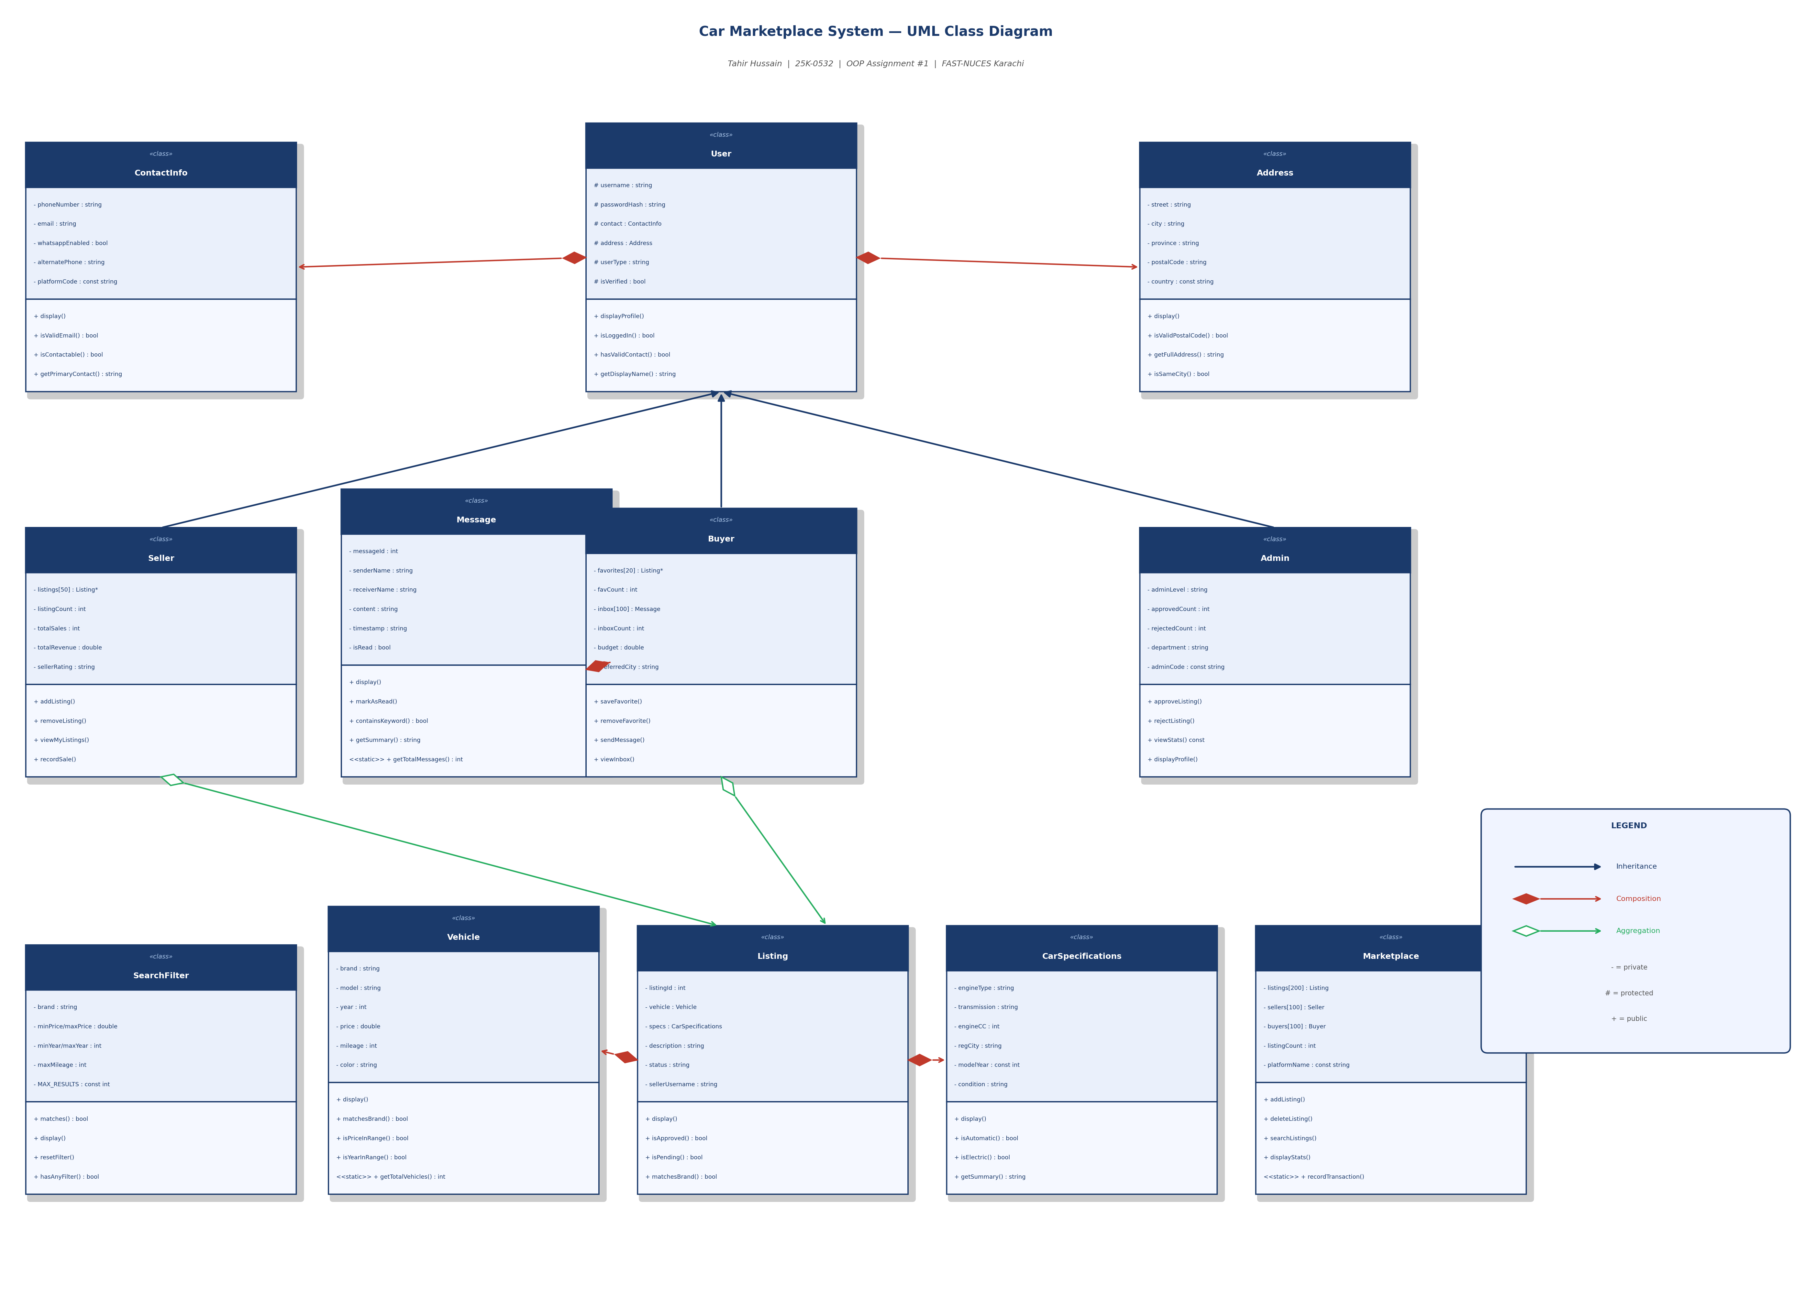

Figure 1: Class Diagram — Car Marketplace System (Tahir Hussain, 25K-0532)

9.1 Inheritance Relationships
- User is the base class. Seller, Buyer, and Admin all inherit from User using public inheritance.
- All three subclasses override displayProfile() — demonstrating polymorphism.

9.2 Composition Relationships (Filled Red Diamond)
- User ◆→ ContactInfo and User ◆→ Address: embedded by value inside User.
- Listing ◆→ Vehicle and Listing ◆→ CarSpecifications: embedded by value inside Listing.
- Buyer ◆→ Message[100]: inbox messages stored directly inside Buyer.

9.3 Aggregation Relationships (Hollow Green Diamond)
- Seller ◇→ Listing*[50]: Seller holds pointers to Listings; Listings exist independently in Marketplace.
- Buyer ◇→ Listing*[20]: Buyer holds favorite pointers; removing a favorite doesn't delete the Listing.

10. Sample Output
The following screenshot shows the actual program output when compiled and run:

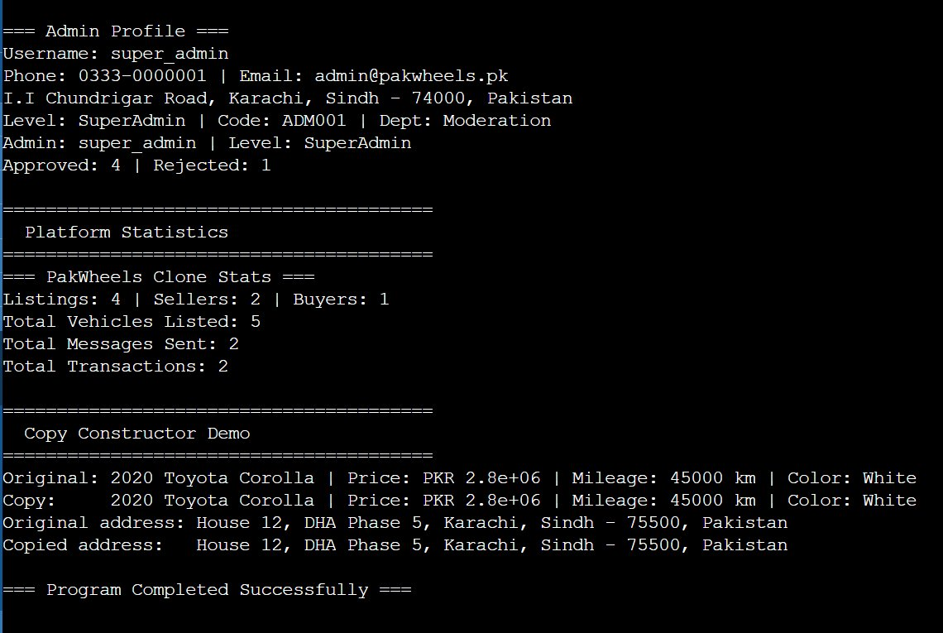

Figure 2: Actual program console output (Admin Profile, Platform Statistics, Copy Constructor Demo)

11. OOP Concepts Summary
OOP Concept | Where Used | Example
Encapsulation | All classes | Private data members with public getters/setters in every class
Inheritance | User hierarchy | Seller, Buyer, Admin all inherit from User base class
Polymorphism | displayProfile() | virtual displayProfile() in User; overridden in Seller, Buyer, Admin
Composition | User, Listing | User owns ContactInfo and Address by value; Listing owns Vehicle and CarSpecs
Aggregation | Seller, Buyer | Seller holds Listing* pointers; Buyer holds Listing* favorites pointers
Arrays of Objects | Marketplace, Buyer | Marketplace: Listing[200], Seller[100]; Buyer: Message inbox[100]
Static Members | Vehicle, Message, Marketplace | totalVehiclesListed, messageCount, totalTransactions — class-level data
Const Members | Multiple classes | const country, const modelYear, const adminCode, const platformName
Const Functions | Multiple classes | viewStats() const, matches() const, display() const — guaranteed read-only
Constructor Overloading | Most classes | Default + Parameterized + Copy constructors in Address, Vehicle, User, etc.

