**Movie Listing App**

1. Data is given in movies.json, design, model and implement a Django app for this data:

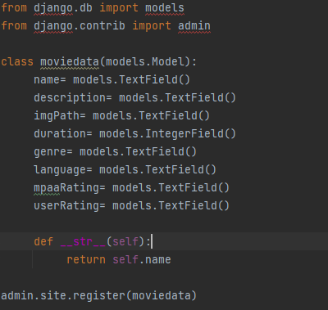

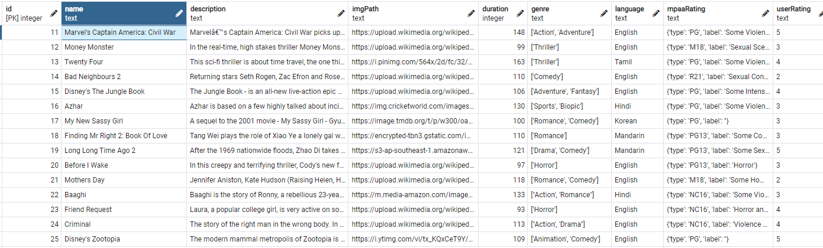

1. Develop Movie Listing Page:

* View.py:

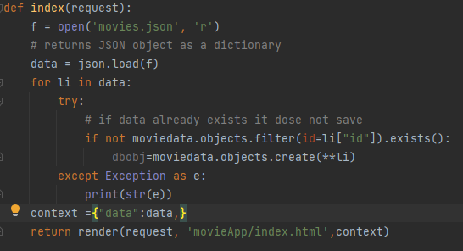

* Index.html:

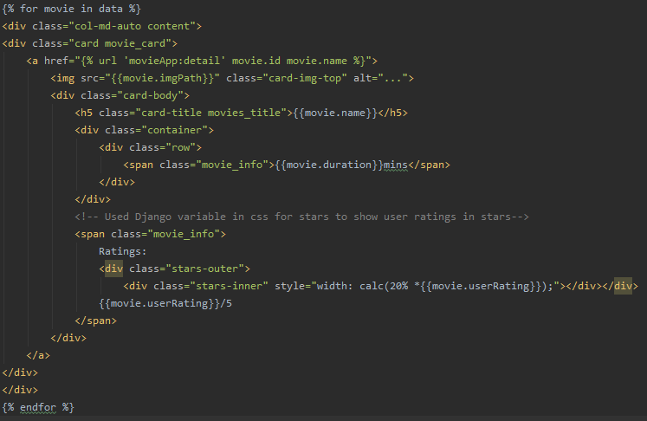

1. Develop Movie Detail Page:

* Views.py

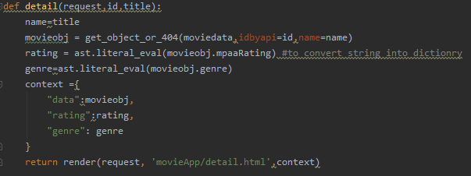

* Details.html

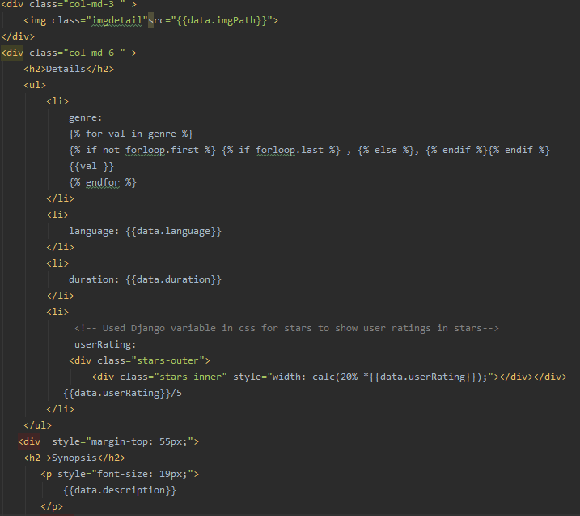

1. Develop Javascript search bar which filters movies listed on the Movie Listing Page based on their names. It should be dynamic loading of search results

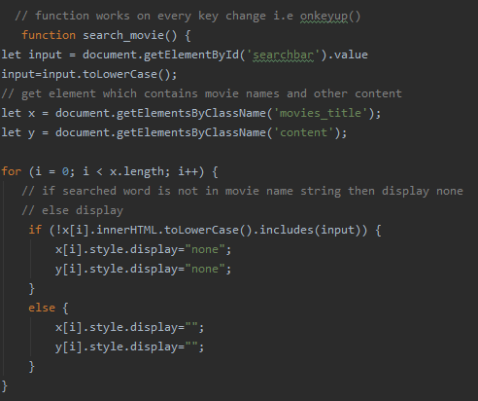

1. Movie Web App link is deployed on heroku:

* Link: <https://movierep.herokuapp.com/>

Name: Usama Bin Saeed

Gmail: Usamarana845@gmail.com

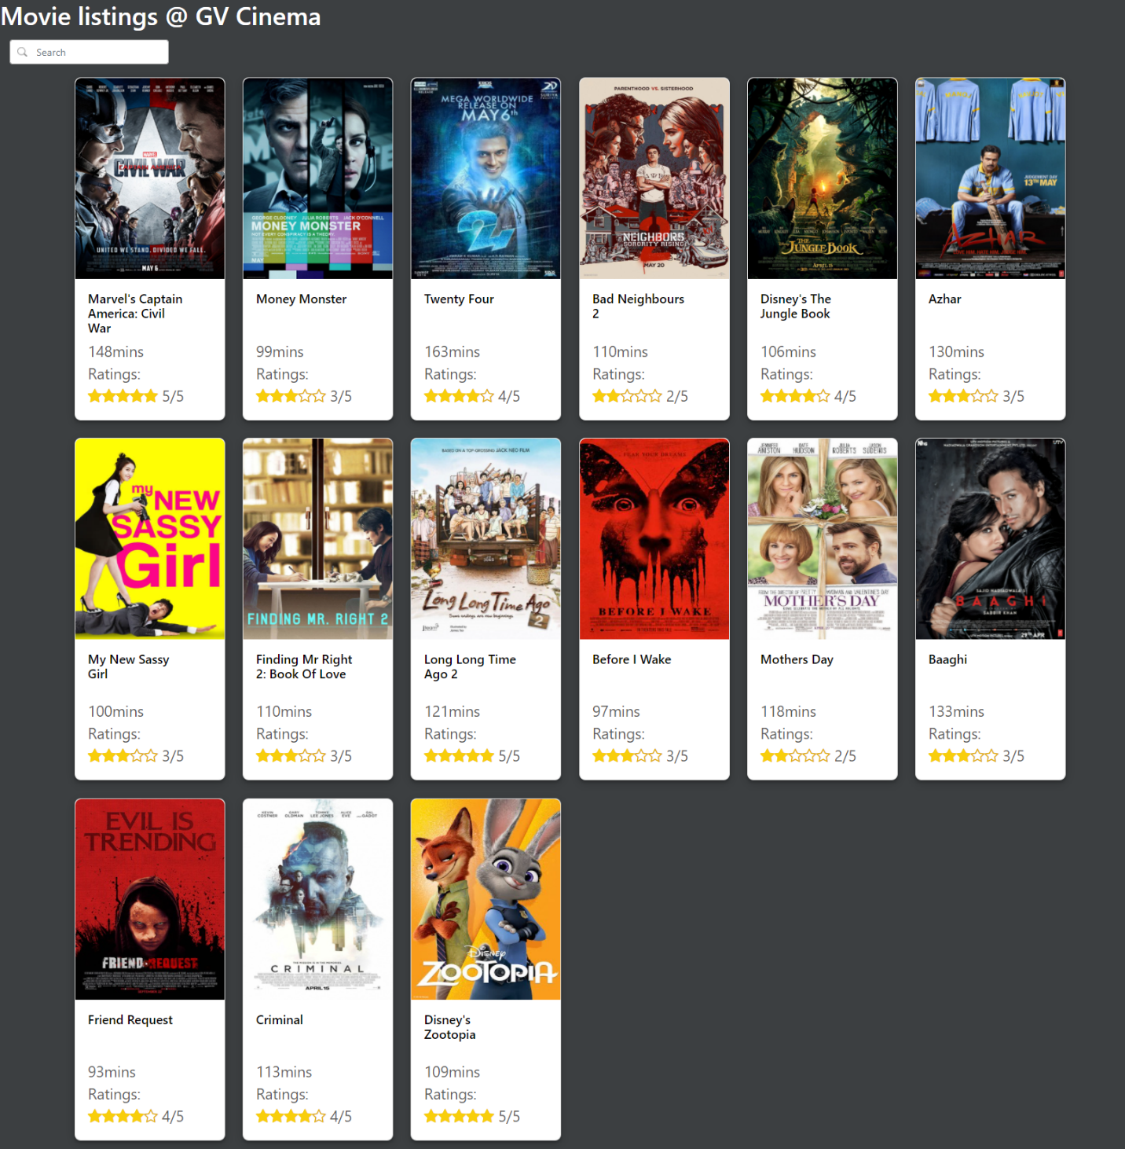

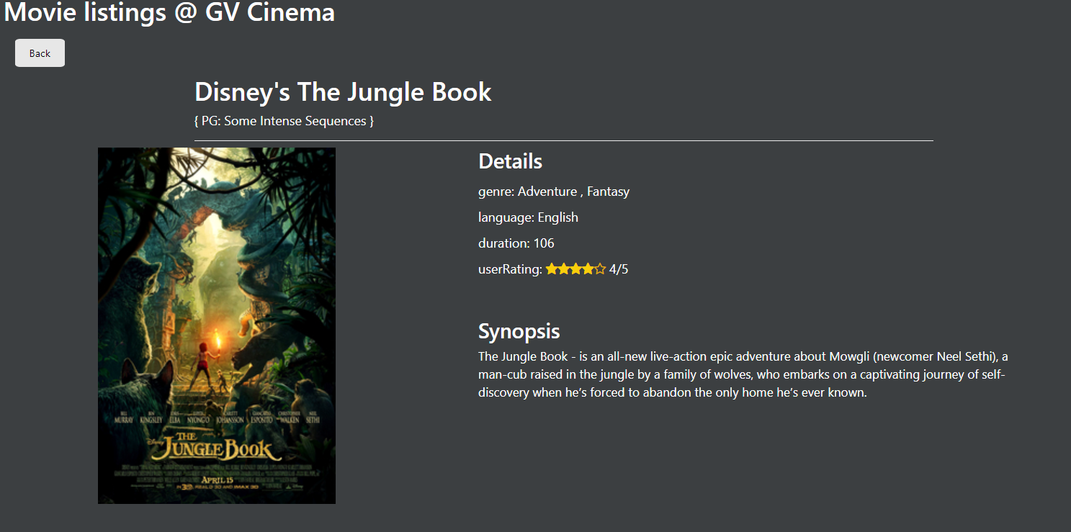

Run app:

I have added virtual env in zip folder just activate it and had to create postgress db named movieDB then it will works