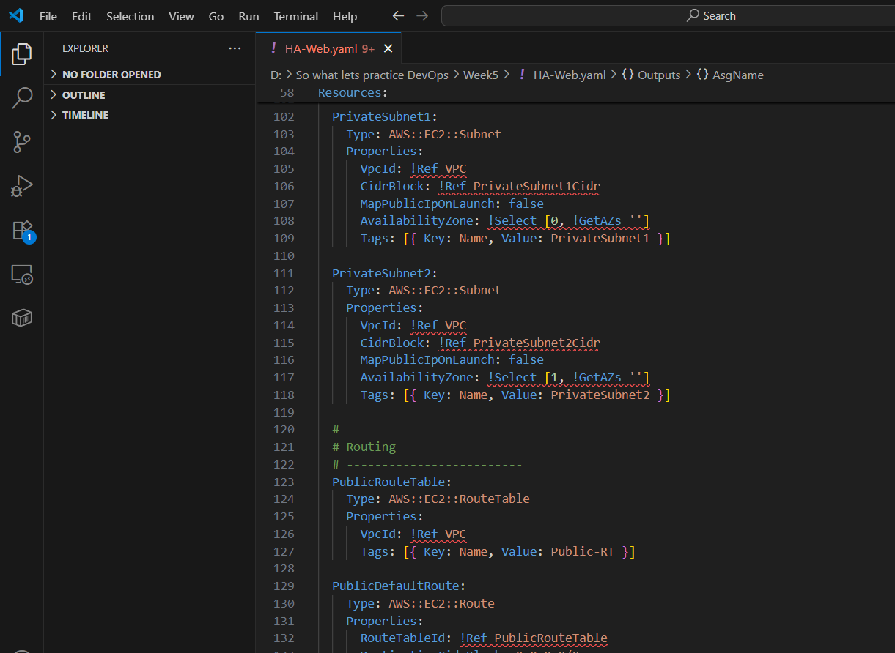

**cd "/d/So what lets practice DevOps/Week5"**

# Initialize git (if not done)

**git init**

# Add files

**git add .**

# Commit

**git commit -m "Add HA app CloudFormation template"**

# Set main branch

**git branch -M main**

# Add remote repo

**git remote add origin https://github.com/RanbirKaur11/Cloudformation-HA-Web.git**

# Push to GitHub

**git push -u origin main**