
NM1051 – SERVICENOW ADMINISTRATOR – SMART INTERNZ STREAMLINING TICKET ASSIGNMENT FOR EFFICIENT
SUPPORT OPERATIONS

A PROJECT REPORT

Submitted by
RANCHANI R (815422104038)
SWETHA S (815422104057)
SANDHIYA S (815422104045)
SELVARANI K (815422104304)

BACHELOR OF ENGINEERING

IN SEVENTH SEMESTER
COMPUTER SCIENCE AND ENGINEERING


SRI RAMAKRISHNA COLLEGE OF ENGINEERING ANNA UNIVERSITY : CHENNAI 600 025
NOV/DEC 2025

ANNA UNIVERSITY : CHENNAI 600 025

BONAFIDE CERTIFICATE
Certified that this project report “STREAMLINING TICKET ASSIGNMENT FOR EFFICIENT SUPPORT OPERATIONS” is the bonafide work of “RANCHANI R, SWETHA S, SANDHIYA S, SELVARANI K” who
carried out the project work under my supervision. No part of the dissertation has been submitted for any degree or any other academic award anywhere before.

SIGNATURE Mrs. C.SURYA M.E.,

ASSISTANT PROFESSOR
Department of CSE
Sri Ramakrishna College of Engineering
Perambalur

SIGNATURE
Mr. R.DINESH RAJ M.E.,

HEAD OF THE DEPARTMENT
Department of CSE
Sri Ramakrishna College of Engineering
Perambalur

Submitted for the University Practical Examination held on……………….

INTERNAL EXAMINER EXTERNAL EXAMINER
TABLE OF CONTENT

S.NO | CONTENTS | PAGE NO
1. | Abstract | 4
2. | Problem Definition | 4
3. | Introduction | 4
4. | Modules and tools used | 5
5. | Creation of tables | 6
6. | Creation of relationship | 7
7. | Creation of business rules | 9
8. | Configure the relationship | 10
9. | Implementation process | 11
10. | Conclusion | 12
11. | Practice scenarios for servicenow admin | 15

1.ABSTRACT
This project, titled “Calculating Family Expenses Using ServiceNow,” focuses on developing an automated system to simplify household budgeting and expense management. The main objective is to replace traditional, manual tracking methods—such as notebooks or spreadsheets—with a centralized digital platform that ensures accuracy, accessibility, and real-time visibility.
The system leverages ServiceNow’s low-code/no-code capabilities to create a custom application that allows users to record, categorize, and analyse daily expenses efficiently. Each family member can enter their spending details, and the system automatically organizes the data based on category, date, and amount. By using tables, relationships, related lists, and business rules, the platform provides a complete structure for managing and summarizing all financial transactions.

1. PROBLEM DEFINITION
Managing family expenses manually can often lead to confusion, errors, and lack of clarity about where the money goes each month. Traditional methods like using notebooks or spreadsheets require manual calculations and frequent updates, which are time-consuming and prone to mistakes.
The goal of this project is to overcome these issues by developing a Family Expense Management System using ServiceNow. The system automates the process of recording and organizing expenses made by different family members. It ensures accuracy, easy tracking, and instant access to data.
By using ServiceNow’s features like tables, relationships, and business rules, the project provides a digital solution that makes expense tracking simple, efficient, and transparent for every household.

INTRODUCTION
Financial management is a key aspect of every household, yet many families struggle to maintain accurate and consistent records of their daily expenses. Traditional methods—like writing in notebooks, using spreadsheets, or relying on memory—often lead to missing data, confusion, and lack of clarity about where money is spent. With technology playing a larger role in everyday life, automating this process has become both practical and necessary.
This project aims to build a Family Expense Management System using ServiceNow, a cloud-based workflow automation platform widely known for IT and business process management. The same platform can be customized to track and analyze personal expenses through forms, tables, workflows, and reports.
In this system, each expense entry includes key details such as date, category, amount, and payment method. The information is stored securely in a database and linked to the respective family member who made the
expense. Relationships and business rules help automate calculations and maintain data accuracy, while related lists and configuration options ensure the interface remains user-friendly.

MODULES AND TOOLS USED
The project was built entirely using ServiceNow, a cloud-based platform known for its low-code application development. Several key modules and tools were used during the development process:
- Tables and Columns: Used to create structured data models for storing family and expense details.

- Form Layouts and Design: Customized to make data entry easy and organized.

- Reference Fields: Used to link the Family Member table with the Expense table.

- Business Rules: Created to automate calculations and validations.

- Client Scripts: Used for small frontend validations and dynamic field behavior.

- Related Lists: Configured to display linked expenses under each family member.

- Reports and Dashboards: Used to generate summaries and visual insights.

These modules together formed a simple yet complete system to manage and analyze expenses effectively.

CREATION OF TABLE
In ServiceNow, a table is the foundation for storing data. For this project, a custom table was created to record and manage family expense details.
The table includes essential fields such as:

  - Date – To record the date of each expense.

  - Category – To classify the expense (e.g., groceries, rent, bills, entertainment).

  - Amount – To store the total spent.

  - Payment Method – To indicate if the expense was paid by cash, card, or UPI.

  - Description – To provide additional details about the transaction.
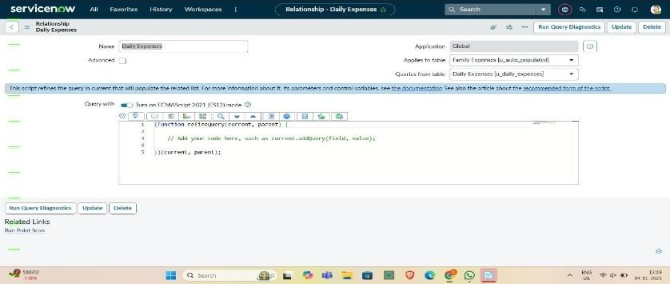

Columns (Fields)
Open the Family Expenses table and navigate to the Columns section. Add new fields to capture necessary data such as:
  - Date – Date/Time type to record when the expense occurred.
  - Category – Choice field to select expense type (Food, Rent, Utilities, etc.).
  - Amount – Currency or Integer type for expense value.
  - Payment Method – Choice field for mode of payment (Cash, UPI, Card).
  - Description – String/Text type for additional notes.
  - Recorded By – Reference field linking to the Family Member table.
  - After adding fields, save and verify that all are visible in the form layout.
Each field is designed with appropriate data type and mandatory settings to maintain data accuracy.

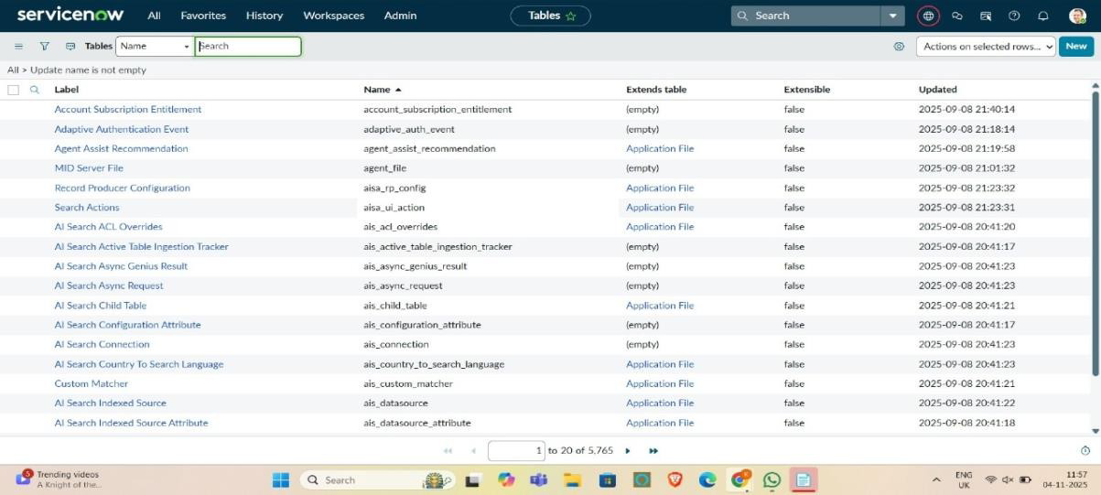

CREATION OF RELATIONSHIP
In ServiceNow, relationships are used to connect two or more tables so that data can be shared or referenced easily. For our project, we created a relationship between the Family Member table and the Expense table.
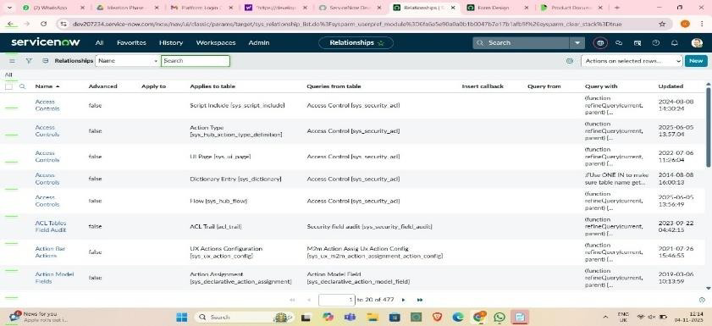
Each family member is linked to their respective expense records using a reference field. This relationship helps identify which member spent how much and on what category. It improves the clarity of the overall expense tracking process.

CONFIGURING RELATED LIST ON FAMILY EXPENSES
Once the relationship between the Family Member and Expense tables was created, the next step was to configure the related list. A related list in ServiceNow displays records from another table that are linked through a reference field or relationship. It provides a quick view of all associated records without having to navigate between multiple tables.
To configure the related list, we performed the following steps:

- Opened the Family Member form in Form Design or Form Layout.

- Selected the Related Lists tab.

- Added the Expenses table as a related list using the reference field created earlier.

- Saved and reloaded the form to verify that the related list appeared correctly.
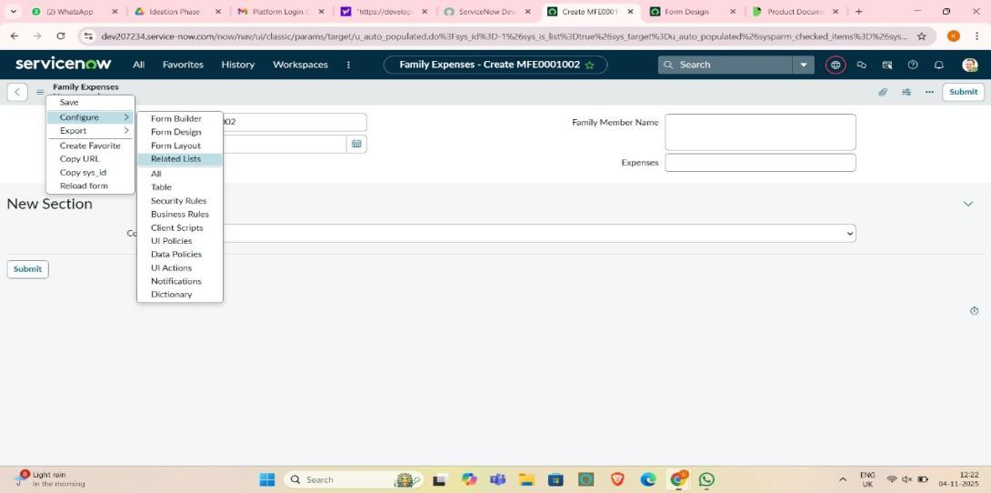

CREATION OF BUSINESS RULES
Business Rules in ServiceNow are server-side scripts that run automatically when a record is inserted, updated, deleted, or displayed. They are mainly used to enforce consistency, apply conditions, and automate processes without manual input. In our Family Expense Management project, business rules helped maintain data accuracy and reduce repetitive work.
Steps to Create a Business Rule:

  - Navigate to System Definition → Business Rules.

  - Click on New to create a new rule.

  - Enter a name like Validate Expense Entry or Auto Calculate Total.

  - Choose the Table (in our case, “Expense”).

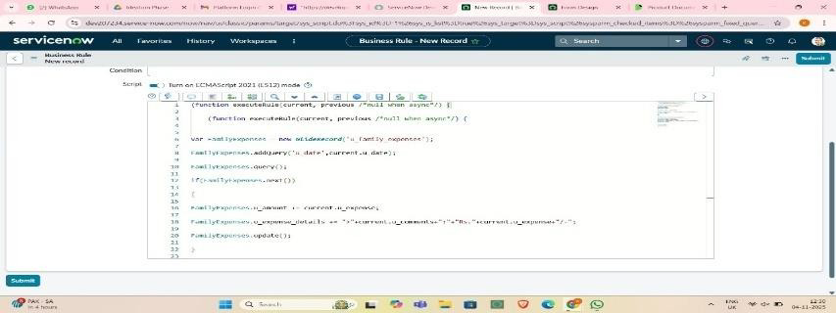

CONFIGURE THE RELATIONSHIP
After creating the relationships and business rules, the next step was to configure them properly so that data flows smoothly between the connected tables. In ServiceNow, configuring relationships ensures that when a change happens in one table, the related tables update automatically, keeping the system consistent and synchronized.
Steps Followed to Configure the Relationship:

  - Opened the System Definition → Tables module.

  - Selected the Expense table, where the reference field to the Family Member table was added.

  - Verified the reference field settings, ensuring it pointed to the correct table (Family Member).

  - Configured the Display Value so that the member’s name appears instead of just a system ID.

  - Enabled the Related List visibility under the Family Member form to show all linked expense records.

  - Tested the configuration by creating new family member and expense entries to confirm that relationships were reflected properly.

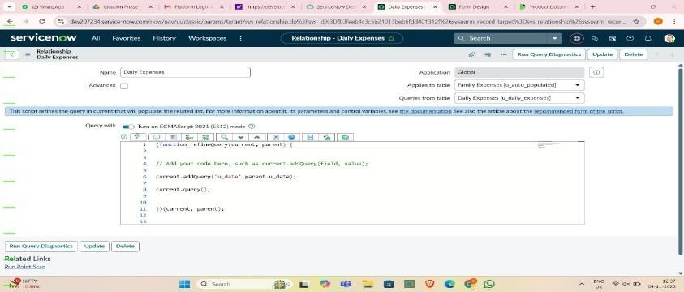

11. SYSTEM DESIGN
The system design defines how data flows within the project and how each part connects to another. Our

IMPLEMENTATION PROCESS
The implementation involved a step-by-step setup within ServiceNow to bring all components together.

  - Creating a Custom Application:

  - Designing Tables:

  - Establishing Relationships:

  - Configuring Related Lists:

  - Adding Business Rules:

CONCLUSION
The project “Calculating Family Expenses using ServiceNow” successfully demonstrated how the ServiceNow platform can be used to design and implement a practical solution for managing and analyzing financial data. Through this project, we learned how to create custom tables, establish relationships, configure related lists, and automate tasks using business rules. Each step helped in building a structured system capable of tracking expenses efficiently.

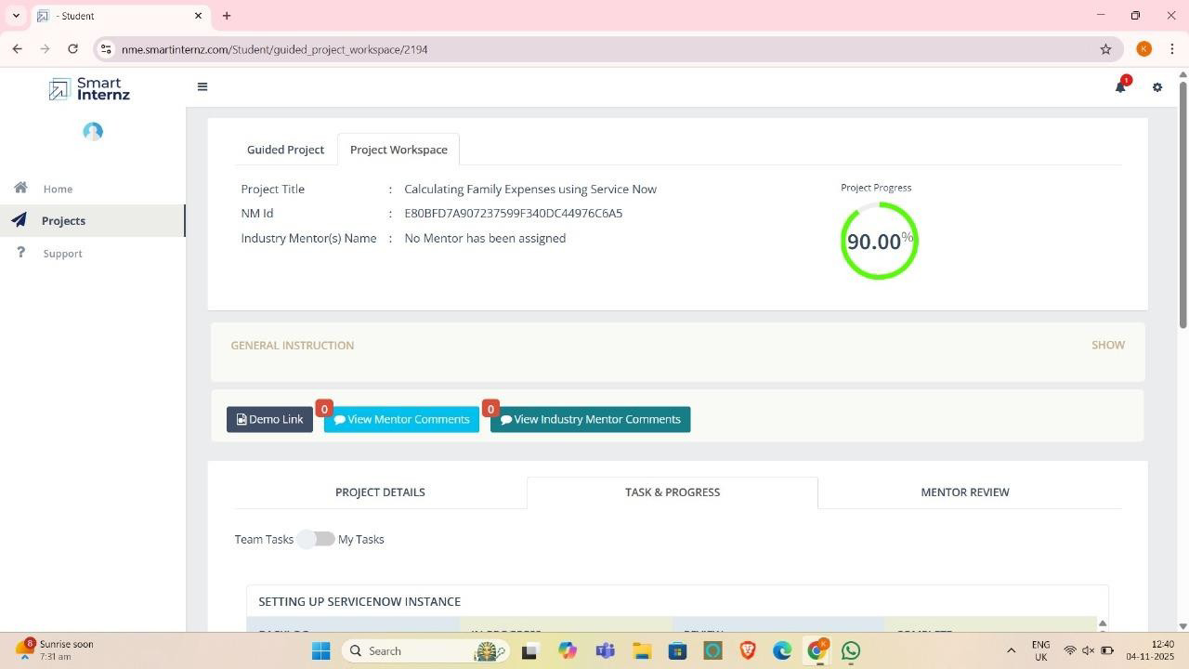

PRACTICE SCENARIOS FOR SERVICENOW ADMIN

- Create a new user for a contractor, assign them to an "IT Support" group, and ensure they can only access the Incident application.

Create the Contractor User

  - Navigate to Users → User Administration > Users.
  - Click New.

  - Fill in details:
    - User ID: contractor1

    - First name / Last name: Contractor User

    - Email: contractor1@gmail.com
    - Active: Checked.

  - Save.

Assign the User to the "IT Support" Group

  - On the user record, scroll to Groups (related list).
  - Click Edit.

  - Add to the IT Support group.

  - Save.

Restrict Access to Only the Incident Application

Now we need to make sure this contractor can only work with Incident.

Option A: Role-Based Control (Mostly Preferred)

  - By default, Incident application requires itil role.

  - Instead of giving full itil access (which gives too much), do the following:
    - Create a new custom role, ex: incident_contractor.

    - Assign this role only to permissions needed for Incident (using ACLs).
    - Assign the new role to your contractor user.

    - Do not give itil or other broad roles.

Option B: Application Menu Restriction

  - Go to System Definition > Application Menus.

  - Open the Incident application menu.
  - In the Roles field, add your custom role (incident_contractor).

    - This ensures only users with this role can see the Incident.

Verify Access

  - Impersonate the contractor user.

  - Check:
    - They should only see the Incident application in the left nav.

    - They can open/create/edit incidents (based on the ACLs you configured).
    - They cannot access other apps (like Change, Problem, etc.).

- Assign a role to a new group so members can read Knowledge Articles but cannot create or edit them.

Create a New Group

- Navigate to User Administration > Groups.
- Click New.

- Enter a Name for the group (e.g., Knowledge Readers).
- Optionally, add a Description.

- Click Submit.

Assign the Appropriate Role
- To allow read-only access to Knowledge Base articles, assign the knowledge
role:
- Open the newly created group.

- Scroll to the Roles related list.
- Click Edit.

- Add the role: knowledge

- This role allows users to view published articles.
- Click Save.

- **Do NOT assign roles like knowledge_admin or knowledge_manager,
which grant create/edit permissions.

Add Users to the Group

- In the group record, scroll to the Group Members related list.
- Click Edit.

- Select users you want to add.
- Click Save.

Verify Access
- Log in as one of the group members.

- Navigate to Knowledge > Articles.

- Confirm they can view articles.
- Try creating or editing an article — they should not have access.

- Configure a UI Policy that hides the "Work Notes" field unless the state is "In Progress".

Solution:

- Navigate to UI Policies
- Go to Application Navigator → type UI Policies → click System UI > UI Policies.
- Create a New UI Policy

- Click New.
- Select the Table → e.g., Incident (or whichever table you’re working on).

- Provide a Name (e.g., Hide Work Notes unless In Progress).

- In the Conditions section, set:
- Field = State

- Operator = is
- Value = In Progress.

- Check the box Active.

- Save the record.

Add a UI Policy Action

- In the same UI Policy record, scroll to UI Policy Actions (Related List).
- Click New.

- Configure the action:
- Field name = Work notes

- Visible = True (since you want it visible only when the condition is met).

- Submit the action

- Configure a UI Policy to hide Notes section in incident, when state is In Progress.

Solution:

- Navigate to UI Policies
- Go to Application Navigator → type UI Policies → click System UI > UI Policies.
- Create a New UI Policy

- Click New.
- Select the Table → e.g., Incident (or whichever table you’re working on).

- Provide a Name (e.g., Hide Work Notes unless In Progress).

- In the Conditions section, set:
- Field = State

- Operator = is
- Value = In Progress.

- Check the box Active.

- Save the record.

Make Run Script box True

- Just write one line of code:
- g_form.setSectionDisplay(‘notes’,false);

- Submit the action

Configure a response SLA, the SLA should pause, when the incident state is in On Hold vice versa.
- Create or Modify an SLA Definition
- Navigate to Service Level Management > SLA Definitions.

- Click New or open an existing SLA (e.g., "Response SLA").
- Fill in the basic details:

- Name: Response SLA

Table: Incident
- Type: Response

- Duration: Set your desired time (e.g., 1 hour)

Set SLA Conditions

- Under the Start Condition:
- Example: State is New

- Under the Stop Condition:

- Example: State is Resolved or Closed
- Under the Pause Condition:

- Add: State is On Hold
- This ensures the SLA timer pauses when the incident is moved to On Hold, and
resumes when it returns to another New state

Test the SLA Behavior
- Create a test incident.

- Confirm SLA starts when an incident is created.
- Change state to On Hold — SLA should pause.

- Change back to Active — SLA should resume.
- Resolve the incident — SLA should stop.

- Configure an email notification that alerts the assigned group whenever a new Change Request is created.

Solution:

- Navigate to Notifications
- In the Application Navigator, type Notifications.

Go to System Notification > Email > Notifications.

- Create a New Notification
- Click New.

- Fill in the basic details:
- Name: New Change Request Assigned Group Alert

- Table: Change Request [change_request]
- Active: Checked

Define When to Send

- Under When to send, configure:
- When to send: Insert (since you want this when a new record is created).

Define Who Will Receive
- In the Recipients tab:

- Under Users/Groups in fields, choose Assigned to group (or the field name for assigned group).
- This ensures the entire assigned group gets the email.

Define What Will Contain
- In the What it will contain tab:

- Subject: New Change Request Created - ${number}
- Message HTML (sample):

A new Change Request has been created.
- Number: ${number}

- Short Description: ${short_description}
- Requested By: ${requested_by}

- Assignment Group: ${assignment_group}

- State: ${state}
- Please review and take necessary action.

Save & Test
- Save the Notification.

- Create a new Change Request record, assign it to a group.
- Verify that the email goes out to all members of the Assigned Group.

- Create a report showing the number of incidents opened by each department in the last 30 days.

Navigate to Reports
- Go to Reports > Open Reports Modules.

- Click Create a Report.

Define Report Source
- Name: Incidents by Department - Last 30 Days

- Source Table: Incident

Set Conditions

- Under Filter, add:
- Opened At → on or after → Today - 30 days

- Department → is not empty (optional, to exclude unassigned)

Choose Report Type
- Select Type: Bar Chart or Pie Chart (or List if you prefer tabular view)

Configure Grouping
- Under Group By, select: Department

- Under Aggregation, choose: Count

Save and Run
- Click Save.

- Click Run to view the report.
- Build a dashboard for Service Desk Managers showing KPIs like incidents by priority, created within a week, state wise also
- Step 1: Create Individual Reports

- You’ll need to create three separate reports first:

- Incidents by Priority
- Go to: Reports > Create New

- Name: Incidents by Priority
- Source Table: Incident

- Type: Bar Chart or Pie Chart

- Group By: Priority
- Aggregation: Count

- Filter: Opened At → on or after → Today - 30 days

Incidents Created Within a Week

- Name: Incidents Created - Last 7 Days
- Source Table: Incident

- Type: Time Series or Bar Chart

- Filter: Opened At → on or after → Today - 7 days
- Group By: Opened At (Daily)

- Aggregation: Count

Incidents by State

- Name: Incidents by State

- Source Table: Incident
- Type: Bar Chart or Pie Chart

- Group By: State
- Aggregation: Count

- Filter: Opened At → on or after → Today - 30 days

Step 2: Create a Dashboard

- Go to Self-Service > Dashboards.

- Click Create New Dashboard.

Name: Service Desk Manager KPIs

- Add a Proper Description
- Click Submit.

Step 3: Add Reports to the Dashboard

- Open the newly created dashboard.
- Click Edit Content.

- Use Add Reports to include:
- Incidents by Priority

- Incidents Created - Last 7 Days
- Incidents by State

- Arrange the widgets as needed for clarity.

- Restrict the ability to delete records in the Change Request table so only users with the "admin" role can do so.

Navigate to Access Control (ACLs)
- In the Application Navigator, type Access Control.

Go to System Security > Access Control (ACL).

- Create a New ACL Rule
- Click New.

- Fill in details:
- Type: record

- Operation: delete
- Table: Change Request [change_request]

- Name: (auto-populates when you pick table + operation)

Define the Condition / Role
- In the Requires role field, add: admin

- This ensures only users with the admin role can delete records.

Save & Test

- Save the ACL.

- Test with a non-admin user → they should not see the delete option (or get a permission error if they try via URL).
- Test with an admin user → delete should work normally.

- Create a custom table and create two reference fields (ex: assignment group and assigned to). Display the users based on selection of assignment group.

Create a Custom Table

- In the Application Navigator, type Tables.
- Go to System Definition > Tables.

- Click New.
- Name: u_custom_task

- Label: Custom Task.

- Save.

Add Fields

- Open your table and go to the Columns tab.
- Add two reference fields:

- Assignment Group → Type = Reference, Table = sys_user_group.
- Assigned To → Type = Reference, Table = sys_user.

Configure Reference Qualifier on "Assigned To"

- We need to filter "Assigned To" users based on the selected Assignment Group.

Using Reference Qualifier

- Right click on the Assigned To field, click on Configure Dictionary.
- Go to Dependent Section, give the name of the Assignment Group(ex: u_ass_group)
- Update and Test the functionality.
- How to auto assign incidents when user selects a category as network, the same incident be assigned to Network group.

Solution:

- Go to Flow Designer → Designer.
- Click New Flow.

- Name: Assign Incident by Category

- Trigger: Created or Updated → Table = Incident
- Add a If action (Condition) with expression:

- Select Trigger Record Category is Network
- Under the If branch, add Action → Update Record:

- Record: Trigger → Incident(Trigger Record)

- Set field Assignment group → Network
- Save and Activate the flow.

- Test the Flow.

- HR Groups members are only able to see HR Related Records in servicenow?

Solution:

- Step 1: Create a Role for HR Access

- Navigate to:
User Administration → Roles → New

- Enter:
- Name: hr_access

- Description: Role to allow access to HR Cases

- Click Submit.

Step 2: Assign the Role to HR Group

- Navigate to:
User Administration → Groups

- Open your HR group record.
- In the Roles tab → click Edit.

- Move hr_access from Available → Selected.

- Click Save.
- Now all members of the HR group have the hr_access role.

Step 3: Create Access Control (ACL) for Viewing HR Cases
- Navigate to:
System Security → Access Control (ACL)

- Click New.

Step 4: Define Access Condition (No Script)
- Scroll down to the Requires role section:

- Add the Role hr_access.
- This means only users with the hr_access role can read/view HR Case records.

Step 5: Save and Test
- Click Submit or Update to save the ACL.

- Impersonate a non-HR user:

- Go to your profile → click Impersonate User → choose a user not in the HR group.
- Try opening an HR Case record → You should see a “Security constraints prevent access to requested page” message.
- Now impersonate an HR group member:

- They should be able to open HR Cases normally
- When the Incident state changes to In Progress, Child incident related list should be hidden.

Solution:

- Navigate to System UI → UI Policies → New.
- Fill the header:

- Name: Hide related lists when State is In Progress

- Table: Incident
- Active: checked

- Global: checked
- Condition: State is In Progress
(Use the exact label used in your instance for the In Progress state.)

- Submit the UI Policy record.
- In the UI Policy record click New under UI Policy Actions.
- Set:

- Field name: select the related list–Child incident
- Visible: false

- Read only: optional
- Save and Test the UI Policy Action.

- How to Display Incident number while loading the incident form

Solution:

- Navigate to System UI → Client Scripts → New.
- Fill the header:

- Name: Show Incident Number on Load

- Table: Incident
- Type: onLoad

- Active: True
- Add this script:

- function onLoad() {
- // Get the Incident number field value

- var incNum = g_form.getValue('number'); // 'number' is the field name

- alert('Incident Number: ' + incNum);
- }

- When the Incident state changes to In Progress, description should be hidden and short description should be mandatory.

Solution:

- Step 1 — Navigate to Client Scripts
- Go to:
System UI → Client Scripts → New
- Fill the header:

- Name: Hide Description and Make Short Description Mandatory
- Table: Incident

- Type: onChange

- Field name: state
- Active: checked

Step 2 — Add the Client Script Code
- function onChange(control, oldValue, newValue, isLoading) {

- if (isLoading) return;

- if (newValue === '2') {
- g_form.setDisplay('description', false);

- g_form.setMandatory('short_description', true);
- } else {

- g_form.setDisplay('description', true);
- g_form.setMandatory('short_description', false);

- }

- }
- Click Submit or Update to save.

- If the description field is empty in the incident table, prevent the form submission.

Solution:

  - Step 1 — Navigate to Client Scripts
  - Go to:
System UI → Client Scripts → New
  - Fill the header:

  - Name: Prevent Submit if Description Empty
  - Table: Incident

  - Type: onSubmit

  - Active: checked

Step 2 — Add the Client Script Code

  - function onSubmit() {
  - var description = g_form.getValue('description');

  - if (description == '') {

  - g_form.addErrorMessage('Description cannot be empty');
  - return false;

  - } else {
  - return true;

  - }
  - }

- Users can not change the state field values in the incident list.

Solution:
  - Step 1 — Navigate to Client Scripts

  - Go to:
System UI → Client Scripts → New

  - Fill the header:

  - Name: Prevent State Inline Edit
  - Table: Incident

  - Type: onCellEdit
  - Field name: state

  - Active: checked

Step 2 — Add the Client Script Code

  - if(newValue==2){

  - alert(‘You can not edit this value’);
  - saveAndClose==false;

  - }else{
  - saveAndClose==true;

  - }

- How to set the Caller to Logged in user automatically in the incident table.

Solution:

  - Navigate: System Definition → Business Rules → New
  - Fill the details:

  - Name: Set Caller on Incident Create
  - Table: Incident

  - When: before

  - Insert/update: checked
  - Advanced: true

Script:
  - current.caller_id = gs.getUserID();

- When a user updates an incident record, priority should change to Critical automatically.

Solution:
  - Navigate: System Definition → Business Rules → New

  - Settings:

  - Name: Set Priority field
  - Table: Incident

  - When: before

  - Update:checked
  - Script:

  - current.impact = 1;
  - current.urgency = 1;

- Create a button on the Incident form that allows users to mark an Incident as Resolved with a single click.

Solution:

  - Navigate: System UI → UI Actions → New
  - Settings:

  - Name: Resolve Incident
  - Table: Incident

  - Action type: Form button

  - Active: checked
  - Script:

  - current.state = 6;
- Create a button on the incident table that copies the Short Description value into the Description field.

Solution:

  - Navigate: System UI → UI Actions → New
  - Settings:

  - Name: Copy Short Description

  - Table: Incident
  - Action type: Form button

  - Active: checked

  - Script:

  - current.description = current.short_description;
  - current.update();

  - action.setRedirectURL(current);

Source Code

https://github.com/Ranchani430/Calculating_family

CERTICICATIONS
  - Micro-Certification - Welcome to ServiceNow

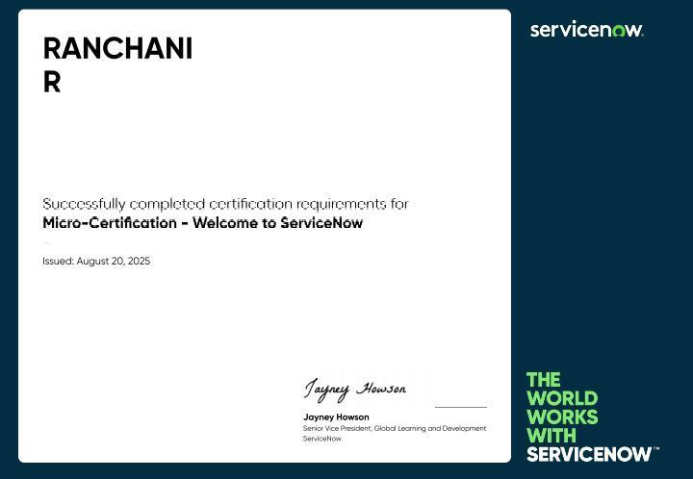

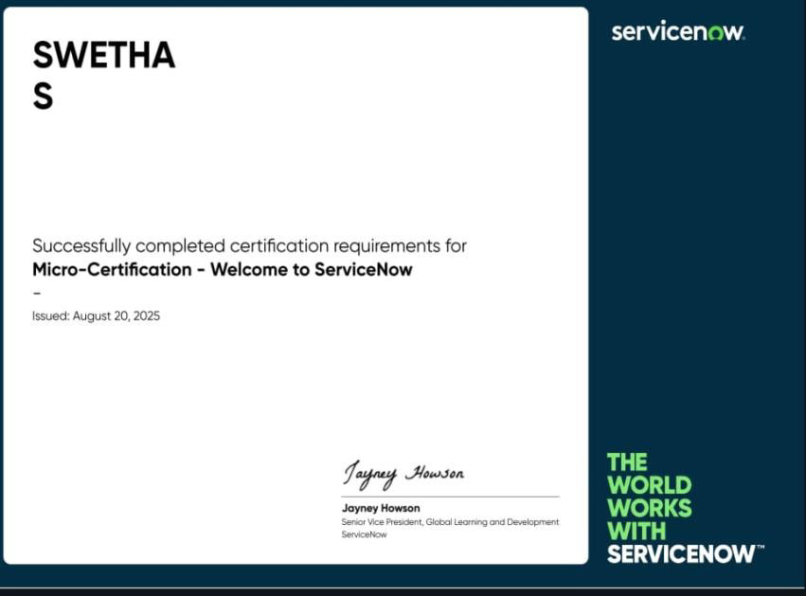
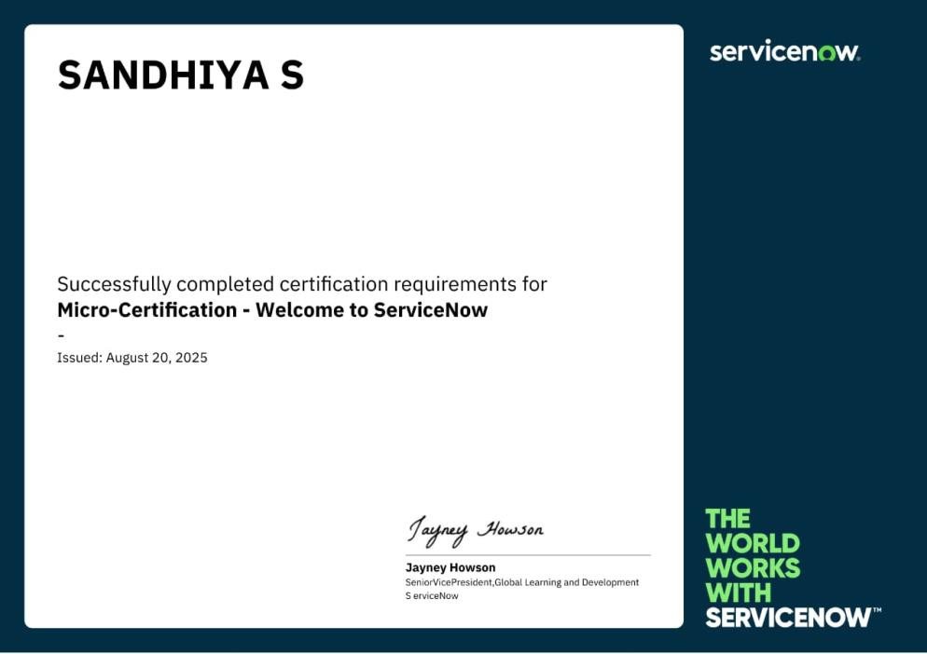

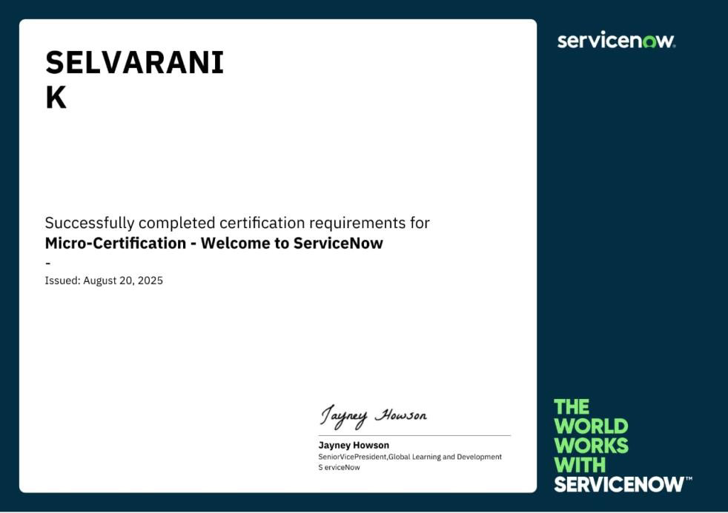
- IBM SkillsBuild – Generative AI in action

