OpenEvent

Software Development Document



An Object-Oriented Programming Project Presented to the Faculty of the
College of Computer Studies
University of the Immaculate Conception Father Selga St., Davao City, Philippines

Team Members:
[Name 1, Name 2, Name 3]

OCTOBER 2026

Software Purpose
Project: "OpenEvent"
Purpose:
OpenEvent is a Java desktop application that helps Hosts organize events and Customers book assigned seats. Hosts create and publish events, arrange venue sections and seats, and set ticket types and prices. Customers find events, choose seats, complete simulated payments and view tickets. Saved records support receipts, eligible cancellations and one-time Host check-in.
Key Value:
- For Hosts: Keeps event details, seating layouts and ticket records organized.
- For Customers: Makes event discovery, seat selection and ticket viewing easier.
- For Accuracy: Prevents duplicate active seat bookings and repeated ticket check-in.

Objectives, Features, and Modules
2.1 Core Objectives:
þ Provide clear Host and Customer account access.
þ Support event management, venue editing and assigned-seat booking.
þ Store accounts, events, seats and tickets in a relational database.
þ Demonstrate encapsulation, inheritance, polymorphism and abstraction.
2.2 Key Features:
þ User Authentication - Create Host or Customer accounts and sign in by role.
þ Event Management - Create, edit, save and publish owned events.
þ Venue and Ticket Management - Arrange sections and seats; create custom ticket names, prices and colors.
þ Booking and Payments - Purchase available seats using simulated Cash, E-wallet or Card payments.
þ Ticket Monitoring - View tickets, export text receipts, cancel eligible tickets and check guests in once.
2.3 System Modules (OOP Structure):
OpenEvent (Entry Point)
+-- SecurityService (Registration, login and role checks)
+-- User (Private data; abstract role method)
| +-- Host
| +-- Customer
+-- Event (Abstract event behavior)
| +-- Concert, SportsMatch and MovieScreening
+-- Payment (Shared simulated payment behavior)
| +-- CashPayment, EWalletPayment, CreditCardPayment
+-- VenuePlan, VenueArea, Stage, TicketType and Seat
+-- BookingController, BookingSystem, BookingRepository
+-- GUI Classes: LoginView, HostView, EventEditorView,
DiscoverView, EventView, CheckoutView, TicketsView

Technology Used
Core Technologies:
- Programming Language: Java 17 or newer; tested with JDK 25.
- GUI Framework: Java Swing.
- Database: MariaDB 10.4 through XAMPP, using JDBC.
- Build Tool: Apache Maven bundled with NetBeans.
Development Tools:
- IDE: Apache NetBeans 28 with GUI Builder and Palette.
- Design: Figma prototype; draw.io for UML diagrams.
- Version Control: Git and GitHub for team sharing.
- Testing and Documentation: Plain Java check programs and Microsoft Word.
Dependencies:
- MySQL Connector/J 8.4.0 for database access.
- KGradientPanel-compatible source included in the project; no separate gradient JAR installation is required.

User Manual
4.1 Installation & Startup:
1. Install Java 17 or newer and complete the database configuration in Section 5.3.
2. Open OpenEvent in NetBeans, choose Clean and Build, then run the project with F6.
3. The sign-in screen appears.
4.2 First-Time Setup:
Choose User Type / Landing Page
- OpenEvent has two user types. Choose Customer to discover events and book seats. Choose Host to organize events and check tickets in. Select the matching role from the sign-in dropdown.
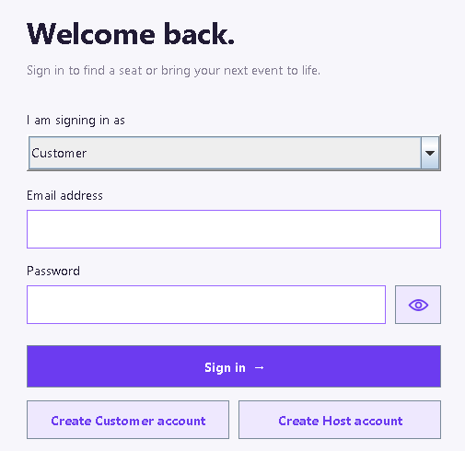
Login Page
- Existing users enter their email and password, then click Sign in. The eye button shows or hides the password. If sign-in fails, check the selected role and account details.
Registration
- New users click Create Customer account or Create Host account. Enter a name, valid email and password of at least eight characters. After registration, sign in with the same role and account details.
Host Dashboard / Event Management
- The Host dashboard lists owned events and ticket summaries. Create an event by entering its title, type, venue, description, schedule and price. Save it as unpublished while preparing it, then publish it when ready for Customers. Enter a valid ticket code on the Host side to check a guest in once.
- A new venue starts with a stage and no sections. Click Add section, then click an empty part of the canvas. Drag sections or the stage to move them, and drag a selected bottom-right corner to resize. Click a section to edit its name, color, shape, seat rows and columns, and ticket type. Click seat positions to make or remove aisles. Ticket types lets the Host create and rename offers and set prices. Save the event after editing.
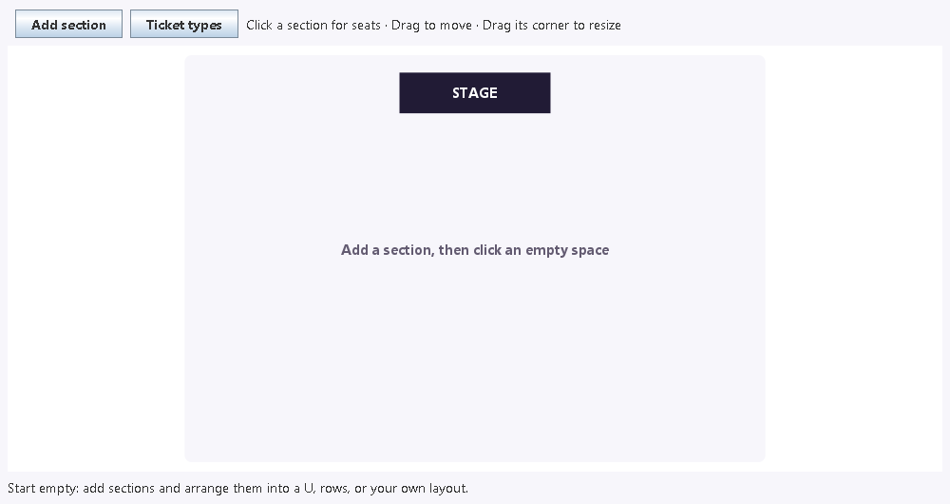
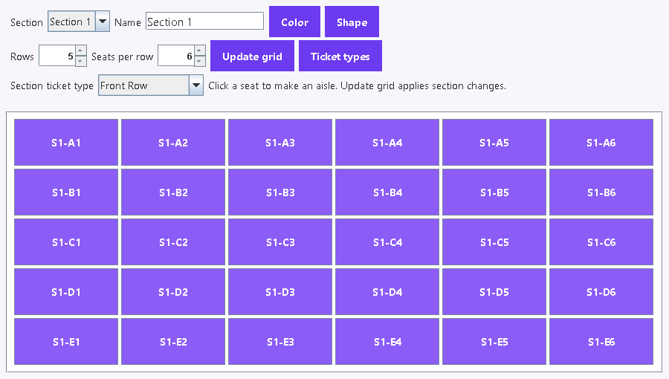
Home Page / Customer Page
- Discover shows published upcoming events. Search by title and open an event. Click a section in the overview, then choose an available numbered seat. Back to overview returns to the sections. Review the price and use a simulated payment to complete the booking.
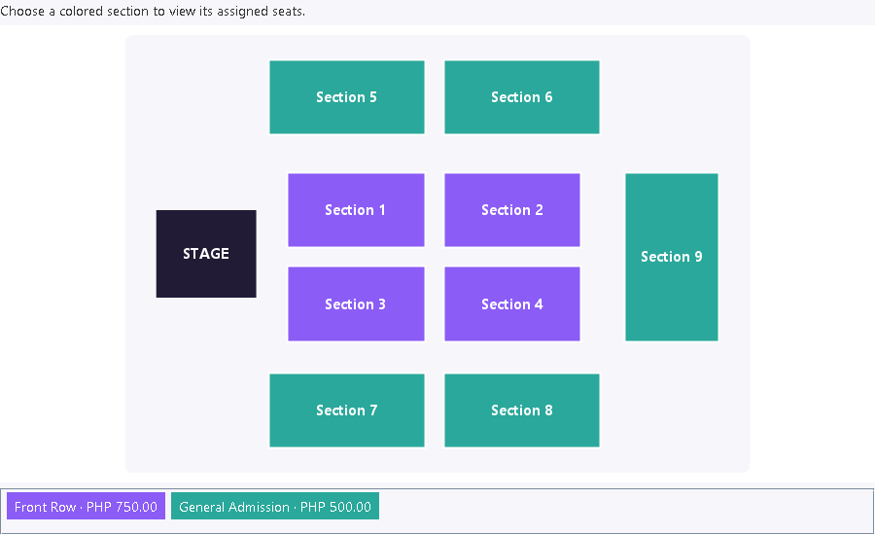
- My tickets shows saved ticket codes, seats, amounts and status. Export a text receipt when needed. An eligible unused ticket can be cancelled before the event starts; its simulated payment is refunded and the seat is released. No real money is transferred.

Technical Manual
5.1 Development Environment Setup:
Prerequisites Verification:
# Check Java installation
java -version
# Required: Java 17 or newer
# Check Maven installation
mvn --version
# Maven is also included with NetBeans.
5.2 Database Schema:
SQL Creation Script:
The three core account and event tables are shown below. The complete definitions and migrations are in database/schema.sql.
-- Host accounts
CREATE TABLE IF NOT EXISTS hosts (
id BIGINT PRIMARY KEY AUTO_INCREMENT,
name VARCHAR(100) NOT NULL,
email VARCHAR(190) UNIQUE NOT NULL,
password_hash VARCHAR(255) NOT NULL,
enabled BOOLEAN NOT NULL DEFAULT 1
) ENGINE=InnoDB;
-- Customer accounts
CREATE TABLE IF NOT EXISTS customers (
id BIGINT PRIMARY KEY AUTO_INCREMENT,
name VARCHAR(100) NOT NULL,
email VARCHAR(190) UNIQUE NOT NULL,
password_hash VARCHAR(255) NOT NULL,
enabled BOOLEAN NOT NULL DEFAULT 1
) ENGINE=InnoDB;
-- Event records
CREATE TABLE IF NOT EXISTS events (
id BIGINT PRIMARY KEY AUTO_INCREMENT,
host_id BIGINT NOT NULL,
type ENUM('CONCERT','SPORTS','MOVIE') NOT NULL,
title VARCHAR(140) NOT NULL,
venue VARCHAR(180) NOT NULL,
description TEXT NOT NULL,
image VARCHAR(50) NOT NULL,
starts_at DATETIME NOT NULL,
early_bird_until DATETIME NOT NULL,
base_price DECIMAL(10,2) NOT NULL,
published BOOLEAN NOT NULL DEFAULT 0,
FOREIGN KEY(host_id) REFERENCES hosts(id)
) ENGINE=InnoDB;
5.3 Project Setup Instructions:
Step-by-Step Guide:
1. Extract Project Files:
Extract or clone the complete OpenEvent project, including src, database, pom.xml, config.example.properties and lib/runtime.
cd OpenEvent
2. Import into IDE (NetBeans):
- File > Open Project > select OpenEvent.
- Select JDK 17 or newer for the project.
- Allow Maven to download missing build components when needed.
3. Database Configuration:
- Start MariaDB in XAMPP. On a fresh database, create openevent and import database/schema.sql.
- Create a local application login with SELECT, INSERT, UPDATE and DELETE permissions on openevent.
- Copy config.example.properties to config.properties. Enter the local database URL, port, application username and password. Keep this file private.
- Existing databases use the relevant additive migrations; do not reset existing records.
4. Build Project:
mvn clean package
5. Run Application:
java -jar target/OpenEvent-1.0-SNAPSHOT.jar
Run from the project folder and keep target/lib beside the JAR. NetBeans F6 can also run com.mycompany.openevent.OpenEvent.

Project Development Phases:
Weekly Progress Snapshot:
- Requirements: Identified Host and Customer needs and prepared the OOP and UML design.
- Database: Created the MariaDB tables and JDBC connection.
- Core Classes: Implemented User, Event, Payment and booking classes.
- Interface: Built the Swing screens, custom ticket options and venue editor.
- Integration and Testing: Checked booking, refunds, check-in and layout behavior; corrected identified problems.
- Documentation: Prepared the user guide, technical guide, diagrams and test case summary.

Limitations and Future Development
7.1 Current Limitations:
Technical Limitations:
- Local configuration - Each computer needs Java and its own MariaDB connection settings.
- Basic receipt export - Receipts are saved as text files.
- Manual backup - No built-in database backup and restore tool.
- Manual refresh - Booking changes are not broadcast automatically.
- Simple 2D layouts - Rectangle or trapezoid sections; no 3D or free rotation.
Functional Limitations:
- Payments and refunds are simulations.
- Assigned seats only; standing-area capacity sales are not supported.
- Flexible layouts allow 1-12 sections, up to 10 rows and 10 columns per section.
- Email delivery and password recovery are not included.
7.2 Future Development Plan:
Short-term Enhancements (Next Version):
¨ Add PDF or spreadsheet export for receipts and reports.
¨ Add a database backup and restore option.
¨ Improve availability refresh between users.
¨ Add more validation and clearer correction messages.
Long-term Roadmap:
¨ Develop a web-based version.
¨ Provide mobile access to customer tickets.
¨ Support a hosted database shared across devices.
¨ Add sales charts and event analytics.
¨ Integrate QR ticket scanning and a real payment service.
Technical Debt & Refactoring:
¨ Make automated checks easier to run.
¨ Add clearer application logs for troubleshooting.
¨ Split long screen-handling methods into smaller reusable methods.
¨ Continue improving error handling and user feedback.

Appendix
A. UML Class Diagram:
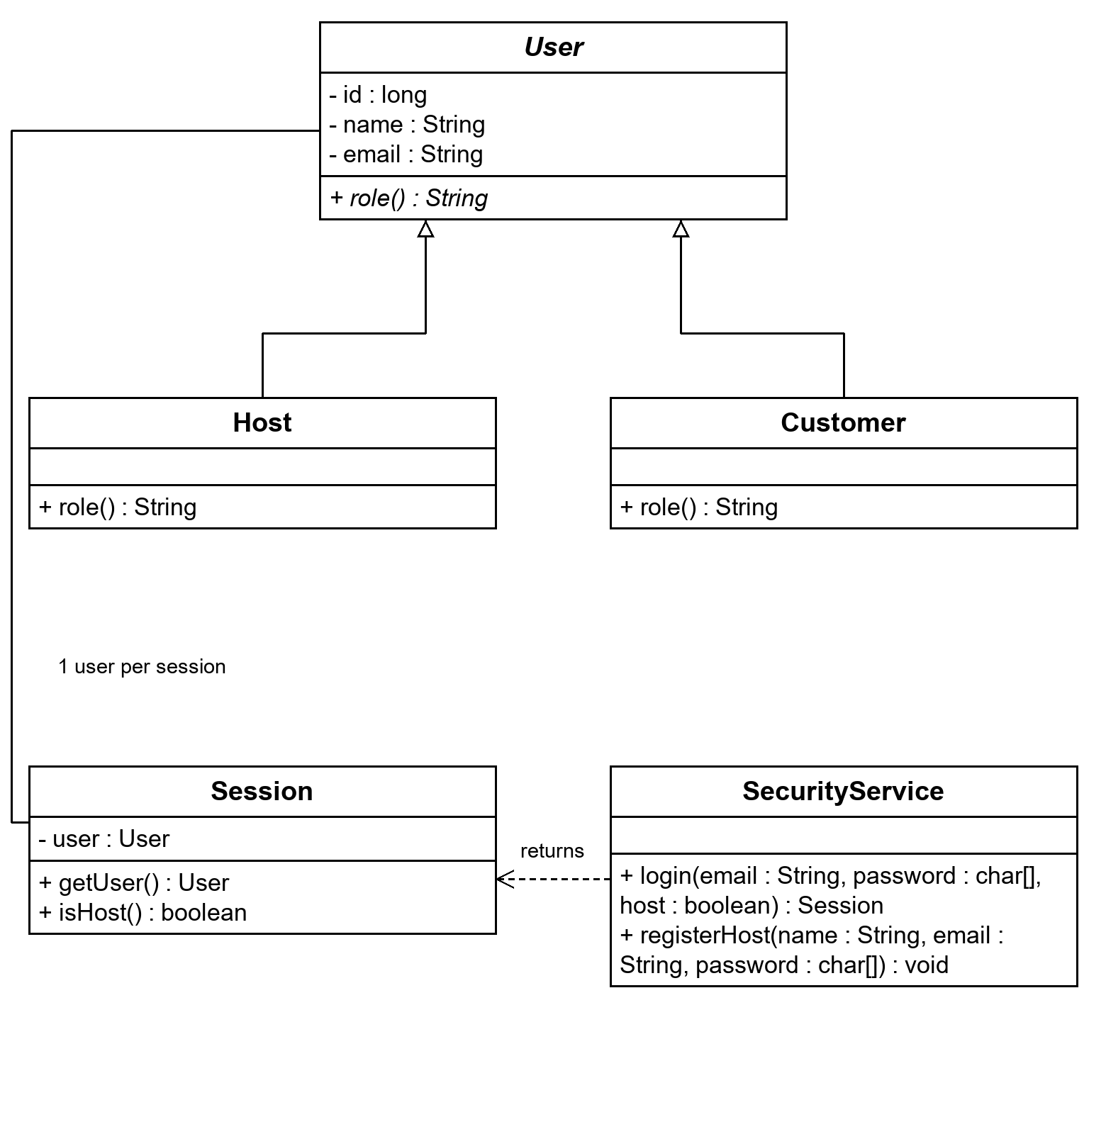
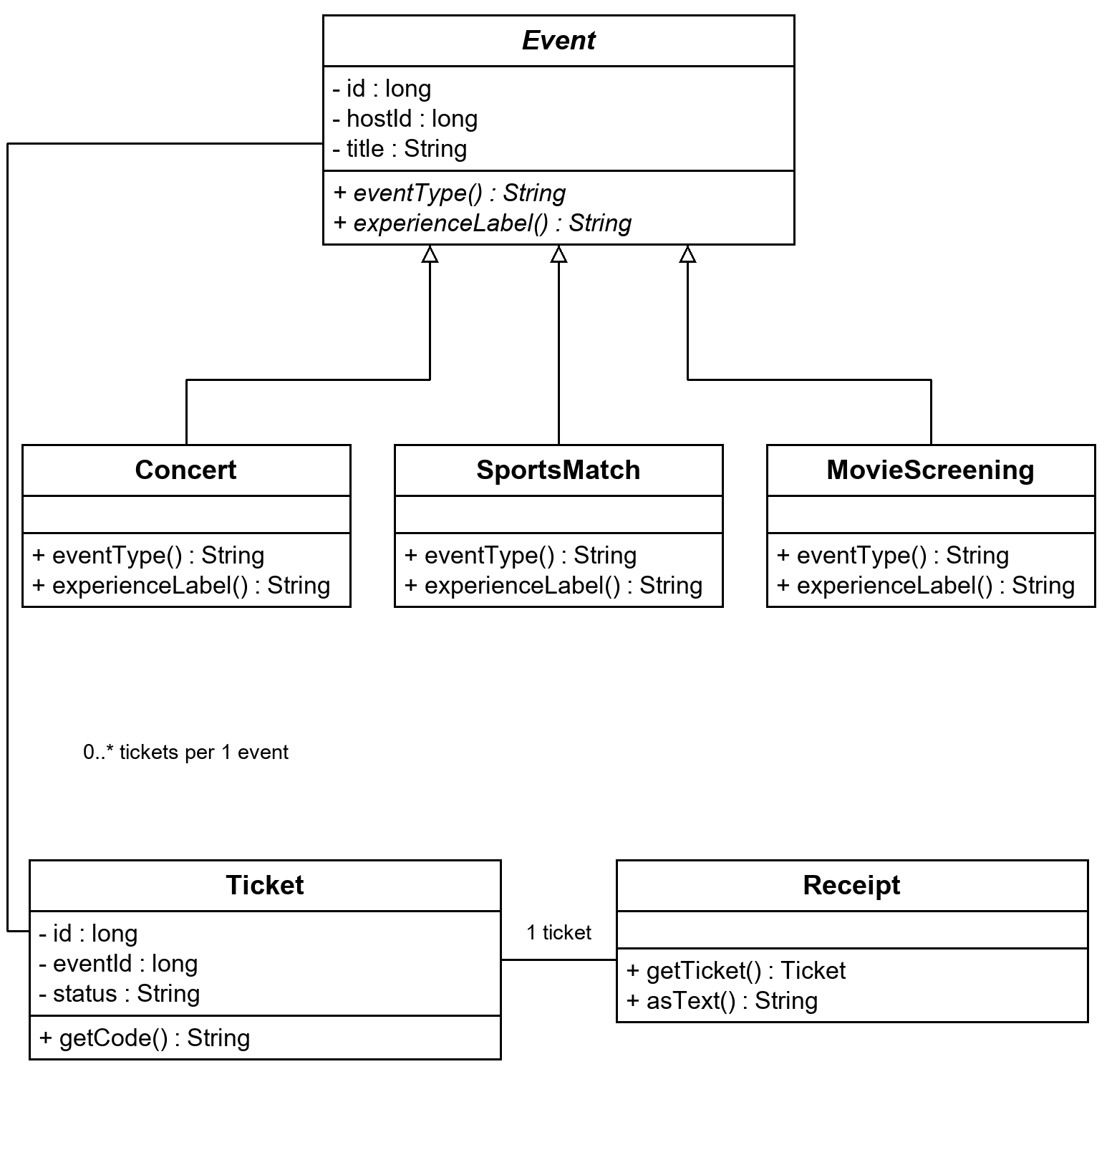
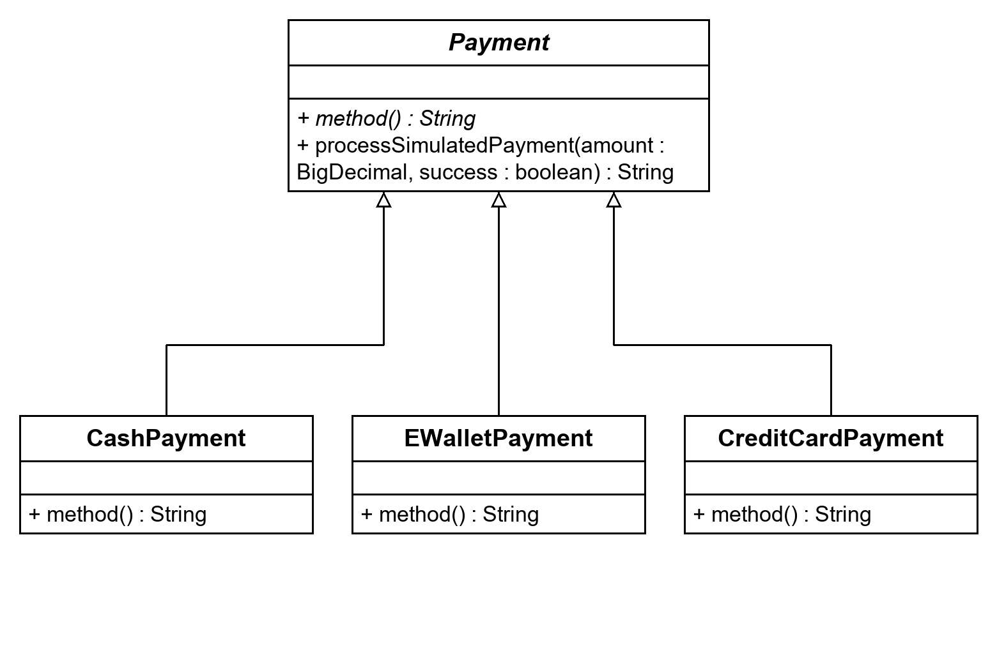
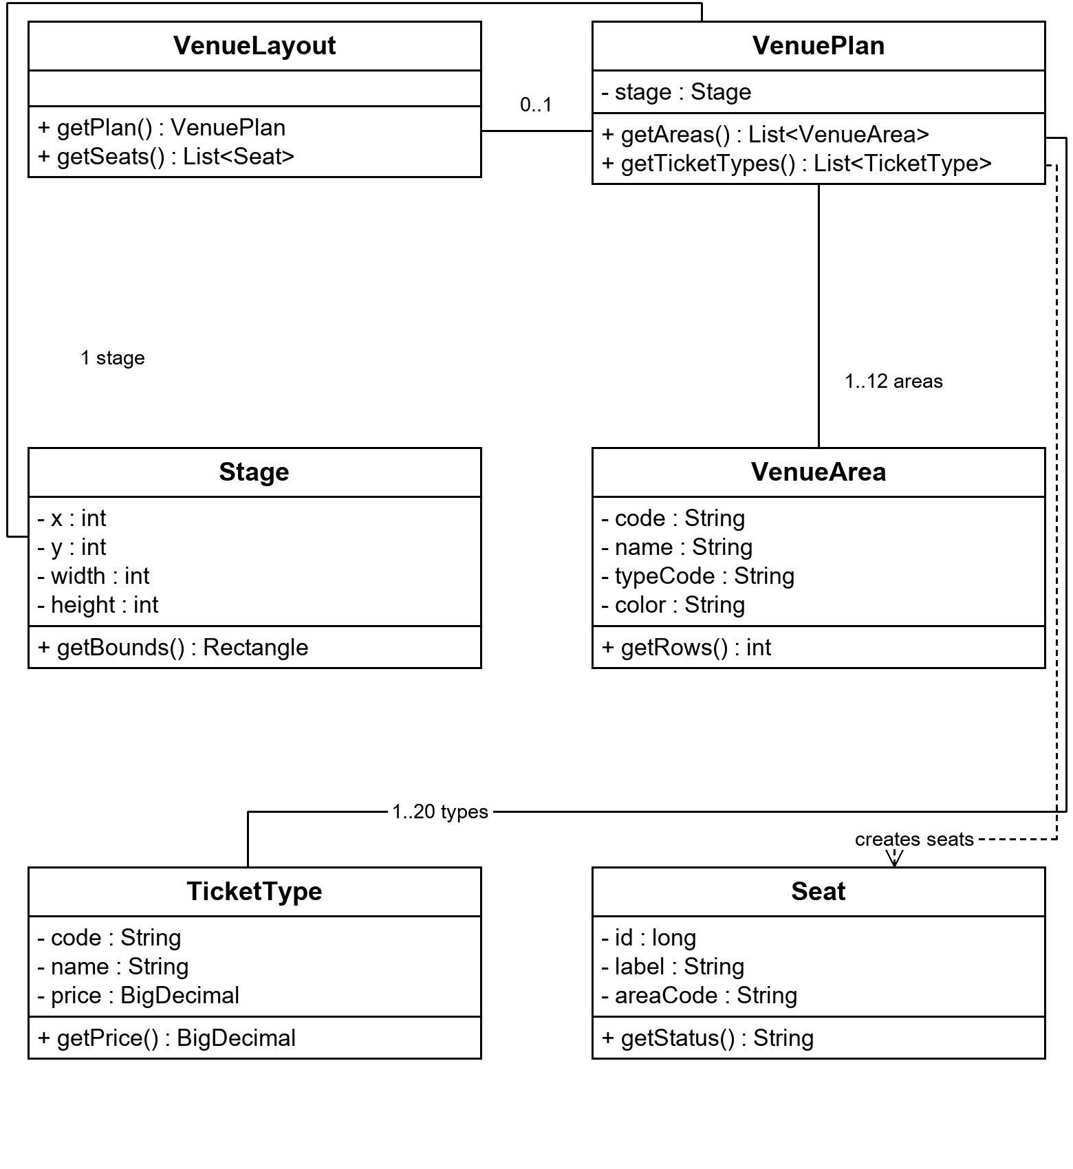
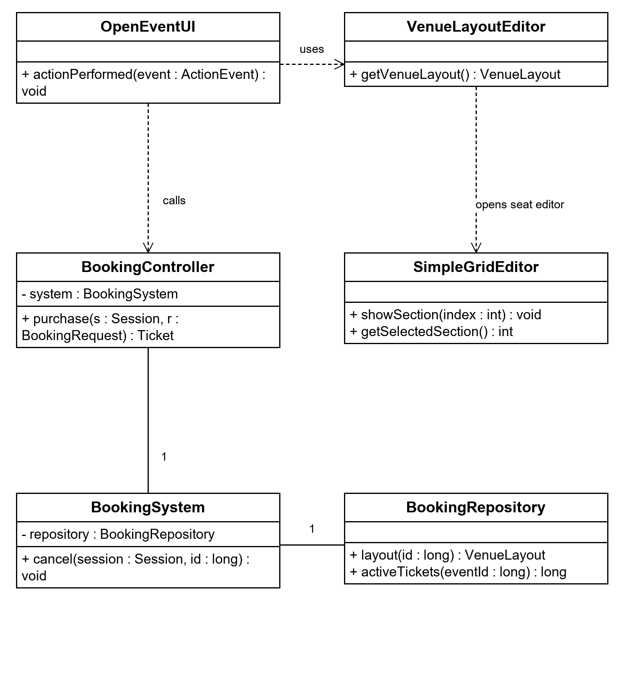
B. UML Sequence Diagram
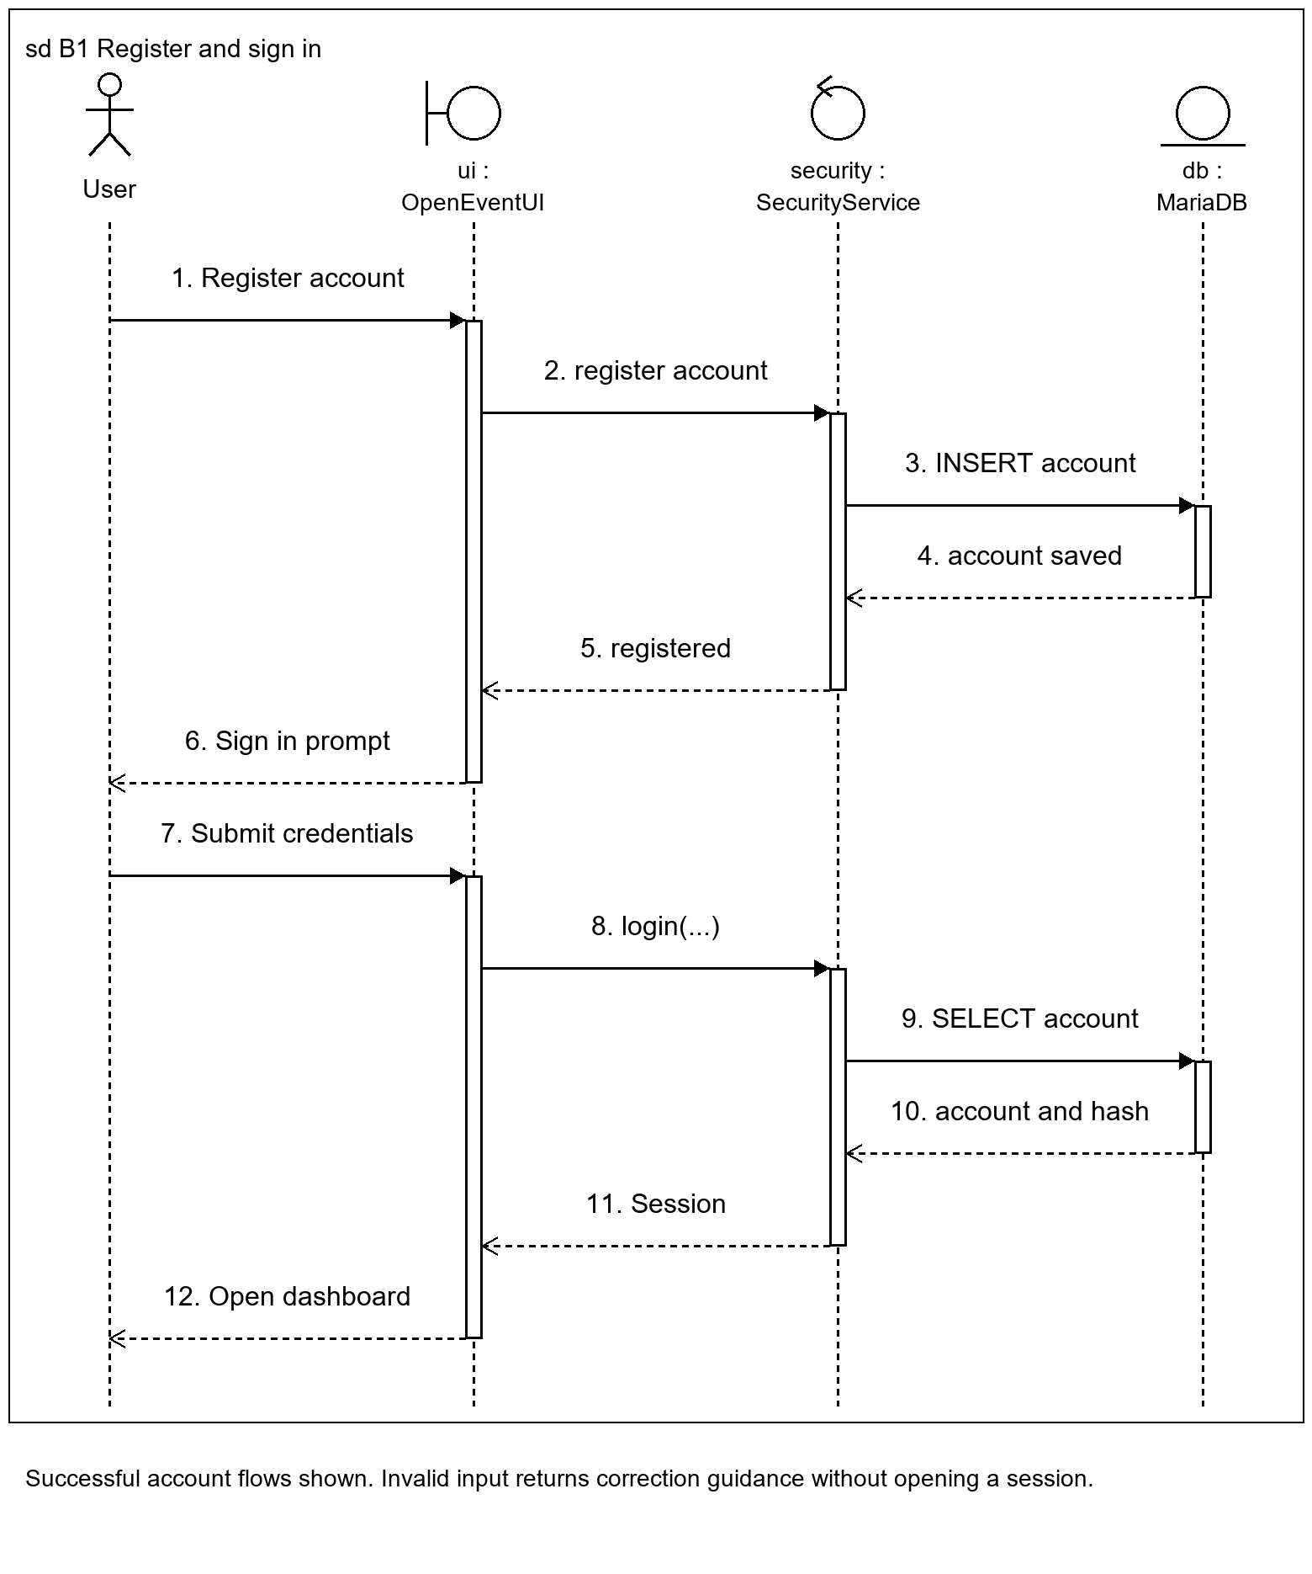
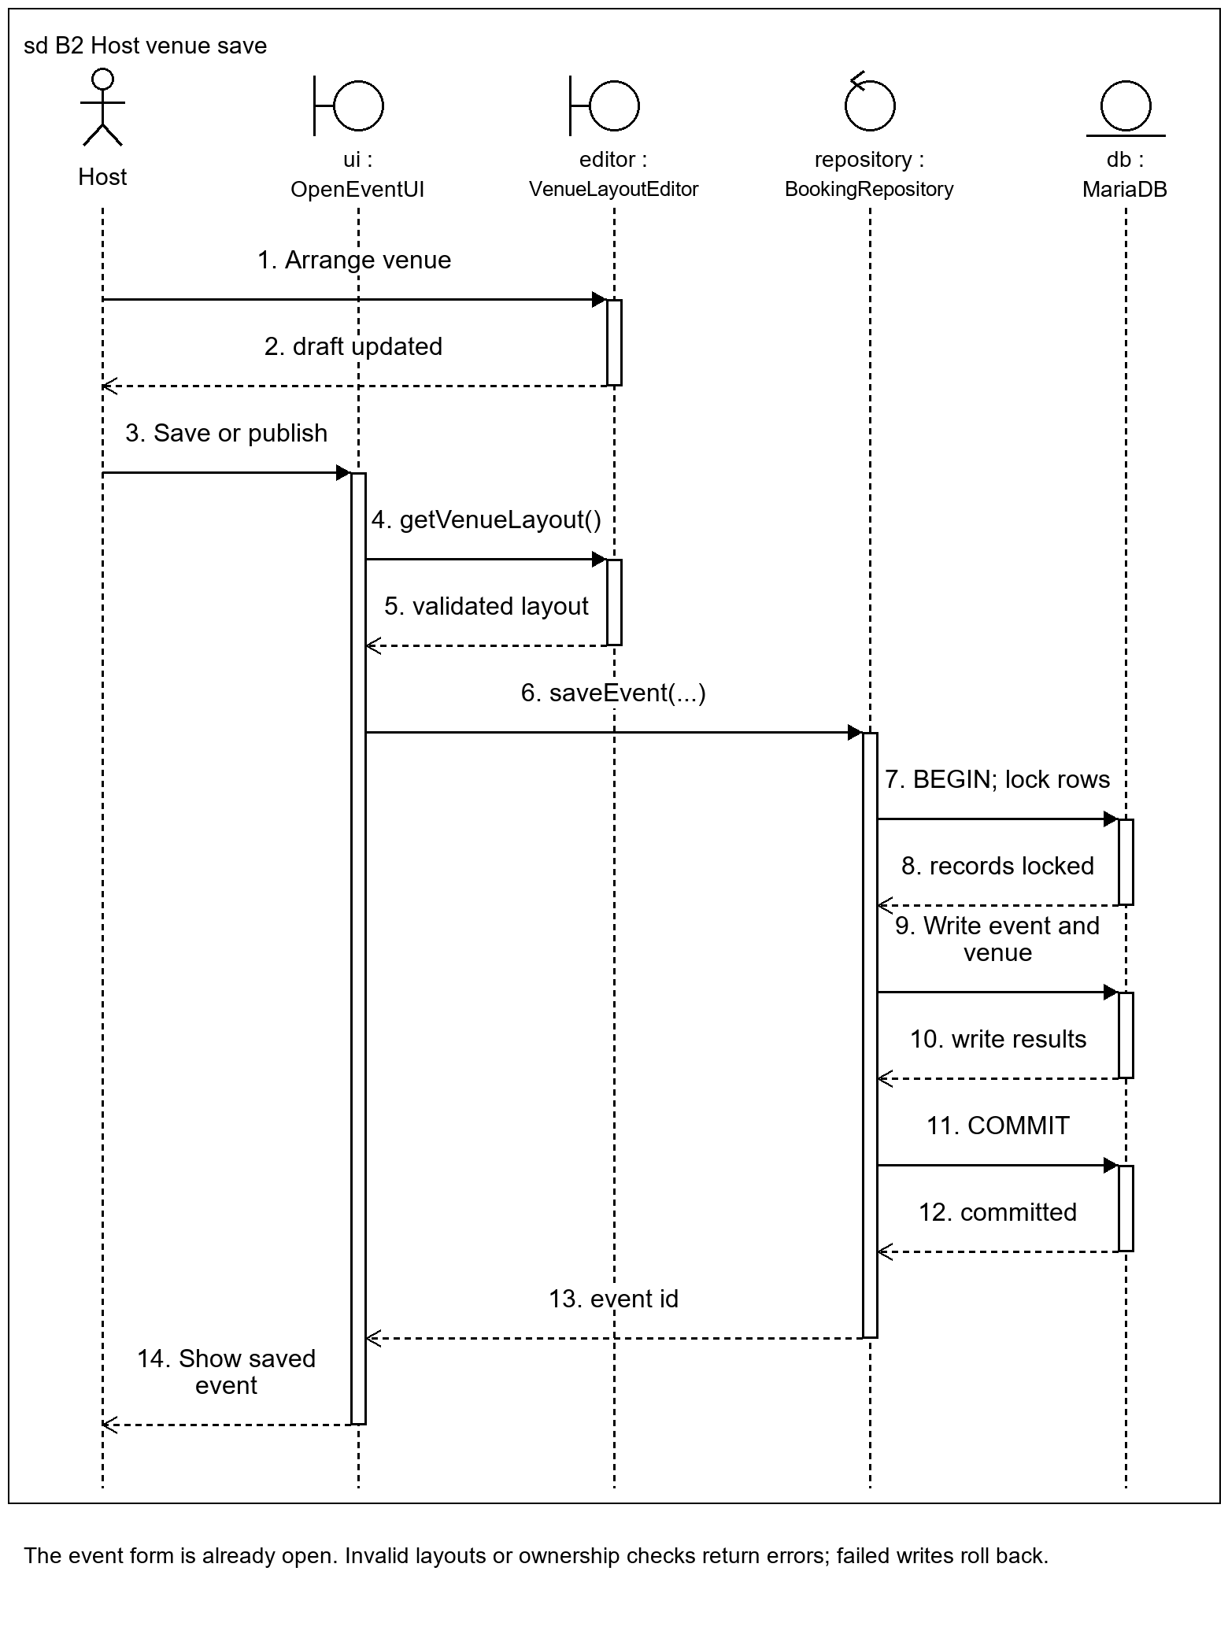
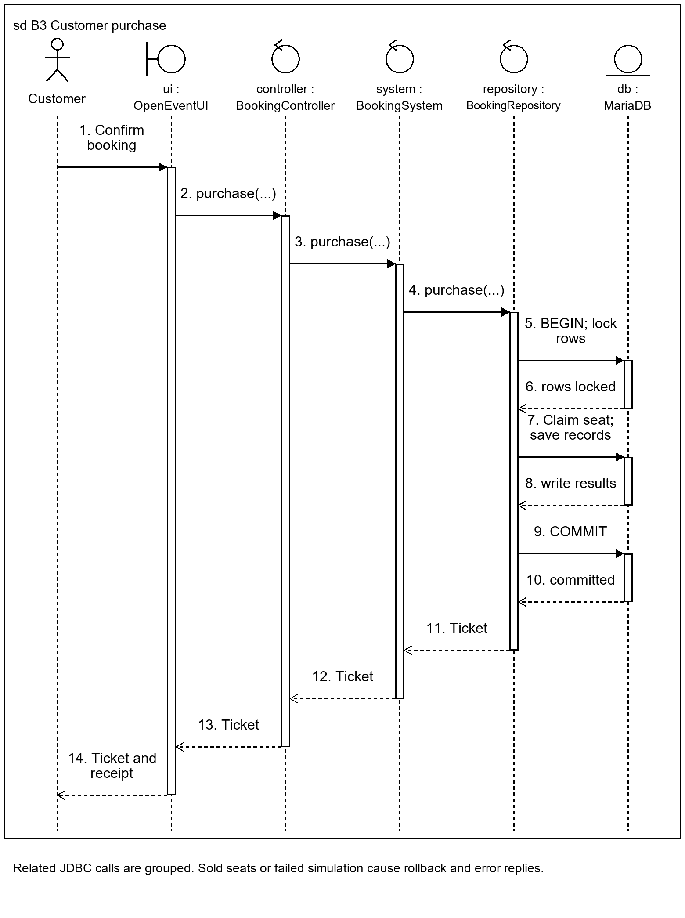
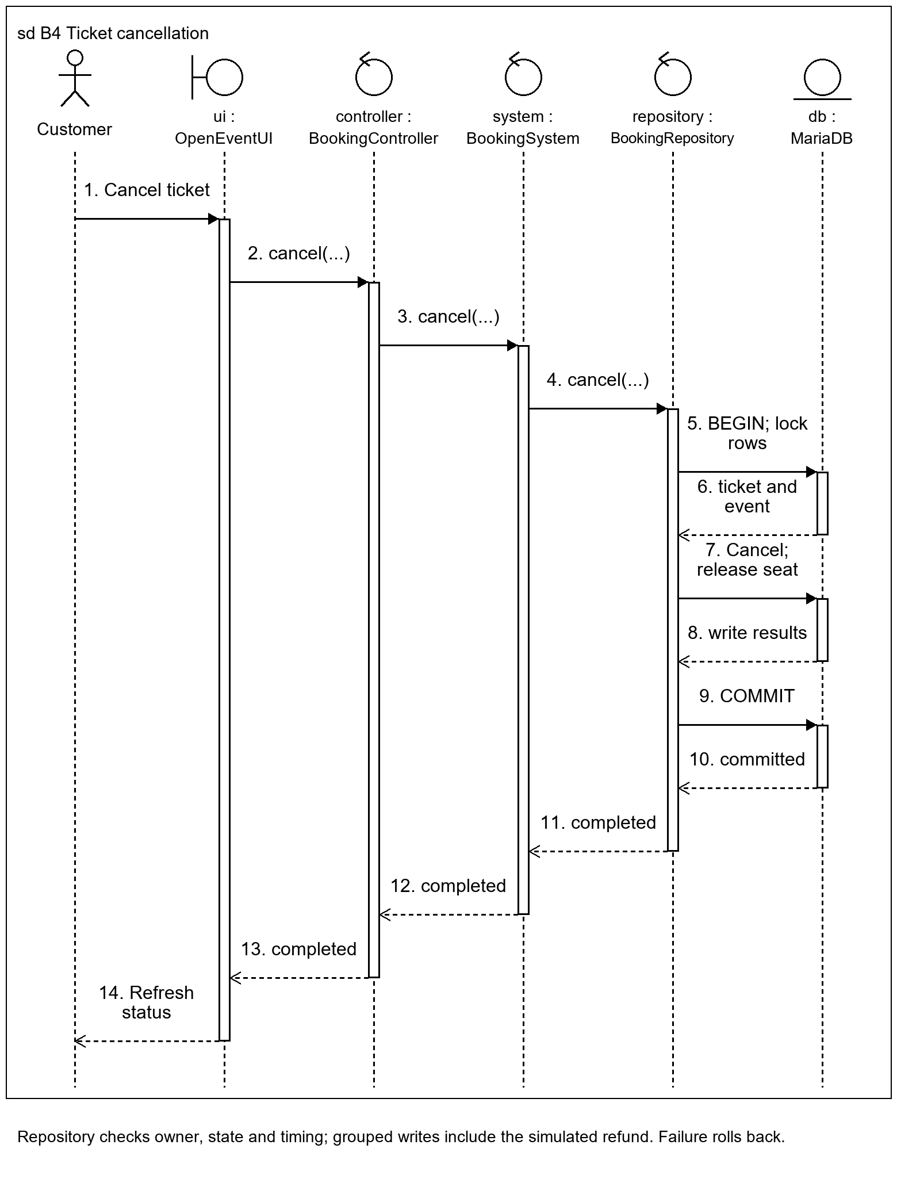
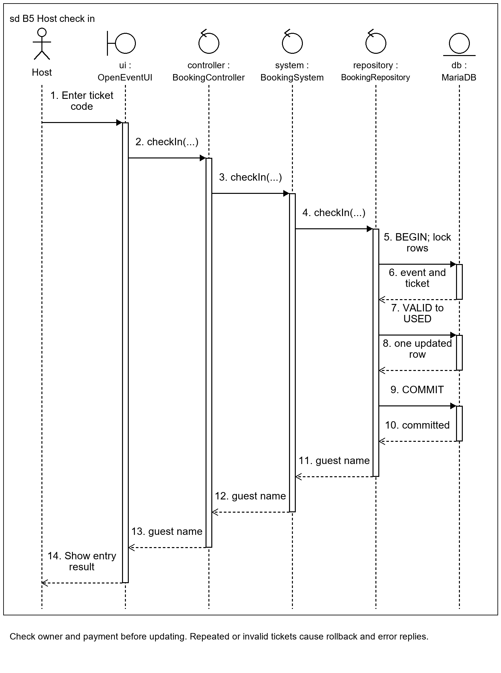
C. Database Relationship Diagram:
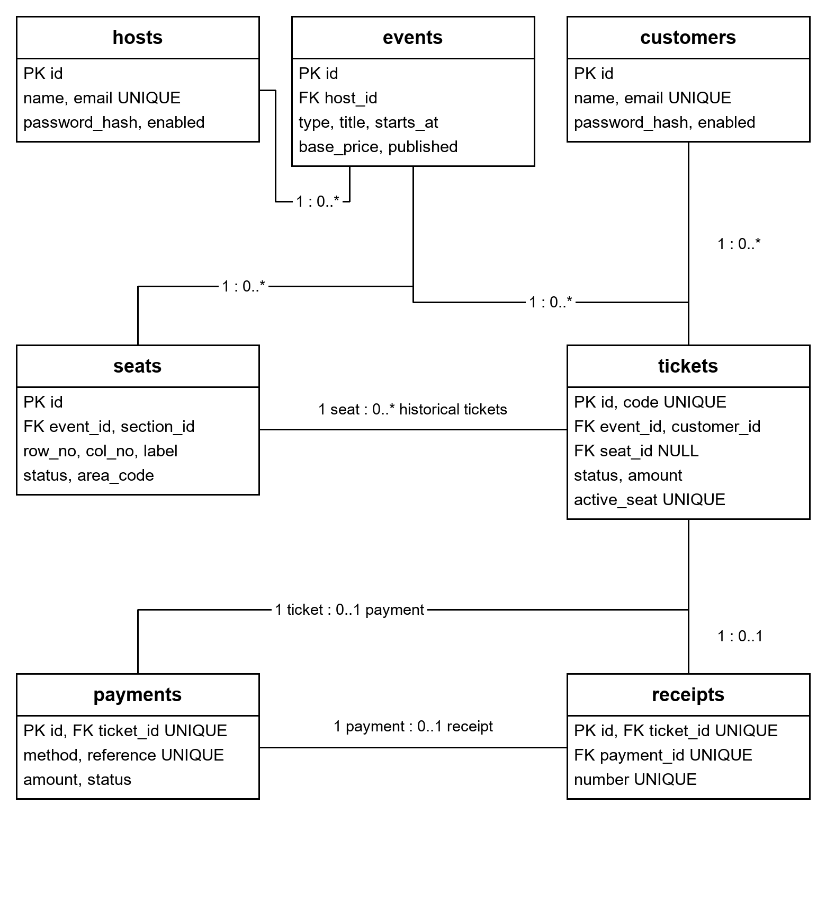
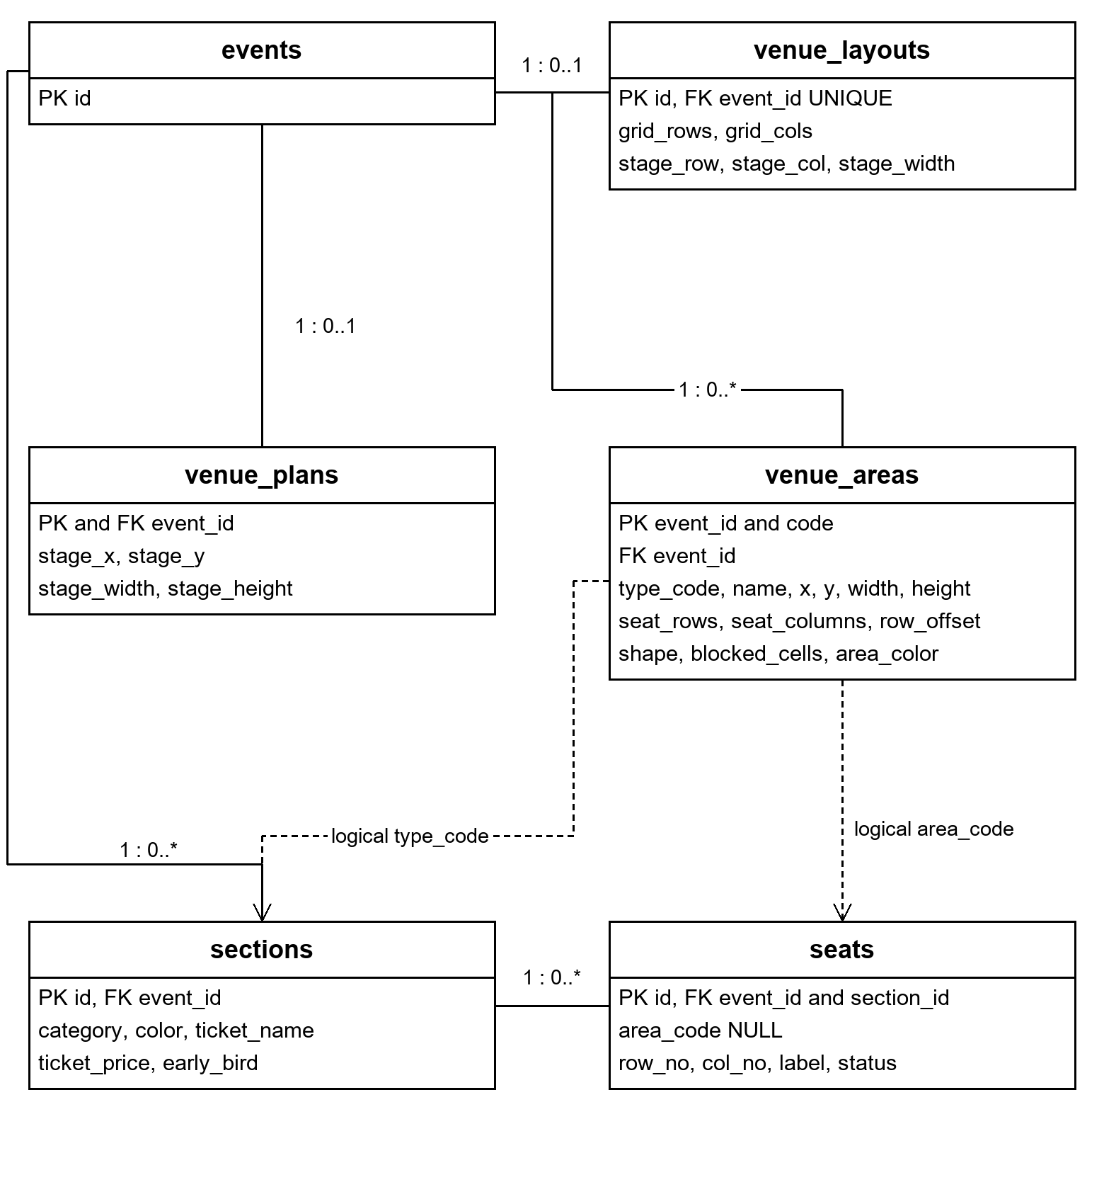
D. Test Cases Summary:
Feature | Test Case | Expected Outcome | Pass/Fail
Login | Enter a valid email and password for the selected role. | User signs in to the correct dashboard. | Pass
Registration | Create a Host or Customer account with valid details. | Account is saved and can sign in. | Pass
Password display | Toggle the password eye control. | Password switches between shown and hidden. | Pass
Event management | Save and publish an event owned by the Host. | Event persists and the published event is discoverable. | Pass
Venue layout | Add a section, drag it and resize it using its corner. | Valid layout edits are retained. | Pass
Custom tickets | Rename a ticket type and save its price and color. | Offers reload with the saved values. | Pass
Seat booking | Buy an available seat using a successful simulation. | Ticket, payment and receipt are saved together. | Pass
Duplicate seat | Attempt competing purchases of the same seat. | Only one active booking succeeds. | Pass
Failed payment | Choose a failed payment simulation. | Booking rolls back; seat remains available. | Pass
Cancellation | Cancel an eligible unused ticket before the event. | Ticket is cancelled, refund is simulated and seat is released. | Pass
Check-in | Check a valid ticket in, then repeat the same code. | First check-in succeeds; repeated entry is rejected. | Pass
Booked layout | Try to change seat geometry after an active booking. | Structural changes are rejected. | Pass

Comments/Grading:
Criteria/Section | Maximum Score | Actual Score
Software Purpose
Objective & Feature Accomplished
Technology Stack
User Manual
Code Quality
UML Diagram
Database Structure & ERD
Total
Instructor Feedback:
_________________________________________________________
Final Grade: ________/100
Instructor Signature: _________________________
Date: _________________________

