UNIVERSITY OF THE IMMACULATE CONCEPTION
BACHELOR OF INFORMATION TECHNOLOGY

OpenEvent Event Management and Ticketing Prototype
Documentation Plan and Implemented System for a BSIT Second Year OOP Project

In Partial Fulfillment of the Requirements for the Subject
CC009.23

Submitted by
[Member 1 - Project Manager]
[Member 2 - Documentation Head]
[Member 3 - Designer]
[Member 4 - Developer]

Submitted to
Carlo Castro

October 28, 2026

Abstract
OpenEvent is a local Java desktop prototype for managing small events and issuing assigned-seat tickets. It demonstrates object-oriented programming through Java Swing, JDBC and MariaDB in XAMPP. Hosts create and publish events, arrange a stage and named venue sections, and define ticket offers with their own names, prices and colors. Customers browse published events, choose a section and available seat, and complete a simulated payment to receive a unique ticket code and receipt. The prototype supports eligible cancellation with a simulated refund, one-time check-in and manually refreshed Host summaries. Encapsulation, inheritance, polymorphism and abstraction are implemented through interacting domain, interface and service classes. This revision records the implemented scope, usability improvements and verified checks. It includes updated class diagrams and all six sequence workflows. Real financial transactions, public deployment, standing-area capacity sales and architectural venue planning remain outside the project scope.

Contents
1.1 Introduction
1.2 Statement of the Problem
1.3 Objectives
1.4 Significance
1.5 Scope and Limitations
1.6 Design and Implementation
1.7 UML Diagrams
1.8 Verification and Quality Assurance
1.9 Operating Guide
Appendix A Class Diagrams
Appendix B Sequence Diagrams

Chapter 1 The Problem and Its Background

1.1 Introduction
Small event organizers and independent artists often coordinate ticket sales through messages, paper records or spreadsheets. These methods can make seat availability, payment records and entry checking difficult to track. OpenEvent brings these tasks into one local desktop application for a classroom demonstration.
The project focuses on an understandable OOP design and a complete booking workflow. It is a prototype for small events, rather than a commercial ticketing service. Concerts are the main example; simple sports-match and movie-screening records are retained to demonstrate the Event class hierarchy shown in the UML.

1.2 Statement of the Problem
The project addresses conflicting seat selections, difficulty distinguishing valid and already-used tickets, and unclear venue arrangements. Each seat and ticket has a visible state. Related records remain consistent when a purchase, cancellation or check-in succeeds or fails.

1.3 Objectives
The general objective is to build a local Java prototype that demonstrates encapsulation, inheritance, polymorphism and abstraction through interacting event and ticketing classes.
- Provide Host and Customer accounts with role-appropriate access.
- Allow a Host to create and publish an event with a stage, named physical sections, numbered seats and event-specific ticket types.
- Allow a Customer to buy one ticket per transaction using a simulated payment and receive a unique code and receipt.
- Prevent duplicate active seat bookings, support eligible simulated cancellation/refund, and reject repeated ticket check-in.
- Save records in MariaDB and demonstrate the implemented behavior using matching class diagrams, sequence diagrams and acceptance checks.

1.4 Significance
Hosts can demonstrate organized event and seat records; Customers can understand the arrangement before choosing a seat. For the student team, the main value is applying OOP, basic relational persistence, input validation and functional testing in one manageable application.

1.5 Scope and Limitations
The implemented build is one Java desktop application connected to one local MariaDB database. Demonstrations use small sample datasets and manually refreshed screens. Each event has one owning Host. Host accounts are preconfigured; Customers can register. Delegated organizer access, administrator tools and account recovery are outside this build.
Area | Required prototype behavior
Accounts | Host and Customer login/logout; Customer registration; salted password hashes; role and event-owner checks. Eye controls show/hide passwords and start hidden.
Events | Create, edit, save drafts and publish Concert, SportsMatch or MovieScreening records. One owning Host per event.
Venue layout | Hall, U-shaped Arena and Fan Theater templates; named physical sections; movable/resizable stage and blocks; numbered seats and blocked cells. Customer opens a section to select an available seat. Original grids remain supported.
Pricing and purchase | Custom ticket offers with unique names, positive prices to two decimal places and colors. Assign one type to each physical section. Optional Early Bird discount. One seat and one ticket per transaction; purchased values remain snapshots.
Payments and refunds | Cash, e-wallet and credit-card subclasses produce simulated outcomes and demo references. Eligible cancellation simulates a full refund. No real money or payment secrets.
Ticket management | Unique code and saved receipt; text receipt export; eligible cancellation; one-time manual code check-in. Friendly labels show Ready for entry, Checked in and Cancelled.
Discovery and monitoring | Published future events with title search. Host-owned event list, inventory, ticket counts, simulated net totals and check-in count; manual refresh.
Real payment processing, public web or mobile versions, cloud deployment, multi-organizer collaboration, live seat broadcasting, queueing, camera or QR scanning, email/SMS delivery, advanced reports and production-scale performance testing are excluded. Advanced date, genre and location filters are also excluded. The available search matches event titles.
The venue editor is a two-dimensional visual arrangement, not an architectural or emergency-capacity planning tool. Each event supports 1–12 physical sections, up to 10 rows and 10 seats per row in each section, and 1–20 ticket types. Sections are rectangular or trapezoid-shaped; the stage is rectangular. Hosts move objects by dragging and resize them through fields. Bounds and conservative overlap checks prevent invalid arrangements. Standing areas, arbitrary rotation, freehand shapes, multi-floor architecture and 3D are excluded. VALID or USED tickets protect geometry and seat assignments from destructive changes.

1.6 Design and Implementation

Application structure
OpenEventUI coordinates the Swing screens and the current Session. BookingController and BookingSystem delegate purchases, cancellations and check-in to BookingRepository. SecurityService authenticates accounts and checks role and event ownership. Event, Ticket, Receipt, User and Payment classes represent the domain. VenueLayout supports original seat grids and an optional VenuePlan. VenuePlan contains a Stage, physical VenueArea sections and custom TicketType definitions. Several physical sections may share the same ticket type. VenuePlanRepository saves overview and offer data using the caller transaction. ResponsiveView, EventCards and DisplayText improve width adaptation, event-list layout and readable status labels.

OOP application
Principle | Application in the prototype
Encapsulation | Private fields and validated constructors/getters protect identity, prices, status and venue data. Immutable plan objects and defensive collection copies prevent accidental edits.
Inheritance | Concert, SportsMatch and MovieScreening extend abstract Event. CashPayment, EWalletPayment and CreditCardPayment extend abstract Payment. Host and Customer extend User.
Polymorphism | UI and booking code work through Event, Payment and User parent types. Subclasses supply eventType, experienceLabel, method and role behavior. Shared calculatePrice uses the assigned offer.
Abstraction | Event, Payment and User provide contracts. VenuePlan, VenueArea, Stage and TicketType separate geometry from pricing. Service/repository classes separate validation and JDBC transactions from Swing.

Persistent data and access
The local openevent database stores hosts, customers, events, venue_layouts, sections, seats, tickets, payments, receipts, venue_plans and venue_areas. The existing sections table retains stable offer codes and optional custom names, prices, colors and Early Bird eligibility. seats.area_code identifies a physical section in a flexible plan. Primary/foreign keys, unique codes, unique seat positions and a unique active-seat claim protect consistency. JDBC uses PreparedStatement and a configured application account limited to SELECT, INSERT, UPDATE and DELETE within openevent. Private connection settings remain outside source code; the connector now uses the values it reads. Account passwords use salted PBKDF2 hashes. Invalid or disabled login creates no Session.

Booking and cancellation rules
BookingRepository locks the event and saved seat, conditionally claims an AVAILABLE seat in an InnoDB transaction, and requires one affected row. The saved offer determines the price; a Customer cannot substitute an unrelated cheaper type. Eligible Early Bird offers receive 20 percent off before the event cutoff. Payment success saves the Ticket, Payment, Receipt and SOLD seat together. The ticket is returned after commit. A decline or failed write rolls back related changes. Purchased tickets retain their original type name, seat label and amount when future offers are renamed or repriced.
Cancellation is allowed only for a VALID ticket before its event starts, requested by that Customer or the event owner. CANCELLED, SIMULATED_REFUNDED and the seat release are saved in one transaction. Check-in verifies the owner, code, selected event and successful payment, then conditionally changes VALID to USED once. USED, CANCELLED, wrong-event and repeated entries are rejected. Customer screens translate these stored states into Ready for entry, Checked in and Cancelled.

1.7 UML Diagrams
Appendix A contains five implementation class views: accounts and payments; event hierarchy and legacy seating; flexible venues and custom offers; application services and persistence; and Swing editors with usability/password controls. Appendix B contains six workflows: authentication, event setup, ticket purchase, cancellation/refund, check-in and Host monitoring. Long figures continue across labeled sheets. Sequence participants are repeated on each continuation sheet.
The diagrams use actual implemented member names and signatures rather than planned-only methods or enums. Abstract classes and methods are italicized; static operations are underlined; visibility and relationship notation are shown. Operation parameters include names and types. Hollow diamonds show shared aggregation of reusable venue value objects; deleting a Java reference does not claim automatic destruction of its parts. The full editable files are OpenEvent-Corrected-Classes.drawio and OpenEvent-Corrected-Sequences.drawio. The embedded figures are current exports, with repeated sequence headers and readable continuation sheets. Authorized Host means the event owner. Summary values are calculated from stored records; no separate EventSummary, AccountRecord or BookingData class is claimed.

1.8 Verification and Quality Assurance
The comprehensive developer QA pass covers the current local Windows build and database. A total of 112 automated assertions and configuration checks passed: 27 core acceptance checks, 42 flexible-venue checks, 29 usability regression checks, 13 password-visibility checks and one configuration-override probe. The plain-Java harnesses are executed explicitly after compilation; Maven package alone does not run them. Temporary test records are cleaned by their harnesses. Live desktop checks also exercised login guidance, Customer search, section/seat selection, simulated issuance, cancellation, receipt export and Host editing/navigation. This is functional and usability QA on the available workstation, not a formal user study or a multi-platform certification.
Check | Expected result
Login and access | Valid login succeeds; invalid/disabled login and duplicate registration are rejected. Customers and other Hosts cannot manage an owner event. Password toggles preserve characters and restore masking.
Venue grid | All templates persist correctly. Invalid bounds, overlaps, duplicate positions, over-limit sections/types and blocked seats are checked. Active bookings protect structure. Legacy grids and customized offers remain compatible.
Purchase and failure | Successful payment saves one ticket and receipt. Declines and SQL-write failures roll back seat, ticket and receipt changes. Custom price/name snapshots persist across repricing.
Seat conflict | Concurrent attempts for one seat produce exactly one winner. The conditional AVAILABLE claim and unique active-seat index prevent two active tickets.
Cancellation and check-in | Eligible refunds release the seat atomically. USED, CANCELLED, wrong-event and repeated entries are rejected. Late refunds are rejected.
Persistence and usability | Records survive a new connection. Edits survive selection changes; overview navigation clears stale seats. Narrow forms/cards adapt without cumulative scaling. Configuration overrides are honored. Live receipt export was verified.

Usability fixes verified in this revision
Switching a section or ticket type now retains valid field edits instead of silently losing them. Selecting a different venue section clears the old checkout seat. Visible focus cues, stronger secondary-text contrast, clearer screen headings, named offer/price legends and status-specific ticket banners improve understanding. Forms and event cards adapt to narrower widths. Leaving the event editor asks before discarding unsaved changes; booked layouts disable structural tools. Registration keeps fields available for correcting local validation errors.
A connection defect was corrected: saved URL/user/password settings are now used by JDBC. The missing restricted application account was restored to match the existing private configuration. Integration checks passed through that account. Existing application data was preserved; only identified QA fixtures were removed.

1.9 Operating Guide
Start MySQL in XAMPP on port 3307, open OpenEvent in NetBeans and press F6. The main class is com.mycompany.openevent.OpenEvent. Classroom accounts are alex@openevent.local for Customer and host@openevent.local for Host; both use OpenEvent2026!. These fictional demonstration credentials are separate from private database settings.

Customer workflow
- Choose Customer and sign in, or create a Customer account. The eye button or Alt+V changes password visibility.
- Browse upcoming events or search by title. Open an event, select a physical section, then choose an available seat. Gray × seats are already sold.
- Review the assigned ticket offer. Choose the Early Bird option only when it is offered and still within the cutoff. Check the event, seat and amount at checkout.
- Choose a demo payment method and simulated success or decline. After success, My tickets shows the saved code, current status and receipt. Save receipt exports a text file.
- Cancel an unused ticket before the event starts to record a simulated full refund. Cancelled tickets cannot be used for entry; used tickets cannot be refunded.

Host workflow
- Choose Host and sign in. The dashboard lists owned events. Create an event or edit one from the selector.
- Enter title, venue, future start time and Early Bird cutoff using yyyy-MM-dd HH:mm. Leave Published unchecked for a private draft.
- Choose a venue template. Select or drag a section, then edit its name, position, size, shape and seat rows/columns. Valid edits are kept when switching sections. Reset field edits restores that section's last accepted values.
- Open Ticket types to add or rename offers, set prices/colors and choose Early Bird eligibility. Assign offers to sections. Different sections can share one offer. Use blocked cells for aisles or unavailable spaces.
- Save the event and venue, and publish when ready. Replacing a template also replaces its unsaved default offers, so confirm the choice carefully. Purchased seats protect geometry; future offer metadata remains editable.
- Use manual Refresh to see saved totals. Enter a ticket code for one-time check-in. Select an eligible unused ticket to request a simulated refund. Save before leaving the editor.

Figure A1 Accounts, tickets and simulated payments part 1 of 2
Appendix A Class diagrams
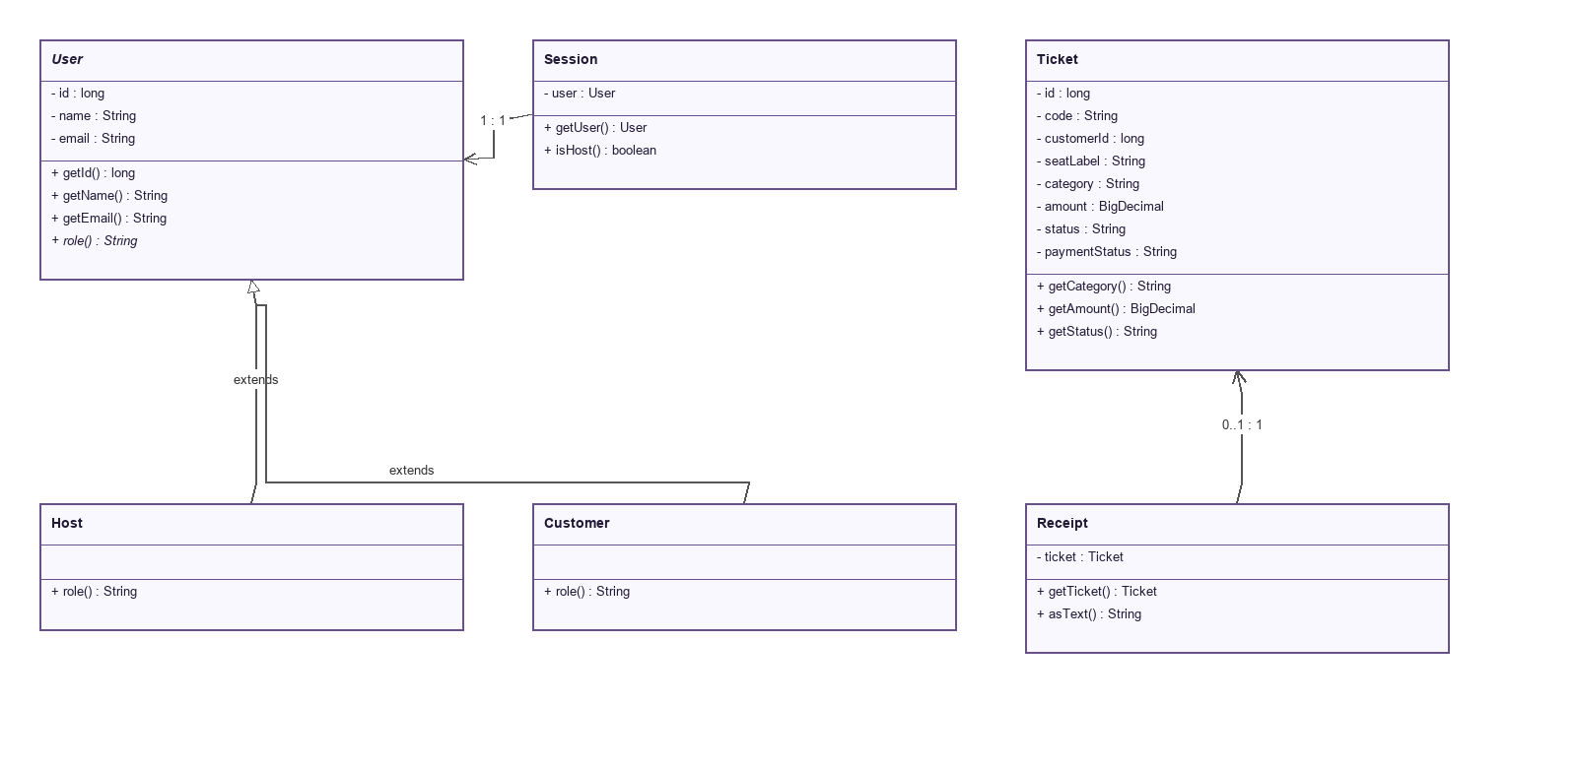

Figure A1 Accounts, tickets and simulated payments part 2 of 2
Appendix A Class diagrams
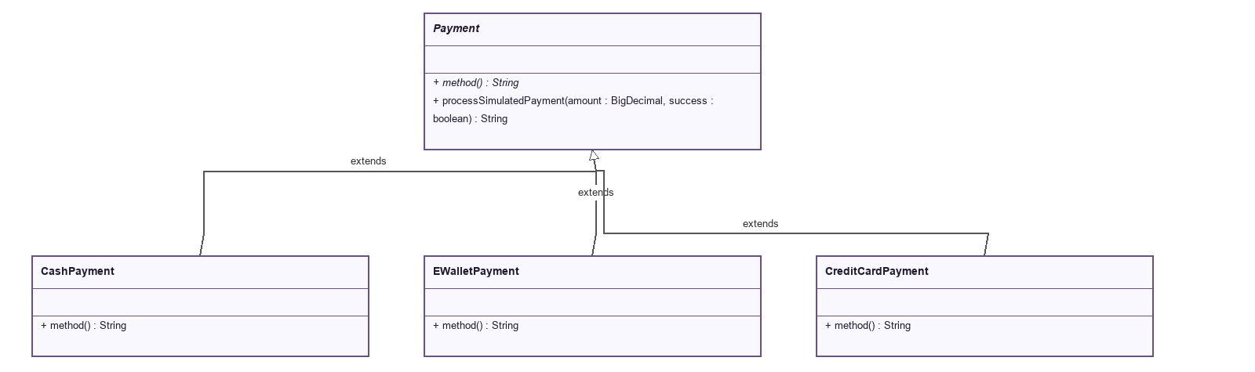

Figure A2 Event hierarchy and legacy seating part 1 of 2
Appendix A Class diagrams
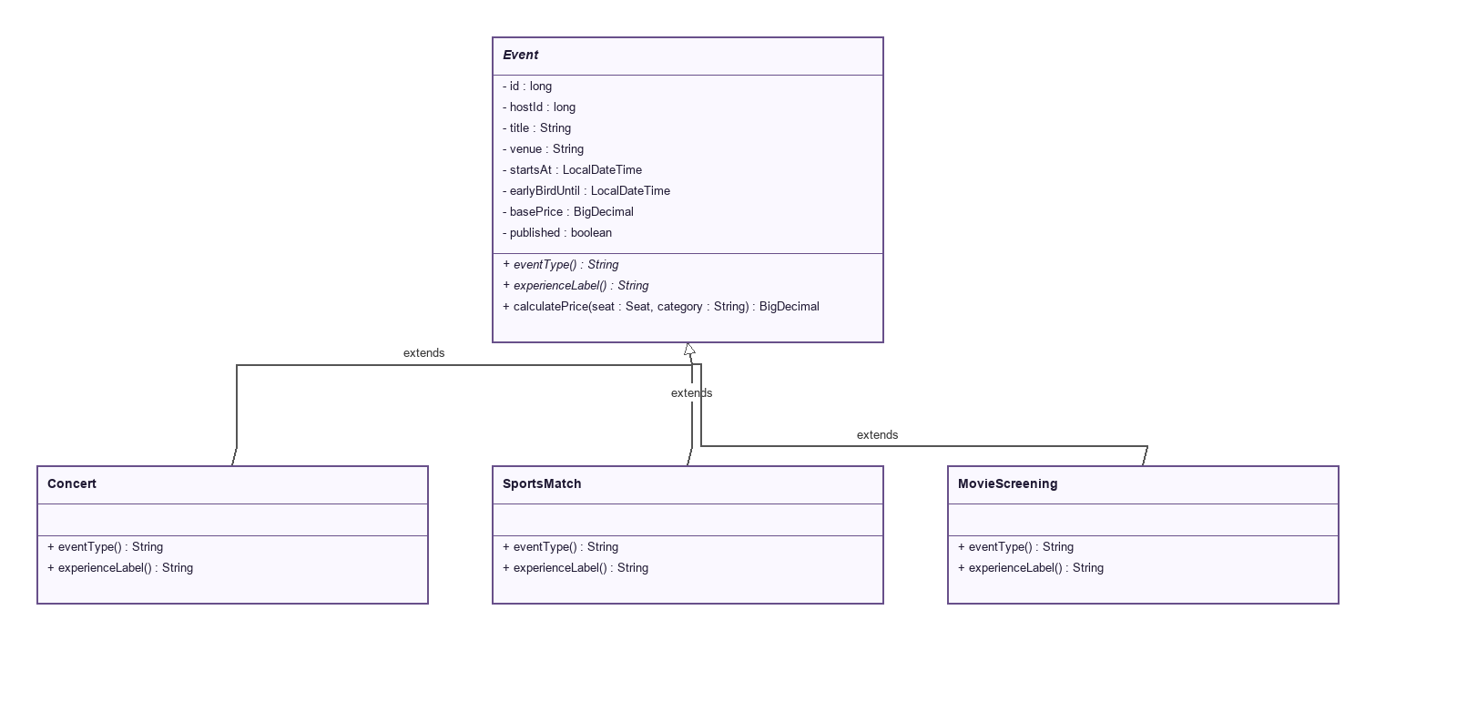

Figure A2 Event hierarchy and legacy seating part 2 of 2
Appendix A Class diagrams
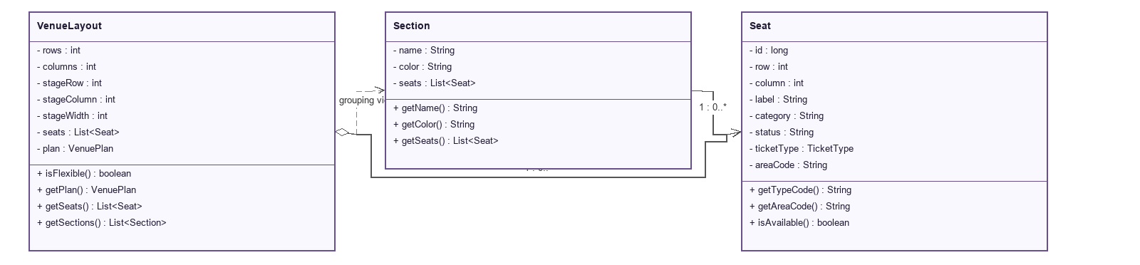

Figure A3 Flexible venue plan and custom ticket offers
Appendix A Class diagrams
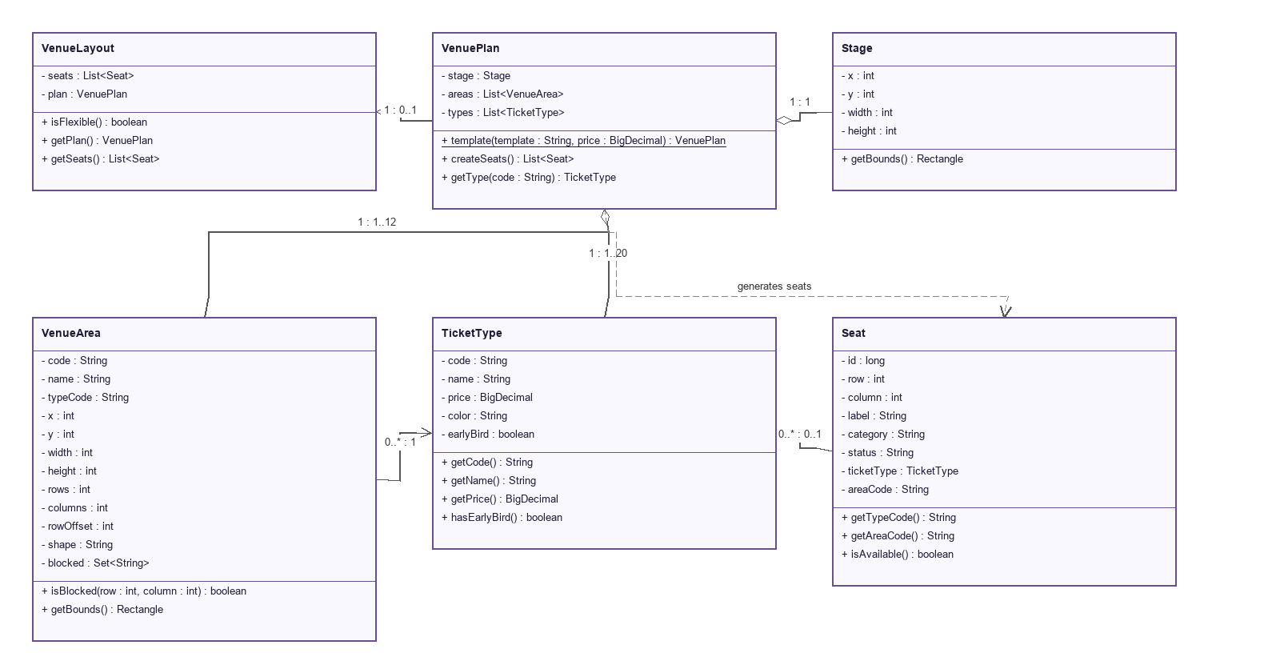

Figure A4 Application, authorization and JDBC persistence part 1 of 2
Appendix A Class diagrams
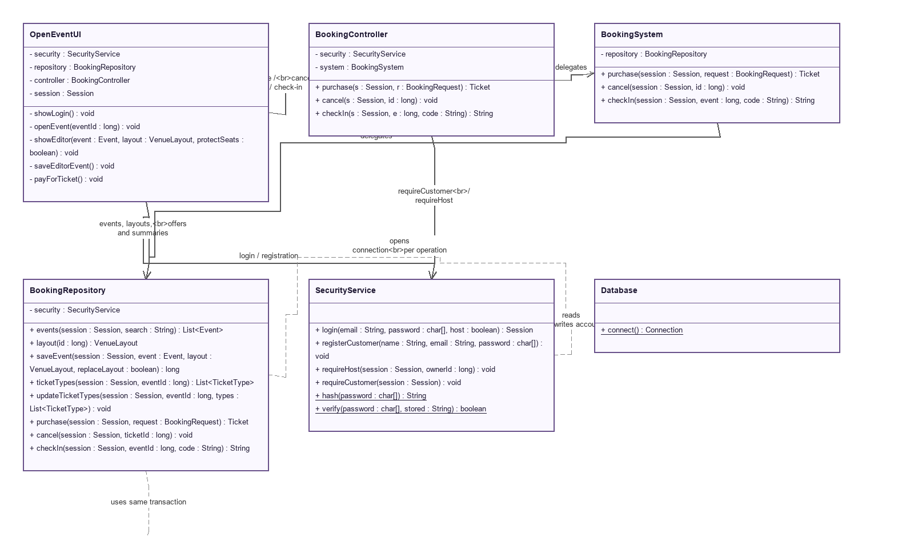

Figure A4 Application, authorization and JDBC persistence part 2 of 2
Appendix A Class diagrams
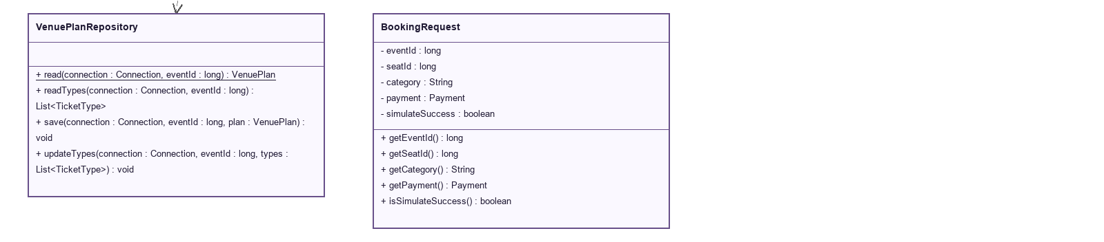

Figure A5 Swing venue editing and password visibility part 1 of 2
Appendix A Class diagrams
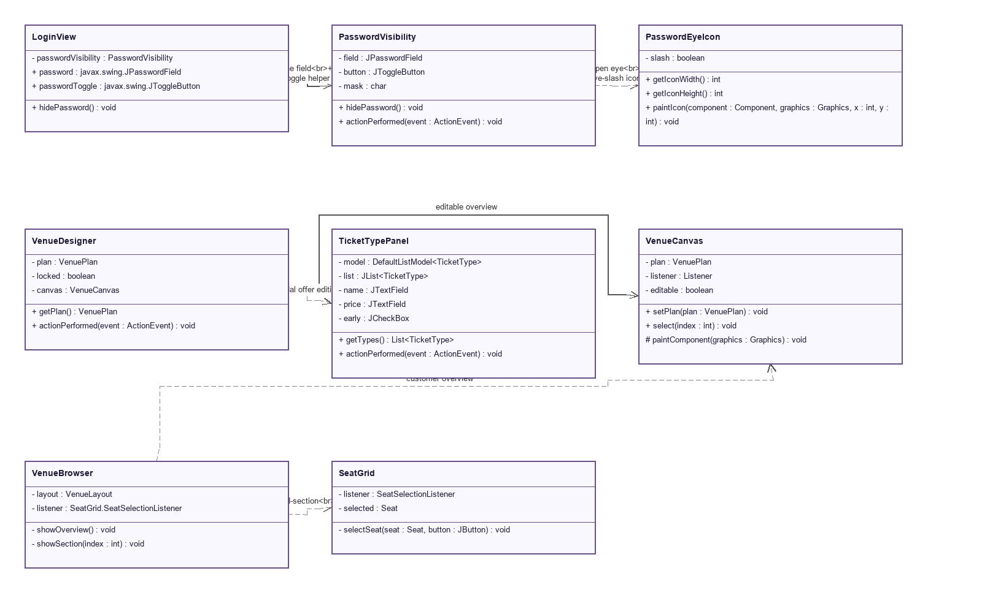

Figure A5 Swing venue editing and password visibility part 2 of 2
Appendix A Class diagrams
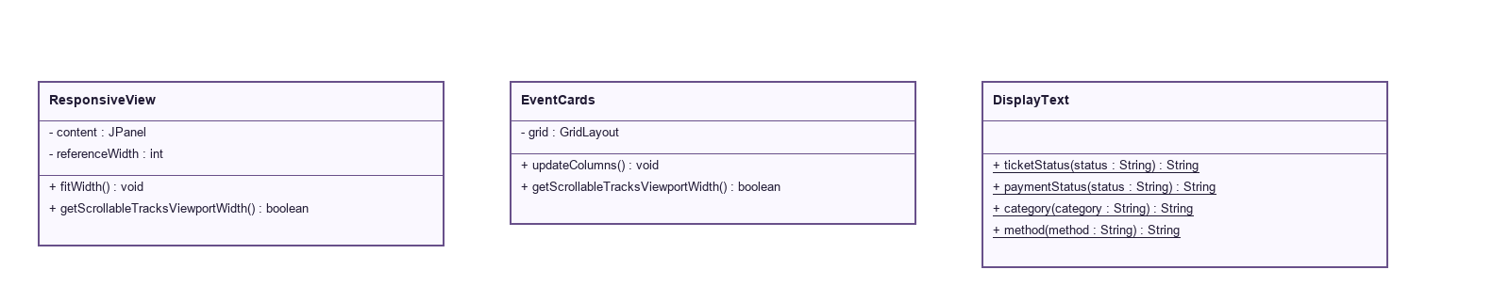

Figure B1 Authentication, visibility and authorization part 1 of 2
Appendix B Sequence diagrams with repeated participant headings
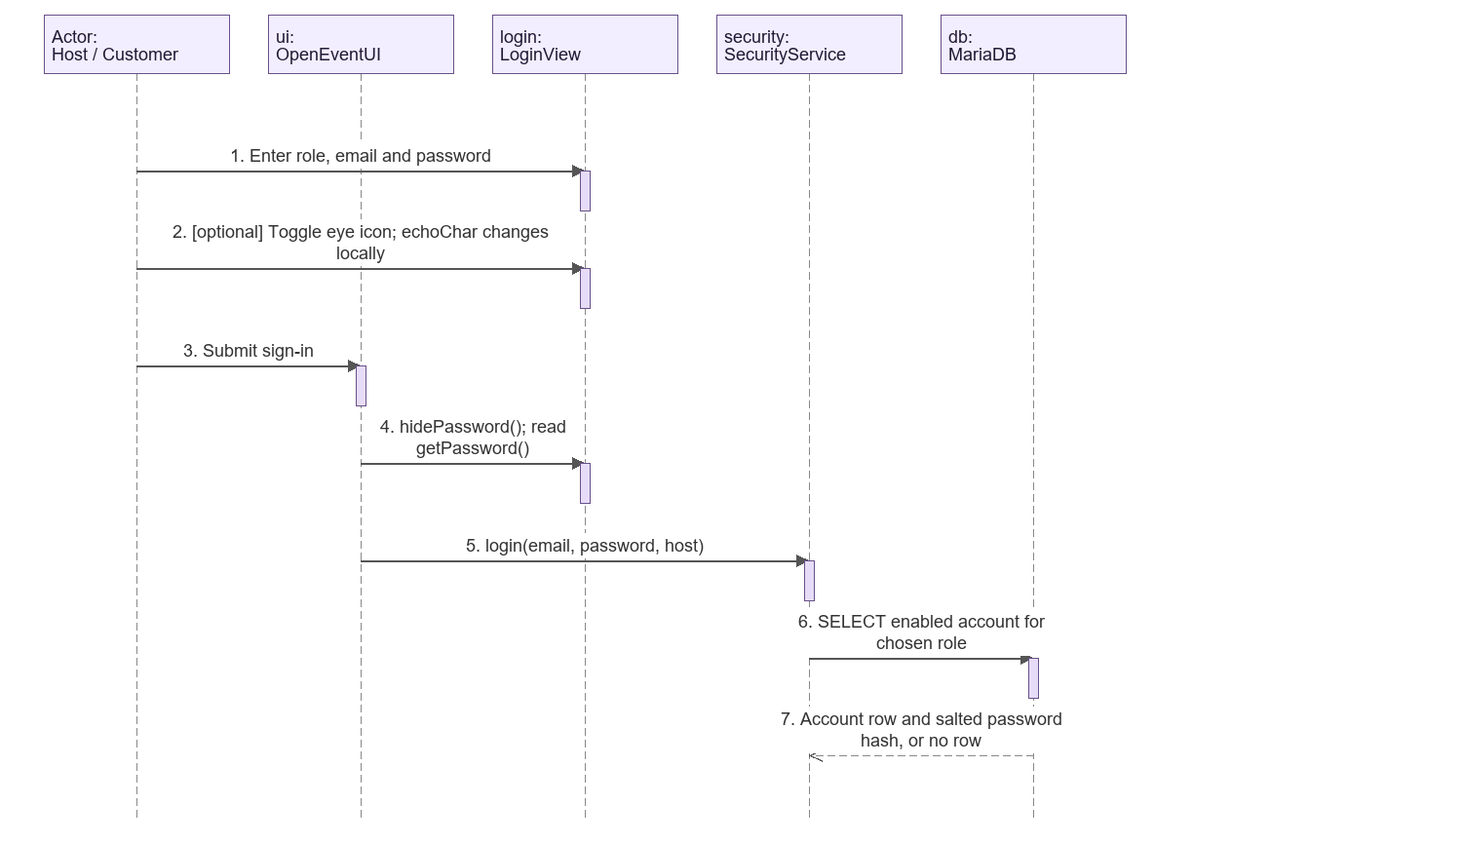

Figure B1 Authentication, visibility and authorization part 2 of 2
Appendix B Sequence diagrams with repeated participant headings
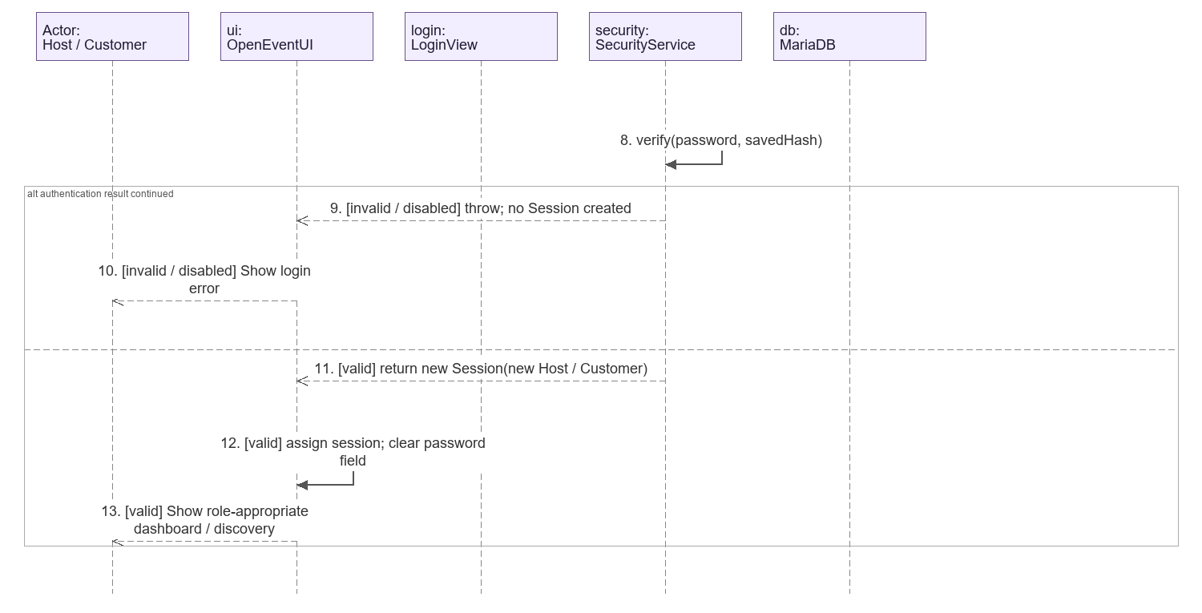

Figure B2 Event setup, flexible venue and custom ticket offers part 1 of 2
Appendix B Sequence diagrams with repeated participant headings
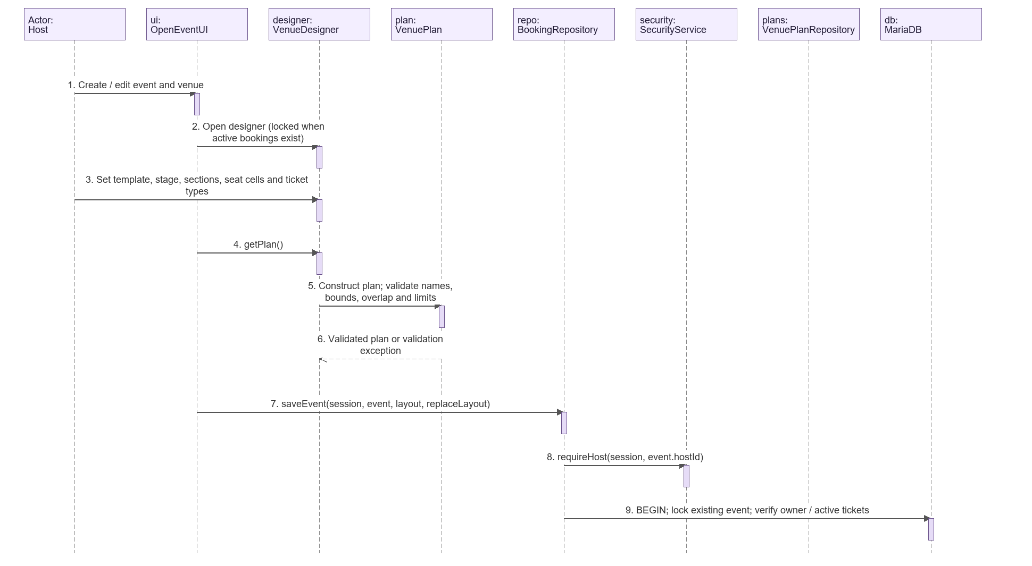

Figure B2 Event setup, flexible venue and custom ticket offers part 2 of 2
Appendix B Sequence diagrams with repeated participant headings
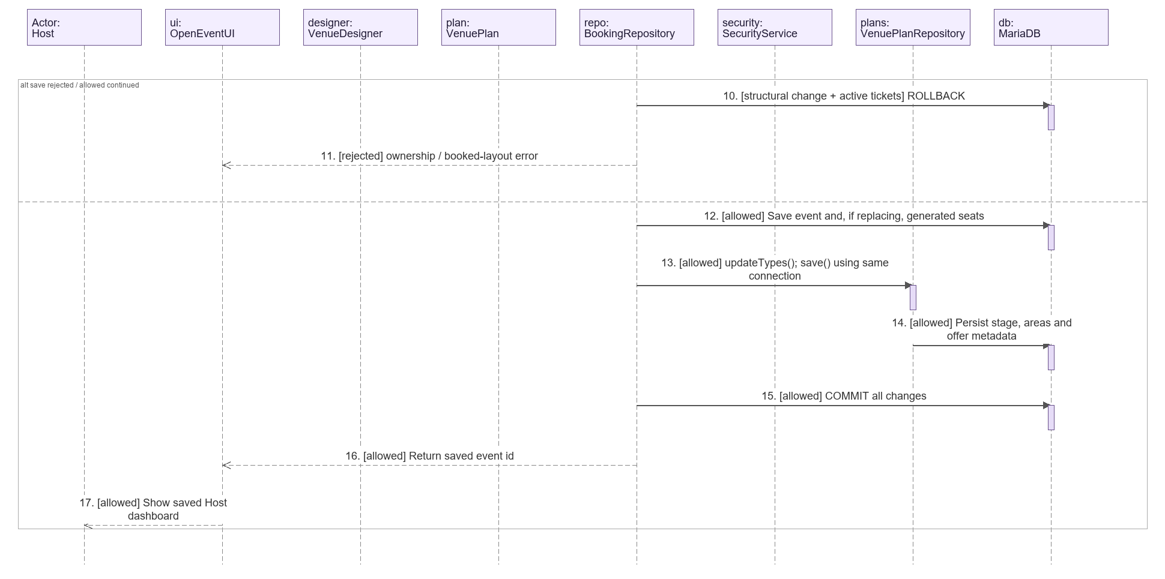

Figure B3 Section selection and atomic ticket purchase part 1 of 3
Appendix B Sequence diagrams with repeated participant headings
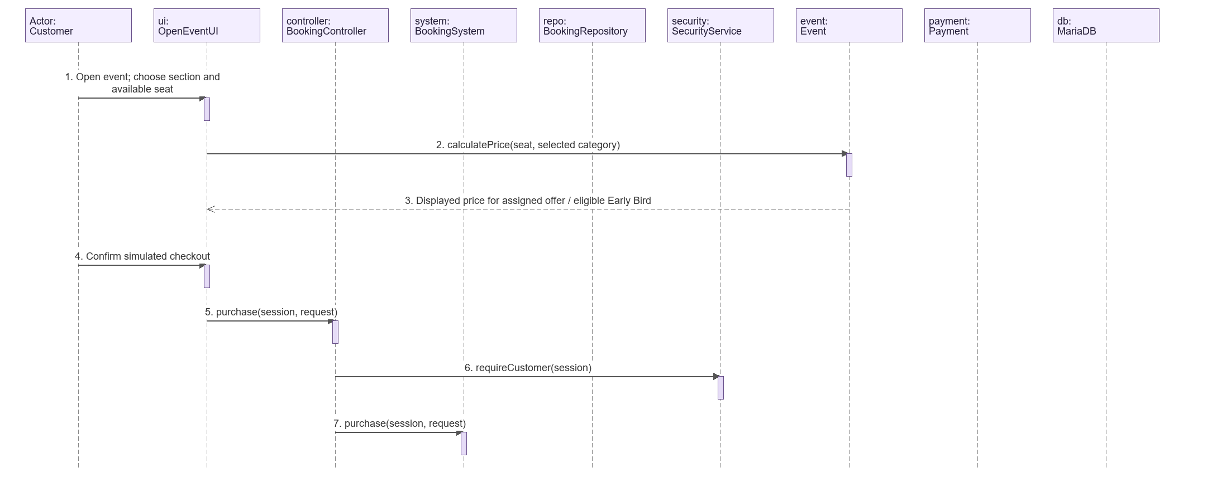

Figure B3 Section selection and atomic ticket purchase part 2 of 3
Appendix B Sequence diagrams with repeated participant headings
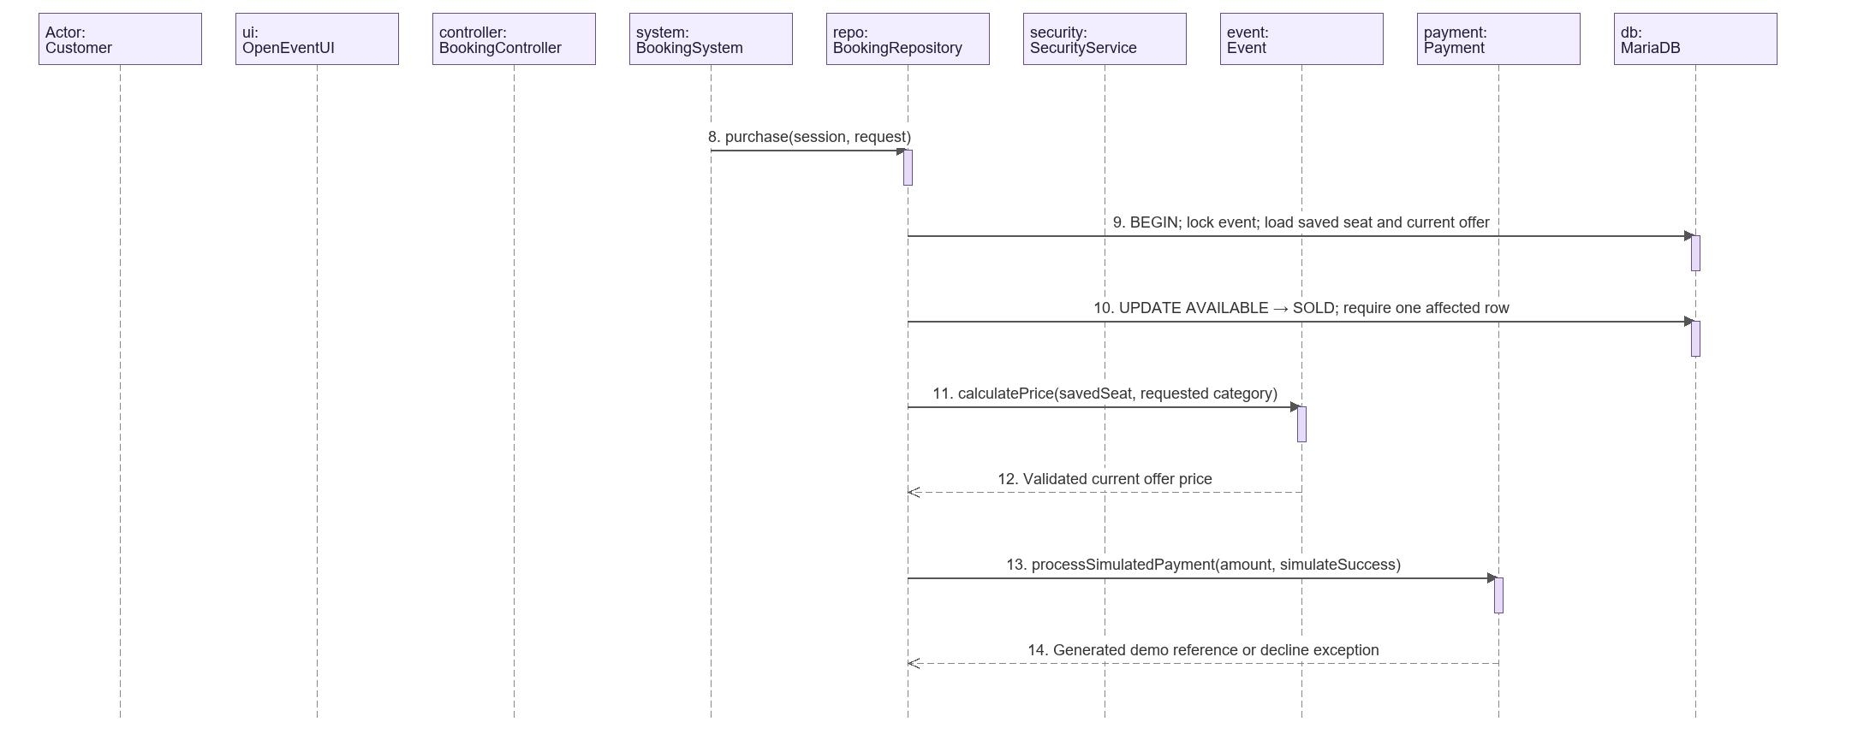

Figure B3 Section selection and atomic ticket purchase part 3 of 3
Appendix B Sequence diagrams with repeated participant headings
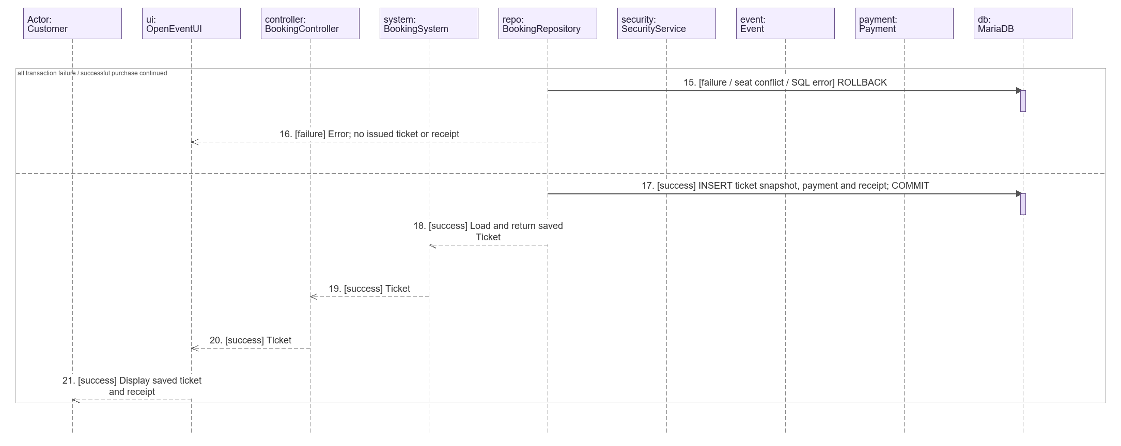

Figure B4 Cancellation and simulated refund part 1 of 2
Appendix B Sequence diagrams with repeated participant headings
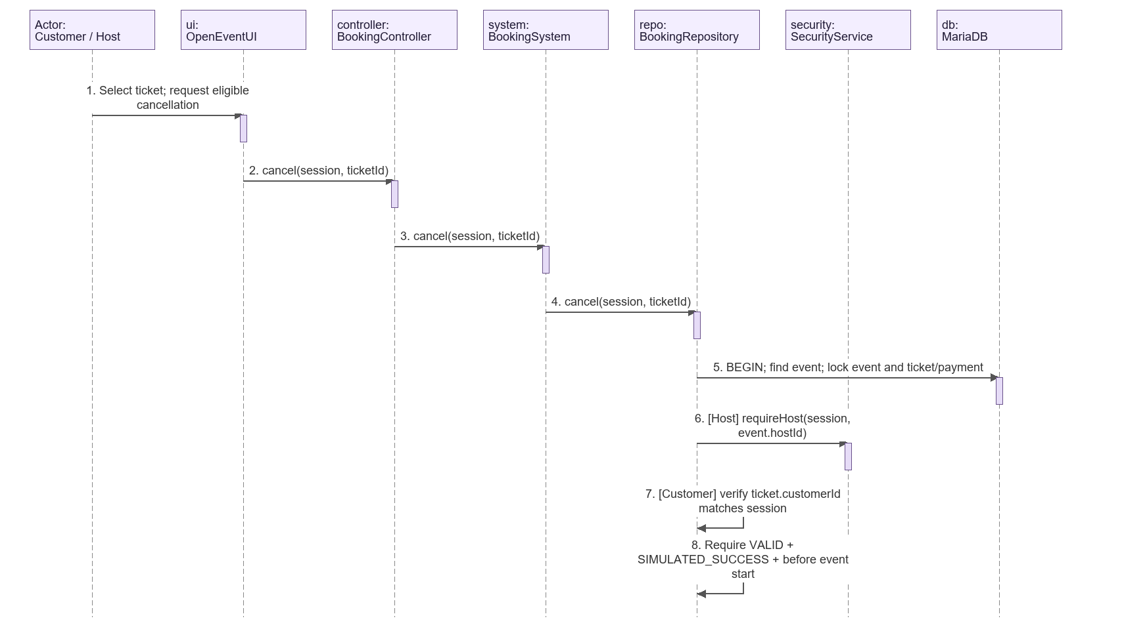

Figure B4 Cancellation and simulated refund part 2 of 2
Appendix B Sequence diagrams with repeated participant headings
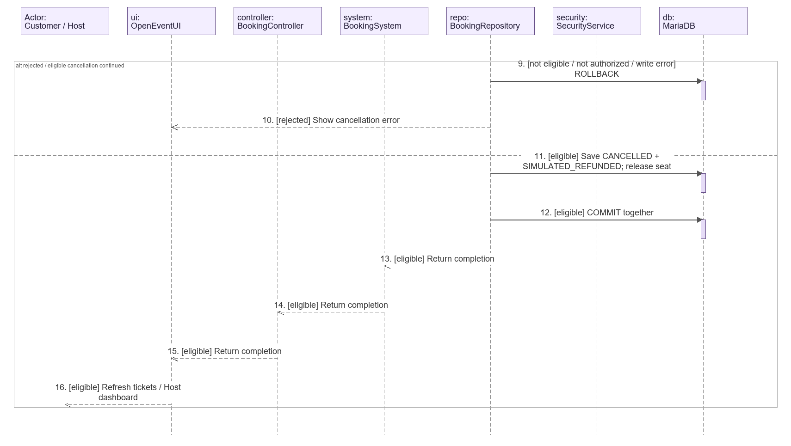

Figure B5 Host validation and one-time ticket check-in part 1 of 2
Appendix B Sequence diagrams with repeated participant headings
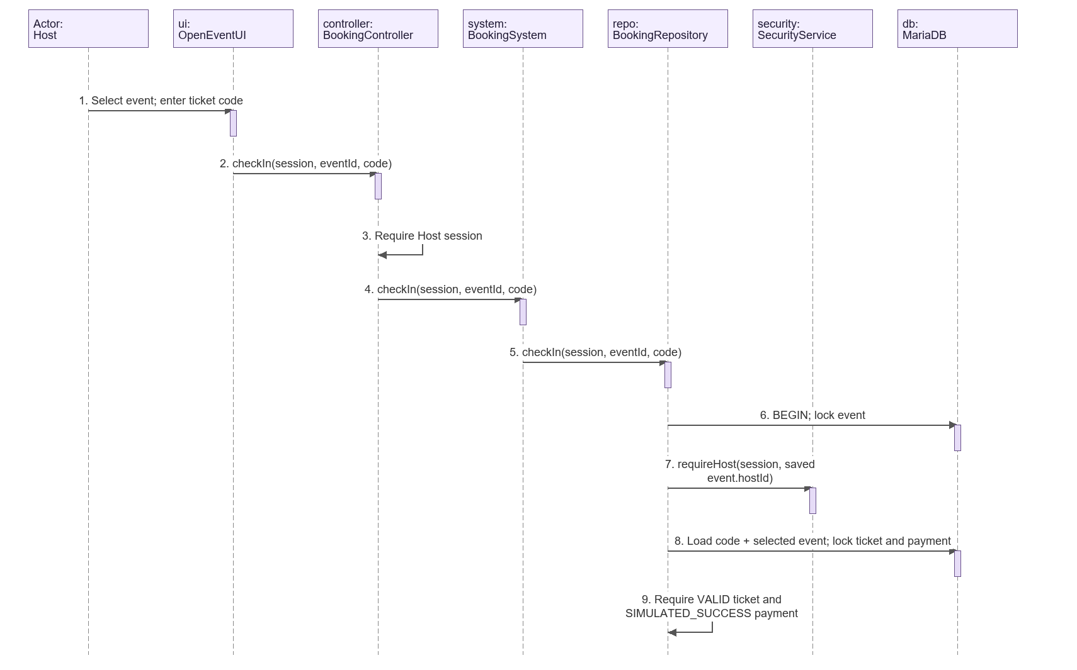

Figure B5 Host validation and one-time ticket check-in part 2 of 2
Appendix B Sequence diagrams with repeated participant headings
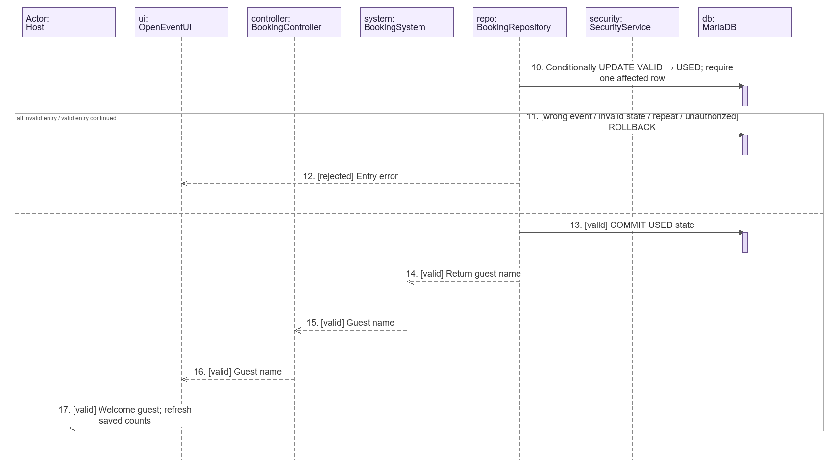

Figure B6 Host event monitoring and manual refresh part 1 of 2
Appendix B Sequence diagrams with repeated participant headings
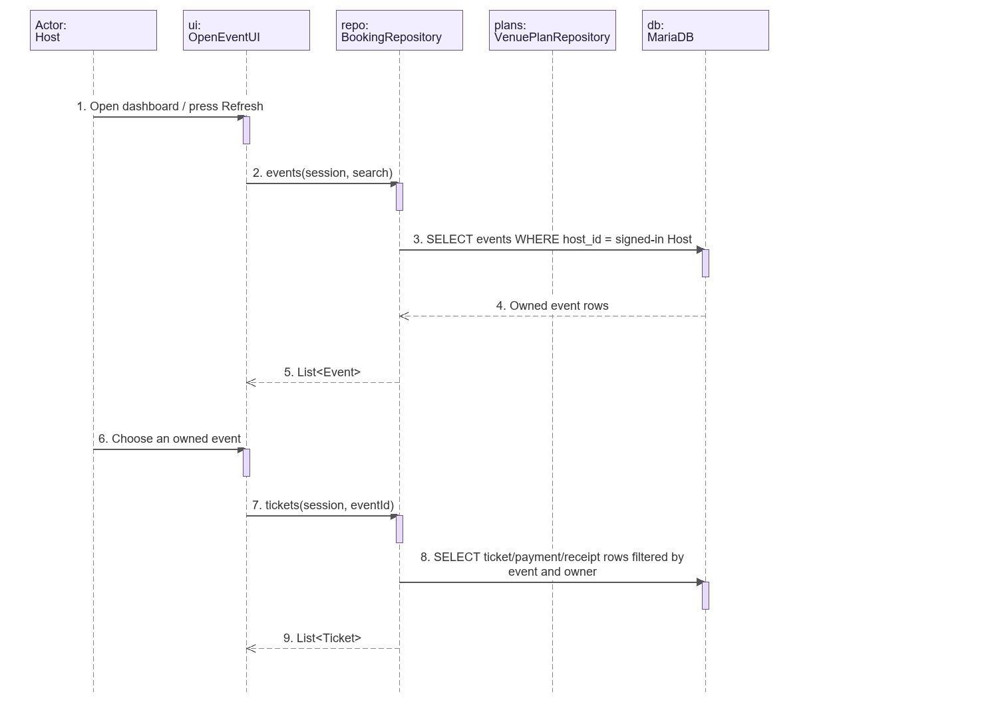

Figure B6 Host event monitoring and manual refresh part 2 of 2
Appendix B Sequence diagrams with repeated participant headings
