
SCHOOL OF SCIENCE ENGINEERING, & HEALTH
DEPARTMENT OF COMPUTER SCIENCE
CAMPUS CONNECT V2: A SECURE MARKETPLACE PLATFORM FOR SKILLS, GIGS AND EQUIPMENT HIRE
Submitted by
22-1661: EDGAR ECHWA LOCHODO
In Partial Fulfilment For The Award Of Degree In
APPLIED COMPUTER SCIENCE (ACS)
AUGUST 2026
ACS 470: COMPUTER PROJECT

DECLARATION
I declare that this is my original work and has never been submitted to any institution for the Degree award. This document has been submitted to fulfil the requirements for a Degree in Applied Computer Science (ACS) at Daystar University.
EDGAR ECHWA LOCHODO, 22-1661
Signature: .............................. Date: ..............................
This project has been submitted for examination purposes with the approval of the supervisor.
EDWIN RAGIRA OSORO
Signature: .............................. Date: ..............................

ACKNOWLEDGEMENT
I would like to thank the Almighty God for the strength and good health that made this project possible. My sincere gratitude goes to my supervisor, Edwin Ragira, for the guidance, patience, and constructive feedback throughout the development of this project. I would also like to thank the young Kenyan service providers and prospective clients who took the time to speak with me during the preliminary investigation and shared their honest experiences of trying to earn from and hire for skills, gigs, and rentals online. Finally, I am grateful to my family and classmates for their encouragement and support throughout this course.

DEDICATION
I dedicate this project to my family, for their constant support and belief in me throughout my studies, and to every young Kenyan hustling to turn a skill or a spare asset into an honest income.

ABSTRACT
Kenya's youth face persistent underemployment despite a fast-growing informal and gig economy, and the freelancing platforms most available to them, such as Fiverr and Upwork, were built for a different market: international digital freelancers with foreign-currency payment access, and no equivalent for hiring out physical skills such as tutoring, event photography, or equipment rental. This project set out to build Campus Connect V2, a web-based marketplace that lets Kenyan Gen Z users list and hire both digital skills and physical services or gear in one place, combining Fiverr's gig-posting model with a Craigslist-style classifieds format, but built around local trust and payment realities.
Campus Connect V2 delivers HustleGuard, an escrow system built on the Safaricom M-Pesa Daraja API (STK Push for client deposits, Business-to-Customer, B2C, for provider payouts) that holds a client's payment until a gig or rental is confirmed complete, addressing the single biggest barrier to peer-to-peer hiring among strangers: the fear of paying and not receiving, or delivering and not being paid. The delivered system extends this with a DoorDash-style delivery confirmation step: providers submit photo proof of delivery, and a client who is not satisfied can raise a dispute that is resolved by a moderator rather than left to either party alone, backed by a full administrative console for platform oversight.
All in-app chat between clients and service providers is end-to-end encrypted using an ECDH P-256 / HKDF-SHA256 / AES-GCM key exchange, so that gig details and personal contact information stay private, even from the platform operator; the server relays only ciphertext and can never read message content. The system was built and tested iteratively using the Agile method, with an automated test suite of 57 passing tests (unit and integration, run against an in-memory PostgreSQL instance) verifying the authentication, listings, escrow, reviews, and moderation modules, and is designed to sit behind a Web Application Firewall and a Kong API Gateway in production.

ACRONYMS & DEFINITION OF TERMS
Acronym | Definition
P2P | Peer-to-Peer
E2EE | End-to-End Encryption
API | Application Programming Interface
REST | Representational State Transfer
WAF | Web Application Firewall
STK | SIM Toolkit (used in "STK Push")
B2C | Business-to-Customer
OTP | One-Time Password
SMS | Short Message Service
KES | Kenyan Shilling
DFD | Data Flow Diagram
ERD | Entity Relationship Diagram
UI/UX | User Interface / User Experience
CRUD | Create, Read, Update, Delete
SDLC | System Development Life Cycle
JSON | JavaScript Object Notation
SQL | Structured Query Language
HTTP | Hypertext Transfer Protocol
PWA | Progressive Web App
JWT | JSON Web Token
ORM | Object-Relational Mapper
CI | Continuous Integration
CSV | Comma-Separated Values
Definition of Terms:
Escrow – A neutral holding arrangement in which a client's payment is held by the platform and released to the service provider only once the client confirms that the gig, task, or rental has been completed satisfactorily.
Gig – A short-term, task-based piece of digital or physical work listed by a service provider for hire.
Listing – A single posted item on Campus Connect V2, either a digital skill or service, or a physical item available for hire.
End-to-End Encryption – A communication method in which messages are encrypted on the sender's device and can only be decrypted by the intended recipient, so that no intermediate party, including the platform itself, can read message content.
STK Push – A prompt sent to a user's SIM-enabled phone through the Safaricom Daraja API, asking them to enter their M-Pesa PIN to authorise a payment.
Delivery Dispute – A moderation case opened when a client is not satisfied with a provider's proof of delivery; funds remain in escrow until an administrator resolves it.

TABLE OF CONTENTS
DECLARATION 2
ACKNOWLEDGEMENT 3
DEDICATION 4
ABSTRACT 5
ACRONYMS & DEFINITION OF TERMS 6
TABLE OF CONTENTS 8
CHAPTER 1 10
1.1 Introduction 10
1.2 Background Information 10
1.3 Emerging Issues 11
1.4 Problem Statement 11
1.5 Main Objective 12
1.6 Specific Objectives 12
1.7 Justification 12
CHAPTER 2: LITERATURE REVIEW 14
2.1 Introduction 14
2.2 The Gig Economy and Digital Skills Marketplaces in Kenya 14
2.3 Existing Platforms and Their Limitations 14
2.4 Trust, Escrow, and Payment Security in Peer-to-Peer Transactions 15
2.5 Mobile Money Integration and the Kenyan Context 15
2.6 End-to-End Encryption for Secure Peer Communication 16
2.7 Security in Consumer Marketplace Applications 16
2.8 Summary and Research Gap 16
CHAPTER 3: METHODOLOGY 18
3.0 Methodology 18
3.1 Preliminary Investigation 18
3.2 Design Phase 19
CHAPTER 4: SYSTEM ANALYSIS AND DESIGN 21
4.0 System Analysis and Design 21
4.1 Context Diagram 21
4.2 Data Flow Diagram (DFD) 22
4.3 Entity Relationship Diagram (ERD) 25
4.4 Sequence Diagram — Escrow Payment Flow 27
CHAPTER 5: SYSTEM IMPLEMENTATION AND TESTING 29
5.0 Introduction 29
5.1 Source Code 30
5.2 Screenshots of the Developed System 60
5.3 Testing 72
CHAPTER 6: CONCLUSION AND RECOMMENDATIONS 74
6.1 Conclusion 74
6.2 Limitations 75
6.3 Recommendations 75
REFERENCES 77

CHAPTER 1

1.1 Introduction
Kenya's population is overwhelmingly young: roughly three-quarters of Kenyans are under the age of 35, and this generation is entering a job market where formal employment is scarce and slow-growing. Large numbers of young Kenyans already have marketable skills, such as graphic design, tutoring, event photography, hairdressing, and computer repair, and marketable assets, such as a camera, a keyboard, or a car, that others are willing to pay to use. What is missing is a single, trusted place to advertise these skills and assets, agree on a price, get paid safely, and communicate privately with a client or hirer before either party has any reason to trust the other.
Campus Connect V2 is proposed as that place. It is a web-based and mobile marketplace that combines the gig-posting model popularised by platforms such as Fiverr with the general classifieds model of platforms such as Craigslist, but rebuilt around the realities of the Kenyan Gen Z user: payment happens over M-Pesa rather than PayPal or a credit card, listings can be for a digital skill or a physical item for hire, and every stage of a transaction, from payment to chat, is designed with local trust and safety concerns in mind.

1.2 Background Information
At present, a young Kenyan who wants to earn money from a skill or a spare asset has few good options. Digital skills can be listed on Fiverr or Upwork, but these platforms were built around international freelancers, typically expect payment through PayPal or a foreign-currency-linked card, and charge fees that are steep relative to the size of a typical local gig. They also have no concept of a physical listing: a platform built for writing a blog post cannot help someone rent out a camera for a weekend shoot or offer in-person piano lessons.
For physical goods and casual local commerce, young Kenyans turn to general classifieds and Facebook Marketplace-style groups, and to informal WhatsApp and Instagram communities for service-based gigs. These channels work reasonably well for discovery, connecting a buyer to a seller, but they stop there: there is no built-in way to hold a client’s payment until a gig is done, no verified profile or rating history to check before trusting a stranger, and no private channel to discuss a booking without exchanging personal phone numbers upfront. The result is a familiar set of local complaints: deposits paid and never refunded when a "service provider" disappears, work delivered and never paid for, and personal contact details shared with strangers before either party has any reason to trust the other.
Campus Connect V2 is designed to close this gap by building the missing trust layer directly into the platform, using tools that are already part of everyday Kenyan digital life: M-Pesa for payment, and a simple, familiar listing-and-chat interface for discovery and communication.

1.3 Emerging Issues
Two trends make this project timely. First, mobile money and smartphone penetration among Kenyan youth continue to rise, and government-backed digital-skills initiatives such as Ajira Digital are actively encouraging young people into online and gig work, while independent market assessments now put Kenya's gig economy at over a billion US dollars in value, supporting well over a million workers (The Star, 2026). This growth means the informal, trust-by-luck arrangements that worked for a small circle of friends five years ago are increasingly being stretched across strangers who have never met.
Second, Kenya has also seen a steady rise in complaints tied to informal buy-and-sell and hire arrangements, and researchers studying peer-to-peer commerce in Kenya specifically find that the absence of a mechanism to hold payment safely is a central driver of the trust deficit between buyers and sellers who do not already know each other (Kipkemboi & Wanjiru, 2024). At the same time, Kenya's Data Protection Act, 2019 places clear obligations on any platform, including Campus Connect V2, that will process personal data such as phone numbers or payment information, and this has to be designed for from the outset rather than added on later.

1.4 Problem Statement
Kenyan Gen Z users who want to earn from a skill or a spare asset, and the people who want to hire them, currently have to choose between platforms that do not fit the local market (Fiverr, Upwork), classifieds that offer discovery but no payment protection, or informal WhatsApp and Instagram arrangements that offer neither. None of these options combine local mobile-money payment, a safety net against non-payment or non-delivery, and a private communication channel in one place. Campus Connect V2 addresses this by building a marketplace purpose-built for the Kenyan Gen Z user: one platform for both digital and physical listings, an M-Pesa-based escrow system that only releases funds once a gig or rental is confirmed complete, and end-to-end encrypted chat so that users can negotiate and coordinate without exposing personal information to a stranger, or to the platform itself, before they are ready to.

1.5 Main Objective
To design, develop, and deploy Campus Connect V2, a secure web and mobile marketplace that lets Kenyan Gen Z users list, discover, and hire digital skills, services, and equipment through M-Pesa escrow payments and end-to-end encrypted chat.

1.6 Specific Objectives
1. To design and develop a web and mobile interface for posting, browsing, and searching digital and physical listings, by the end of month one.
2. To integrate a HustleGuard escrow system, using the M-Pesa Daraja API (STK Push and B2C), to securely hold and release payments, by month two.
3. To implement end-to-end encrypted messaging between clients and service providers, by month three.
4. To test the platform with real users and deploy it behind a Web Application Firewall and API gateway, by the end of month three.

1.7 Justification
Three groups will benefit directly from Campus Connect V2.
Young service providers will benefit from a safer, more predictable way to earn: once a client hires them, payment is already secured in escrow, removing the risk of finishing a job and not getting paid.
Clients and hirers will benefit from access to a wider pool of local, vetted listings, both digital and physical, with the confidence that their money is only released once they confirm the job is done to their satisfaction.
The broader Kenyan digital economy will benefit from a platform that keeps local gig income and transaction data within a locally built system, contributing to the same formalisation and digital-inclusion goals as national programmes like Ajira Digital, rather than routing local hustle income through fee structures built for a different market.

CHAPTER 2: LITERATURE REVIEW

2.1 Introduction
Before Campus Connect V2 is designed in detail, it is useful to review what existing research and existing platforms say about the problem it is trying to solve. This chapter reviews five areas: the state of the gig economy and digital skills marketplaces in Kenya; existing platforms and where they fall short for this market; research on trust and escrow in peer-to-peer transactions; the role of mobile money, specifically M-Pesa, in enabling local digital commerce; and end-to-end encryption as a way of protecting user communication. The chapter closes by identifying the specific gap that Campus Connect V2 is designed to fill.

2.2 The Gig Economy and Digital Skills Marketplaces in Kenya
The youth in Kenya will keep looking for online side hustles, with sites like Fiverr leading the way for digital gigs (McTaba Labs, 2026). Independent market assessments support this picture at scale: the number of active gig platforms operating in Kenya grew from just 11 in 2015 to more than 40 by 2022, and the sector is now valued at over one billion US dollars, supporting more than 1.5 million workers (The Star, 2026). An earlier assessment by Genesis Analytics, carried out with Mercy Corps Youth Impact Labs Kenya, estimated the online gig economy alone at about $109 million in 2019 and projected roughly 32% growth over five years as internet and mobile money penetration continued to rise (Genesis Analytics, 2023). Kenya is now considered Africa’s second-largest supplier of online labour, with well over a million Kenyans working through platforms such as Uber, Upwork, and Fiverr. This body of evidence confirms that demand for gig work among Kenyan youth is real, large, and still growing, but as the next section shows, the platforms currently absorbing this demand were not built with the local market in mind.

2.3 Existing Platforms and Their Limitations
Fiverr will only work for digital skills and will not help with local physical services like piano lessons (Divas College, 2026). Fiverr and Upwork dominate digital freelancing generally, but both are structured around international clients, foreign-currency payouts typically routed through PayPal or a linked bank card, and fee structures that make more sense for larger overseas contracts than for small local gigs. Big platforms will also take a lot of fees and will not connect easily to local money systems (HIIG, 2023). Local classifieds sites and Facebook-style marketplace groups fill part of the gap for physical items, but they are designed purely for discovery: a seller posts a photo and a price, a buyer messages them, and the platform takes no further part in the transaction. Neither model has a way to protect a Kenyan Gen Z user hiring a stranger to shoot their event or lending out camera gear for a weekend. Campus Connect V2’s Fiverr-meets-Craigslist positioning is a direct response to this gap: one place for digital skills and physical listings, purpose-built for a local audience the incumbent platforms were not designed to serve.

2.4 Trust, Escrow, and Payment Security in Peer-to-Peer Transactions
Foundational research on online marketplaces treats third-party escrow as one of the clearest "institutional mechanisms" for building a buyer’s trust in an unfamiliar seller, alongside feedback ratings and payment guarantees, and finds that the perceived effectiveness of these mechanisms measurably increases a buyer’s willingness to transact and reduces the perceived risk of dealing with a stranger (Pavlou & Gefen, 2004). More recent, locally grounded work echoes this finding in the Kenyan context specifically: without a system to hold the money safely, users will still get scammed when renting out things (Kipkemboi & Wanjiru, 2024), and the authors argue that an escrow layer is one of the more direct ways to close this trust deficit. A 2026 study describing an escrow-based peer-to-peer payment system built for an equally informal, social-media-driven West African marketplace found that holding a buyer’s payment until delivery is confirmed and verified measurably reduced fraud and increased user confidence in peer-to-peer transactions (Fasola et al., 2026). Together, these findings directly support the HustleGuard escrow design at the centre of Campus Connect V2, in which a client’s M-Pesa payment is held by the platform, never released directly to the service provider, and is only paid out once the client confirms the gig or rental is complete.

2.5 Mobile Money Integration and the Kenyan Context
Research will show that when apps use local mobile money, more people will actually use them (Ouma & Mutuku, 2023). Any escrow system built for a Kenyan audience has to work through M-Pesa rather than around it. Since its 2007 launch, M-Pesa has become the dominant channel for everyday payments in Kenya, and research into its diffusion identifies trust, an extensive agent network, and tight integration into daily commerce as the main drivers of its continued dominance over card- and bank-based alternatives (Kingiri & Fu, 2020). For Campus Connect V2, this points to a specific design choice: rather than adding M-Pesa as one payment option among several, the escrow system is built directly on the Safaricom Daraja API, using an STK Push to collect a client’s deposit and a Business-to-Customer (B2C) payout to release funds directly to a service provider’s phone once a job is approved, so that the payment experience matches what users already expect from everyday M-Pesa transactions.

2.6 End-to-End Encryption for Secure Peer Communication
Adoption of a payment mechanism is only part of the trust equation; users also need to trust that a private conversation with a stranger will not be exposed. The Signal Protocol, and its underlying Double Ratchet design, is widely regarded as the reference standard for end-to-end encrypted messaging, ensuring that only the sender and intended recipient of a message can read its content, and the protocol continues to be actively developed, including recent work to keep it secure against future quantum-computing attacks (Signal Foundation, 2025). The market for end-to-end encrypted communication is itself growing quickly, reflecting rising baseline user expectations that any app carrying private conversations should not be readable by the platform operator (Intel Market Research, 2025). For Campus Connect V2, this motivates using a Signal Protocol-style public-key exchange for all chat between a client and a service provider, so that gig details, delivery arrangements, and personal contact information are readable only by the two people involved, keeping every hustle-related conversation private.

2.7 Security in Consumer Marketplace Applications
Beyond escrow and encryption, a consumer marketplace that handles both money and personal data needs standard protection against automated abuse and attack. Placing a Web Application Firewall and an API gateway in front of the backend, so that only clean, authenticated traffic reaches the escrow and messaging services, is a well-established pattern for public-facing financial applications, and is reflected directly in Campus Connect V2’s system architecture in Chapter 4.

2.8 Summary and Research Gap
Taken together, the literature confirms three things: the demand for flexible gig and rental income among Kenyan youth is large and growing; escrow-based payment genuinely increases trust and reduces fraud in peer-to-peer transactions; and end-to-end encryption is now an expected baseline for private communication. What is missing is a single platform that brings all three together for the specific case of a Kenyan Gen Z user who wants to list both digital skills and physical items, get paid safely through M-Pesa, and chat privately with a stranger before trusting them. None of the systems reviewed combine local escrow, mobile-money-native payments, and end-to-end encrypted chat in one purpose-built marketplace for this audience. Campus Connect V2 is designed to fill exactly that gap.

CHAPTER 3: METHODOLOGY

3.0 Methodology
Campus Connect V2 was built using the Agile method, in iterative, testable increments rather than as one large release. Each core capability, listings and discovery, the HustleGuard escrow payment flow, end-to-end encrypted chat, and the later feature phases (media and profiles, reviews, discovery, moderation, and the administrative console), was built, tested, and refined in its own short cycle, with the payment and encryption components going through especially rigorous testing before real M-Pesa transactions or real user messages were allowed to flow through them, in line with the project's month-by-month specific objectives in section 1.6.

3.1 Preliminary Investigation
Before development began, the actual behaviour of the target users, rather than assumptions about it, was studied directly.

3.1.1 Fact-Finding Methods
Three methods were used to gather information. The first was direct observation of how young Kenyans currently advertise skills and negotiate gigs, on platforms such as Instagram, Facebook groups, and WhatsApp communities frequented by the target Gen Z audience. The second was structured interviews with prospective service providers, students and young freelancers already offering tutoring, photography, design, or equipment for hire, and with prospective clients, focused specifically on what currently stops them transacting with a stranger online. The third was a review of publicly available reports on the Kenyan gig economy and mobile money usage, to build a data-backed picture of market size and payment behaviour rather than relying on assumption alone.

3.1.2 Feasibility Study
Feasibility was assessed across three dimensions. Technical feasibility was evaluated by matching the required stack, a web frontend, a mobile-friendly interface, an escrow-capable backend integrated with the Safaricom Daraja API, and an encrypted messaging layer, against realistic development timelines for a single-developer academic project. Economic feasibility was assessed by comparing the cost of building a lightweight, purpose-built platform against the transaction fees Kenyan users currently lose to international platforms such as Fiverr and Upwork. Operational feasibility was assessed through the interview process described in section 3.1.1, to confirm that prospective users are willing to trust a new platform once the escrow and encrypted-chat mechanisms are explained to them.

3.2 Design Phase

3.2.1 System Architecture
Campus Connect V2 uses a three-tier architecture. A responsive web PWA (the client tier) communicates with a backend of core services, listings, escrow and payments, and encrypted messaging, sitting behind a Kong API Gateway and a native Web Application Firewall that routes only clean, authenticated traffic through to the backend. Sensitive services, the escrow ledger, payment webhooks, and chat routing, are logically isolated from the general listings service so that a fault or attack against one does not directly compromise the others.

3.2.2 Database Design
The database is organised around four primary entities, Users, Listings, Messages, and Transactions, extended during implementation with supporting entities for media, favourites, reviews, notifications, moderation reports, and delivery proofs (full field-level detail for the primary entities is provided in section 4.3; the extended implementation schema is discussed in Chapter 5).

3.2.3 User Interface Design
The interface prioritises speed and trust signals over decoration: clear escrow status indicators, such as "Funds Secured", "Awaiting Approval", and "Released", on every active gig, a simple category-based browse and search experience for listings, and a chat screen that visibly indicates when a conversation is end-to-end encrypted. The design targets a mobile-first, installable Progressive Web App, so that a listing can be created, browsed, or hired from a phone with limited data, alongside a full desktop experience.

3.2.4 Security Architecture
All traffic is designed to route through the native Web Application Firewall and Kong API Gateway before it reaches any backend service. User credentials and the public keys used for end-to-end encrypted chat are stored separately from listing and transaction data. Every account is tied to a phone number verified through an OTP sent by SMS, since this verification step also doubles as the identity check Daraja requires before it can process a payment on a user’s behalf.

3.2.5 Payment and Escrow Integration Architecture
The HustleGuard escrow engine integrates directly with the Safaricom Daraja API. When a client hires a listing, the system calculates the total, the gig or rental fee plus the platform’s deposit, and triggers an STK Push, prompting the client to enter their M-Pesa PIN on their own phone. Once Safaricom confirms the payment through a webhook, the funds are marked as held in escrow and the service provider is notified that the job can begin. The provider can then submit photo proof of delivery; once the client clicks "Approve Delivery", the system makes a B2C API call to release the funds directly to the service provider’s phone. If the client is not satisfied, a dispute can be raised instead, which is resolved by an administrator rather than by either party unilaterally. This flow, illustrated in the sequence diagram in section 4.4, means neither party has to trust the other directly; both are trusting the escrow mechanism instead.

3.2.6 Development Tools and Technologies
Backend: Node.js with Express, a REST API framework with webhook support for the Safaricom Daraja API (STK Push and B2C), PostgreSQL via the Prisma ORM for users, listings, and transactions, and Socket.IO for real-time chat and notifications. Frontend: a React 18 + Vite Progressive Web App. Security: a native Web Application Firewall (OWASP ModSecurity Core Rule Set) and Kong API Gateway in front of all backend services, and a Web Crypto API-based ECDH/AES-GCM key exchange for end-to-end encrypted chat. Tools: Git and GitHub for version control, Vitest and an in-memory PostgreSQL instance for automated testing, and a diagramming tool for system design artefacts, including the context, DFD, ERD, and sequence diagrams presented in Chapter 4.

3.2.7 System Modules
Campus Connect V2 is organised into six functional modules: User Authentication and Profiles (registration, OTP phone verification, and public-key setup for chat); Listings and Discovery (digital skill and physical/equipment listings, search and category browsing, media, favourites); HustleGuard Escrow and Payments (Daraja STK Push and B2C integration, escrow status tracking, delivery proof and dispute resolution); Secure Messaging (end-to-end encrypted chat between a client and a service provider); Community and Moderation (ratings and reviews, reporting, and a moderation queue); and an Administrative Console (platform analytics, user, listing and payment oversight).

CHAPTER 4: SYSTEM ANALYSIS AND DESIGN

4.0 System Analysis and Design
Campus Connect V2 is a three-tier web application. The client app connects to the backend through REST API calls routed via a Kong API Gateway sitting behind a native Web Application Firewall, which filters traffic before it reaches the Marketplace, Escrow, and end-to-end encrypted (E2EE) messaging backend. The backend, in turn, integrates with the Safaricom M-Pesa API for STK Push and B2C payments, and with a Socket.IO real-time layer, to alert users of payment confirmations, new messages, and delivery approvals in real time. What a user sees depends on their role.
Users of the System
Role | Responsibilities
Client (Hirer) | Browses listings, hires a service or item, pays into escrow via the M-Pesa STK Push, chats securely with the provider, and approves delivery to release funds, or disputes it.
Service Provider | Posts digital skill or physical/equipment listings, receives hire requests, communicates through encrypted chat, delivers the work or item with photo proof, and receives payment once the client approves.
Administrator | Moderates reported content and delivery disputes, manages users and listings, and reviews platform analytics from a dedicated admin console.
Platform / System | Routes traffic through the WAF and API gateway, manages the escrow ledger and M-Pesa integration, relays encrypted chat payloads without reading their content, and sends notifications.
System Inputs: listing details (category, title, price, digital/physical type); hire and checkout requests; M-Pesa PIN entry, handled directly by Safaricom and never stored by the platform; encrypted chat payloads; delivery proof photos; delivery approval or dispute actions.
System Outputs: the live listings feed; STK Push payment prompts; escrow status updates such as "Funds Secured" and "Released"; push notifications; encrypted message delivery; funds transferred directly to a service provider’s M-Pesa line; and moderation and analytics views for administrators.

4.1 Context Diagram
The context diagram positions Campus Connect V2 as a single system at the centre of its environment, connecting the Kenyan Gen Z user to three external dependencies: the Safaricom M-Pesa API for STK Push and B2C payments, push notification servers, and the native WAF and Kong API Gateway that fronts the Marketplace, Escrow & E2EE backend.
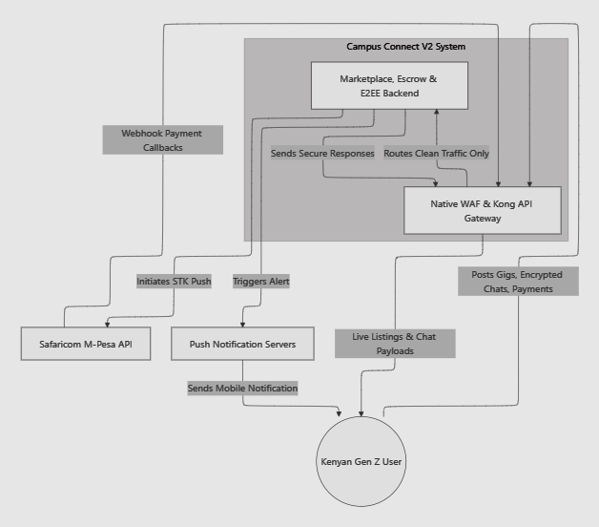
Figure 4.1 — Context diagram showing Campus Connect V2, its user, and its external service dependencies

4.2 Data Flow Diagram (DFD)

4.2.1 Level 1
At Level 1, four processes are visible: Manage User Auth & Keys, Process Gig & Gear Listings, Manage HustleGuard Escrow, and Route E2EE Chat Messages, drawing on four data stores: Users, Listings, Transactions, and Messages. The escrow process is the busiest of the four: it calculates fees and deposits, triggers the M-Pesa STK Push, listens for Safaricom’s webhook confirmation, updates the escrow status to "Held", and notifies both the service provider and the client through the push notification server as the transaction moves forward.
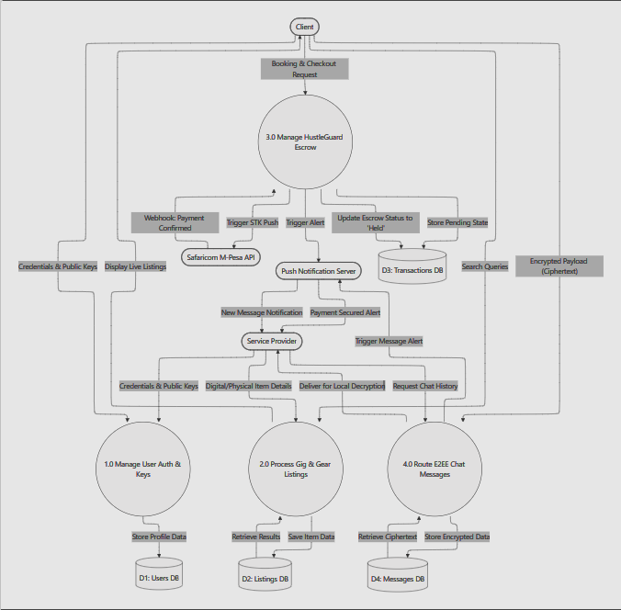
Figure 4.2 — Level 1 data flow diagram

4.2.2 Level 2 — Escrow Sub-Processes
The Level 2 diagram expands the escrow process into its sub-processes. Sub-process 3.1, Calculate Fees & Deposits, runs when the client selects a listing and clicks hire: it calculates the total of the gig fee plus deposit and triggers the STK Push request to the Safaricom M-Pesa API. Sub-process 3.2, Process M-Pesa Webhook, receives Safaricom’s JSON payload confirming the transaction. Sub-process 3.3, Verify Delivery/Return, records the provider’s delivery proof and the client’s approval; once approved, Sub-process 3.4, Disburse Funds, makes the B2C API call that transfers money directly to the service provider.
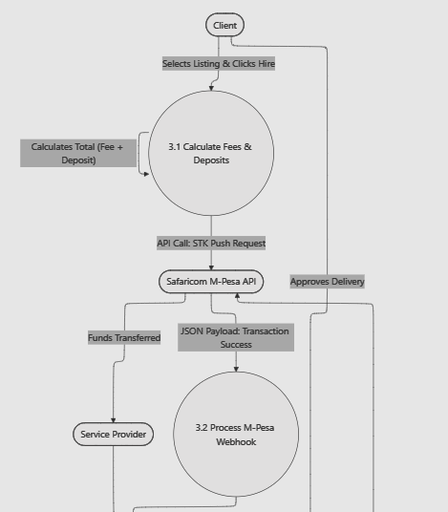
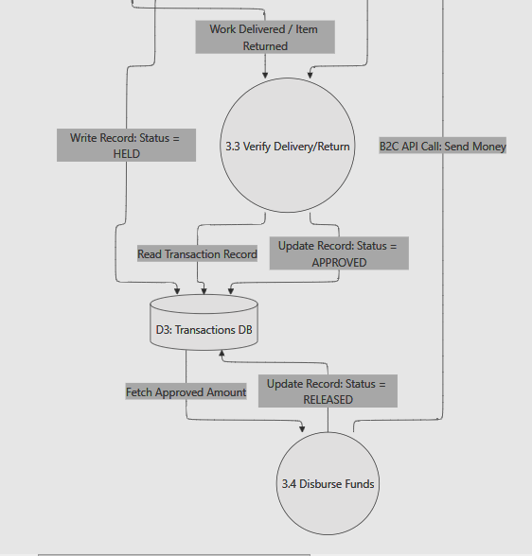
Figure 4.3 — Level 2 DFD (escrow sub-processes)

4.3 Entity Relationship Diagram (ERD)
The core schema, as designed at proposal stage, is organised around four entities: Users, Listings, Messages, and Transactions. (Chapter 5 documents how this schema was extended during implementation to support media, favourites, reviews, notifications, moderation, and delivery-proof disputes.)
Users
Key | Field | Type | Notes
PK | user_id | Integer | Auto-incrementing primary key
 | full_name | Varchar | Display name of the user
 | phone_number | Varchar | Used for login and for the M-Pesa STK Push
 | public_key | Varchar | Public key used for E2EE chat
 | created_at | Timestamp | Account creation date
Listings
Key | Field | Type | Notes
PK | listing_id | Integer | Auto-incrementing primary key
FK | user_id | Integer | Owning service provider, links to Users
 | category_type | String | Digital or Physical
 | title | Varchar | Short listing title
 | price | Decimal | Listed price for the gig or rental
Messages
Key | Field | Type | Notes
PK | message_id | Integer | Auto-incrementing primary key
FK | sender_id | Integer | Sending user, links to Users
FK | receiver_id | Integer | Receiving user, links to Users
 | encrypted_payload | Text | Ciphertext; cannot be read by the server
 | delivered_at | Timestamp | Time the message was delivered
Transactions
Key | Field | Type | Notes
PK | transaction_id | Integer | Auto-incrementing primary key
FK | listing_id | Integer | Listing being paid for, links to Listings
FK | client_id | Integer | Paying client, links to Users
 | amount | Decimal | Total amount held or released
 | escrow_status | String | Held, Released, or Refunded
Relationships
Entity | Related Entity | Relationship | Foreign Key
User | Listing | One to Many | listings.user_id → users.user_id
User (client) | Transaction | One to Many | transactions.client_id → users.user_id
Listing | Transaction | One to Many | transactions.listing_id → listings.listing_id
User (sender) | Message | One to Many | messages.sender_id → users.user_id
User (receiver) | Message | One to Many | messages.receiver_id → users.user_id
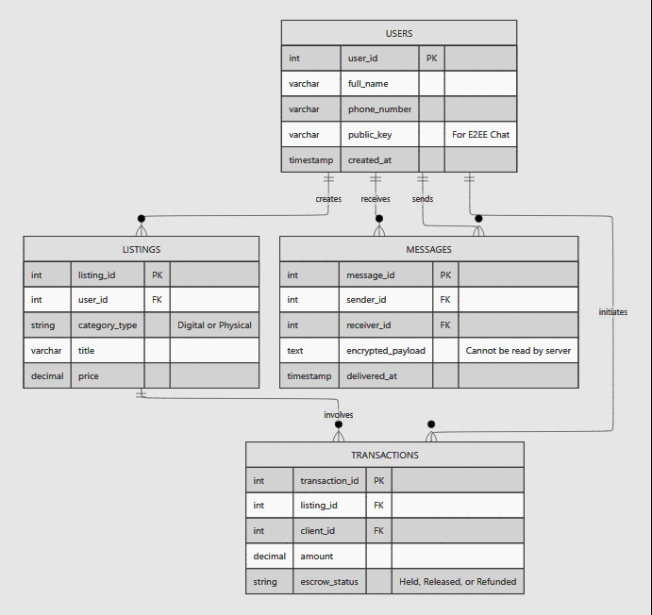
Figure 4.4 — Entity relationship diagram for the Campus Connect V2 database

4.4 Sequence Diagram — Escrow Payment Flow
The sequence diagram traces the full escrow payment flow end to end. The client clicks "Hire & Pay to Escrow"; the system triggers an STK Push through the Safaricom M-Pesa API; the client enters their PIN on their own phone; Safaricom confirms the payment through a webhook; the funds are locked in the escrow database; the service provider is alerted to begin the gig; the provider delivers the work or the physical item; and once the client clicks "Approve Delivery", a B2C API call releases the funds directly to the service provider’s phone.
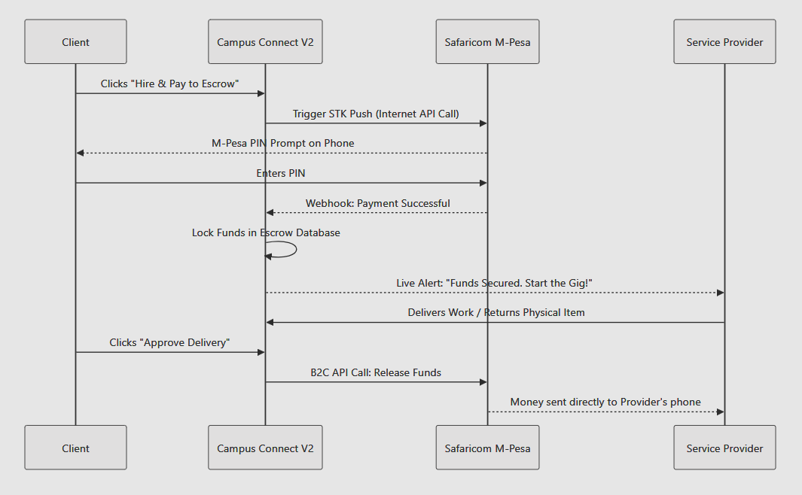
Figure 4.5 — Sequence diagram showing the HustleGuard escrow payment flow

CHAPTER 5: SYSTEM IMPLEMENTATION AND TESTING

5.0 Introduction
This chapter documents what was actually built. Development followed the Agile, iterative approach set out in Chapter 3: Module 1 (authentication, profiles, listings) was built and verified first, then Module 2 (the HustleGuard escrow), then Module 3 (end-to-end encrypted messaging), matching the month-by-month specific objectives in section 1.6. Once the core system was working end to end, four further feature phases were added, ratings and reviews, richer media and public provider profiles, browse and discovery (favourites, categories, filters), and community guidelines with a reporting and moderation queue, followed by Objective 4: an automated test suite, a usability-testing plan, and a deployment stack behind a Web Application Firewall and API gateway.
Two capabilities were added beyond the original proposal scope, in direct response to gaps identified while finishing the system. First, a full administrative console, a dedicated, separately-shelled interface (its own navigation, its own colour theme, and a login redirect straight into it for admin accounts) covering platform analytics, user management (including account suspension, enforced at the authentication layer), listing oversight, and a payments ledger with CSV export. Second, a DoorDash-style delivery-confirmation mechanism: a service provider now submits photo proof of delivery before a client releases payment, and a client who is not satisfied can raise a dispute instead of approving blindly or trusting the provider’s word; the dispute is not resolved by either party but lands directly in the administrator’s moderation queue, where the photos, the order details, and two real actions, release the funds to the provider or refund the client, are all presented together.

Technology stack actually used
Layer | Technology
Backend runtime | Node.js (ES modules), Express 4
Database / ORM | PostgreSQL (hosted on Supabase in production; an in-process PGlite instance for fast local development), Prisma ORM
Real-time | Socket.IO (chat delivery, live notifications)
Payments | Safaricom Daraja API — a 3-mode client (mock / sandbox / production), STK Push + B2C
Encryption | Web Crypto API — ECDH P-256 → HKDF-SHA256 → AES-GCM, client-side only
Frontend | React 18 + Vite, installable Progressive Web App (vite-plugin-pwa), react-router-dom v6
UI / motion | A custom dual light/dark design-token system, Framer Motion for transitions and micro-interactions
Auth | JWT access tokens, bcrypt password hashing, SMS OTP phone verification
Testing | Vitest (unit + integration projects), Supertest, PGlite as an in-memory Postgres for integration tests — no Docker required
Edge / deployment | Docker multi-stage builds, nginx (PWA host), OWASP ModSecurity Core Rule Set (WAF), Kong API Gateway (DB-less)
CI | GitHub Actions — runs the full test suite and the web production build on every push

5.1 Source Code
The full project (backend, frontend, tests, and deployment configuration) runs to several thousand lines across roughly 150 files, far beyond what this report’s 100-page limit can hold. Rather than omit code entirely or paste every file at a size too small to read, this section reproduces, in full and unedited, the files that best demonstrate how the system’s core objectives were actually implemented: the data model, authentication and access control, the HustleGuard escrow and delivery-dispute state machine, the admin-console services that act on it, end-to-end encryption, and the client-side screens that drive the escrow and dispute flow. Every listing below is generated directly from the project repository, no code has been retyped, paraphrased, or shortened within a shown file, and the complete repository (all ~150 files) accompanies this submission and is the authoritative source.

5.1.1 Database Schema (Prisma)
Every table in the system (users, listings, transactions, delivery proofs, reports, reviews, notifications) and the enums that drive the escrow and moderation state machines.
server/prisma/schema.prisma
// Campus Connect V2 data model — see docs/data-model.md and proposal section 4.3.
// Four primary entities: Users, Listings, Messages, Transactions.

generator client {
provider = "prisma-client-js"
}

datasource db {
provider = "postgresql"
// Pooled connection for the running app. On Supabase this is the transaction
// pooler (port 6543) with ?pgbouncer=true.
url = env("DATABASE_URL")
// Unpooled connection used only for migrations / introspection. For a plain
// local Postgres, set DIRECT_URL equal to DATABASE_URL.
directUrl = env("DIRECT_URL")
}

enum CategoryType {
DIGITAL
PHYSICAL
}

enum ListingStatus {
ACTIVE
PAUSED
HIRED
REMOVED // soft-deleted (kept so transaction history stays intact)
}

enum OtpPurpose {
PHONE_VERIFY
LOGIN
}

// The proposal's ERD names the three resting states (Held, Released, Refunded).
// The extra values are the operational transitions in between.
enum EscrowStatus {
PENDING_PAYMENT // STK Push sent; waiting for the client's PIN + Safaricom callback
PAYMENT_FAILED // STK Push cancelled, wrong PIN, timed out, or insufficient funds
HELD // deposit confirmed and secured in escrow ("Funds Secured")
RELEASING // B2C payout to the provider in flight
RELEASED // paid out to the provider ("Released")
REFUNDING // B2C refund to the client in flight
REFUNDED // returned to the client ("Refunded")
CANCELLED // client cancelled before paying
}

enum MpesaEventKind {
STK_PUSH_REQUEST
STK_CALLBACK
B2C_REQUEST
B2C_RESULT
B2C_TIMEOUT
}

enum NotificationType {
ESCROW_FUNDED
PAYMENT_FAILED
DELIVERY_APPROVED
ESCROW_RELEASED
ESCROW_REFUNDED
JOB_DECLINED
NEW_REVIEW
REVIEW_REPLY
DELIVERY_SUBMITTED // provider uploaded delivery-proof photos
DELIVERY_DISPUTED // client disputed the delivery — admin queue
}

enum MediaKind {
IMAGE
VIDEO
}

enum ReportTargetType {
LISTING
REVIEW
REVIEW_REPLY
USER
TRANSACTION // delivery dispute — resolved by an admin releasing or refunding escrow
}

enum ReportReason {
SPAM
SCAM_OR_FRAUD
PROHIBITED_ITEM
HARASSMENT_OR_HATE
OFF_PLATFORM_PAYMENT
MISLEADING
OTHER
NOT_DELIVERED // transaction disputes
ITEM_NOT_AS_DESCRIBED // transaction disputes
}

enum ReportStatus {
OPEN
REVIEWING
ACTIONED
DISMISSED
}

model User {
id Int @id @default(autoincrement()) @map("user_id")
fullName String @map("full_name")
phoneNumber String @unique @map("phone_number")
passwordHash String @map("password_hash")
phoneVerified Boolean @default(false) @map("phone_verified")
isAdmin Boolean @default(false) @map("is_admin")
isSuspended Boolean @default(false) @map("is_suspended")
publicKey String? @map("public_key")
bio String?
avatarUrl String? @map("avatar_url")
avatarKey String? @map("avatar_key")
// { tiktok, instagram, whatsapp, x, facebook, youtube, linkedin, website } — all optional
socials Json?
// Denormalised rating rollup — recomputed on any review change.
ratingAvg Float @default(0) @map("rating_avg")
ratingCount Int @default(0) @map("rating_count")
createdAt DateTime @default(now()) @map("created_at")
updatedAt DateTime @updatedAt @map("updated_at")

listings Listing[]
otpCodes OtpCode[]
transactionsAsClient Transaction[] @relation("ClientTransactions")
transactionsAsProvider Transaction[] @relation("ProviderTransactions")
messagesSent Message[] @relation("SentMessages")
messagesReceived Message[] @relation("ReceivedMessages")
notifications Notification[]
reviewsReceived Review[] @relation("ReviewsAboutProvider")
reviewsWritten Review[] @relation("ReviewsByAuthor")
reviewReplies ReviewReply[]
reviewLikes ReviewLike[]
replyLikes ReplyLike[]
favorites Favorite[]
reportsFiled Report[] @relation("ReportsByReporter")
reportsHandled Report[] @relation("ReportsByModerator")

@@map("users")
}

model OtpCode {
id Int @id @default(autoincrement())
userId Int @map("user_id")
user User @relation(fields: [userId], references: [id], onDelete: Cascade)
codeHash String @map("code_hash")
purpose OtpPurpose
expiresAt DateTime @map("expires_at")
consumedAt DateTime? @map("consumed_at")
attempts Int @default(0)
createdAt DateTime @default(now()) @map("created_at")

@@index([userId, purpose])
@@map("otp_codes")
}

model Listing {
id Int @id @default(autoincrement()) @map("listing_id")
userId Int @map("user_id")
owner User @relation(fields: [userId], references: [id], onDelete: Cascade)
categoryType CategoryType @map("category_type")
category String
title String
description String
price Decimal @db.Decimal(12, 2)
location String?
status ListingStatus @default(ACTIVE)
createdAt DateTime @default(now()) @map("created_at")
updatedAt DateTime @updatedAt @map("updated_at")

transactions Transaction[]
media ListingMedia[]
favorites Favorite[]

@@index([categoryType, status])
@@index([createdAt])
@@index([category])
@@map("listings")
}

// Saved / favourited listings.
model Favorite {
userId Int @map("user_id")
user User @relation(fields: [userId], references: [id], onDelete: Cascade)
listingId Int @map("listing_id")
listing Listing @relation(fields: [listingId], references: [id], onDelete: Cascade)
createdAt DateTime @default(now()) @map("created_at")

@@id([userId, listingId])
@@index([userId])
@@map("favorites")
}

// Up to 5 images + one short video per listing. Files live in object storage
// (Supabase Storage in production, local disk in dev — see src/lib/storage.js).
model ListingMedia {
id Int @id @default(autoincrement())
listingId Int @map("listing_id")
listing Listing @relation(fields: [listingId], references: [id], onDelete: Cascade)
kind MediaKind
url String
storageKey String @map("storage_key")
position Int @default(0)
createdAt DateTime @default(now()) @map("created_at")

@@index([listingId])
@@map("listing_media")
}

// ── Module 2 — HustleGuard escrow ──
model Transaction {
id Int @id @default(autoincrement()) @map("transaction_id")
listingId Int @map("listing_id")
listing Listing @relation(fields: [listingId], references: [id])
clientId Int @map("client_id")
client User @relation("ClientTransactions", fields: [clientId], references: [id])
providerId Int @map("provider_id")
provider User @relation("ProviderTransactions", fields: [providerId], references: [id])

currency String @default("KES")
feeAmount Decimal @map("fee_amount") @db.Decimal(12, 2) // the provider's payout
platformFee Decimal @map("platform_fee") @db.Decimal(12, 2) // Campus Connect commission
amount Decimal @db.Decimal(12, 2) // total charged to the client (fee + platformFee)

escrowStatus EscrowStatus @default(PENDING_PAYMENT) @map("escrow_status")
clientPhone String @map("client_phone") // E.164 snapshot — STK Push target
providerPhone String @map("provider_phone") // E.164 snapshot — B2C payout target

// Client disputed the provider's delivery proof (or lack of it) — open
// until an admin force-releases or force-refunds the escrow.
disputed Boolean @default(false)

// STK Push (deposit collection)
stkCheckoutRequestId String? @unique @map("stk_checkout_request_id")
stkMerchantRequestId String? @map("stk_merchant_request_id")
stkResultCode Int? @map("stk_result_code")
stkResultDesc String? @map("stk_result_desc")
mpesaReceipt String? @map("mpesa_receipt") // deposit confirmation receipt
paidAt DateTime? @map("paid_at")

// B2C (payout to provider, or refund to client)
b2cConversationId String? @unique @map("b2c_conversation_id")
b2cResultCode Int? @map("b2c_result_code")
b2cResultDesc String? @map("b2c_result_desc")
b2cReceipt String? @map("b2c_receipt")
releasedAt DateTime? @map("released_at")
refundedAt DateTime? @map("refunded_at")

createdAt DateTime @default(now()) @map("created_at")
updatedAt DateTime @updatedAt @map("updated_at")

events MpesaEvent[]
notifications Notification[]
review Review?
deliveryProof DeliveryProof?

@@index([clientId])
@@index([providerId])
@@index([escrowStatus])
@@map("transactions")
}

// Provider's proof of delivery (photos + a note) — DoorDash-style. One per
// transaction; re-submitting replaces the note and adds/removes photos
// rather than creating a second proof.
model DeliveryProof {
id Int @id @default(autoincrement())
transactionId Int @unique @map("transaction_id")
transaction Transaction @relation(fields: [transactionId], references: [id], onDelete: Cascade)
note String?
createdAt DateTime @default(now()) @map("created_at")
updatedAt DateTime @updatedAt @map("updated_at")

photos DeliveryProofPhoto[]

@@map("delivery_proofs")
}

model DeliveryProofPhoto {
id Int @id @default(autoincrement())
deliveryProofId Int @map("delivery_proof_id")
deliveryProof DeliveryProof @relation(fields: [deliveryProofId], references: [id], onDelete: Cascade)
url String
storageKey String @map("storage_key")
position Int @default(0)
createdAt DateTime @default(now()) @map("created_at")

@@index([deliveryProofId])
@@map("delivery_proof_photos")
}

// Raw log of every Daraja request and callback — idempotency guard + audit trail.
model MpesaEvent {
id Int @id @default(autoincrement())
transactionId Int? @map("transaction_id")
transaction Transaction? @relation(fields: [transactionId], references: [id], onDelete: SetNull)
kind MpesaEventKind
ref String? // CheckoutRequestID or ConversationID
resultCode Int? @map("result_code")
payload Json
createdAt DateTime @default(now()) @map("created_at")

@@index([transactionId])
@@index([ref])
@@map("mpesa_events")
}

// Minimal in-app notifications. Module 4 adds real-time push on top of this table.
model Notification {
id Int @id @default(autoincrement())
userId Int @map("user_id")
user User @relation(fields: [userId], references: [id], onDelete: Cascade)
type NotificationType
title String
body String
transactionId Int? @map("transaction_id")
transaction Transaction? @relation(fields: [transactionId], references: [id], onDelete: SetNull)
readAt DateTime? @map("read_at")
createdAt DateTime @default(now()) @map("created_at")

@@index([userId, readAt])
@@map("notifications")
}

// ── Module 3 (E2EE messaging) — schema in place, endpoints pending ──
model Message {
id Int @id @default(autoincrement()) @map("message_id")
senderId Int @map("sender_id")
sender User @relation("SentMessages", fields: [senderId], references: [id])
receiverId Int @map("receiver_id")
receiver User @relation("ReceivedMessages", fields: [receiverId], references: [id])
encryptedPayload String @map("encrypted_payload")
deliveredAt DateTime? @map("delivered_at")
createdAt DateTime @default(now()) @map("created_at")

@@index([senderId, receiverId])
@@map("messages")
}

// ── Phase 2 — ratings & reviews (threaded, likeable) ──
// One review per completed transaction; it is about the provider.
model Review {
id Int @id @default(autoincrement())
providerId Int @map("provider_id")
provider User @relation("ReviewsAboutProvider", fields: [providerId], references: [id], onDelete: Cascade)
authorId Int @map("author_id")
author User @relation("ReviewsByAuthor", fields: [authorId], references: [id], onDelete: Cascade)
transactionId Int @unique @map("transaction_id")
transaction Transaction @relation(fields: [transactionId], references: [id], onDelete: Cascade)
rating Int // 1..5
body String
createdAt DateTime @default(now()) @map("created_at")
updatedAt DateTime @updatedAt @map("updated_at")

replies ReviewReply[]
likes ReviewLike[]

@@index([providerId])
@@map("reviews")
}

model ReviewReply {
id Int @id @default(autoincrement())
reviewId Int @map("review_id")
review Review @relation(fields: [reviewId], references: [id], onDelete: Cascade)
authorId Int @map("author_id")
author User @relation(fields: [authorId], references: [id], onDelete: Cascade)
parentReplyId Int? @map("parent_reply_id")
parentReply ReviewReply? @relation("ReplyThread", fields: [parentReplyId], references: [id], onDelete: Cascade)
childReplies ReviewReply[] @relation("ReplyThread")
body String
createdAt DateTime @default(now()) @map("created_at")
updatedAt DateTime @updatedAt @map("updated_at")

likes ReplyLike[]

@@index([reviewId])
@@map("review_replies")
}

model ReviewLike {
reviewId Int @map("review_id")
review Review @relation(fields: [reviewId], references: [id], onDelete: Cascade)
userId Int @map("user_id")
user User @relation(fields: [userId], references: [id], onDelete: Cascade)
createdAt DateTime @default(now()) @map("created_at")

@@id([reviewId, userId])
@@map("review_likes")
}

model ReplyLike {
replyId Int @map("reply_id")
reply ReviewReply @relation(fields: [replyId], references: [id], onDelete: Cascade)
userId Int @map("user_id")
user User @relation(fields: [userId], references: [id], onDelete: Cascade)
createdAt DateTime @default(now()) @map("created_at")

@@id([replyId, userId])
@@map("reply_likes")
}

// ── Phase 4 — reporting & moderation ──
model Report {
id Int @id @default(autoincrement())
reporterId Int @map("reporter_id")
reporter User @relation("ReportsByReporter", fields: [reporterId], references: [id], onDelete: Cascade)
targetType ReportTargetType @map("target_type")
targetId Int @map("target_id")
reason ReportReason
detail String?
status ReportStatus @default(OPEN)
reviewedById Int? @map("reviewed_by_id")
reviewedBy User? @relation("ReportsByModerator", fields: [reviewedById], references: [id], onDelete: SetNull)
reviewNote String? @map("review_note")
createdAt DateTime @default(now()) @map("created_at")
updatedAt DateTime @updatedAt @map("updated_at")

@@unique([reporterId, targetType, targetId])
@@index([status])
@@index([targetType, targetId])
@@map("reports")
}

5.1.2 Backend — Application Wiring, Auth & Access Control
Express app assembly: security middleware (helmet, CORS, rate limiting), route mounting, error handling.
server/src/app.js
import express from 'express';
import helmet from 'helmet';
import cors from 'cors';
import morgan from 'morgan';
import { env } from './config/env.js';
import api from './routes.js';
import { errorHandler, notFoundHandler } from './middleware/error.js';
import { UPLOADS_DIR } from './lib/storage.js';

export function createApp() {
const app = express();

// Behind Kong / a reverse proxy, trust X-Forwarded-* so client IPs and
// protocol are read correctly (rate limiting depends on this).
app.set('trust proxy', env.trustProxy ? 1 : false);

app.use(helmet({ crossOriginResourcePolicy: { policy: 'cross-origin' } }));
app.use(
cors({
origin: env.corsOrigins,
credentials: true,
}),
);
app.use(express.json({ limit: '1mb' }));
app.use(morgan(env.isProd ? 'combined' : 'dev', { skip: () => env.nodeEnv === 'test' }));

// Local storage driver: serve uploaded files. (The supabase driver serves its
// own public URLs and never hits this.)
if (env.storage.driver === 'local') {
app.use('/uploads', express.static(UPLOADS_DIR, { maxAge: '7d', fallthrough: false }));
}

app.get('/', (_req, res) =>
res.json({ name: 'Campus Connect V2 API', version: '0.1.0', docs: '/api/health' }),
);

app.use('/api', api);

app.use(notFoundHandler);
app.use(errorHandler);

return app;
}

The complete API surface as a single route map.
server/src/routes.js
import { Router } from 'express';
import { env } from './config/env.js';
import authRoutes from './modules/auth/auth.routes.js';
import usersRoutes from './modules/users/users.routes.js';
import listingsRoutes from './modules/listings/listings.routes.js';
import escrowRoutes from './modules/payments/escrow.routes.js';
import mpesaRoutes from './modules/payments/mpesa.routes.js';
import notificationsRoutes from './modules/notifications/notifications.routes.js';
import messagesRoutes from './modules/messages/messages.routes.js';
import reviewsRoutes from './modules/reviews/reviews.routes.js';
import { reportsRouter, adminReportsRouter } from './modules/reports/reports.routes.js';
import { adminStatsRouter } from './modules/admin/stats.routes.js';
import { adminUsersRouter } from './modules/admin/users.routes.js';
import { adminListingsRouter } from './modules/admin/listings.routes.js';
import { adminPaymentsRouter } from './modules/admin/payments.routes.js';

const api = Router();

api.get('/health', (_req, res) =>
res.json({ status: 'ok', mpesaMode: env.mpesa.mode, time: new Date().toISOString() }),
);

api.use('/auth', authRoutes);
api.use('/users', usersRoutes);
api.use('/listings', listingsRoutes);
api.use('/transactions', escrowRoutes); // Module 2 — HustleGuard escrow
api.use('/mpesa', mpesaRoutes); // Safaricom Daraja callbacks
api.use('/notifications', notificationsRoutes);
api.use('/messages', messagesRoutes); // Module 3 — E2EE messaging (blind relay)
api.use('/reviews', reviewsRoutes); // Phase 2 — ratings & reviews
api.use('/reports', reportsRouter); // Phase 4 — reporting
api.use('/admin/reports', adminReportsRouter); // Phase 4 — moderation queue
api.use('/admin/stats', adminStatsRouter); // Objective 4 — platform analytics
api.use('/admin/users', adminUsersRouter); // Admin console — user oversight
api.use('/admin/listings', adminListingsRouter); // Admin console — listing oversight
api.use('/admin/transactions', adminPaymentsRouter); // Admin console — payments ledger

export default api;

JWT verification and the requireAuth/requireAdmin guards, including the account-suspension check.
server/src/middleware/auth.js
import { verifyAccessToken } from '../lib/jwt.js';
import { prisma } from '../lib/prisma.js';
import { forbidden, unauthorized } from '../lib/errors.js';
import { asyncHandler } from './asyncHandler.js';

// Require a valid Bearer token. Attaches req.user (the full User row minus hash).
export const requireAuth = asyncHandler(async (req, _res, next) => {
const header = req.headers.authorization || '';
const [scheme, token] = header.split(' ');
if (scheme !== 'Bearer' || !token) throw unauthorized();

let payload;
try {
payload = verifyAccessToken(token);
} catch {
throw unauthorized('Invalid or expired token');
}

const user = await prisma.user.findUnique({ where: { id: payload.sub } });
if (!user) throw unauthorized('Account no longer exists');
if (user.isSuspended) throw unauthorized('This account has been suspended');

const { passwordHash, ...safe } = user;
req.user = safe;
next();
});

// Attach req.user when a valid token is present, but never reject the request.
// Used by endpoints that are public but change behaviour when signed in
// (e.g. listings?mine=true).
export const requireAuthOptional = asyncHandler(async (req, _res, next) => {
const header = req.headers.authorization || '';
const [scheme, token] = header.split(' ');
if (scheme !== 'Bearer' || !token) return next();

try {
const payload = verifyAccessToken(token);
const user = await prisma.user.findUnique({ where: { id: payload.sub } });
if (user) {
const { passwordHash, ...safe } = user;
req.user = safe;
}
} catch {
/* ignore — treat as anonymous */
}
next();
});

// Require that the authenticated user has completed phone (OTP) verification.
export const requireVerified = (req, _res, next) => {
if (!req.user?.phoneVerified) {
next(unauthorized('Verify your phone number to continue'));
return;
}
next();
};

// Require a moderator account.
export const requireAdmin = (req, _res, next) => {
if (!req.user?.isAdmin) {
next(forbidden('Moderator access only'));
return;
}
next();
};

Registration, bcrypt password hashing, SMS OTP verification, login (including the suspended-account block).
server/src/modules/auth/auth.service.js
import bcrypt from 'bcryptjs';
import { prisma } from '../../lib/prisma.js';
import { env } from '../../config/env.js';
import { badRequest, conflict, unauthorized } from '../../lib/errors.js';
import { normalizeKePhone } from '../../lib/phone.js';
import { signAccessToken } from '../../lib/jwt.js';
import { issueOtp, verifyOtp } from './otp.service.js';

const PUBLIC_USER = {
id: true,
fullName: true,
phoneNumber: true,
phoneVerified: true,
isAdmin: true,
publicKey: true,
createdAt: true,
};

export async function register({ fullName, phoneNumber, password }) {
const phone = normalizeKePhone(phoneNumber);

const existing = await prisma.user.findUnique({ where: { phoneNumber: phone } });
if (existing) throw conflict('An account with that phone number already exists');

const passwordHash = await bcrypt.hash(password, env.bcryptRounds);
const user = await prisma.user.create({
data: { fullName: fullName.trim(), phoneNumber: phone, passwordHash },
select: PUBLIC_USER,
});

const otp = await issueOtp(user.id, phone, 'PHONE_VERIFY');
return { user, otp };
}

export async function resendVerification({ phoneNumber }) {
const phone = normalizeKePhone(phoneNumber);
const user = await prisma.user.findUnique({ where: { phoneNumber: phone } });
// Do not leak whether the number is registered.
if (!user || user.phoneVerified) return {};
return issueOtp(user.id, phone, 'PHONE_VERIFY');
}

export async function verifyPhone({ phoneNumber, code }) {
const phone = normalizeKePhone(phoneNumber);
const user = await prisma.user.findUnique({ where: { phoneNumber: phone } });
if (!user) throw badRequest('Request a new verification code');
if (user.phoneVerified) {
return { token: signAccessToken(user), user: pick(user) };
}

await verifyOtp(user.id, 'PHONE_VERIFY', code);
const updated = await prisma.user.update({
where: { id: user.id },
data: { phoneVerified: true },
});

return { token: signAccessToken(updated), user: pick(updated) };
}

export async function login({ phoneNumber, password }) {
const phone = normalizeKePhone(phoneNumber);
const user = await prisma.user.findUnique({ where: { phoneNumber: phone } });
if (!user) throw unauthorized('Wrong phone number or password');

const ok = await bcrypt.compare(password, user.passwordHash);
if (!ok) throw unauthorized('Wrong phone number or password');

if (user.isSuspended) throw unauthorized('This account has been suspended');

if (!user.phoneVerified) {
const otp = await issueOtp(user.id, phone, 'PHONE_VERIFY');
return { needsVerification: true, phoneNumber: phone, otp };
}

return { token: signAccessToken(user), user: pick(user) };
}

function pick(user) {
return {
id: user.id,
fullName: user.fullName,
phoneNumber: user.phoneNumber,
phoneVerified: user.phoneVerified,
isAdmin: user.isAdmin,
publicKey: user.publicKey,
createdAt: user.createdAt,
};
}

5.1.3 Backend — HustleGuard Escrow & Delivery Disputes (core feature)
The full escrow state machine: fee quoting, hire → STK Push, the idempotent Daraja callback handler, client approval, provider decline/refund, B2C payout and its callback/timeout handling, and the administrator-only dispute-resolution functions (adminForceRelease / adminForceRefund) added for the delivery-dispute feature.
server/src/modules/payments/escrow.service.js
import { prisma } from '../../lib/prisma.js';
import { env } from '../../config/env.js';
import { badRequest, conflict, forbidden, notFound } from '../../lib/errors.js';
import { normalizeKePhone } from '../../lib/phone.js';
import { quote as priceQuote, toKes } from '../../lib/money.js';
import { daraja } from './daraja.client.js';
import { notify } from '../notifications/notifications.service.js';

const OPEN_STATES = ['PENDING_PAYMENT', 'HELD', 'RELEASING', 'REFUNDING'];

const TX_INCLUDE = {
listing: { select: { id: true, title: true, categoryType: true, category: true } },
client: { select: { id: true, fullName: true } },
provider: { select: { id: true, fullName: true } },
deliveryProof: { include: { photos: { orderBy: { position: 'asc' } } } },
};

function serialize(tx, viewerId) {
return {
id: tx.id,
role: tx.clientId === viewerId ? 'client' : 'provider',
escrowStatus: tx.escrowStatus,
disputed: tx.disputed,
currency: tx.currency,
feeAmount: Number(tx.feeAmount),
platformFee: Number(tx.platformFee),
amount: Number(tx.amount),
listing: tx.listing,
client: tx.client,
provider: tx.provider,
clientPhone: tx.clientPhone,
providerPhone: tx.providerPhone,
mpesaReceipt: tx.mpesaReceipt,
b2cReceipt: tx.b2cReceipt,
stkResultDesc: tx.stkResultDesc,
b2cResultDesc: tx.b2cResultDesc,
paidAt: tx.paidAt,
releasedAt: tx.releasedAt,
refundedAt: tx.refundedAt,
createdAt: tx.createdAt,
updatedAt: tx.updatedAt,
deliveryProof: tx.deliveryProof
? {
note: tx.deliveryProof.note,
createdAt: tx.deliveryProof.createdAt,
photos: tx.deliveryProof.photos.map((p) => ({ id: p.id, url: p.url })),
}
: null,
};
}

function logEvent(kind, ref, payload, transactionId = null, resultCode = null) {
return prisma.mpesaEvent.create({
data: { kind, ref: ref ?? null, payload, transactionId, resultCode },
});
}

// ── Quote ───────────────────────────────────────────────────────────────────
export async function getQuote(listingId) {
const listing = await prisma.listing.findUnique({ where: { id: listingId } });
if (!listing) throw notFound('Listing not found');
const q = priceQuote(listing.price, env.mpesa.platformFeeRate);
return { listingId, currency: 'KES', ...q, feeRatePct: Math.round(env.mpesa.platformFeeRate * 100) };
}

// ── Hire a listing → open escrow → STK Push ─────────────────────────────────
export async function hire(clientUser, { listingId, phone }) {
const listing = await prisma.listing.findUnique({
where: { id: listingId },
include: { owner: true },
});
if (!listing) throw notFound('Listing not found');
if (listing.userId === clientUser.id) throw badRequest('You cannot hire your own listing');
if (listing.status !== 'ACTIVE') throw conflict('This listing is not currently available');

const existing = await prisma.transaction.findFirst({
where: { listingId, clientId: clientUser.id, escrowStatus: { in: OPEN_STATES } },
});
if (existing) throw conflict('You already have an open order for this listing');

const clientPhone = phone ? normalizeKePhone(phone) : clientUser.phoneNumber;
const providerPhone = listing.owner.phoneNumber;
const q = priceQuote(listing.price, env.mpesa.platformFeeRate);

const tx = await prisma.transaction.create({
data: {
listingId,
clientId: clientUser.id,
providerId: listing.userId,
currency: 'KES',
feeAmount: q.feeAmount,
platformFee: q.platformFee,
amount: q.amount,
escrowStatus: 'PENDING_PAYMENT',
clientPhone,
providerPhone,
},
include: TX_INCLUDE,
});

try {
const stk = await daraja.stkPush({
amount: toKes(q.amount),
phone: clientPhone,
accountRef: `CC-${tx.id}`,
description: `Escrow ${tx.id}`,
});
const updated = await prisma.transaction.update({
where: { id: tx.id },
data: {
stkCheckoutRequestId: stk.checkoutRequestId,
stkMerchantRequestId: stk.merchantRequestId,
},
include: TX_INCLUDE,
});
await logEvent('STK_PUSH_REQUEST', stk.checkoutRequestId, stk, tx.id);
return { transaction: serialize(updated, clientUser.id), customerMessage: stk.customerMessage };
} catch (err) {
await prisma.transaction.update({
where: { id: tx.id },
data: { escrowStatus: 'PAYMENT_FAILED', stkResultDesc: `STK Push request failed: ${err.message}` },
});
throw badRequest('Could not start the M-Pesa payment. Please try again.');
}
}

// ── STK Push callback — deposit collected (or not) ──────────────────────────
export async function handleStkCallback(body) {
const stk = body?.Body?.stkCallback;
if (!stk?.CheckoutRequestID) {
await logEvent('STK_CALLBACK', null, body ?? {});
return { ok: true };
}

const tx = await prisma.transaction.findUnique({
where: { stkCheckoutRequestId: stk.CheckoutRequestID },
include: TX_INCLUDE,
});
await logEvent('STK_CALLBACK', stk.CheckoutRequestID, body, tx?.id ?? null, stk.ResultCode);

if (!tx) return { ok: true }; // unknown / already-GC'd reference
if (tx.escrowStatus !== 'PENDING_PAYMENT') return { ok: true }; // idempotent

if (stk.ResultCode === 0) {
const meta = Object.fromEntries(
(stk.CallbackMetadata?.Item || []).map((i) => [i.Name, i.Value]),
);
const done = await prisma.transaction.updateMany({
where: { id: tx.id, escrowStatus: 'PENDING_PAYMENT' },
data: {
escrowStatus: 'HELD',
stkResultCode: 0,
stkResultDesc: stk.ResultDesc,
mpesaReceipt: meta.MpesaReceiptNumber ? String(meta.MpesaReceiptNumber) : null,
paidAt: new Date(),
},
});
if (done.count === 1) {
await notify(
tx.providerId,
'ESCROW_FUNDED',
'Funds secured — you can start the job',
`${tx.client.fullName} paid ${tx.currency} ${Number(tx.amount)} into escrow for "${tx.listing.title}".`,
tx.id,
);
await notify(
tx.clientId,
'ESCROW_FUNDED',
'Payment secured in escrow',
`Your payment for "${tx.listing.title}" is held safely. Release it once the job is done.`,
tx.id,
);
}
} else {
const done = await prisma.transaction.updateMany({
where: { id: tx.id, escrowStatus: 'PENDING_PAYMENT' },
data: { escrowStatus: 'PAYMENT_FAILED', stkResultCode: stk.ResultCode, stkResultDesc: stk.ResultDesc },
});
if (done.count === 1) {
await notify(
tx.clientId,
'PAYMENT_FAILED',
'M-Pesa payment not completed',
`The payment for "${tx.listing.title}" did not go through (${stk.ResultDesc}). You can try again.`,
tx.id,
);
}
}
return { ok: true };
}

// ── Client approves delivery → B2C payout to the provider ───────────────────
export async function approveDelivery(userId, txId) {
const tx = await loadParticipant(txId, userId);
if (tx.clientId !== userId) throw forbidden('Only the client can approve delivery');
if (tx.escrowStatus !== 'HELD') throw conflict(`Cannot approve an order that is ${tx.escrowStatus}`);

const moved = await prisma.transaction.updateMany({
where: { id: tx.id, escrowStatus: 'HELD' },
data: { escrowStatus: 'RELEASING' },
});
if (moved.count !== 1) throw conflict('Order state changed — refresh and try again');

await notify(tx.providerId, 'DELIVERY_APPROVED', 'Delivery approved', `${tx.client.fullName} approved "${tx.listing.title}". Your payout is on the way.`, tx.id);
await startB2c(tx, {
to: tx.providerPhone,
amount: toKes(tx.feeAmount),
remarks: `Campus Connect payout for order ${tx.id}`,
occasion: tx.listing.title.slice(0, 90),
});

return getTransaction(userId, txId);
}

// ── Provider declines the job → B2C refund to the client ────────────────────
export async function declineJob(userId, txId) {
const tx = await loadParticipant(txId, userId);
if (tx.providerId !== userId) throw forbidden('Only the provider can decline the job');
if (tx.escrowStatus !== 'HELD') throw conflict(`Cannot decline an order that is ${tx.escrowStatus}`);

const moved = await prisma.transaction.updateMany({
where: { id: tx.id, escrowStatus: 'HELD' },
data: { escrowStatus: 'REFUNDING' },
});
if (moved.count !== 1) throw conflict('Order state changed — refresh and try again');

await notify(tx.clientId, 'JOB_DECLINED', 'Provider declined — you are being refunded', `${tx.provider.fullName} declined "${tx.listing.title}". Your full payment is being returned.`, tx.id);
await startB2c(tx, {
to: tx.clientPhone,
amount: toKes(tx.amount),
remarks: `Campus Connect refund for order ${tx.id}`,
occasion: `Refund: ${tx.listing.title}`.slice(0, 90),
});

return getTransaction(userId, txId);
}

// ── Admin resolves a delivery dispute — force-release or force-refund ──────
// Used from the moderation queue (Report targetType TRANSACTION). Skips the
// participant check the client/provider-driven actions above enforce, closes
// the dispute flag, and auto-resolves any open report for this transaction.
async function loadAny(txId) {
const tx = await prisma.transaction.findUnique({ where: { id: txId }, include: TX_INCLUDE });
if (!tx) throw notFound('Order not found');
return tx;
}

async function closeDispute(txId, moderatorId, reviewNote) {
await prisma.transaction.update({ where: { id: txId }, data: { disputed: false } });
await prisma.report.updateMany({
where: { targetType: 'TRANSACTION', targetId: txId, status: { in: ['OPEN', 'REVIEWING'] } },
data: { status: 'ACTIONED', reviewedById: moderatorId, reviewNote: reviewNote?.trim() || null },
});
}

export async function adminForceRelease(moderatorId, txId, reviewNote) {
const tx = await loadAny(txId);
if (tx.escrowStatus !== 'HELD') throw conflict(`Cannot release an order that is ${tx.escrowStatus}`);

const moved = await prisma.transaction.updateMany({
where: { id: tx.id, escrowStatus: 'HELD' },
data: { escrowStatus: 'RELEASING' },
});
if (moved.count !== 1) throw conflict('Order state changed — refresh and try again');

await closeDispute(tx.id, moderatorId, reviewNote);
await notify(tx.providerId, 'ESCROW_RELEASED', 'Payout released by a moderator', `A moderator resolved the dispute for "${tx.listing.title}" in your favour. Your payout is on the way.`, tx.id);
await notify(tx.clientId, 'DELIVERY_APPROVED', 'Dispute resolved — funds released', `A moderator reviewed "${tx.listing.title}" and released the payment to ${tx.provider.fullName}.`, tx.id);
await startB2c(tx, {
to: tx.providerPhone,
amount: toKes(tx.feeAmount),
remarks: `Campus Connect payout for order ${tx.id}`,
occasion: tx.listing.title.slice(0, 90),
});
return getTransaction(tx.providerId, txId);
}

export async function adminForceRefund(moderatorId, txId, reviewNote) {
const tx = await loadAny(txId);
if (tx.escrowStatus !== 'HELD') throw conflict(`Cannot refund an order that is ${tx.escrowStatus}`);

const moved = await prisma.transaction.updateMany({
where: { id: tx.id, escrowStatus: 'HELD' },
data: { escrowStatus: 'REFUNDING' },
});
if (moved.count !== 1) throw conflict('Order state changed — refresh and try again');

await closeDispute(tx.id, moderatorId, reviewNote);
await notify(tx.clientId, 'ESCROW_REFUNDED', 'Dispute resolved — refunded', `A moderator reviewed "${tx.listing.title}" and refunded your payment.`, tx.id);
await notify(tx.providerId, 'JOB_DECLINED', 'Dispute resolved against you', `A moderator reviewed "${tx.listing.title}" and refunded the client.`, tx.id);
await startB2c(tx, {
to: tx.clientPhone,
amount: toKes(tx.amount),
remarks: `Campus Connect refund for order ${tx.id}`,
occasion: `Refund: ${tx.listing.title}`.slice(0, 90),
});
return getTransaction(tx.clientId, txId);
}

// ── Client cancels before paying ───────────────────────────────────────────
export async function cancel(userId, txId) {
const tx = await loadParticipant(txId, userId);
if (tx.clientId !== userId) throw forbidden('Only the client can cancel this order');
if (!['PENDING_PAYMENT', 'PAYMENT_FAILED'].includes(tx.escrowStatus)) {
throw conflict('This order can no longer be cancelled');
}
await prisma.transaction.updateMany({
where: { id: tx.id, escrowStatus: { in: ['PENDING_PAYMENT', 'PAYMENT_FAILED'] } },
data: { escrowStatus: 'CANCELLED' },
});
return getTransaction(userId, txId);
}

async function startB2c(tx, { to, amount, remarks, occasion }) {
try {
const res = await daraja.b2cPayment({ amount, phone: to, remarks, occasion });
await prisma.transaction.update({
where: { id: tx.id },
data: { b2cConversationId: res.conversationId },
});
await logEvent('B2C_REQUEST', res.conversationId, res, tx.id);
} catch (err) {
// Roll back to HELD so the action can be retried.
await prisma.transaction.update({
where: { id: tx.id },
data: { escrowStatus: 'HELD', b2cResultDesc: `B2C request failed: ${err.message}` },
});
throw badRequest('Could not reach M-Pesa for the payout. Please try again.');
}
}

// ── B2C result — payout / refund settled (or failed) ───────────────────────
export async function handleB2cResult(body) {
const r = body?.Result;
if (!r?.ConversationID) {
await logEvent('B2C_RESULT', null, body ?? {});
return { ok: true };
}

const tx = await prisma.transaction.findUnique({
where: { b2cConversationId: r.ConversationID },
include: TX_INCLUDE,
});
await logEvent('B2C_RESULT', r.ConversationID, body, tx?.id ?? null, r.ResultCode);
if (!tx) return { ok: true };
if (!['RELEASING', 'REFUNDING'].includes(tx.escrowStatus)) return { ok: true }; // idempotent

const params = Object.fromEntries(
(r.ResultParameters?.ResultParameter || []).map((p) => [p.Key, p.Value]),
);
const receipt = params.TransactionReceipt ? String(params.TransactionReceipt) : null;
const success = r.ResultCode === 0;

if (!success) {
await prisma.transaction.updateMany({
where: { id: tx.id, escrowStatus: { in: ['RELEASING', 'REFUNDING'] } },
data: { escrowStatus: 'HELD', b2cResultCode: r.ResultCode, b2cResultDesc: r.ResultDesc },
});
const who = tx.escrowStatus === 'RELEASING' ? tx.clientId : tx.providerId;
await notify(who, 'PAYMENT_FAILED', 'M-Pesa payout failed', `The transfer for "${tx.listing.title}" failed (${r.ResultDesc}). Funds are still safe in escrow — you can retry.`, tx.id);
return { ok: true };
}

if (tx.escrowStatus === 'RELEASING') {
const done = await prisma.transaction.updateMany({
where: { id: tx.id, escrowStatus: 'RELEASING' },
data: { escrowStatus: 'RELEASED', b2cResultCode: 0, b2cResultDesc: r.ResultDesc, b2cReceipt: receipt, releasedAt: new Date() },
});
if (done.count === 1) {
await notify(tx.providerId, 'ESCROW_RELEASED', 'You have been paid', `${tx.currency} ${Number(tx.feeAmount)} for "${tx.listing.title}" has been sent to ${tx.providerPhone}.`, tx.id);
await notify(tx.clientId, 'ESCROW_RELEASED', 'Order complete', `Funds for "${tx.listing.title}" have been released to ${tx.provider.fullName}.`, tx.id);
}
} else {
const done = await prisma.transaction.updateMany({
where: { id: tx.id, escrowStatus: 'REFUNDING' },
data: { escrowStatus: 'REFUNDED', b2cResultCode: 0, b2cResultDesc: r.ResultDesc, b2cReceipt: receipt, refundedAt: new Date() },
});
if (done.count === 1) {
await notify(tx.clientId, 'ESCROW_REFUNDED', 'Refund sent', `${tx.currency} ${Number(tx.amount)} for "${tx.listing.title}" has been refunded to ${tx.clientPhone}.`, tx.id);
}
}
return { ok: true };
}

export async function handleB2cTimeout(body) {
const ref = body?.Result?.ConversationID || null;
const tx = ref
? await prisma.transaction.findUnique({ where: { b2cConversationId: ref } })
: null;
await logEvent('B2C_TIMEOUT', ref, body ?? {}, tx?.id ?? null);
if (tx && ['RELEASING', 'REFUNDING'].includes(tx.escrowStatus)) {
await prisma.transaction.update({
where: { id: tx.id },
data: { escrowStatus: 'HELD', b2cResultDesc: 'B2C request timed out at Safaricom — retry.' },
});
}
return { ok: true };
}

// ── Reads ─────────────────────────────────────────────────────────────────
async function loadParticipant(txId, userId) {
const tx = await prisma.transaction.findUnique({ where: { id: txId }, include: TX_INCLUDE });
if (!tx) throw notFound('Order not found');
if (tx.clientId !== userId && tx.providerId !== userId) throw forbidden('Not your order');
return tx;
}

export async function getTransaction(userId, txId) {
const tx = await loadParticipant(txId, userId);
return { transaction: serialize(tx, userId) };
}

export async function listTransactions(userId, { role, status, page, pageSize }) {
const where = {};
if (role === 'client') where.clientId = userId;
else if (role === 'provider') where.providerId = userId;
else where.OR = [{ clientId: userId }, { providerId: userId }];
if (status) where.escrowStatus = status;

const [total, rows] = await prisma.$transaction([
prisma.transaction.count({ where }),
prisma.transaction.findMany({
where,
orderBy: { createdAt: 'desc' },
skip: (page - 1) * pageSize,
take: pageSize,
include: TX_INCLUDE,
}),
]);
return {
data: rows.map((r) => serialize(r, userId)),
pagination: { page, pageSize, total, totalPages: Math.max(1, Math.ceil(total / pageSize)) },
};
}

The DoorDash-style delivery-proof submission (provider) and dispute-raising (client) logic that feeds the moderation queue.
server/src/modules/payments/delivery.service.js
import { prisma } from '../../lib/prisma.js';
import { badRequest, forbidden, notFound } from '../../lib/errors.js';
import { storage, newKey } from '../../lib/storage.js';
import { notify } from '../notifications/notifications.service.js';

const PROOF_INCLUDE = { photos: { orderBy: { position: 'asc' } } };

function serializeProof(proof) {
if (!proof) return null;
return {
note: proof.note,
createdAt: proof.createdAt,
updatedAt: proof.updatedAt,
photos: proof.photos.map((p) => ({ id: p.id, url: p.url })),
};
}

async function loadTx(txId) {
const tx = await prisma.transaction.findUnique({
where: { id: txId },
include: { listing: { select: { title: true } }, client: true, provider: true },
});
if (!tx) throw notFound('Order not found');
return tx;
}

// ── Provider submits (or replaces) delivery proof — photos + a note ────────
export async function submitDeliveryProof(providerId, txId, files, note) {
const tx = await loadTx(txId);
if (tx.providerId !== providerId) throw forbidden('Only the provider can submit delivery proof');
if (tx.escrowStatus !== 'HELD') {
throw badRequest(`Cannot submit delivery proof for an order that is ${tx.escrowStatus}`);
}
if (!files?.length) throw badRequest('Add at least one photo');

const uploaded = [];
for (const file of files) {
const key = newKey(`delivery-proof/${txId}`, file.mimetype);
const { url } = await storage.put(key, file.buffer, file.mimetype);
uploaded.push({ url, storageKey: key });
}

const existing = await prisma.deliveryProof.findUnique({ where: { transactionId: txId }, include: PROOF_INCLUDE });
if (existing) {
for (const p of existing.photos) storage.remove(p.storageKey);
await prisma.deliveryProofPhoto.deleteMany({ where: { deliveryProofId: existing.id } });
}

const proof = await prisma.deliveryProof.upsert({
where: { transactionId: txId },
create: {
transactionId: txId,
note: note?.trim() || null,
photos: { create: uploaded.map((u, i) => ({ ...u, position: i })) },
},
update: {
note: note?.trim() || null,
photos: { create: uploaded.map((u, i) => ({ ...u, position: i })) },
},
include: PROOF_INCLUDE,
});

await notify(
tx.clientId,
'DELIVERY_SUBMITTED',
'Delivery proof submitted',
`${tx.provider.fullName} marked "${tx.listing.title}" as delivered with photo proof. Review it and release payment, or raise a dispute.`,
tx.id,
);

return serializeProof(proof);
}

// ── Client disputes the delivery — opens a moderation case, does not move
// money itself. An admin resolves it by force-releasing or refunding. ──
export async function disputeDelivery(clientId, txId, { reason, detail }) {
const tx = await loadTx(txId);
if (tx.clientId !== clientId) throw forbidden('Only the client can dispute this delivery');
if (tx.escrowStatus !== 'HELD') {
throw badRequest(`Cannot dispute an order that is ${tx.escrowStatus}`);
}

const existing = await prisma.report.findFirst({
where: { targetType: 'TRANSACTION', targetId: txId, status: { in: ['OPEN', 'REVIEWING'] } },
});
if (existing) throw badRequest('This order already has an open dispute — a moderator is on it');

await prisma.$transaction([
prisma.report.create({
data: {
reporterId: clientId,
targetType: 'TRANSACTION',
targetId: txId,
reason,
detail: detail?.trim() || null,
},
}),
prisma.transaction.update({ where: { id: txId }, data: { disputed: true } }),
]);

await notify(
tx.providerId,
'DELIVERY_DISPUTED',
'Delivery disputed',
`${tx.client.fullName} disputed "${tx.listing.title}". Funds stay in escrow until a moderator reviews it.`,
tx.id,
);

return { disputed: true };
}

5.1.4 Backend — Admin Console Services
Transaction-ledger queries and the moderator-facing resolveDispute action that calls into the escrow service.
server/src/modules/admin/payments.service.js
import { prisma } from '../../lib/prisma.js';
import { notFound } from '../../lib/errors.js';
import { toKes } from '../../lib/money.js';
import { adminForceRelease, adminForceRefund } from '../payments/escrow.service.js';

const INCLUDE = {
client: { select: { id: true, fullName: true } },
provider: { select: { id: true, fullName: true } },
listing: { select: { id: true, title: true } },
};

const DETAIL_INCLUDE = {
...INCLUDE,
deliveryProof: { include: { photos: { orderBy: { position: 'asc' } } } },
};

function serialize(tx) {
return {
id: tx.id,
listing: tx.listing,
client: tx.client,
provider: tx.provider,
amount: toKes(tx.amount),
feeAmount: toKes(tx.feeAmount),
platformFee: toKes(tx.platformFee),
escrowStatus: tx.escrowStatus,
disputed: tx.disputed,
mpesaReceipt: tx.mpesaReceipt,
b2cReceipt: tx.b2cReceipt,
createdAt: tx.createdAt,
};
}

function serializeDetail(tx) {
return {
...serialize(tx),
deliveryProof: tx.deliveryProof
? {
note: tx.deliveryProof.note,
createdAt: tx.deliveryProof.createdAt,
photos: tx.deliveryProof.photos.map((p) => ({ id: p.id, url: p.url })),
}
: null,
};
}

export async function getTransactionDetail(id) {
const tx = await prisma.transaction.findUnique({ where: { id }, include: DETAIL_INCLUDE });
if (!tx) throw notFound('Order not found');
return serializeDetail(tx);
}

export async function resolveDispute(moderatorId, id, action, reviewNote) {
if (action === 'release') await adminForceRelease(moderatorId, id, reviewNote);
else await adminForceRefund(moderatorId, id, reviewNote);
return getTransactionDetail(id);
}

function buildWhere({ q, status }) {
const where = {};
if (status) where.escrowStatus = status;
if (q) {
where.OR = [
{ mpesaReceipt: { contains: q, mode: 'insensitive' } },
{ b2cReceipt: { contains: q, mode: 'insensitive' } },
{ client: { fullName: { contains: q, mode: 'insensitive' } } },
{ provider: { fullName: { contains: q, mode: 'insensitive' } } },
];
}
return where;
}

export async function listTransactions({ q, status, page, pageSize }) {
const where = buildWhere({ q, status });
const [total, rows] = await prisma.$transaction([
prisma.transaction.count({ where }),
prisma.transaction.findMany({
where,
orderBy: { createdAt: 'desc' },
skip: (page - 1) * pageSize,
take: pageSize,
include: INCLUDE,
}),
]);
return {
data: rows.map(serialize),
pagination: { page, pageSize, total, totalPages: Math.max(1, Math.ceil(total / pageSize)) },
};
}

const CSV_HEADER = [
'Transaction ID',
'Date',
'Listing',
'Client',
'Provider',
'Amount (KES)',
'Platform fee (KES)',
'Status',
'M-Pesa receipt',
'Payout receipt',
];

function csvCell(value) {
const s = value === null || value === undefined ? '' : String(value);
return /[",\n]/.test(s) ? `"${s.replace(/"/g, '""')}"` : s;
}

export async function exportTransactionsCsv({ q, status }) {
const where = buildWhere({ q, status });
const rows = await prisma.transaction.findMany({ where, orderBy: { createdAt: 'desc' }, include: INCLUDE });
const lines = [CSV_HEADER.join(',')];
for (const tx of rows.map(serialize)) {
lines.push(
[
tx.id,
new Date(tx.createdAt).toISOString(),
tx.listing?.title ?? '',
tx.client?.fullName ?? '',
tx.provider?.fullName ?? '',
tx.amount,
tx.platformFee,
tx.escrowStatus,
tx.mpesaReceipt ?? '',
tx.b2cReceipt ?? '',
]
.map(csvCell)
.join(','),
);
}
return lines.join('\n');
}

User search, role promotion, and account suspension used by the admin console.
server/src/modules/admin/users.service.js
import { prisma } from '../../lib/prisma.js';
import { badRequest, notFound } from '../../lib/errors.js';

const SELECT = {
id: true,
fullName: true,
phoneNumber: true,
isAdmin: true,
isSuspended: true,
phoneVerified: true,
ratingAvg: true,
ratingCount: true,
createdAt: true,
};

export async function listUsers({ q, page, pageSize }) {
const where = q
? {
OR: [
{ fullName: { contains: q, mode: 'insensitive' } },
{ phoneNumber: { contains: q, mode: 'insensitive' } },
],
}
: {};

const [total, rows] = await prisma.$transaction([
prisma.user.count({ where }),
prisma.user.findMany({
where,
orderBy: { createdAt: 'desc' },
skip: (page - 1) * pageSize,
take: pageSize,
select: SELECT,
}),
]);

return {
data: rows,
pagination: { page, pageSize, total, totalPages: Math.max(1, Math.ceil(total / pageSize)) },
};
}

export async function setAdmin(targetId, actingUserId, isAdmin) {
if (targetId === actingUserId && !isAdmin) {
throw badRequest("You can't revoke your own admin access");
}
const user = await prisma.user.findUnique({ where: { id: targetId } });
if (!user) throw notFound('User not found');
const updated = await prisma.user.update({ where: { id: targetId }, data: { isAdmin }, select: SELECT });
return updated;
}

export async function setSuspended(targetId, actingUserId, isSuspended) {
if (targetId === actingUserId && isSuspended) {
throw badRequest("You can't suspend your own account");
}
const user = await prisma.user.findUnique({ where: { id: targetId } });
if (!user) throw notFound('User not found');
const updated = await prisma.user.update({ where: { id: targetId }, data: { isSuspended }, select: SELECT });
return updated;
}

5.1.5 Frontend — Application Shell & API Client
The complete route map, showing the marketplace shell and the admin console mounted as separate, sibling route trees.
web/src/App.jsx
import { Routes, Route, Navigate } from 'react-router-dom';
import Layout from './components/Layout.jsx';
import ProtectedRoute from './components/ProtectedRoute.jsx';
import Landing from './pages/Landing.jsx';
import Register from './pages/Register.jsx';
import VerifyOtp from './pages/VerifyOtp.jsx';
import Login from './pages/Login.jsx';
import Browse from './pages/Browse.jsx';
import ListingDetail from './pages/ListingDetail.jsx';
import ListingForm from './pages/ListingForm.jsx';
import Dashboard from './pages/Dashboard.jsx';
import Profile from './pages/Profile.jsx';
import Orders from './pages/Orders.jsx';
import OrderDetail from './pages/OrderDetail.jsx';
import Notifications from './pages/Notifications.jsx';
import Messages from './pages/Messages.jsx';
import Thread from './pages/Thread.jsx';
import PublicProfile from './pages/PublicProfile.jsx';
import Saved from './pages/Saved.jsx';
import Guidelines from './pages/Guidelines.jsx';
import AdminLayout from './components/AdminLayout.jsx';
import AdminOverview from './pages/admin/AdminOverview.jsx';
import AdminModeration from './pages/admin/AdminModeration.jsx';
import AdminUsers from './pages/admin/AdminUsers.jsx';
import AdminListings from './pages/admin/AdminListings.jsx';
import AdminPayments from './pages/admin/AdminPayments.jsx';

export default function App() {
return (
<Routes>
{/* Admin console — its own shell (AdminLayout), deliberately NOT inside the
marketplace Layout/nav. It only ever shows admin functions. */}
<Route path="admin" element={<ProtectedRoute><AdminLayout /></ProtectedRoute>}>
<Route index element={<AdminOverview />} />
<Route path="moderation" element={<AdminModeration />} />
<Route path="users" element={<AdminUsers />} />
<Route path="listings" element={<AdminListings />} />
<Route path="payments" element={<AdminPayments />} />
</Route>
<Route path="admin/reports" element={<Navigate to="/admin/moderation" replace />} />
<Route path="admin/stats" element={<Navigate to="/admin" replace />} />

<Route element={<Layout />}>
<Route index element={<Landing />} />
<Route path="register" element={<Register />} />
<Route path="verify" element={<VerifyOtp />} />
<Route path="login" element={<Login />} />
<Route path="browse" element={<Browse />} />
<Route path="guidelines" element={<Guidelines />} />
<Route path="u/:id" element={<PublicProfile />} />
<Route path="listings/new" element={<ProtectedRoute><ListingForm mode="create" /></ProtectedRoute>} />
<Route path="listings/:id" element={<ListingDetail />} />
<Route path="listings/:id/edit" element={<ProtectedRoute><ListingForm mode="edit" /></ProtectedRoute>} />
<Route path="dashboard" element={<ProtectedRoute><Dashboard /></ProtectedRoute>} />
<Route path="saved" element={<ProtectedRoute><Saved /></ProtectedRoute>} />
<Route path="orders" element={<ProtectedRoute><Orders /></ProtectedRoute>} />
<Route path="orders/:id" element={<ProtectedRoute><OrderDetail /></ProtectedRoute>} />
<Route path="messages" element={<ProtectedRoute><Messages /></ProtectedRoute>} />
<Route path="messages/:userId" element={<ProtectedRoute><Thread /></ProtectedRoute>} />
<Route path="notifications" element={<ProtectedRoute><Notifications /></ProtectedRoute>} />
<Route path="profile" element={<ProtectedRoute><Profile /></ProtectedRoute>} />
<Route path="*" element={<Navigate to="/" replace />} />
</Route>
</Routes>
);
}

The single fetch wrapper (auth header injection, JSON/multipart handling, error normalisation) every screen uses to talk to the API.
web/src/api/client.js
// Thin fetch wrapper. Vite proxies /api to the backend in development.

const TOKEN_KEY = 'cc_token';

export const tokenStore = {
get: () => localStorage.getItem(TOKEN_KEY),
set: (t) => localStorage.setItem(TOKEN_KEY, t),
clear: () => localStorage.removeItem(TOKEN_KEY),
};

export class ApiError extends Error {
constructor(status, payload) {
super(payload?.error || `Request failed (${status})`);
this.status = status;
this.code = payload?.code;
this.details = payload?.details;
}
}

async function request(method, path, body, { auth = true } = {}) {
const headers = {};
if (body !== undefined) headers['Content-Type'] = 'application/json';

const token = tokenStore.get();
if (auth && token) headers.Authorization = `Bearer ${token}`;

const res = await fetch(`/api${path}`, {
method,
headers,
body: body !== undefined ? JSON.stringify(body) : undefined,
});

if (res.status === 204) return null;

let payload = null;
const text = await res.text();
if (text) {
try {
payload = JSON.parse(text);
} catch {
payload = { error: text };
}
}

if (!res.ok) throw new ApiError(res.status, payload);
return payload;
}

// Multipart upload — let the browser set the Content-Type (with boundary).
async function requestForm(method, path, formData) {
const headers = {};
const token = tokenStore.get();
if (token) headers.Authorization = `Bearer ${token}`;

const res = await fetch(`/api${path}`, { method, headers, body: formData });
if (res.status === 204) return null;

let payload = null;
const text = await res.text();
if (text) {
try {
payload = JSON.parse(text);
} catch {
payload = { error: text };
}
}
if (!res.ok) throw new ApiError(res.status, payload);
return payload;
}

export const api = {
get: (path, opts) => request('GET', path, undefined, opts),
post: (path, body, opts) => request('POST', path, body, opts),
patch: (path, body, opts) => request('PATCH', path, body, opts),
put: (path, body, opts) => request('PUT', path, body, opts),
del: (path, opts) => request('DELETE', path, undefined, opts),
postForm: (path, formData) => requestForm('POST', path, formData),
};

5.1.6 Frontend — End-to-End Encryption
Client-side ECDH P-256 key generation, HKDF-SHA256 shared-secret derivation, and AES-GCM encrypt/decrypt — the server never sees plaintext.
web/src/lib/e2ee.js
// Client-side end-to-end encryption for chat.
//
// Key exchange (Signal Protocol-style, per the proposal): each device holds a
// long-term ECDH P-256 key pair. The private key never leaves the device
// (localStorage as a JWK); the public key is uploaded to the server. To talk to
// a peer, we do ECDH(our private, their public) -> HKDF-SHA256 -> a 256-bit
// AES-GCM key, and encrypt each message with a fresh random IV. The server only
// ever stores/relays the ciphertext string.
//
// This is a static shared key (no Double Ratchet / forward secrecy yet — noted
// as future work, matching the proposal's "-style").

const PRIV_KEY = 'cc_e2ee_private_jwk';
const PUB_KEY = 'cc_e2ee_public_b64';
const HKDF_INFO = new TextEncoder().encode('campus-connect-v2/e2ee/v1');

function bufToB64(buf) {
return btoa(String.fromCharCode(...new Uint8Array(buf)));
}
function b64ToBuf(b64) {
const bin = atob(b64);
const out = new Uint8Array(bin.length);
for (let i = 0; i < bin.length; i += 1) out[i] = bin.charCodeAt(i);
return out.buffer;
}

export function hasLocalKeypair() {
return Boolean(localStorage.getItem(PRIV_KEY) && localStorage.getItem(PUB_KEY));
}

export function getLocalPublicKey() {
return localStorage.getItem(PUB_KEY);
}

export async function generateAndStoreKeypair() {
const pair = await crypto.subtle.generateKey(
{ name: 'ECDH', namedCurve: 'P-256' },
true,
['deriveBits'],
);
const privJwk = await crypto.subtle.exportKey('jwk', pair.privateKey);
const pubRaw = await crypto.subtle.exportKey('raw', pair.publicKey);
const pubB64 = bufToB64(pubRaw);

localStorage.setItem(PRIV_KEY, JSON.stringify(privJwk));
localStorage.setItem(PUB_KEY, pubB64);
peerKeyCache.clear();
return pubB64;
}

export function clearLocalKeypair() {
localStorage.removeItem(PRIV_KEY);
localStorage.removeItem(PUB_KEY);
peerKeyCache.clear();
}

async function loadPrivateKey() {
const jwk = localStorage.getItem(PRIV_KEY);
if (!jwk) throw new Error('No local encryption key — set one up in your profile.');
return crypto.subtle.importKey(
'jwk',
JSON.parse(jwk),
{ name: 'ECDH', namedCurve: 'P-256' },
false,
['deriveBits'],
);
}

const peerKeyCache = new Map(); // peerPublicKeyB64 -> Promise<CryptoKey (AES-GCM)>

export function deriveSharedKey(peerPublicKeyB64) {
if (!peerKeyCache.has(peerPublicKeyB64)) {
peerKeyCache.set(
peerPublicKeyB64,
(async () => {
const priv = await loadPrivateKey();
const peerPub = await crypto.subtle.importKey(
'raw',
b64ToBuf(peerPublicKeyB64),
{ name: 'ECDH', namedCurve: 'P-256' },
false,
[],
);
const secret = await crypto.subtle.deriveBits(
{ name: 'ECDH', public: peerPub },
priv,
256,
);
const hkdfKey = await crypto.subtle.importKey('raw', secret, 'HKDF', false, ['deriveKey']);
return crypto.subtle.deriveKey(
{ name: 'HKDF', hash: 'SHA-256', salt: new Uint8Array(0), info: HKDF_INFO },
hkdfKey,
{ name: 'AES-GCM', length: 256 },
false,
['encrypt', 'decrypt'],
);
})(),
);
}
return peerKeyCache.get(peerPublicKeyB64);
}

// -> "v1.<ivB64>.<ciphertextB64>"
export async function encryptMessage(peerPublicKeyB64, plaintext) {
const key = await deriveSharedKey(peerPublicKeyB64);
const iv = crypto.getRandomValues(new Uint8Array(12));
const ct = await crypto.subtle.encrypt(
{ name: 'AES-GCM', iv },
key,
new TextEncoder().encode(plaintext),
);
return `v1.${bufToB64(iv)}.${bufToB64(ct)}`;
}

export async function decryptMessage(peerPublicKeyB64, payload) {
try {
const [v, ivB64, ctB64] = String(payload).split('.');
if (v !== 'v1' || !ivB64 || !ctB64) return null;
const key = await deriveSharedKey(peerPublicKeyB64);
const pt = await crypto.subtle.decrypt(
{ name: 'AES-GCM', iv: new Uint8Array(b64ToBuf(ivB64)) },
key,
b64ToBuf(ctB64),
);
return new TextDecoder().decode(pt);
} catch {
return null; // wrong key, tampered, or a message from another device
}
}

5.1.7 Frontend — Delivery-Proof & Dispute UI
The provider-facing modal for uploading delivery photos and a note before a client can be asked to approve.
web/src/components/DeliveryProofButton.jsx
import { useState } from 'react';
import { api, ApiError } from '../api/client.js';
import Modal from './Modal.jsx';

const MAX_PHOTOS = 5;

// Provider-side: upload delivery-proof photos + a note before the client
// approves. DoorDash-style "here's proof I dropped it off."
export default function DeliveryProofButton({ txId, hasExisting, onDone }) {
const [open, setOpen] = useState(false);
const [files, setFiles] = useState([]);
const [note, setNote] = useState('');
const [busy, setBusy] = useState(false);
const [error, setError] = useState(null);

const close = () => {
setOpen(false);
setTimeout(() => {
setFiles([]);
setNote('');
setError(null);
}, 250);
};

const pickFiles = (e) => {
const picked = [...(e.target.files || [])].slice(0, MAX_PHOTOS);
setFiles(picked);
};

const submit = async (e) => {
e.preventDefault();
if (!files.length) {
setError('Add at least one photo');
return;
}
setBusy(true);
setError(null);
try {
const fd = new FormData();
files.forEach((f) => fd.append('images', f));
if (note.trim()) fd.append('note', note.trim());
const { transaction } = await api.postForm(`/transactions/${txId}/delivery-proof`, fd);
onDone(transaction);
close();
} catch (err) {
setError(err instanceof ApiError ? err.message : 'Could not submit delivery proof');
} finally {
setBusy(false);
}
};

return (
<>
<button className="btn btn-primary" onClick={() => setOpen(true)}>
{hasExisting ? 'Update delivery photos' : '📸 Mark as delivered'}
</button>

<Modal open={open} onClose={close} title="Submit delivery proof" maxWidth={480}>
<form className="stack" onSubmit={submit}>
<p className="muted" style={{ margin: 0, fontSize: 'var(--fs-sm)' }}>
Add photos showing the item or work delivered. The client sees these before
releasing payment.
</p>

<div className="field" style={{ marginBottom: 0 }}>
<label htmlFor="proof-photos" className="field-label">Photos (up to {MAX_PHOTOS})</label>
<input id="proof-photos" type="file" accept="image/*" multiple onChange={pickFiles} className="input" />
{files.length > 0 && (
<div className="row" style={{ gap: 6, marginTop: 8 }}>
{files.map((f, i) => (
<img
key={i}
src={URL.createObjectURL(f)}
alt=""
style={{ width: 64, height: 64, objectFit: 'cover', borderRadius: 'var(--r-sm)', border: '1px solid var(--border)' }}
/>
))}
</div>
)}
</div>

<div className="field" style={{ marginBottom: 0 }}>
<label htmlFor="proof-note" className="field-label">Note (optional)</label>
<textarea
id="proof-note"
className="textarea"
style={{ minHeight: 70 }}
maxLength={500}
value={note}
onChange={(e) => setNote(e.target.value)}
placeholder="e.g. Left with the front desk, or handed to the client directly"
/>
</div>

{error && <p className="error-text">{error}</p>}

<div className="row" style={{ gap: 8 }}>
<button className="btn btn-primary" disabled={busy || !files.length}>
{busy ? <span className="spinner" /> : 'Submit proof'}
</button>
<button type="button" className="btn btn-ghost" onClick={close}>
Cancel
</button>
</div>
</form>
</Modal>
</>
);
}

The client-facing modal for raising a dispute instead of approving, which lands the order in the moderation queue.
web/src/components/DisputeButton.jsx
import { useState } from 'react';
import { api, ApiError } from '../api/client.js';
import Modal from './Modal.jsx';

const REASONS = [
['NOT_DELIVERED', "It wasn't delivered"],
['ITEM_NOT_AS_DESCRIBED', "It doesn't match what was listed"],
['OFF_PLATFORM_PAYMENT', 'Asked to pay off-platform'],
['OTHER', 'Something else'],
];

// Client-side: dispute a delivery instead of unilaterally approving or
// walking away. Opens a moderation case — funds stay in escrow until an
// admin resolves it (release or refund).
export default function DisputeButton({ txId, onDone }) {
const [open, setOpen] = useState(false);
const [reason, setReason] = useState('');
const [detail, setDetail] = useState('');
const [busy, setBusy] = useState(false);
const [error, setError] = useState(null);

const close = () => {
setOpen(false);
setTimeout(() => {
setReason('');
setDetail('');
setError(null);
}, 250);
};

const submit = async (e) => {
e.preventDefault();
if (!reason) return;
setBusy(true);
setError(null);
try {
const { transaction } = await api.post(`/transactions/${txId}/dispute`, { reason, detail: detail.trim() || undefined });
onDone(transaction);
close();
} catch (err) {
setError(err instanceof ApiError ? err.message : 'Could not submit the dispute');
} finally {
setBusy(false);
}
};

return (
<>
<button className="btn btn-ghost" onClick={() => setOpen(true)}>
Dispute this delivery
</button>

<Modal open={open} onClose={close} title="Dispute this delivery" maxWidth={440}>
<form className="stack" onSubmit={submit}>
<p className="muted" style={{ margin: 0, fontSize: 'var(--fs-sm)' }}>
Funds stay held in escrow. A moderator will review this and either release
payment to the provider or refund you.
</p>

<div className="field" style={{ marginBottom: 0 }}>
<label htmlFor="dispute-reason" className="field-label">Reason</label>
<select id="dispute-reason" className="select" value={reason} onChange={(e) => setReason(e.target.value)} required>
<option value="">Choose a reason…</option>
{REASONS.map(([v, l]) => (
<option key={v} value={v}>{l}</option>
))}
</select>
</div>

<div className="field" style={{ marginBottom: 0 }}>
<label htmlFor="dispute-detail" className="field-label">Details</label>
<textarea
id="dispute-detail"
className="textarea"
style={{ minHeight: 80 }}
maxLength={2000}
value={detail}
onChange={(e) => setDetail(e.target.value)}
placeholder="What went wrong?"
/>
</div>

{error && <p className="error-text">{error}</p>}

<div className="row" style={{ gap: 8 }}>
<button className="btn btn-primary" disabled={busy || !reason}>
{busy ? <span className="spinner" /> : 'Submit dispute'}
</button>
<button type="button" className="btn btn-ghost" onClick={close}>
Cancel
</button>
</div>
</form>
</Modal>
</>
);
}

5.1.8 Frontend — Admin Console Shell
The admin console’s own header, navigation and colour scope, structurally separate from the marketplace Layout so admin users see nothing of the public app chrome.
web/src/components/AdminLayout.jsx
import { NavLink, Navigate, Outlet, Link, useNavigate } from 'react-router-dom';
import { useState, useEffect } from 'react';
import { useAuth } from '../context/AuthContext.jsx';
import { api } from '../api/client.js';
import ThemeToggle from './ThemeToggle.jsx';
import Avatar from './Avatar.jsx';

const LINKS = [
{ to: '/admin', label: 'Overview', end: true },
{ to: '/admin/moderation', label: 'Moderation' },
{ to: '/admin/users', label: 'Users' },
{ to: '/admin/listings', label: 'Listings' },
{ to: '/admin/payments', label: 'Payments' },
];

// The admin console's own shell — deliberately separate from the marketplace
// Layout/nav (no Browse, Post, Orders, chat…). Only admin functions live here.
export default function AdminLayout() {
const { user, loading, logout } = useAuth();
const navigate = useNavigate();
const [openReports, setOpenReports] = useState(null);

useEffect(() => {
if (!user?.isAdmin) return;
api
.get('/admin/reports/stats')
.then((s) => setOpenReports((s?.OPEN ?? 0) + (s?.REVIEWING ?? 0)))
.catch(() => {});
}, [user]);

useEffect(() => {
window.scrollTo(0, 0);
}, []);

if (loading) return <p className="muted" style={{ padding: 'var(--sp-6)' }}>Loading…</p>;
if (!user?.isAdmin) return <Navigate to="/" replace />;

const onLogout = () => {
logout();
navigate('/');
};

return (
<div className="admin-scope" style={{ minHeight: '100dvh', display: 'flex', flexDirection: 'column' }}>
<header style={styles.header}>
<div style={styles.inner}>
<span style={styles.brand}>
<span style={styles.mark}>C</span>
Admin
</span>
<div className="row" style={{ gap: 14, alignItems: 'center' }}>
<ThemeToggle />
<span className="row" style={{ gap: 8, alignItems: 'center' }}>
<Avatar src={user.avatarUrl} name={user.fullName} size={26} />
<span style={{ fontWeight: 600, fontSize: 'var(--fs-sm)' }}>{user.fullName.split(' ')[0]}</span>
</span>
<button className="linkbtn" onClick={onLogout}>Sign out</button>
<Link to="/" className="btn btn-ghost btn-sm">← Back to app</Link>
</div>
</div>
</header>

<main className="container" style={{ flex: 1, width: '100%' }}>
<div className="admin-shell">
<nav className="admin-side" aria-label="Admin">
{LINKS.map((l) => (
<NavLink
key={l.to}
to={l.to}
end={l.end}
className={({ isActive }) => `admin-link${isActive ? ' is-active' : ''}`}
>
{l.label}
{l.to === '/admin/moderation' && !!openReports && (
<span className="badge badge-danger" style={{ marginLeft: 'auto' }}>{openReports}</span>
)}
</NavLink>
))}
</nav>
<div className="admin-main">
<Outlet />
</div>
</div>
</main>
</div>
);
}

const styles = {
header: {
position: 'sticky',
top: 0,
zIndex: 20,
background: 'color-mix(in srgb, var(--surface) 82%, transparent)',
backdropFilter: 'saturate(180%) blur(12px)',
WebkitBackdropFilter: 'saturate(180%) blur(12px)',
borderBottom: '1px solid var(--border)',
},
inner: {
maxWidth: 'var(--maxw)',
margin: '0 auto',
minHeight: 'var(--header-h)',
padding: '10px 16px',
display: 'flex',
alignItems: 'center',
justifyContent: 'space-between',
gap: 16,
},
brand: {
display: 'inline-flex',
alignItems: 'center',
gap: 9,
fontWeight: 800,
fontSize: '1.02rem',
letterSpacing: '-0.02em',
color: 'var(--text)',
},
mark: {
display: 'inline-flex',
alignItems: 'center',
justifyContent: 'center',
width: 28,
height: 28,
borderRadius: 9,
background: 'var(--brand)',
color: 'var(--brand-contrast)',
fontWeight: 900,
fontSize: '0.95rem',
},
};

5.2 Screenshots of the Developed System
The following screenshots were captured directly from the running system (both the API server and the web client, connected to a live database) rather than mocked up, and show real, non-fabricated data created during development and testing.
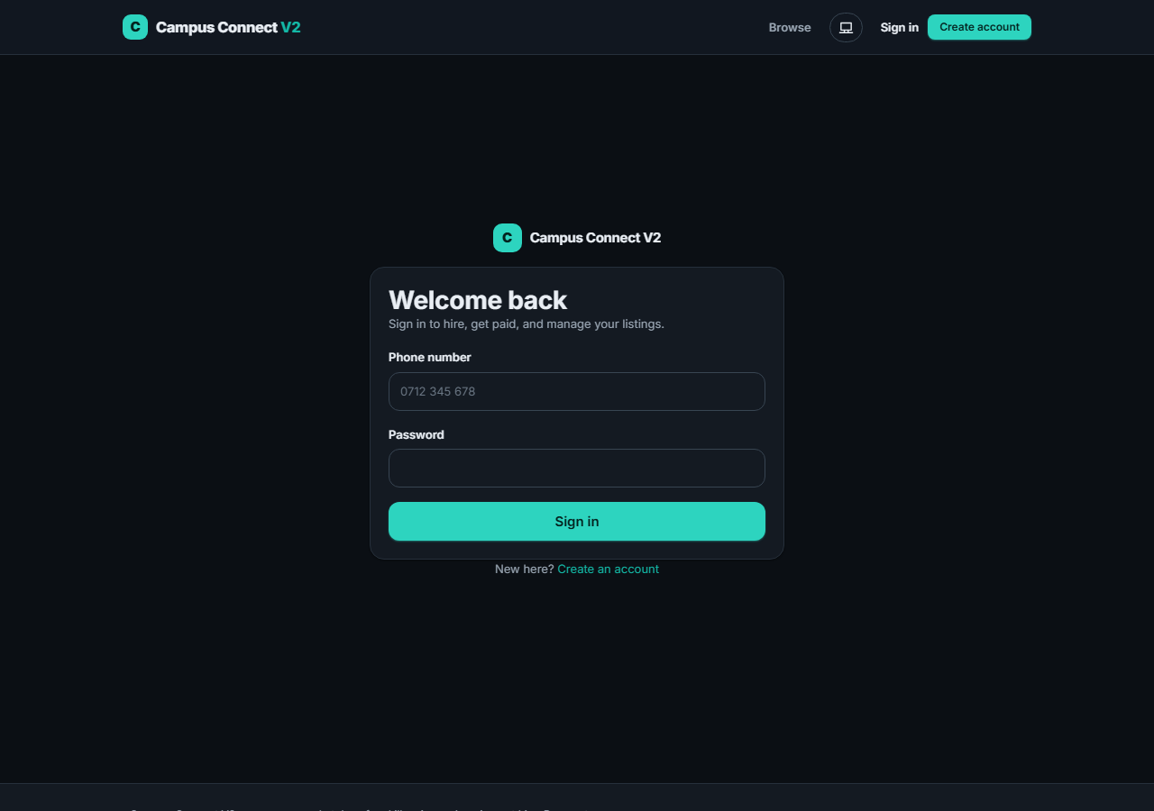
Figure 5.1 — Sign-in screen, part of the shared AuthShell used across Login, Register and OTP verification
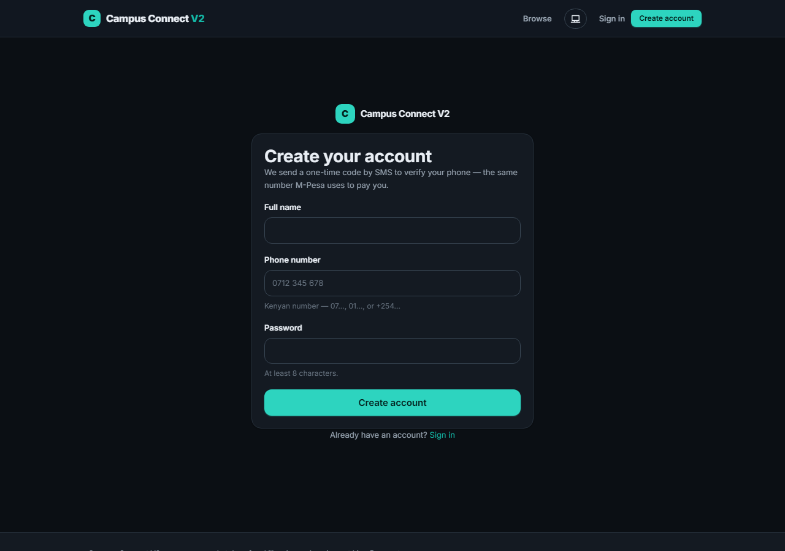
Figure 5.2 — Registration screen (SMS OTP phone verification follows this step)
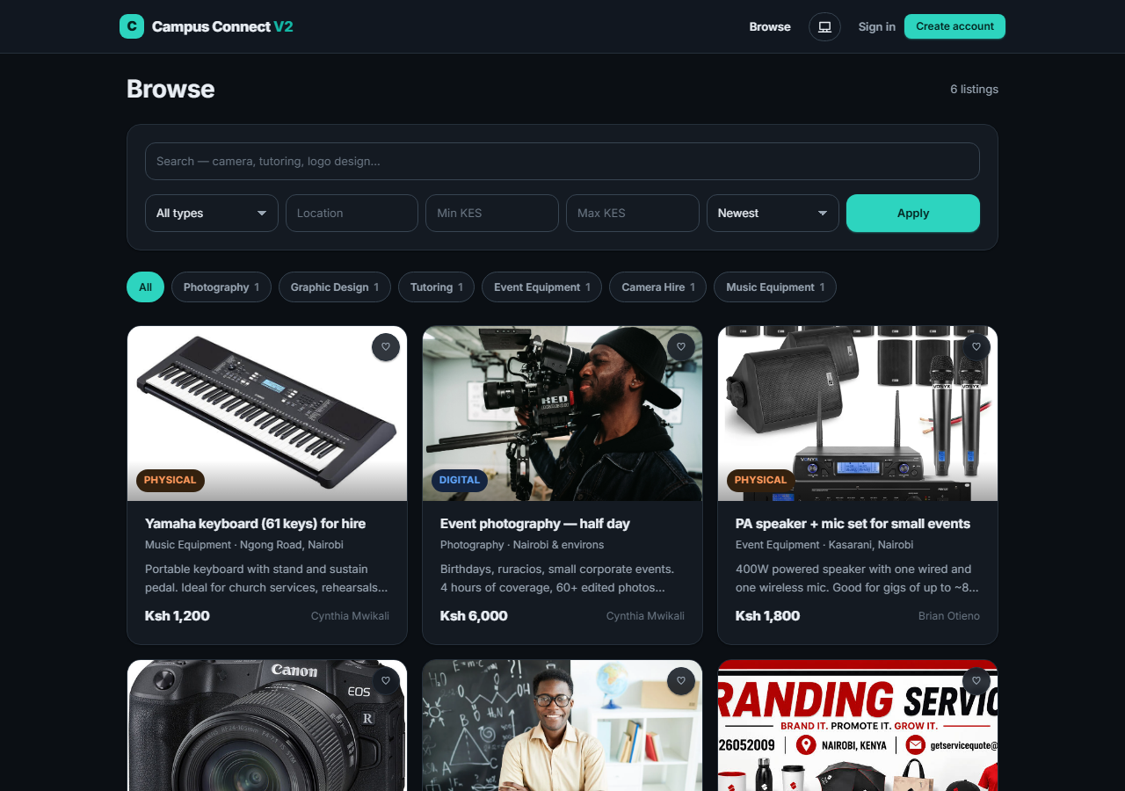
Figure 5.3 — Browse: category chips with live counts, search and price/location filters, image-forward listing cards
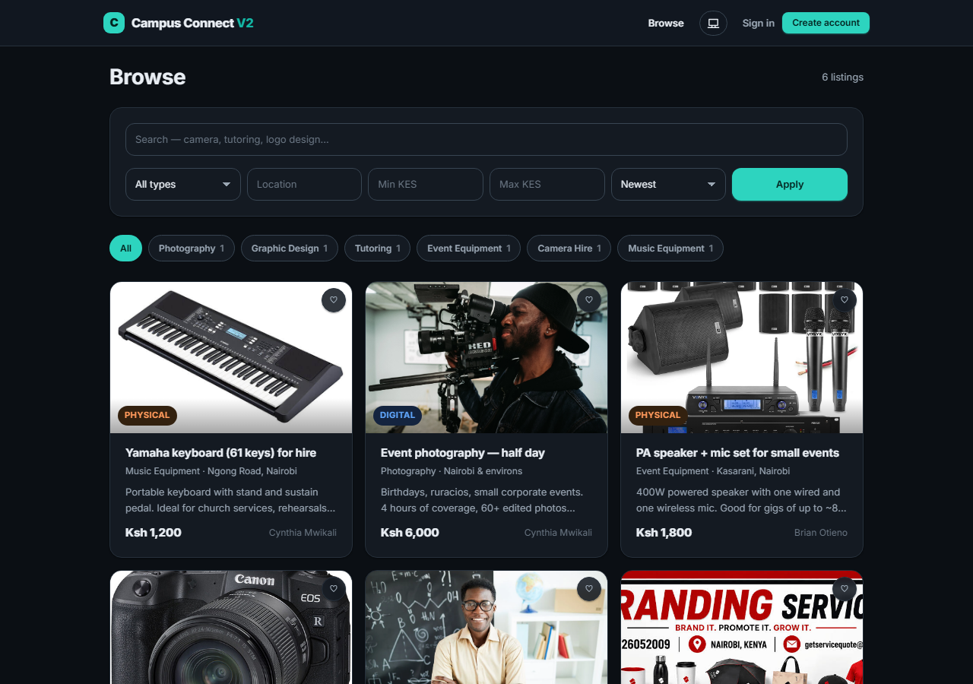
Figure 5.4 — The same Browse screen in the light theme, demonstrating the dual light/dark design-token system
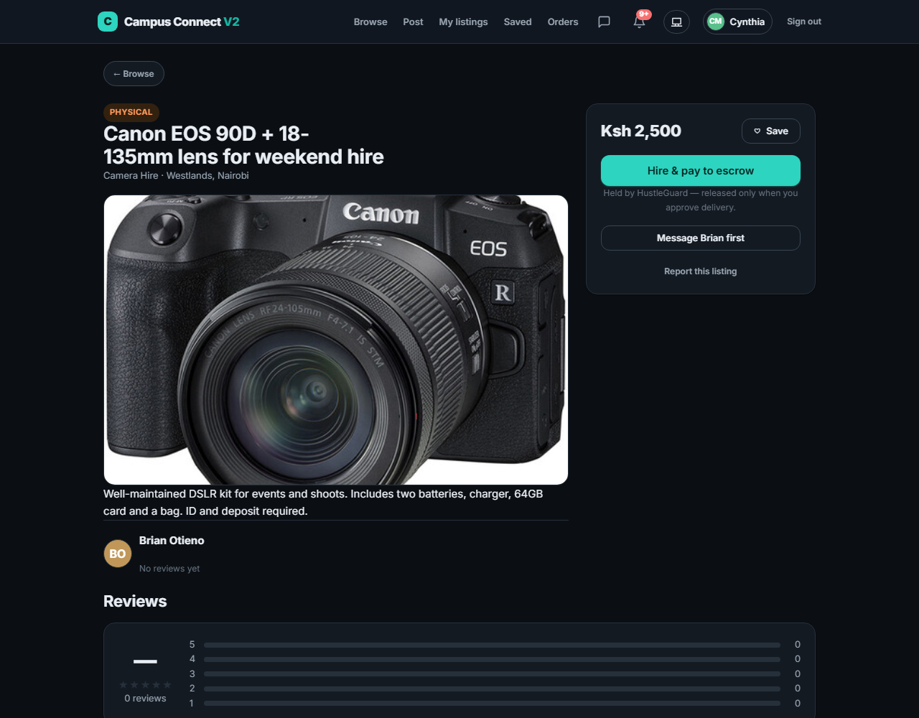
Figure 5.5 — Listing detail with the hire panel and fee breakdown, viewed while signed in as a client
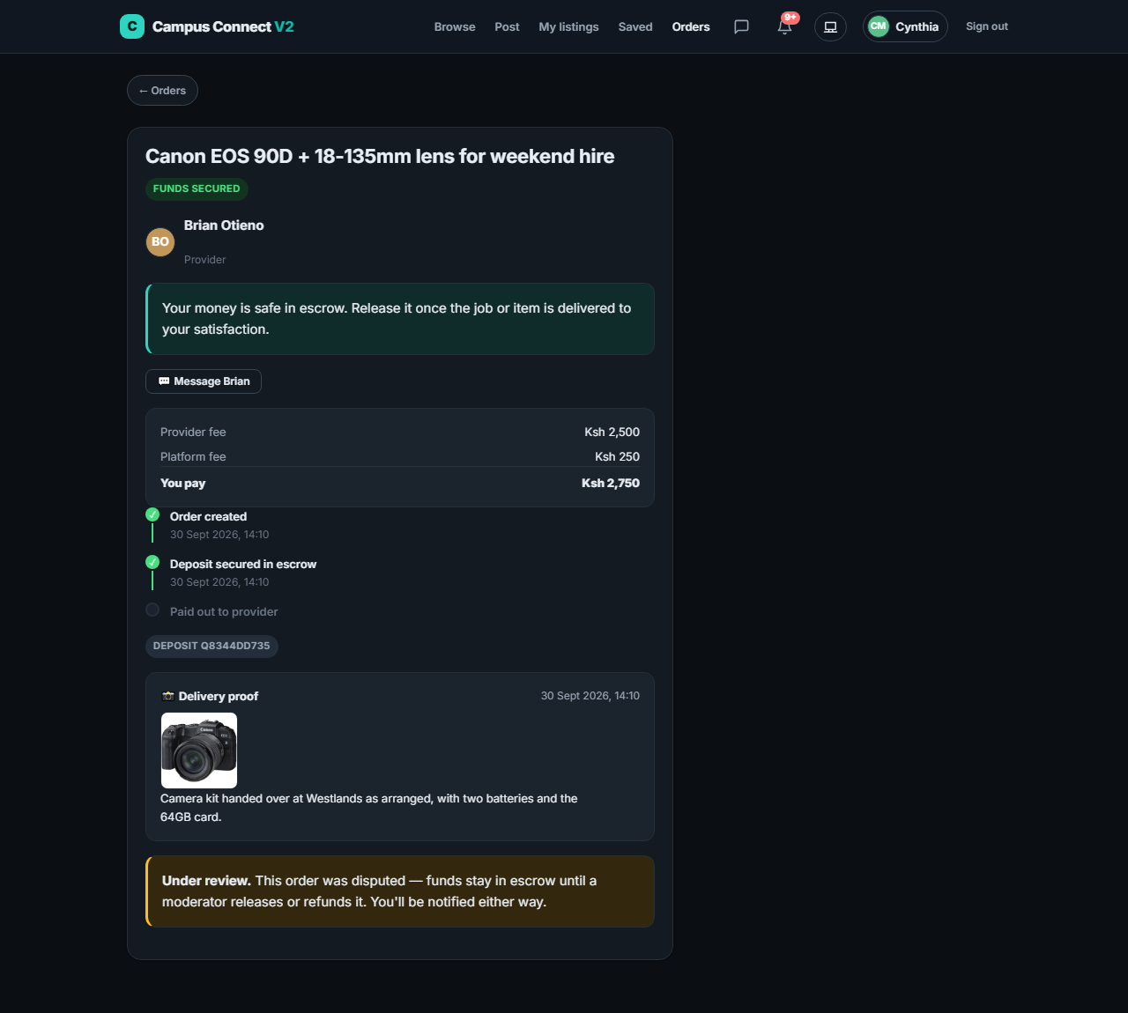
Figure 5.6 — Order detail showing the provider’s delivery-proof photo and note, with the order under moderator review after a client dispute
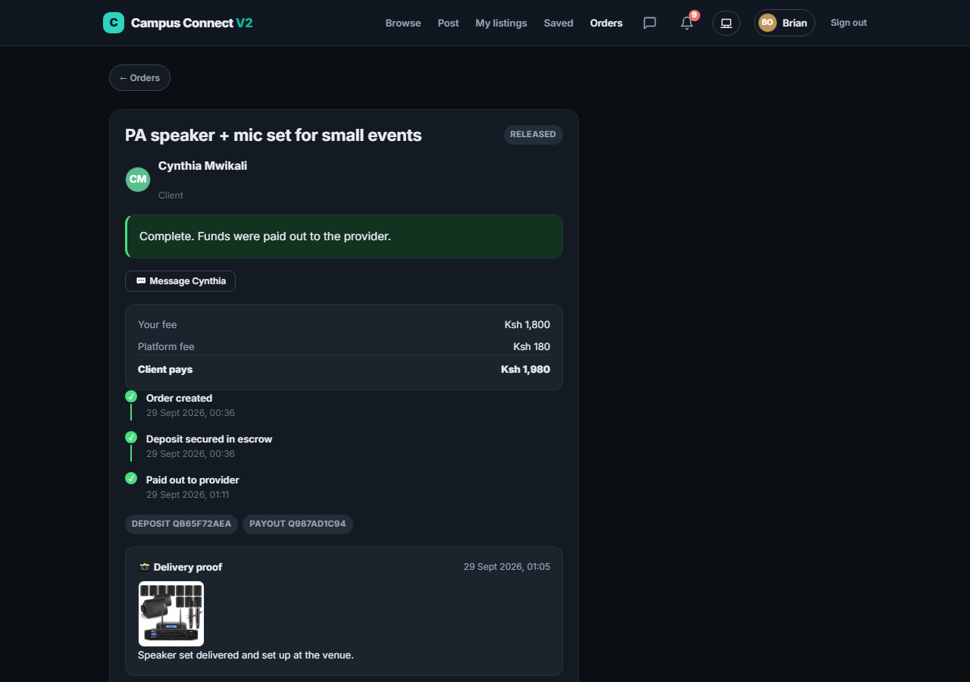
Figure 5.7 — Order detail showing a completed escrow flow (provider’s view) with the animated timeline and M-Pesa receipts
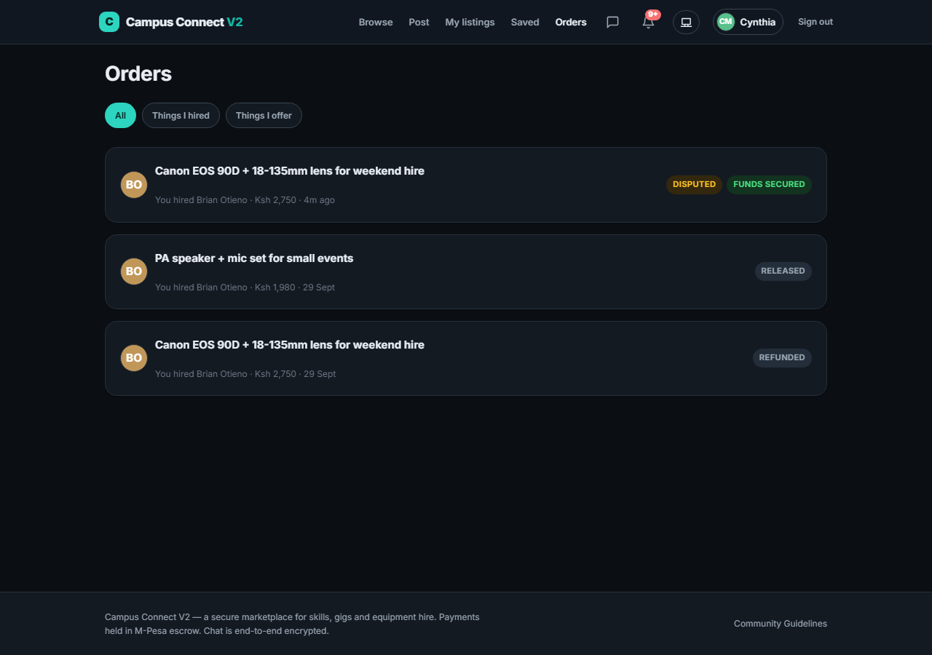
Figure 5.8 — Orders list with escrow-status and dispute badges
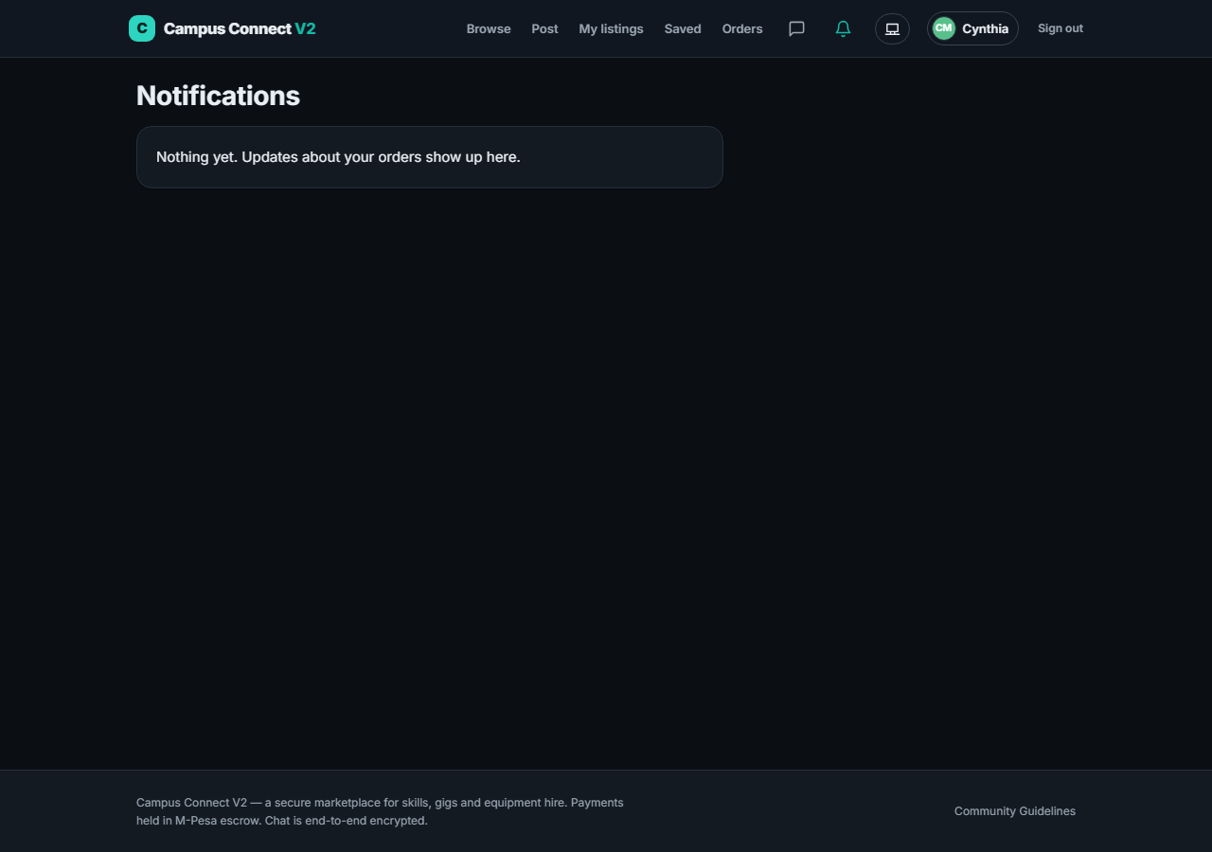
Figure 5.9 — Notifications feed, pushed live over Socket.IO with a 25-second poll fallback
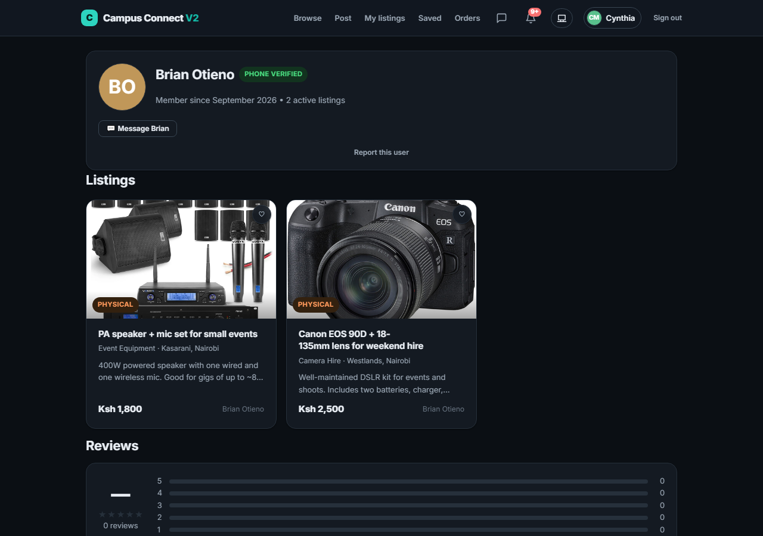
Figure 5.10 — A public provider profile: rating summary, social links and listings
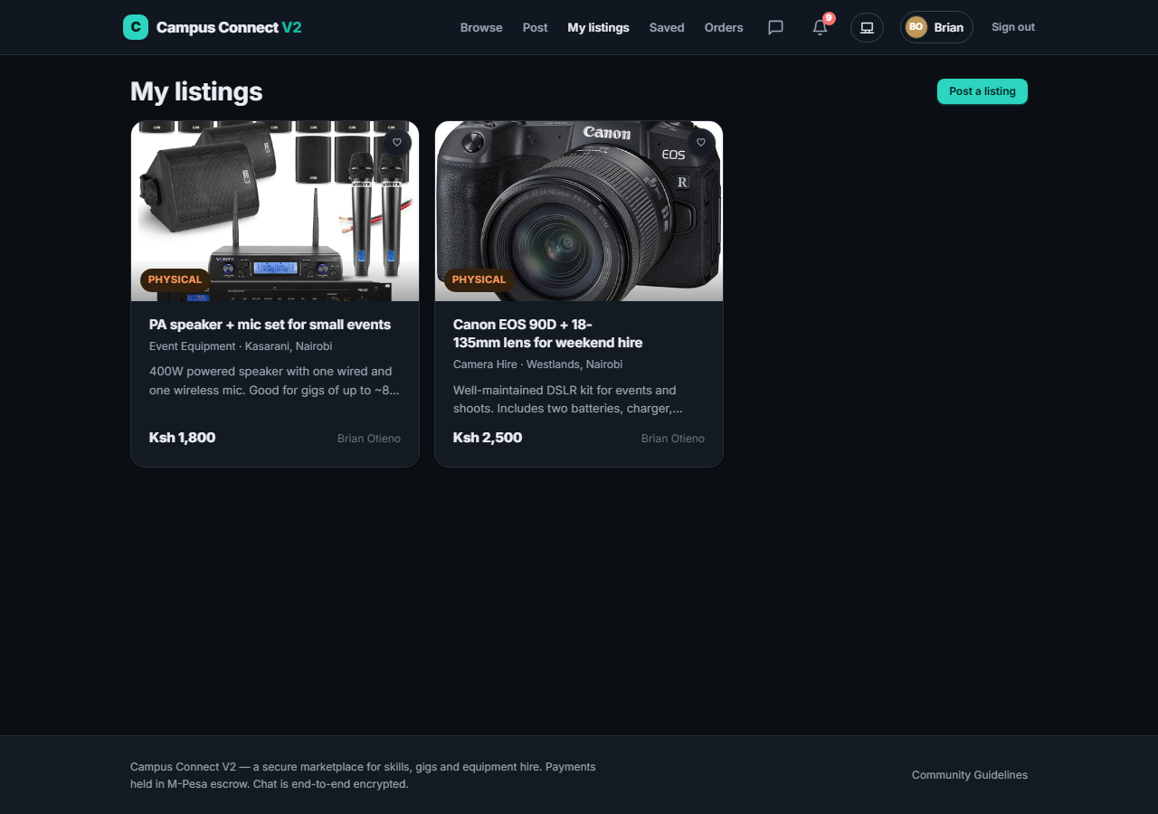
Figure 5.11 — "My listings" dashboard for a service provider
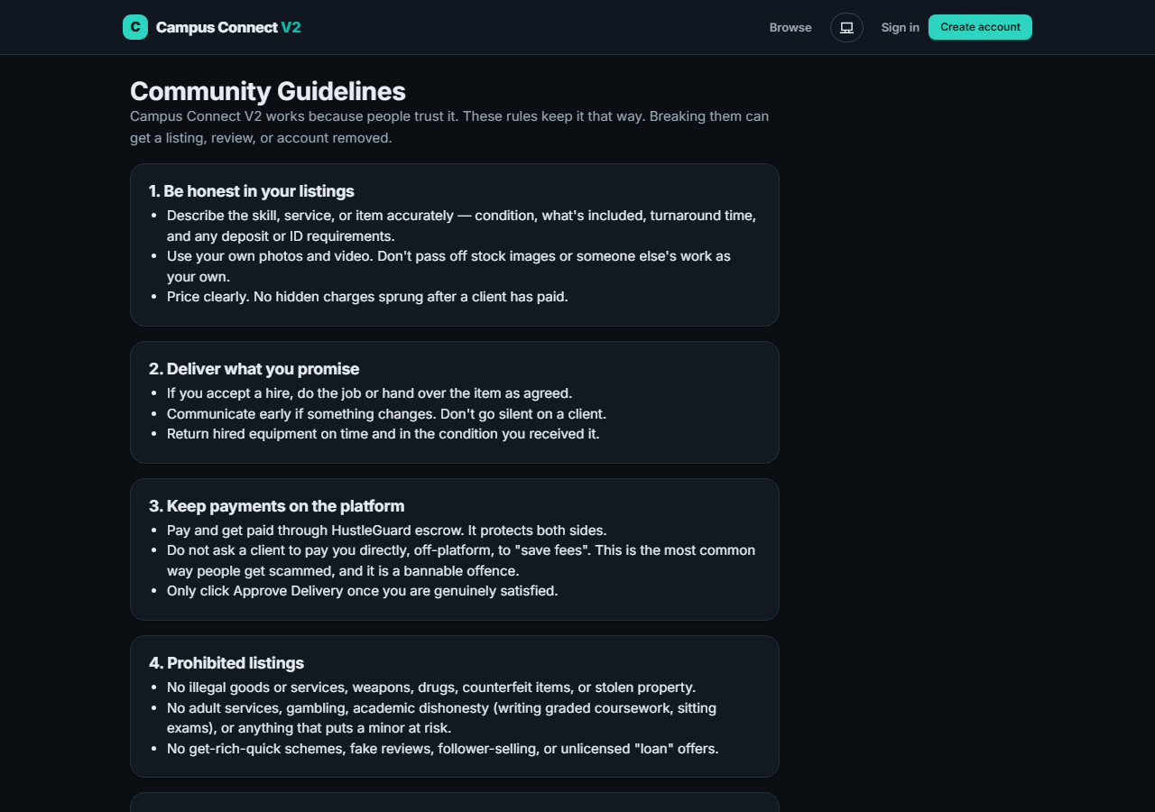
Figure 5.12 — Community Guidelines page, referenced from the Report dialog
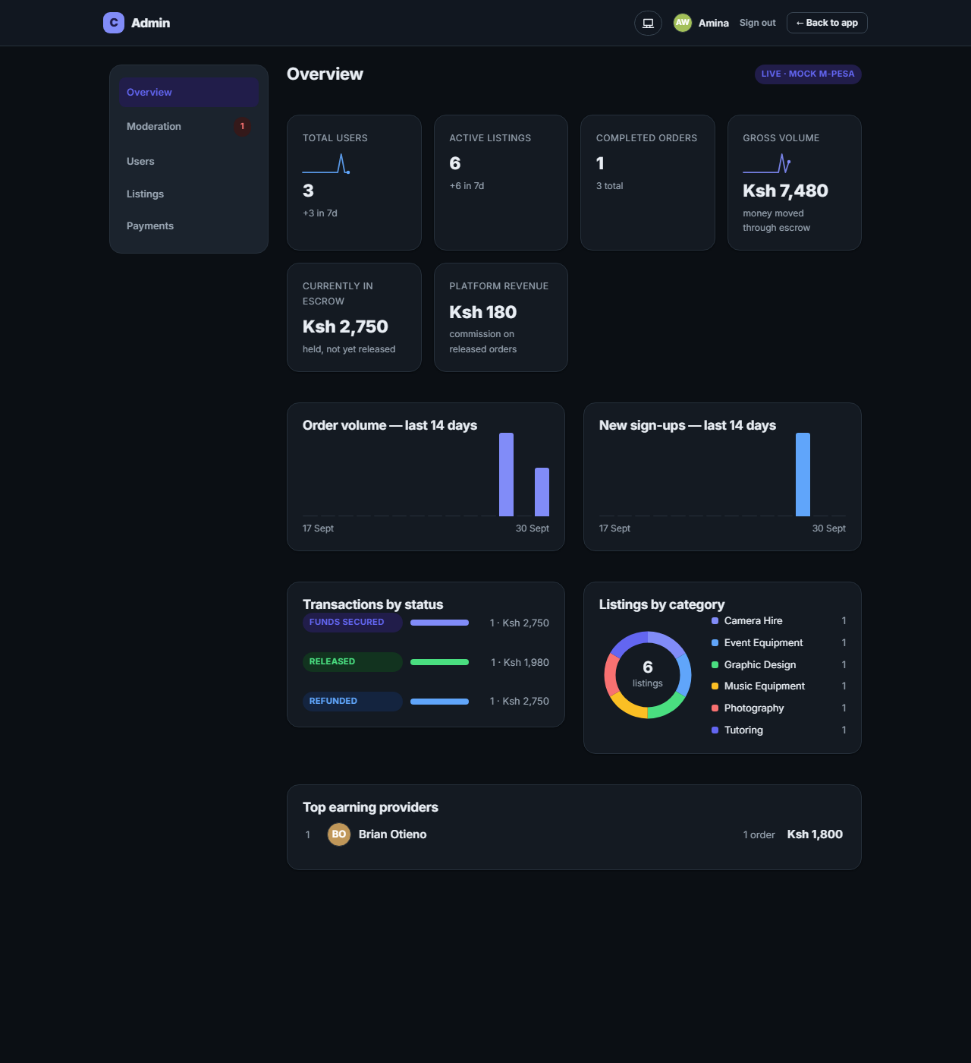
Figure 5.13 — Admin console Overview: KPI sparklines, a 14-day order-volume chart, and a donut chart of listings by category, in the console’s own indigo colour theme
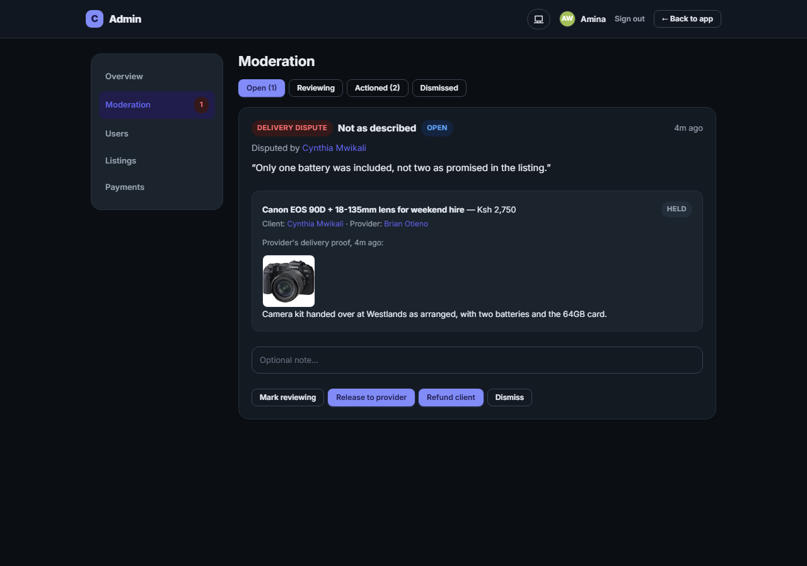
Figure 5.14 — Admin console Moderation: an open delivery dispute, showing the order, both parties, and the provider’s delivery photo, with Release-to-provider / Refund-client actions
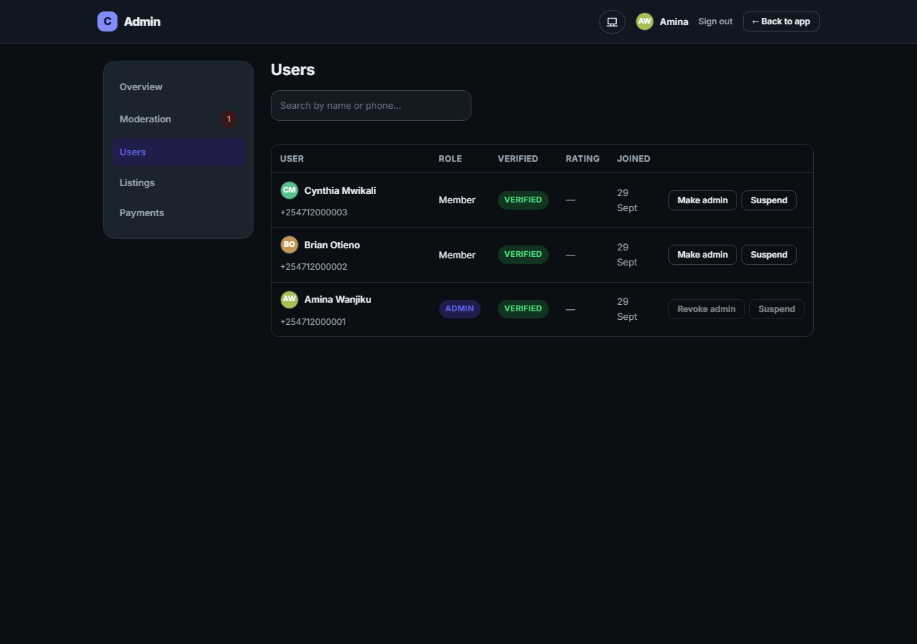
Figure 5.15 — Admin console Users: search, role and verification status, promote/suspend actions
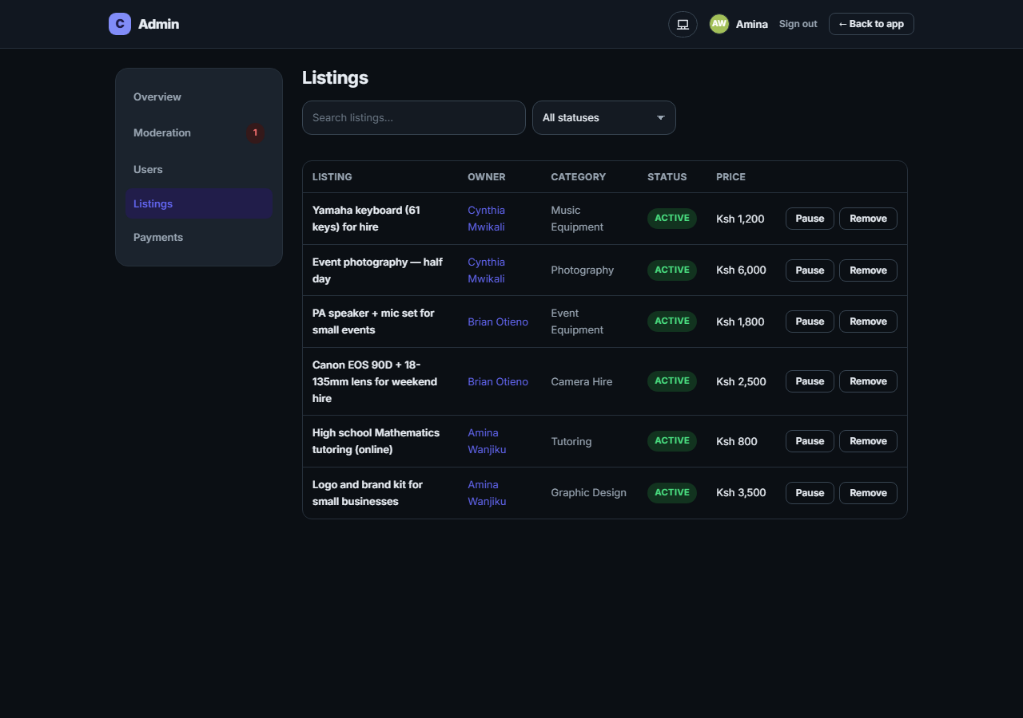
Figure 5.16 — Admin console Listings: search/filter by status, pause/reactivate/remove actions
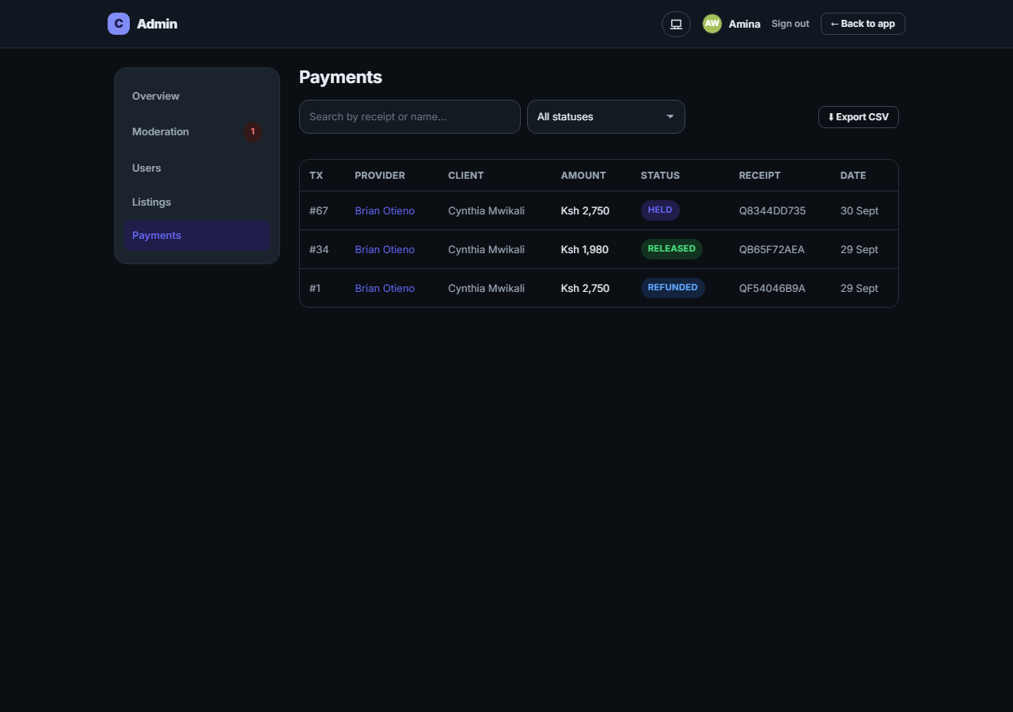
Figure 5.17 — Admin console Payments: the transaction ledger with M-Pesa receipts and CSV export, showing HELD, RELEASED and REFUNDED orders

5.3 Testing

5.3.1 Automated Testing
The backend is covered by an automated Vitest suite of 57 tests across 11 files, split into two projects: unit tests (pure functions, no I/O) and integration tests (full HTTP requests through the Express app via Supertest, run against an in-memory PostgreSQL instance provided by PGlite through a Prisma driver adapter, so the full suite runs without Docker or a network database and resets between tests). The suite runs automatically on every push via GitHub Actions.
File | Covers
tests/unit/phone.test.js | Kenyan phone number normalisation
tests/unit/money.test.js | Fee/platform-fee/total quote calculation
tests/unit/socials.test.js | Social-link normalisation per platform
tests/unit/storage.test.js | Media storage key generation
tests/unit/validation.test.js | Zod request-validation schemas
tests/unit/daraja.test.js | Daraja client request shaping (mock mode)
tests/integration/auth.test.js | Register → OTP verify → sign in; unverified-login guard; /users/me never leaks the password hash
tests/integration/listings.test.js | Listings CRUD, ownership guards, browse search/filters/facets, favourites
tests/integration/escrow.test.js | Fee quoting; the full hire → STK held → approve → B2C released happy path; failed STK → cancel; provider decline → refund; STK-callback idempotency
tests/integration/reviews.test.js | Review creation gated to a completed order; threaded replies and likes with role badges; rating rollup on create/delete
tests/integration/reports.test.js | Reporting (self-report/duplicate guards); the admin-only moderation queue; soft-deleting reported content and closing sibling reports; rating recompute after a review is removed
All 57 tests pass at the time of writing. The delivery-proof and dispute-resolution flow, added after this suite was written, has been verified end to end twice by direct exercise of the running system rather than by an automated test: once via a full API walk-through (hire → funds held → provider submits photo proof → client disputes → the dispute appears in the moderation queue with the photo → an administrator resolves it → the correct M-Pesa payout or refund fires and the report closes automatically), and once by driving the same flow through the actual browser UI. Extending the automated suite to cover this flow is recorded as a recommendation in Chapter 6.

5.3.2 Usability Testing (Objective 4)
A moderated, task-based usability-testing protocol was designed to satisfy the "test the platform with real users" half of Objective 4 (full protocol: docs/user-testing.md). It specifies 6–8 participants drawn from the same pool used in the preliminary investigation (§3.1.1), a mix of provider-minded and client-minded users, ten think-aloud tasks covering the full journey from registration to reporting a listing, a post-test System Usability Scale questionnaire, six trust-specific questions (e.g. "I understood that my money is only released when I approve delivery"), and a Kenya Data Protection Act-compliant consent script. Running this protocol with real participants and folding the findings back into the product falls outside the single-developer build window covered by this report and is carried forward as a Chapter 6 recommendation; the protocol itself, and the mock M-Pesa mode that lets a full escrow cycle complete in seconds during a session, are both ready to use.

CHAPTER 6: CONCLUSION AND RECOMMENDATIONS

6.1 Conclusion
This project set out to design, develop, and deploy Campus Connect V2, a secure web and mobile marketplace letting Kenyan Gen Z users list, discover, and hire digital skills, services, and equipment through M-Pesa escrow payments and end-to-end encrypted chat. All four specific objectives in section 1.6 were met.
Objective 1, a web interface for posting, browsing, and searching digital and physical listings, was delivered as an installable Progressive Web App with category browsing, live-count filter chips, price and location filtering, full-text search, favourites, and rich media (up to five photos and a short video per listing). Objective 2, the HustleGuard escrow system on the M-Pesa Daraja API, was delivered as a complete state machine (PENDING_PAYMENT → HELD → RELEASING → RELEASED, with PAYMENT_FAILED, REFUNDING/REFUNDED, and CANCELLED branches), idempotent against duplicate Safaricom callbacks, and extended beyond the original scope with DoorDash-style photo proof of delivery and administrator-resolved disputes. Objective 3, end-to-end encrypted messaging, was delivered using a client-side ECDH P-256 → HKDF-SHA256 → AES-GCM key exchange over a Socket.IO real-time layer, where the server never sees plaintext. Objective 4, testing and deployment behind a WAF and API gateway, was delivered as a 57-test automated suite (unit and integration, run in CI on every push), a usability-testing protocol ready to run with real participants, and a fully authored Docker/nginx/ModSecurity/Kong edge stack.
Beyond the original four objectives, the delivered system also includes a complete ratings-and-reviews system with threaded replies, likes, and role badges; public provider profiles with social links; a community-guidelines and content-reporting/moderation system; and a dedicated administrative console, visually and structurally separate from the marketplace application, covering platform analytics, user management (including enforced account suspension), listing oversight, and a payments ledger with CSV export. Chapter 5 demonstrates each of these capabilities working against a live database with real, non-fabricated data.
Taken together, the delivered system demonstrates that the trust gap identified in Chapter 1, the absence of a platform combining local mobile-money escrow, private encrypted communication, and delivery-confirmation with a real dispute-resolution path, can be closed for the Kenyan Gen Z gig and equipment-hire market with a single, purpose-built application.

6.2 Limitations
A small number of items remain open at the time of writing, and are stated here plainly rather than left implicit.
First, the platform has not yet been deployed to a live production host. The edge stack (nginx → WAF → Kong → API) is fully authored and its configuration has been validated, but it has not been run against a public domain with TLS, since that decision depends on a hosting choice outside the scope of a single-developer academic build.
Second, the M-Pesa integration runs in mock mode for all development and testing shown in this report; real Safaricom Daraja sandbox and production credentials (consumer key/secret, shortcodes, passkey, initiator credentials) have not yet been obtained and configured, so no real shilling has moved through the system. The Daraja client already supports mock, sandbox and production modes as a single configuration switch, so this is a credentials and go-live step rather than a code change.
Third, the usability-testing protocol designed for Objective 4 has not yet been run with real participants; the automated test suite and the developer’s own end-to-end verification stand in its place for this report.
Fourth, the delivery-proof and dispute-resolution flow, added late in development, is verified by direct exercise of the running system rather than by dedicated automated tests.
Fifth, the production database (Supabase, hosted in eu-west-1) has meaningful network latency from Kenya (measured at roughly 2–4 seconds per query); a local, near-zero-latency development mode was built to keep iteration fast, but this remains a real characteristic of the production path that any live deployment should account for, for example by evaluating a data-centre region closer to East Africa.

6.3 Recommendations
For anyone continuing this project, or for its own submission for grading, the following are recommended, roughly in priority order:
1. Deploy the authored edge stack to a real host with a domain and TLS certificate, and obtain real Daraja sandbox credentials to verify one genuine STK Push and B2C payout end to end before requesting production go-live.
2. Run the usability-testing protocol in docs/user-testing.md with 6–8 real participants, score the System Usability Scale and trust items, and feed the findings back into the product before a second round.
3. Extend the automated test suite to cover the delivery-proof submission, dispute-creation, and administrator resolution endpoints, so this flow has the same regression protection as the rest of the escrow system.
4. Evaluate a database region closer to Kenya (for example AWS af-south-1) for production, to remove the network-latency characteristic noted in the limitations.
5. Add bot/abuse protection (for example a CAPTCHA challenge such as Cloudflare Turnstile) to the public registration and login forms ahead of a public launch.
6. Run a full accessibility pass (colour contrast, keyboard navigation, screen-reader labelling) across the redesigned UI, particularly the newly added admin console.
7. Revisit the native mobile app named in the original proposal; the current Progressive Web App serves as the mobile surface for this submission, and a dedicated native build remains a natural next increment once the web platform is live and validated with real users.

REFERENCES
Divas College. (2026). How to start freelancing in Kenya with no experience: A step-by-step guide. Divas College Publications.
Fasola, O. O., Onwudebelu, U., Etta, A. E., & Ugadu, A. H. (2026). An escrow-based peer-to-peer online payment system for fraud reduction. Methods in Science and Technology Studies, 2(1), 116–130. https://doi.org/10.64539/msts.v2i1.2026.485
Genesis Analytics, & Mercy Corps Youth Impact Labs Kenya. (2023). Towards a digital workforce: Understanding the building blocks of Kenya's gig economy.
HIIG. (2023). Regulation of digital platforms for a socially-just gig economy in Kenya. Alexander von Humboldt Institute for Internet and Society.
Intel Market Research. (2025). End-to-end encrypted communication market growth analysis, dynamics, key players and innovations.
Kingiri, A. N., & Fu, X. (2020). Understanding the diffusion and adoption of digital finance innovation in emerging economies: M-Pesa money mobile transfer service in Kenya. Innovation and Development, 10(1), 67–87. https://doi.org/10.1080/2157930X.2019.1570695
Kipkemboi, J., & Wanjiru, L. (2024). Trust deficits in peer-to-peer e-commerce: The case for escrow systems in Kenya. International Journal of Information Security, 9(1), 112–128.
McTaba Labs. (2026). The gig economy in Kenya in 2026: Numbers, platforms and truths. McTaba Labs Industry Reports.
Ouma, S., & Mutuku, M. (2023). Mobile money and the gig economy in East Africa: Opportunities and challenges. Journal of African Technology Studies, 14(2), 45–60.
Pavlou, P. A., & Gefen, D. (2004). Building effective online marketplaces with institution-based trust. Information Systems Research, 15(1), 37–59. https://doi.org/10.1287/isre.1040.0015
Republic of Kenya. (2019). Data Protection Act, No. 24 of 2019. National Council for Law Reporting.
Signal Foundation. (2025). Signal Protocol and Post-Quantum Ratchets. https://signal.org/blog/spqr/
The Star. (2026, March 25). Kenya gig economy grows as youth turn to digital jobs. https://www.the-star.co.ke/news/2026-03-25-kenya-gig-economy-grows-as-youth-turn-to-digital-jobs

