**Complete with propositions  
  
A)** The sink is _______ the cooker and the fridge.  
**B)** The bath is _______ the toilet.  
**C)** The night table is _______ the bed.  
**D)** There is a picture _______ the wall in the living room.  
**E)** The computer is _______ the table.  
**F)** The bathroom is _______ the bedroom.

  **Página 29, Lesson 2**Deberás trabajar en esta página:  
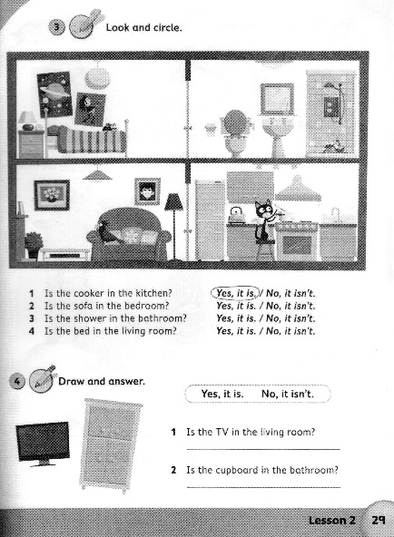  
  
**G)** The frog is _______ the shower.  
**H)** The cat is cooking _______ the kitchen.  
**I)** There is a cupboard _______ the fridge.  
**J)** There is a picture _______ the sofa _______ the wall.