Deberás trabajar en esta página del cuadernillo:  
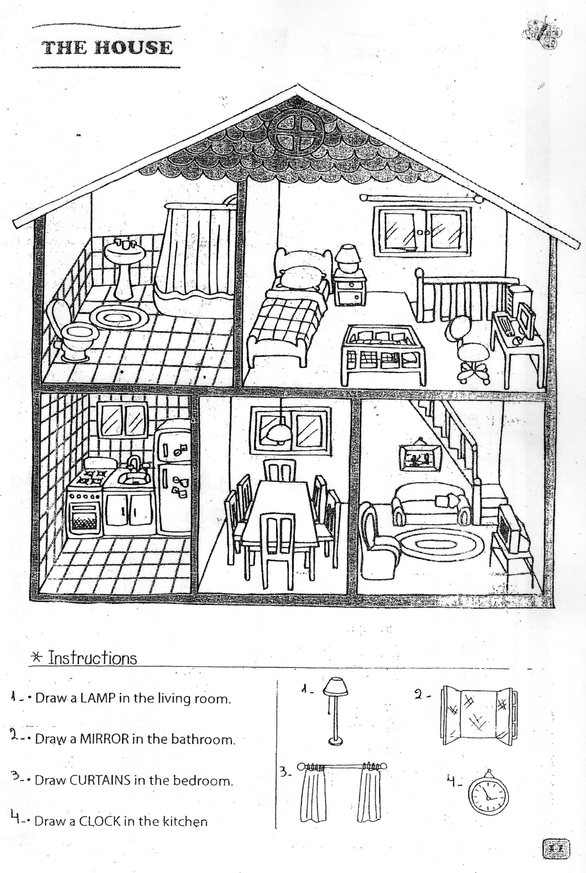  
**Draw:**  
A plant in the living room.  
A boat in the bathroom.  
A cat on the roof.  
Flowers in the garden.  
  
**Paint:**  
Brown chairs.  
Blue sofa and armchair.  
Yellow fridge.  
Purple curtains.  
Black table.  
Red and blue mat.  
Pink and green cover.