**DAYANANDA SAGAR COLLEGE OF ENGINEERING**



(An Autonomous Institute affiliated to VTU, Belagavi Approved by AICTE & ISO 9001:2008 Certified)

Accredited by National Assessment & Accreditation Council (NAAC) with ‘A’ grade,

ShavigeMalleshwara Hills, Kumaraswamy Layout, Bangalore-560078.

**Mini Project Report**

**on**

**“REAL TIME NSE STOCKS PREDICTIONS & ANALYSIS DASHBOARD IN PYTHON”**

*Submitted by*

## Mrinal Walia

**[1DS17CS068]**

**[Sixth Semester B.E (CSE)]**

Under the guidance of

**Prof. Poornima K S Dept. of CSE DSCE,**

**Dept. of CSE**

**Bangalore**

**2019-2020**

**Department of Computer Science & Engineering**

**DAYANANDA SAGAR COLLEGE OF ENGINEERING**

**BANGALORE – 560078**

|  |
| --- |
| **VISVESVARAYA TECHNOLOGICALUNIVERSITY**  **DAYANANDA SAGAR COLLEGE OF ENGINEERING**  **ShavigeMalleshwara Hills, Kumaraswamy Layout, Bangalore - 560078**  **Department of Computer Science & Engineering**    **CERTIFICATE**  This is to certify that the project entitled “**REAL TIME NSE STOCKS PREDICTIONS & ANALYSIS DASHBOARD IN PYTHON”** is a bonafide work carried out by “**Mrinal Walia [1DS17CS068**]” in partial fulfilment of 6th semester **Bachelor of Engineering** in **Computer Science and Engineering** under **Visvesvaraya Technological University, Belgaum** during the year 2019-20.  [Internal Guide Name] [Senior Faculty Name] Dr.RameshBabu.D.R  **Internal Guide Prof. Poornima K S**  **Vice Principal & Head**  Designation  Department CSE, DSCE Department CSE, DSCE Department CSE, DSCE  **Bangalore Bangalore.**        Signature : ....................... Signature : ....................... Signature :.......................  **Name of the Examiners: Signature with date:**  **1. ........................................... ....................................**  **2. ........................................... ...................................** |

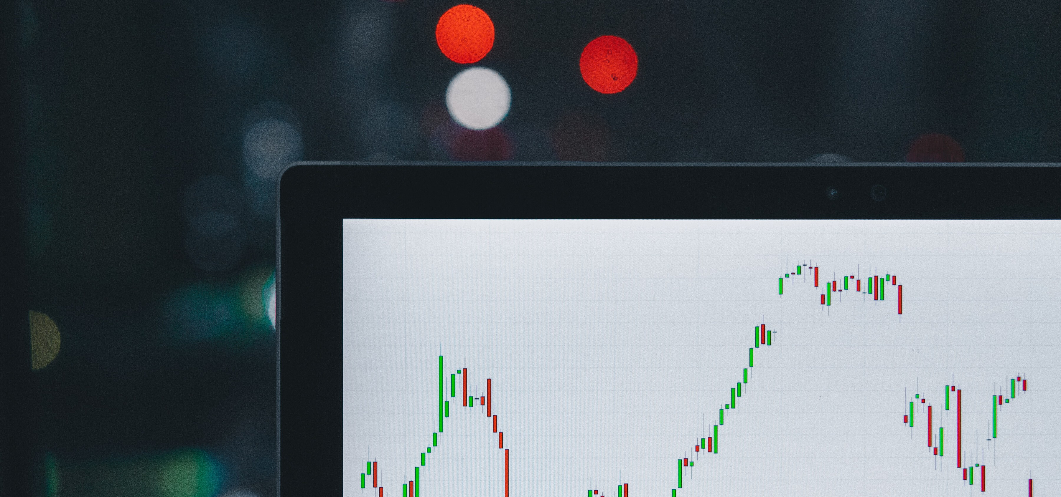

R E A L - T I M EN S ES T O C K S P R E D I C T I O N S&A N A L Y S I S

D A S H B O A R DI NP Y T H O N

**Mrinal Walia 1Ds17CS068**

***What is NSE?***

*The National Stock market of India is the biggest stock market of India which is found* in Mumbai, which was first established in Nov 1992 and it was the very first fully automated electronic exchange of India with a nationwide presence.

# In this project, I have implemented the following:

*how to fetch data of any stock(NSE) in realtime*

*how you can perform basis visualizations to analyze the stock price* using machine learning algorithms to predict the future stock price and how to make an interactive web-app using Streamlit framework available in python

# Machine Learning algorithm used is LSTM:

*Long Short Term Memory, usually just called “LSTMs”- are a special* kind of Recurrent neural network which is capable of learning long- term dependencies i.e remembering information for long periods of time.

**Note:** *Predicting future prices is very difficult, even for machine learning models. Especially when it comes to the Stock Market,the only input your algorithm take is the stock price, there is a whole lot of information you are going to lose about the underlying factor that will affect the price. Just remember your main motive of this project is to learn new techniques and tools.*

**Github:**https://github.com/abhiwalia15/AI-for-Finance-Stocks-real-time-analysis- **Medium:**https://medium.com/@waliamrinal15/real-time-nse-stocks-predictions-analysis- dashboard-in-python-f340461101c6

Minor Project- Report Aug-2019-2020

Course Faculty: Poornima K S Course Name & code: Machine Learning, 17CS6DCMLG

Semester:6th Date:20th may, 2020

|  |  |  |  |  |
| --- | --- | --- | --- | --- |
| TITLE OF THE PROJECT | Real-Time NSE Stocks Predictions & Analysis Dashboard in Python | | | |
|  |  | | | |
| STUDENT NAME | Mrinal Walia |  |  |  |
| USN | 1DS17CS068 |  |  |  |
| INDIVIDUAL CONTRIBUTION | Implementation of the complete project. |  |  |  |
| GUIDE | Poornima K S Dr. Md Tajuddin | | | |
|  |  | | | |
| PROJECT ABSTRACT : | **In this project, I have implemented the following:**   * how to fetch data of any stock(NSE) in realtime * how you can perform basis visualizations to analyze the stock price * using machine learning algorithms to predict the future stock price * and how to make an interactive web-app using Streamlit framework available in python | | | |
| PLATFORM USED (H/W & S/W TOOLS  USED | GOOGLE COLAB, JUPYTER NOTEBOOK, KERAS, TENSORFLOW, STREAMLIT, PYTHON, PYTHON DATA VISUALIZATION LIBRARIES | | | |
|  |  | | | |
| INTRODUCTION | **What is NSE?**  The National Stock market of India is the biggest stock market of India which is found in Mumbai, which was first established in Nov 1992 and it was the very first fully automated electronic exchange of India with a nationwide presence.  **Note:** Predicting future prices is very difficult, even for machine learning models. Especially when it comes to the  Stock Market,the only input your algorithm take is the stock price, there is a whole lot of information you are going to | | | |

|  |  |
| --- | --- |
|  | lose about the underlying factor that will affect the price. Just remember your main motive of this project is to learn  new techniques and tools. |
| LIST OF PAPERS/URLS REFERRED | **GITHUB:**HTTPS://GITHUB.COM/ABHIWALIA15/AI-FOR-FINANCE-STOCKS-REAL-TIME- ANALYSIS-  **MEDIUM:**HTTPS://MEDIUM.COM/@WALIAMRINAL15/REAL-TIME-NSE-STOCKS- PREDICTIONS-ANALYSIS-  DASHBOARD-IN-PYTHON-F340461101C6 |
|  |  |
| DESIGN  {SYSTEM DESIGN DIAGRAM} | **Machine Learning algorithm used is LSTM:**  Long Short Term Memory, usually just called “LSTMs”- are a special kind of Recurrent neural network which is capable of learning long- term dependencies i.e remembering information for long periods of time.  ***How can we use LSTM to predict the Stock Prices in the future?***  LSTMs are very powerful in sequence prediction problems because they’re ready to store past information. In our case the previous price of a stock is crucial in predicting its future price so this part is very important to understand.  ***In this project, we will use the last 30 days’ stocks Close***  ***price to predict the close price for the next day.*** |
| PROJECT SOURCE CODE  LINK (GITHUB/ GOOGLE DRIVE) | **GITHUB:**HTTPS://GITHUB.COM/ABHIWALIA15/AI-FOR-FINANCE-STOCKS-REAL-TIME- ANALYSIS- |
|  |  |
| CONCLUSION /FUTURE ENHANCEMENT | *THERE ARE MANY EXTERNAL FACTORS TO CONSIDER TO UNDERSTAND WHETHER THE PRICE OF A STOCK WILL GO UP OR WILL FALL IN THE FUTURE. WE CAN MAKE OUR MODEL*  *UNDERSTAND THESE EXTERNAL FACTOS TO PREDICT.* |
|  |  |

|  |  |
| --- | --- |
| UI SCREENSHOTS OF SAMPLE RESULTS |  |

|  |  |
| --- | --- |
|  |  |
| REFERENCES | **References:**   * [*https://medium.com/@randerson112358/stock-price-*](https://medium.com/@randerson112358/stock-price-prediction-using-python-machine-learning-e82a039ac2bb) *prediction-using-python-machine-learning-e82a039ac2bb* * [*https://docs.streamlit.io/*](https://docs.streamlit.io/) * [*https://nsepy.readthedocs.io/en/latest/*](https://nsepy.readthedocs.io/en/latest/) * [*https://colab.research.google.com/*](https://colab.research.google.com/) |