**Introduction**

LSTM networks were designed specifically to overcome the long-term dependency problem faced by recurrent neural networks RNNs (due to the vanishing gradient problem). LSTMs have feedback connections which make them different to more traditional feedforward neural networks. This property enables LSTMs to process entire sequences of data (e.g. time series) without treating each point in the sequence independently, but rather, retaining useful information about previous data in the sequence to help with the processing of new data points. As a result, LSTMs are particularly good at processing sequences of data such as text, speech and general time-series. At a basic level, the output of an LSTM at a particular point in time is dependant on three things including; the current long-term memory of the network — known as the cell state; the output at the previous point in time — known as the previous hidden state and the input data at the current time step. LSTMs use a series of ‘gates’ which control how the information in a sequence of data comes into, is stored in and leaves the network. There are three gates in a typical LSTM; forget gate, input gate and output gate. These gates can be thought of as filters and are each their own neural network. The forget gate decides which pieces of the long-term memory should now be forgotten (have less weight) given the previous hidden state and the new data point in the sequence. This project is an attempt at forecasting the stock prices for Apple (AAPL), Microsoft (MSFT) and Meta (FB) with the use of the Long Short-Term Memory (LSTM) neural network. The data was extracted from Yahoo finance for daily, weekly and monthly intervals’. Apple and Microsoft stock prices covered the period from 01-01-1999 to 12-08-2022 while the Meta data available covers from 19-05-2012 to 12-08-2022. The forecasting was done with use of the closing stock prices for the respective time frequency. The need for stock price forecasting lies on the need by investors to beat the market and earn a living from market mispricings/fluctuations. This task has proven to be difficult given that stock prices are knownfollow a random walk distribution, therefore, predicting the future behavior of the prices is almost impossible, especially with traditional methods.

**Literature Review**

Recently, the combination of statistics and learning models have polished several machine learning algorithms, such as acritical neural networks, gradient boosted regression trees, support vector machines and, random forecast. These algorithms can reveal complex patterns characterized by non-linearity as well as some relations that are difficult to detect with linear algorithms. A large number of studies are currently active on the subject of machine learning methods used in finance such as tree-based models for predicting portfolio returns (Zimmermann, 2016); others used deep learning in the production of future values of financial assets (Estrada, 2015). Others have also worked on forecasting returns using the ADaBoost algorithm (Luo, 2012). Recent studies also proceed to forecast stock returns using unique decision-making models for trading investments in the stock market using the support vector machine (SVM) method, and the mean variance (MV) method for portfolio selection (Duarte, 2018). Another paper conversed deep learning models for smart indexing (Witte, 2017). Also, some study has covered a large number of trends and Applications of Machine Learning in Quantitative Finance (O'Brien, 2019), the literature review covered by this paper consist of return forecasting portfolio construction, ethics, fraud detection, decision making, language processing and sentiment analysis. These models don't depend one long term memory (passed sequences of data), in this regard a class of machine learning algorithms based on Recurrent Neural Network prove to be very useful in financial market price prediction and forecasting. More studies also made a comparison of the accuracy of autoregressive integrated moving average ARIMA and LSTM, as illustrative techniques when forecasting time series data. These techniques were executed on a set of financial data and the results showed that LSTM was far more superior to ARIMA (Namin, 2018). Our project aims at using ML algorithm based on LSTM RNN to forecast the closing stock prices for Apple, Microsoft and Meta. The main objective is to obtain the most accurate trained LSTM architecture to predict stock prices for these assets.

**Methodology and Data**

The data, Apple (AAPL), Microsoft (MSFT) and Meta (FB), was extracted from Yahoo finance at daily, weekly and monthly intervals. Apple and Microsoft stock prices covered the period from 01-01-1999 to 12-08-2022 while the Meta data available covers from 19-05-2012 to 12-08-2022. The forecasting was done with use of the closing stock prices for the respective time frequency dataset. For training we use mean squared error to optimize our model. We used different Epochs for training data (25 epochs and batch size of 5 for AAPL and 1 epoch and batch size for MSFT and META) to obtain more desirable RMSE values. We built an LSTM model and 80% of the data was used for training and the other 20% of data for testing/validation.

**Results**

i) RMSE values for the datasets

|  | AAPL_daily | MSFT_daily | META_daily | AAPL_week | MSFT_week | META_week | AAPL_month | MSFT_month | META_month |
| --- | --- | --- | --- | --- | --- | --- | --- | --- | --- |
| RMSE | 140.70 | 53.85 | 27.72 | 139.41 | 51.19 | 41.52 | 120.84 | 39.21 | 71.85 |

i) Daily Predictions

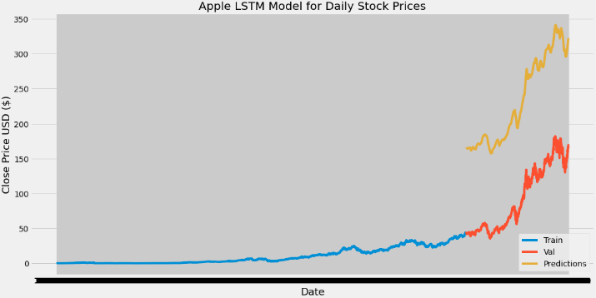

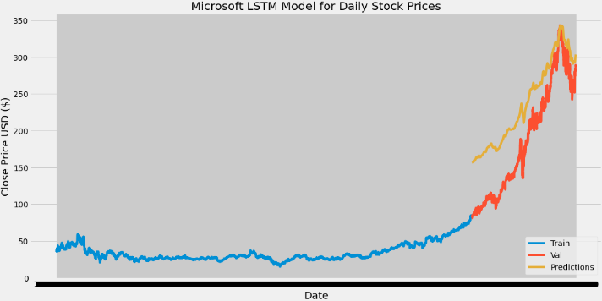

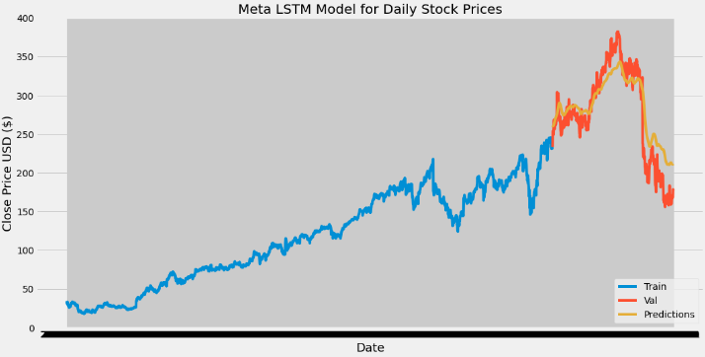

ii) Weekly Predictions

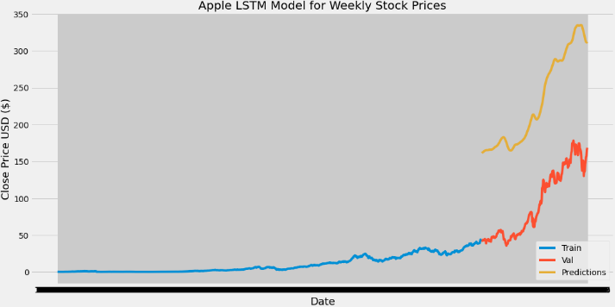

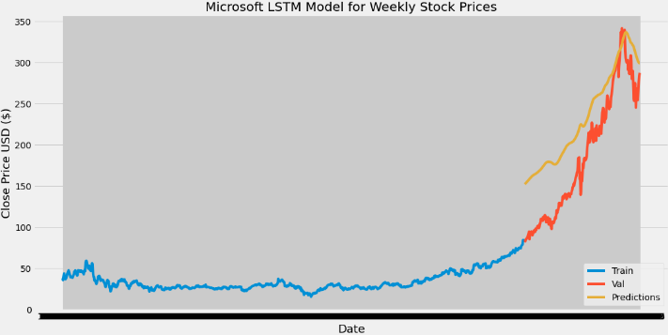

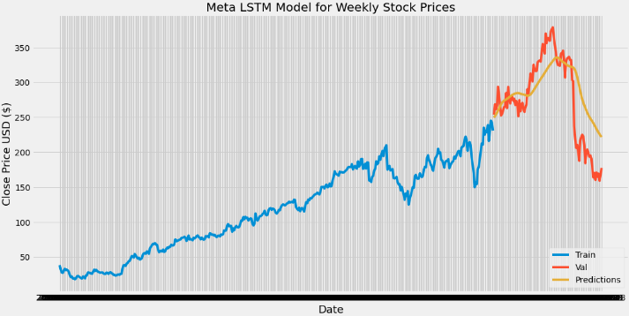

iii) Monthly Predictions

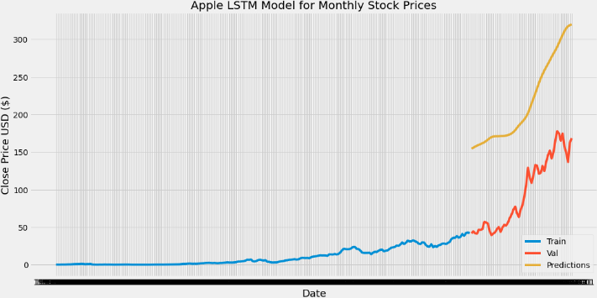

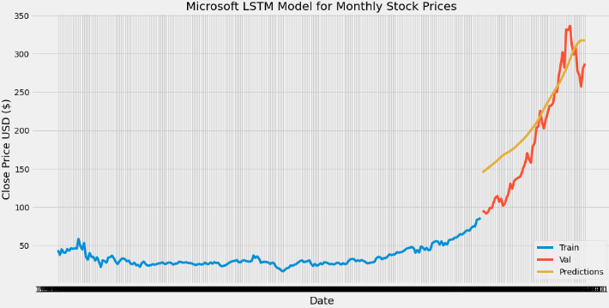

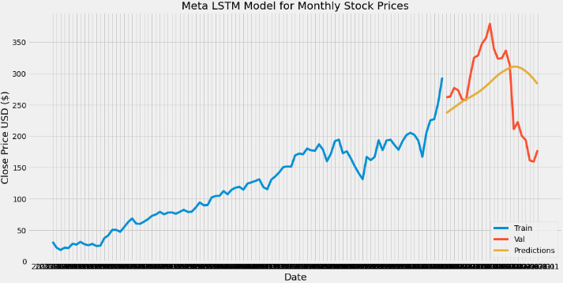

**Discussion & Conclusion**

This project proposes RNN based on LSTM built to forecast future values for both MSFT and META assets at weekly interval, the result from our model shows some promising results as seen from the RMSE values and the graphical representation. The testing result confirm that our model is capable of tracing the evolution of opening prices for both assets. For our future work, we could try more range of hyperparameter tuning to get to the global minima of the loss function.

**References**

[1] Batres-Estrada, B. (2015). Deep learning for multivariate financial time series.

[2] Emerson, S., Kennedy, R., O'Shea, L., & O'Brien, J. (2019, May). Trends and Applications of Machine Learning in Quantitative Finance. In 8th International Conference on Economics and Finance Research (ICEFR 2019).

[3] Heaton, J. B., Polson, N. G., & Witte, J. H. (2017). Deep learning for finance: deep portfolios. Applied Stochastic Models in Business and Industry, 33(1), 3-12.

[4] Moritz, B., & Zimmermann, T. (2016). Tree-based conditional portfolio sorts: The relation between past and future stock returns. Available at SSRN 2740751.

[5] Olah, C. (2015). Understanding lstm networks–colah’s blog. Colah. github. io.

[6] Paiva, F. D., Cardoso, R. T. N., Hanaoka, G. P., & Duarte, W. M. (2018). Decision-Making for Financial Trading: A Fusion Approach of Machine Learning and Portfolio Selection. Expert Systems with Applications.

[7] Patterson J., 2017. Deep Learning: A Practitioner’s Approach, O’Reilly Media.

[8] Siami-Namini, S., & Namin, A. S. (2018). Forecasting economics and financial time series: Arima vs. lstm. arXiv preprint arXiv:1803.06386.

[9] Takeuchi, L., & Lee, Y. Y. A. (2013). Applying deep learning to enhance momentum trading strategies in stocks. In Technical Report. Stanford University.

[10] Wang, S., and Y. Luo. (2012). “Signal Processing: The Rise of the Machines.” Deutsche Bank Quantitative Strategy (5 June)