ECE 425

Microprocessor Systems

Final Project

Maze game

Randy Ortiz

Instructor: Aaron Nanas

Fall 2024

**Objective:**

The objective of this project is to deepen my understanding of game development by creating a functional game that incorporates various core concepts. My main focus is to design the game with a dynamic maze generator that introduces randomization in the maze structure, making each gameplay experience unique through diverse maze configurations.

**Background and Methodology:**

The embedded systems concepts will be applied to my project will be UART. My overall plan to accomplish my objective is to learn UART programming to get the microcontroller to work with my computer to start making this maze game. I will also look for make patterns that work for randomization to use. The algorithms that I will be using code to match with player current strategy and make sure when he hits a wall it is game over. It also will include coordinates of the player up to date constantly. I will using the UART to display the game on the computer which will build a option menu and then from there it will build the maze and allow the game to start.

**Block Diagram:**

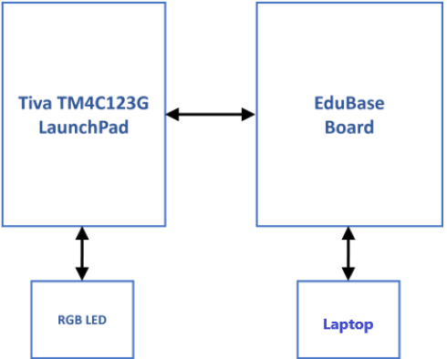

**Pinout Plan:**

|  |  |  |
| --- | --- | --- |
| **Function** | **Pin Name/Label** | **Description** |
| **UART TX (Transmit)** | PD1 | Sends data to the connected device |
| **UART RX (Receive)** | PD0 | Receives data from the connected device |

**Components Used:**

|  |  |  |
| --- | --- | --- |
| Description | Quantity | Manufacturer |
| Tiva C Series TM4C123G LaunchPad | 1 | Texas Instruments |
| USB-A to Micro-USB Cable | 1 | N/A |
| EduBase Board | 1 | Trainer4Edu |
| Laptop | 1 | N/A |

**Analysis and Results:**

When completing the project, I came into 2 main problem. The first problem was that my main idea of creating a maze recursively was harder to implement into my code. I was able to get the recursion to work to make a maze but it would never build correctly in which there would be a path from the start to the finish. This led to go to plan B and draw out 3 mazes however only 1 worked so in the end, I made the maze inly to build and work for one maze. My second Problem was the appearance in the maze in which it also came shifted or moved, so I had to test different styles until it came to how it looks now.

My video for the game is here:  
 **[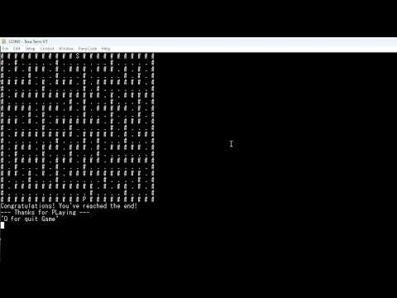](https://www.youtube.com/watch?v=qFXZF7q3fjQ)**

**Conclusion:**

This project was a valuable learning experience that combined various aspects of embedded systems, algorithm development, and practical problem-solving. By working on maze navigation, I learned how to implement efficient movement algorithms within a grid while handling challenges such as boundary conditions and real-time updates to the maze's state. Using UART for communication, I developed a better understanding of processing user inputs and outputs in real-time, which was crucial for creating an interactive system. Debugging became an essential part of the process, teaching me how to identify and fix issues systematically. Additionally, I gained insight into the constraints of embedded systems, such as limited memory and processing power, and learned how to write optimized and efficient code. Overall, the project allowed me to develop both technical and problem-solving skills, offering a deeper appreciation for designing and implementing embedded solutions.