RC Airplane
  - Independent Design, Fabrication, Electronics Integration & Flight Testing
Summer 2025 • Personal engineering project
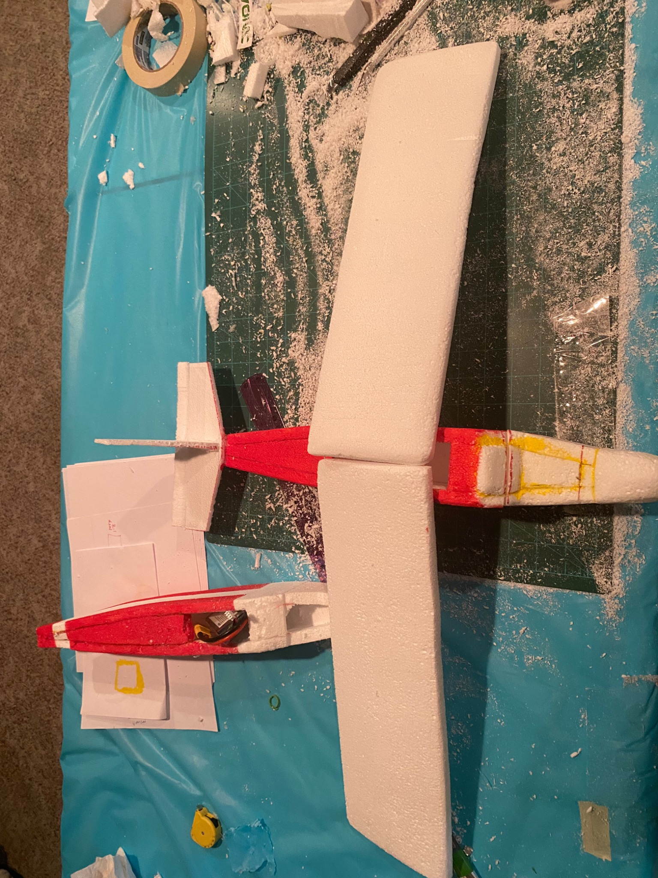

Executive Summary
This independent engineering project involved researching, constructing, modifying, and flight-testing a lightweight radio-controlled fixed-wing airplane. The prototype used a foam airframe and integrated battery-powered radio-control electronics. Iterative construction focused on structural durability, wing mounting, tail configuration, weight distribution, and wiring. The aircraft achieved an approximately 89-second flight before a crash during the builder’s first experience piloting an RC airplane. The available evidence does not establish a definitive crash cause.

Project Objectives
- Develop and assemble a functional fixed-wing RC aircraft independently.
- Investigate lightweight structural materials and wing geometry.
- Integrate power and radio-control components.
- Iterate through build challenges and conduct initial flight testing.

Design and Construction
The airframe features a long tapered fuselage, two main foam wing panels, and a conventional tail assembly with horizontal and vertical stabilizing surfaces. The supplied photographs document wing shaping, foam fabrication, fuselage modifications, and an internal battery compartment. Exact dimensions, airfoil profile, mass, and motor specifications were not provided.
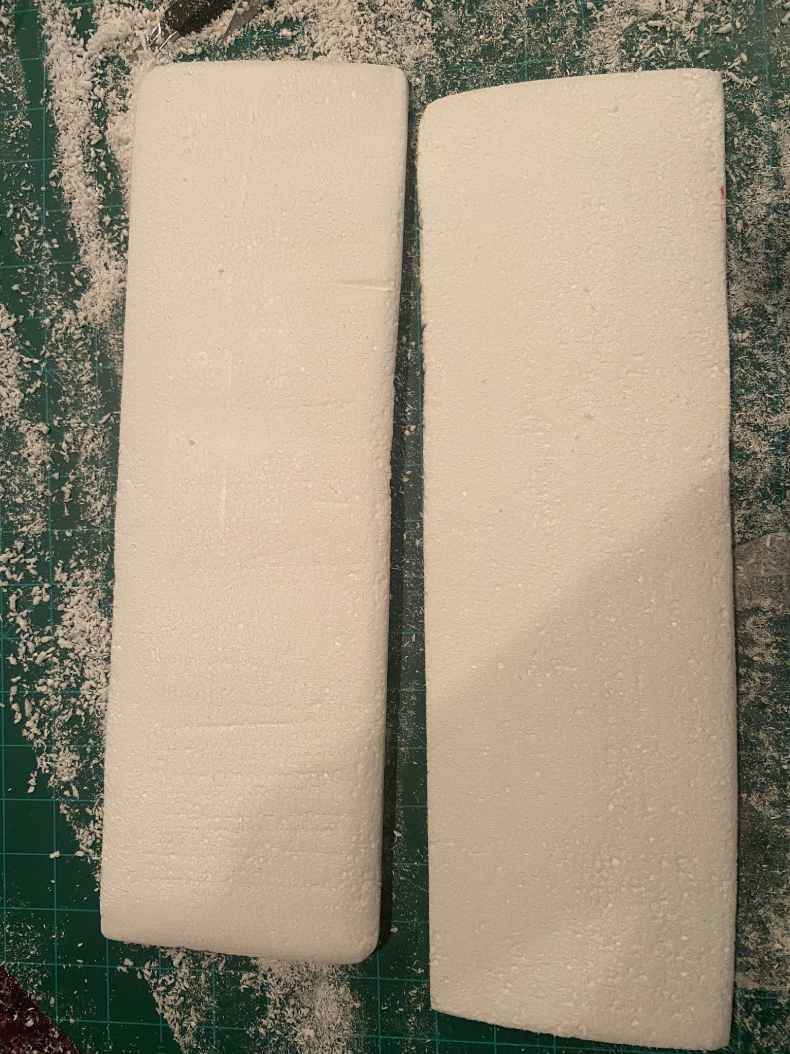
Figure 1. Two shaped foam wing panels during fabrication.

Engineering Iterations
Early June — Evaluated wing length and mass; changed planned body material in response to weight concerns.
Mid June — Constructed and rebuilt foam body after fabrication damage and tooling challenges.
Late June — Rebuilt the fuselage for balance and durability; reconsidered a heavy battery.
Early July — Reworked tail and rudder geometry; evaluated modular wing mounting and servo placement.
Mid July — Updated wiring, reinforced foam structures, and conducted ground-roll/taxi checks.

Electronics and Control System
Photographs show a battery and power connector in a fuselage compartment. The progress log records component wiring, efforts to reduce electromagnetic interference, servo-position evaluation, and control-surface calibration research. Exact hardware models and the completed circuit topology cannot be verified from the supplied materials.
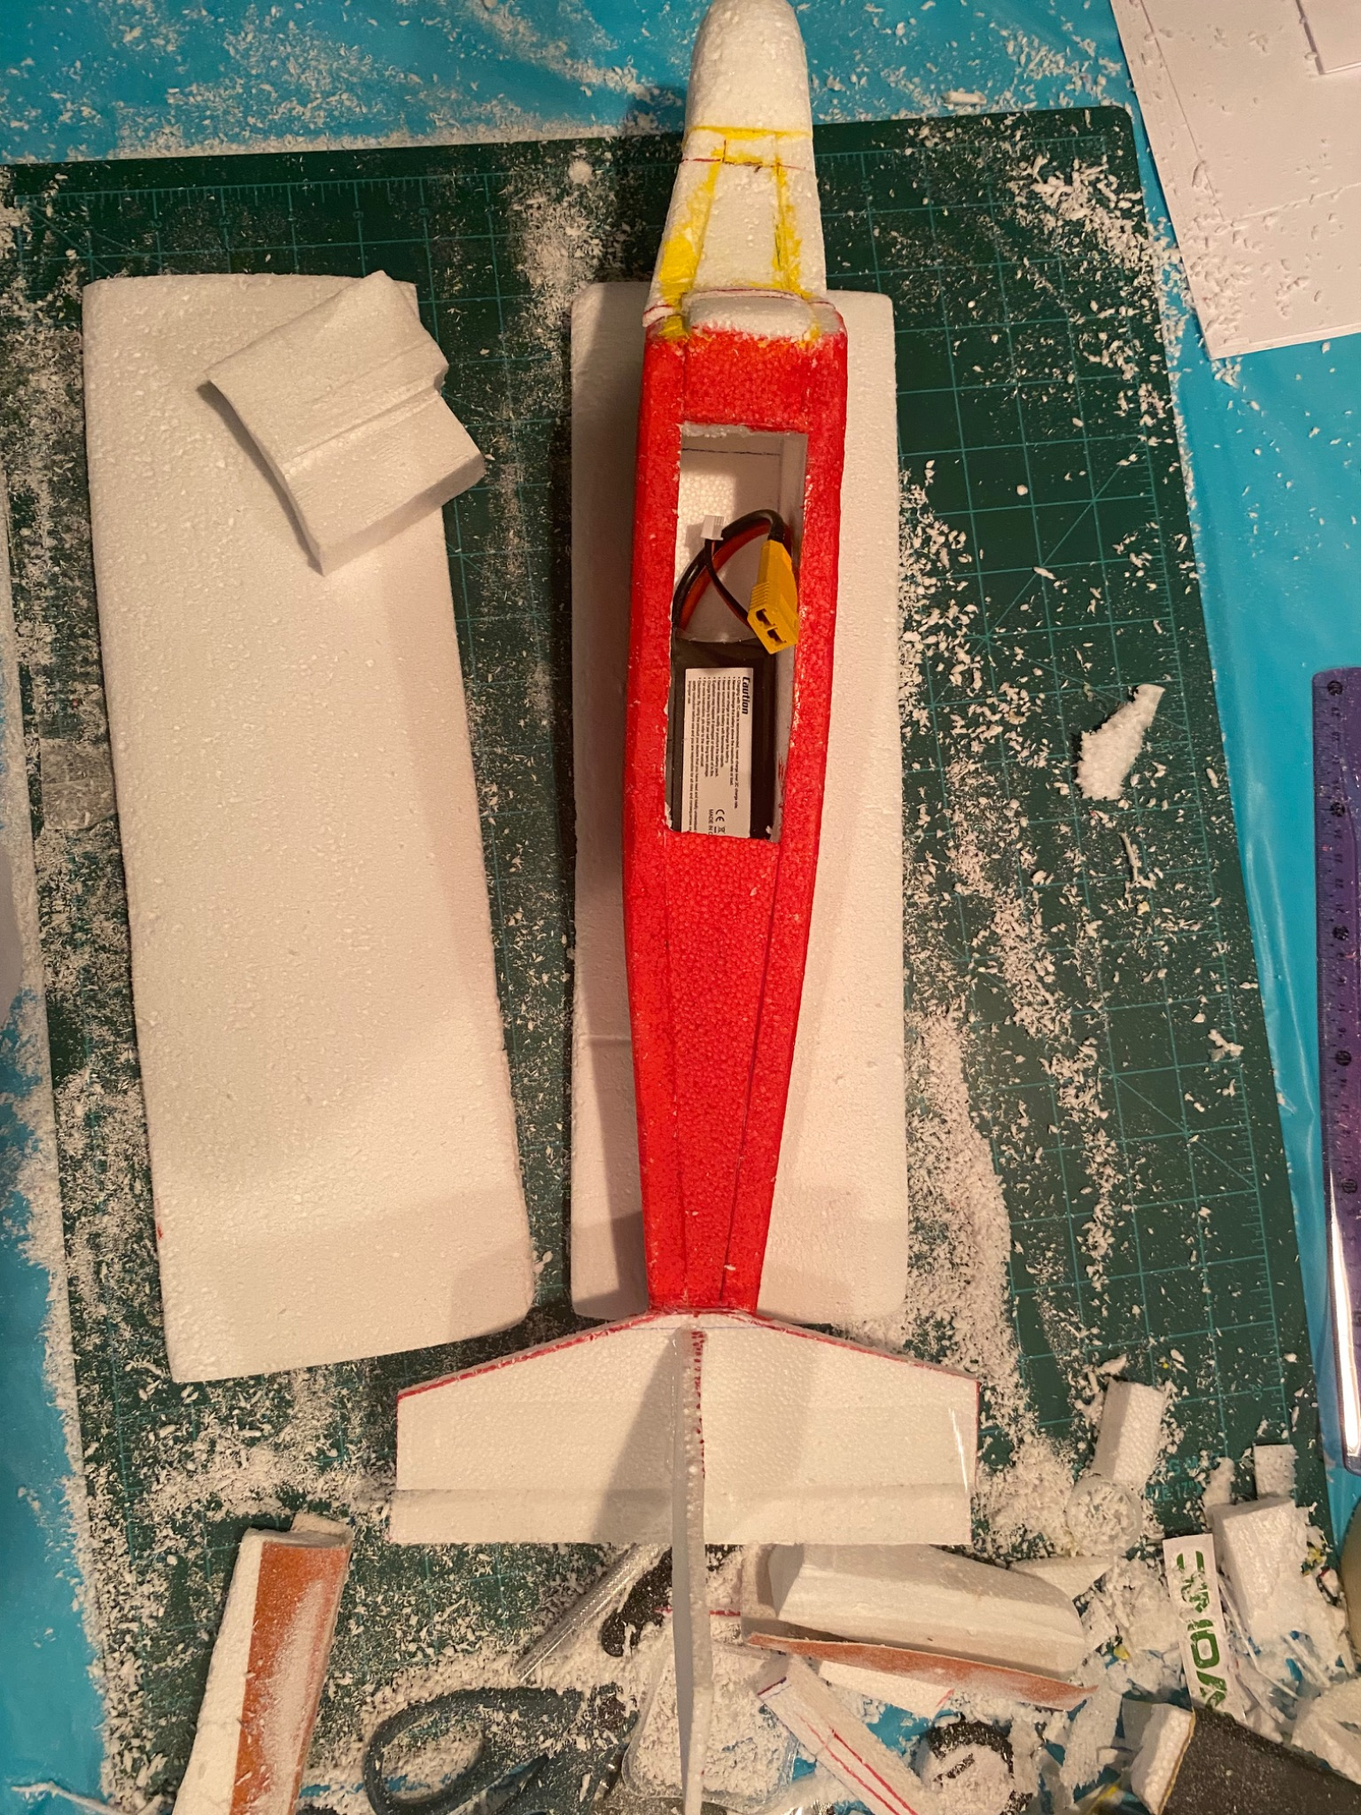
Figure 2. Battery compartment and connector visible in the fuselage.
Typical RC aircraft electrical subsystems (reference only, not a confirmed parts list): rechargeable flight battery; electronic speed controller (ESC); propulsion motor and propeller; radio receiver/transmitter; control-surface servos; and possibly a BEC/regulator. These are common subsystem categories and should not be interpreted as verified model numbers or wiring for this aircraft.
Electrical reference image: https://modelistam.com.ua/images/yak-zibrati-sviy-pershiy-litak-z-naboru-5.jpg
Technical reference: PX4 fixed-wing assembly guide — https://docs.px4.io/main/en/assembly/assembly_fw

Flight Test and Outcome
Reported flight duration: approximately 1 minute 29 seconds (89 seconds). Outcome: the aircraft flew and subsequently crashed. Pilot experience: first time controlling an RC airplane. The footage is supplied separately as flight-test.mov. A controlled root-cause analysis has not been completed; pilot inexperience is context, not proof of the cause.

Lessons and Next Iteration
- Airframe weight and battery placement are important design constraints.
- Modular construction makes replacement and adjustment easier after damage.
- Ground checks and control-surface verification should precede each flight.
- For future testing, practice with a simulator or experienced RC pilot and record trim, balance, conditions, and observations.

Documentation and Evidence
Evidence: seven original construction photographs; one uploaded flight video; and a ten-week Summer 2025 activity record. The timesheet also includes non-aircraft career-development hours, so its 256.866 total should not be presented as RC-airplane build time.

References
PX4. “Assembling a Fixed-Wing.” https://docs.px4.io/main/en/assembly/assembly_fw
Modelistam. “Step-by-step first RC airplane assembly” (illustrative labeled electrical component photo). https://modelistam.com.ua/shag-shagom-kak-sobrati-svoi-pervyi-samolet-nabora-a-309/
Primary sources: author-provided construction photos, flight footage, and Summer 2025 progress log.

