There are only a 2,248 active users out of 12,000 total Users in the file, 0r 18.7%. A full 8,823 have never used the application even once, they have just created an account/downloaded the app.

*So what are the factors that contribute to acquiring active users?*

According to our test, Guest Invites, Google Login, Signup, and opting into the mailing list are all very strongly associated with active users. Whereas, and organizational invite of a Personal Project are actually negatively correlated.

This suggests that there is strong user-network affects happening here, and that marketing emails are a nice inducement to greater user activity.

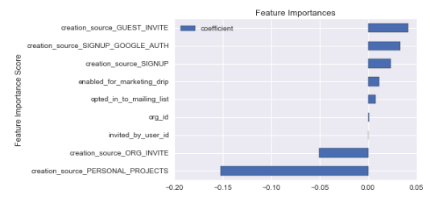

However, all of that needs to be caveated, by the fact that these attributes only account of about 60% explanatory power. Therefore, these takeaways need to be accepted with a ‘grain of salt’, there are quite a few other things happening, that we have not included in this model. And that is where we leave off, further analysis can be done, on how long a user is active for, how many actions that person took, and if those actions where shared with a wider audience.

