A CASE STUDY ON
LIBRARY MANAGEMENT SYSTEM
Replacing a Manual Library Register with an Object Oriented Program
Language: C++
Submitted By Randeep Singh
UID 25bcd10148

Submitted To __________________
Designation __________________

Submission Date __ / __ / ____
Chandigarh University

1. Introduction and Background
A college library lends books and magazines to hundreds of students every semester. In many libraries this work is still done with handwritten registers and index cards. The librarian writes down who took which book and on which date, and later searches the register to find the entry when the book is returned.
This case study looks at one such library and shows how its day-to-day work can be handled by a small program built with Object Oriented Programming (OOP) in C++. The aim is not only to build the program but also to understand why the manual system fails and how OOP gives a cleaner solution.

2. Problem Statement
The library faces the following problems with its manual register:
- The same book can be issued to two students because nobody checks its status quickly.
- A student can borrow any number of books, so popular books stay out of circulation.
- Fines for late return are calculated by hand, and different item types (books, magazines) have different rules, so mistakes are common.
- Finding the current status of one book means searching through pages of entries.
Problem to solve: design a program that keeps track of every item and member, blocks wrong issues, and calculates fines automatically.

3. Existing System and Its Limitations
Area | How the manual system works | Limitation
Availability | Librarian looks through the register | Slow, and a book may be issued twice by mistake
Borrowing limit | Depends on the librarian remembering | Not enforced, so rules are applied unequally
Fine calculation | Counted by hand from dates | Errors, and different rules for books and magazines
Records | Handwritten pages | Can be lost, damaged or misread
Searching | Page by page | Takes a long time as records grow

4. Proposed Solution

4.1 Objectives
- Keep the status of every item (available or issued) up to date.
- Allow an item to be issued only when it is available and the member is under the borrowing limit.
- Calculate the fine automatically using the rule of the item type.
- Report every wrong operation with a clear error message.

4.2 Library Rules Used
Item type | Loan period | Fine per late day | Borrowing limit
Book | 14 days | Rs. 2 | 2 items per member
Magazine | 7 days | Rs. 1 | 2 items per member

4.3 OOP Design
The real-world objects of the library are mapped to classes. Books and magazines share most of their data, so they inherit from one abstract class, and each one supplies its own loan period and fine through virtual functions.
Class | Type | Responsibility
Item | Abstract base class | Stores ID, title and issued status. Declares the pure virtual functions type(), loanDays() and finePerDay().
Book | Derived from Item | Loan period 14 days, fine Rs. 2 per late day.
Magazine | Derived from Item | Loan period 7 days, fine Rs. 1 per late day.
Member | Independent class | Stores member ID and name, and counts the items borrowed. Enforces the limit of 2.
Library | Controller class | Holds all items and members, issues and returns items, calculates the fine and prints the catalog. Frees memory in its destructor.

4.4 OOP Concepts Applied
Concept | Use in this case study
Encapsulation | Data members are protected or private. Status changes only through methods such as setIssued() and borrow().
Abstraction | Item hides the details of each item type behind pure virtual functions.
Inheritance | Book and Magazine reuse the ID, title and status handling of Item.
Polymorphism | The Library calls finePerDay() and loanDays() through an Item pointer, and the correct version runs for each object.
Exception handling | runtime_error is thrown for a missing item, an item already issued and a member over the limit.

5. Implementation
The prototype is written in one file, library.cpp (137 lines). It compiles without warnings using g++ -std=c++17 -Wall -Wextra. The main() function runs a fixed demonstration so that every rule of the library is shown.

5.1 Source Code
// Case Study: Library Management System (OOP prototype in C++)
#include <iostream>
#include <vector>
#include <string>
#include <iomanip>
#include <stdexcept>
using namespace std;

// ---------- Abstract class for everything the library lends ----------
class Item {
protected:
int id;
string title;
bool issued;
public:
Item(int i, string t) : id(i), title(t), issued(false) {}
virtual ~Item() {}
int getId() const { return id; }
string getTitle() const { return title; }
bool isIssued() const { return issued; }
void setIssued(bool s) { issued = s; }
virtual string type() const = 0;
virtual int loanDays() const = 0;
virtual double finePerDay() const = 0;
};

class Book : public Item {
public:
Book(int i, string t) : Item(i, t) {}
string type() const override { return "Book"; }
int loanDays() const override { return 14; }
double finePerDay() const override { return 2.0; }
};

class Magazine : public Item {
public:
Magazine(int i, string t) : Item(i, t) {}
string type() const override { return "Magazine"; }
int loanDays() const override { return 7; }
double finePerDay() const override { return 1.0; }
};

// ---------- Member ----------
class Member {
int id;
string name;
int borrowed;
static const int LIMIT = 2;
public:
Member(int i, string n) : id(i), name(n), borrowed(0) {}
int getId() const { return id; }
string getName() const { return name; }
bool canBorrow() const { return borrowed < LIMIT; }
void borrow() { borrowed++; }
void giveBack() { borrowed--; }
int count() const { return borrowed; }
};

// ---------- Library (controller) ----------
class Library {
vector<Item*> items;
vector<Member*> members;
Item* findItem(int id) {
for (Item* x : items) if (x->getId() == id) return x;
throw runtime_error("Item not found");
}
Member* findMember(int id) {
for (Member* m : members) if (m->getId() == id) return m;
throw runtime_error("Member not found");
}
public:
~Library() {
for (Item* x : items) delete x;
for (Member* m : members) delete m;
}
void addItem(Item* x) { items.push_back(x); }
void addMember(Member* m) { members.push_back(m); }

void issue(int memberId, int itemId) {
Member* m = findMember(memberId);
Item* x = findItem(itemId);
if (x->isIssued()) throw runtime_error("'" + x->getTitle() + "' is already issued");
if (!m->canBorrow()) throw runtime_error(m->getName() + " has reached the borrowing limit");
x->setIssued(true);
m->borrow();
cout << "Issued : " << x->getTitle() << " (" << x->type() << ") to "
<< m->getName() << " for " << x->loanDays() << " days\n";
}

void giveBackItem(int memberId, int itemId, int daysKept) {
Member* m = findMember(memberId);
Item* x = findItem(itemId);
if (!x->isIssued()) throw runtime_error("'" + x->getTitle() + "' was not issued");
int late = daysKept > x->loanDays() ? daysKept - x->loanDays() : 0;
double fine = late * x->finePerDay();
x->setIssued(false);
m->giveBack();
cout << fixed << setprecision(2);
cout << "Returned: " << x->getTitle() << " by " << m->getName()
<< " | late days: " << late << " | fine: Rs." << fine << "\n";
}

void catalog() const {
cout << "\n" << left << setw(6) << "ID" << setw(10) << "Type"
<< setw(28) << "Title" << "Status\n" << string(54, '-') << "\n";
for (const Item* x : items)
cout << left << setw(6) << x->getId() << setw(10) << x->type()
<< setw(28) << x->getTitle() << (x->isIssued() ? "Issued" : "Available") << "\n";
}
};

int main() {
Library lib;
lib.addItem(new Book(101, "Let Us C++"));
lib.addItem(new Book(102, "Data Structures"));
lib.addItem(new Book(103, "Operating Systems"));
lib.addItem(new Magazine(201, "Digit Monthly"));
lib.addMember(new Member(1, "Randeep Singh"));
lib.addMember(new Member(2, "Aman Verma"));

cout << "===== LIBRARY MANAGEMENT SYSTEM - DEMO =====\n";
lib.catalog();
cout << "\n--- Issuing items ---\n";
const int steps[][2] = { {1,101}, {1,201}, {1,102}, {2,101}, {2,103} };
for (auto& s : steps) {
try { lib.issue(s[0], s[1]); }
catch (const exception& e) { cout << "Error : " << e.what() << "\n"; }
}
cout << "\n--- Returning items ---\n";
try {
lib.giveBackItem(1, 101, 20); // 6 days late
lib.giveBackItem(1, 201, 5); // on time
lib.giveBackItem(1, 102, 3); // never issued
} catch (const exception& e) { cout << "Error : " << e.what() << "\n"; }
lib.catalog();
return 0;
}

5.2 Output
The screenshot below shows the program running in the console.
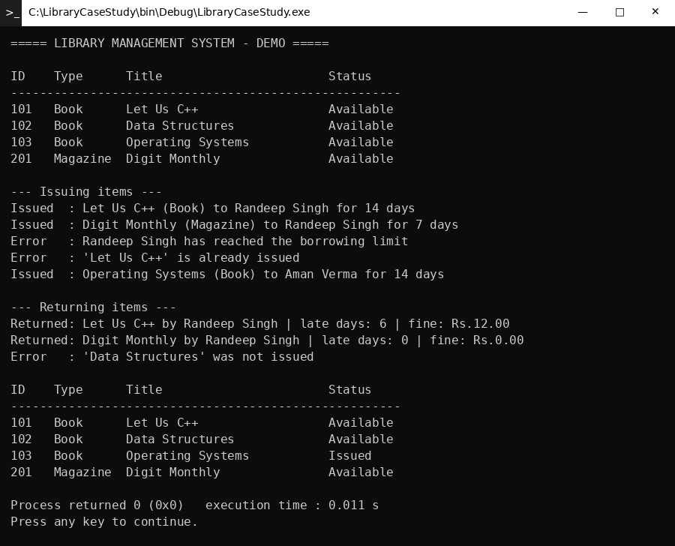
Output: Library Management System demo

5.3 What the Output Shows
- The catalog first lists all four items as Available.
- Randeep Singh is issued a book and a magazine. A third issue is refused because the limit of 2 items is reached.
- Aman Verma cannot take “Let Us C++” because it is already issued, but he can take “Operating Systems”.
- The book is returned after 20 days. It is 6 days late, so the fine is 6 x Rs. 2 = Rs. 12.00.
- The magazine is returned after 5 days, within its 7-day period, so the fine is Rs. 0.00.
- Returning an item that was never issued gives an error, and the final catalog shows only the item still issued.

6. Results and Benefits
Area | Manual register | Proposed OOP program
Availability | Search the register | Checked instantly through the issued status
Double issue | Possible | Blocked with an error message
Borrowing limit | Not enforced | Enforced automatically for every member
Fine | Calculated by hand | Calculated by the item’s own rule
Adding a new item type | New rules to remember | Add one new class derived from Item

7. Limitations and Future Scope
The prototype is a demonstration and has some limits. It keeps data only while the program runs, it takes the number of days kept as a number instead of real dates, and it has no search or login. These can be improved in future work:
- Store items and members permanently using file handling or a database.
- Use real issue and return dates instead of a count of days.
- Add search by title or author, and a librarian login.
- Add a graphical user interface.

8. Conclusion
The case study shows that the problems of a manual library register, such as double issue, unequal rules and wrong fines, can be solved with a small OOP program. Putting the shared data in the abstract Item class and the different rules in Book and Magazine keeps the design simple. A new item type, such as a journal or a DVD, can be added later without changing the Library class. This is the main benefit of using inheritance and polymorphism in a real-life problem.

