A MINI PROJECT REPORT ON
VEHICLE RENTAL SYSTEM
Subject: Object Oriented Programming (OOP)
Language: C++
Submitted By Randeep Singh
UID 25bcd10148

Submitted To Mr. Jatinder Kumar
Designation Assistant Professor

Submission Date 29/10/2026
Chandigarh University

1. Introduction
Object Oriented Programming (OOP) is a way of writing programs in which the software is built around objects. An object combines data and the functions that work on that data. The four main pillars of OOP are encapsulation, abstraction, inheritance and polymorphism. Together they make a program modular, reusable and easy to maintain.
This mini project, the Vehicle Rental System, is a console application written in C++ that applies these concepts to a real business: renting cars, bikes and trucks to customers. Using a simple menu, the operator can view the vehicles in the fleet, register a customer, rent a vehicle for a number of days, return it and receive the bill, and view all rental records.
Every type of vehicle calculates its own rent. A car gets a discount on long rentals, a bike is charged by the day, and a truck carries an extra loading fee. The program uses one common interface for all of them, which clearly demonstrates polymorphism.

2. Objectives / Problem Statement

2.1 Problem Statement
Small vehicle rental shops often keep their records on paper. This leads to mistakes: the same vehicle can be given to two customers, the bill can be calculated wrongly, and old records are difficult to find. There is a need for a simple and reliable program that tracks the availability of vehicles, stores customer and rental details, and calculates the rent automatically.

2.2 Objectives
- To design a vehicle rental system using the concepts of Object Oriented Programming in C++.
- To show inheritance by deriving the Car, Bike and Truck classes from the abstract Vehicle class.
- To show polymorphism by calculating rent differently for each vehicle type through virtual functions.
- To protect data using encapsulation, with protected or private members and public methods.
- To prevent double booking by keeping track of the availability of every vehicle.
- To handle wrong input and invalid operations using exception handling.
- To generate the rental confirmation and the return bill automatically.

3. Modules, Tools and Technologies Used

3.1 Modules
The project is divided into five modules. Each module is implemented using one or more classes.
No. | Module | Class / Function | Description
1 | Vehicle Management | Vehicle (abstract), Car, Bike, Truck | Stores vehicle details and availability. Each derived class calculates its own rent.
2 | Customer Management | Customer | Stores the customer ID, name and phone number.
3 | Rental Management | Rental | Keeps the record of one rental: customer, vehicle, days, amount and status.
4 | Controller | RentalSystem | Connects all modules: show vehicles, register, rent, return and records. Frees memory in its destructor.
5 | User Interface | main(), readInt(), readLine() | Shows the menu, validates the input and catches exceptions.

3.2 Rent Calculation Rules
- Car: rent = rate per day x days. A 10% discount is given when the rental is 7 days or more.
- Bike: rent = rate per day x days. The helmet is included free.
- Truck: rent = rate per day x days + Rs. 500 fixed loading fee.

3.3 OOP Concepts Used
Concept | Where it is used
Encapsulation | Data members of every class are protected or private and are accessed only through public methods.
Abstraction | Vehicle is an abstract class with the pure virtual functions getType() and calculateRent().
Inheritance | Car, Bike and Truck inherit from Vehicle and reuse its common data and functions.
Polymorphism | calculateRent() is called through a Vehicle pointer and runs the version of the actual vehicle (function overriding).
Constructors / Destructors | Constructors initialise objects. A virtual destructor and the RentalSystem destructor release dynamic memory.
Exception handling | try / catch with runtime_error reports problems such as an invalid ID or a vehicle that is already rented.
STL containers | vector is used to store vehicles, customers and rental records.

3.4 Tools and Technologies
Item | Details
Programming language | C++ (ISO C++17)
Compiler | GCC (g++)
IDE / Console | Code::Blocks (console output)
Header files | iostream, vector, string, iomanip, limits, stdexcept
Version control | Git and GitHub
Documentation | Microsoft Word
GitHub Repository: PASTE YOUR GITHUB LINK HERE

4. Source Code
The complete program is in a single file, main.cpp. It has 253 lines and compiles without warnings using g++ -std=c++17 -Wall -Wextra.
// ============================================================
// Vehicle Rental System - OOP Mini Project (C++)
// Submitted By : Randeep Singh | UID : 25bcd10148
// Chandigarh University
// ============================================================
#include <iostream>
#include <vector>
#include <string>
#include <iomanip>
#include <limits>
#include <stdexcept>
using namespace std;

// ---------- Abstract base class ----------
class Vehicle {
protected:
int id;
string brand, model;
double ratePerDay;
bool available;
public:
Vehicle(int i, string b, string m, double r)
: id(i), brand(b), model(m), ratePerDay(r), available(true) {}
virtual ~Vehicle() {}

int getId() const { return id; }
string getName() const { return brand + " " + model; }
bool isAvailable() const { return available; }
void setAvailable(bool a) { available = a; }

virtual string getType() const = 0; // pure virtual
virtual double calculateRent(int days) const = 0; // pure virtual

virtual void display() const {
cout << left << setw(6) << id << setw(8) << getType()
<< setw(24) << getName() << "Rs." << setw(7) << (int)ratePerDay
<< (available ? "Available" : "Rented") << endl;
}
};

// ---------- Derived classes ----------
class Car : public Vehicle {
int seats;
public:
Car(int i, string b, string m, double r, int s)
: Vehicle(i, b, m, r), seats(s) {}
string getType() const override { return "Car"; }
double calculateRent(int days) const override {
double total = ratePerDay * days;
if (days >= 7) total *= 0.90; // 10% weekly discount
return total;
}
};

class Bike : public Vehicle {
bool helmetIncluded;
public:
Bike(int i, string b, string m, double r, bool h)
: Vehicle(i, b, m, r), helmetIncluded(h) {}
string getType() const override { return "Bike"; }
double calculateRent(int days) const override {
return ratePerDay * days; // helmet is free
}
};

class Truck : public Vehicle {
double loadCapacityTon;
public:
Truck(int i, string b, string m, double r, double load)
: Vehicle(i, b, m, r), loadCapacityTon(load) {}
string getType() const override { return "Truck"; }
double calculateRent(int days) const override {
return ratePerDay * days + 500; // fixed loading fee
}
};

// ---------- Customer ----------
class Customer {
int id;
string name, phone;
public:
Customer(int i, string n, string p) : id(i), name(n), phone(p) {}
int getId() const { return id; }
string getName() const { return name; }
string getPhone() const { return phone; }
};

// ---------- Rental record ----------
class Rental {
public:
int rentalId;
Vehicle* vehicle;
Customer* customer;
int days;
double amount;
bool active;
Rental(int r, Vehicle* v, Customer* c, int d)
: rentalId(r), vehicle(v), customer(c), days(d), active(true) {
amount = v->calculateRent(d);
}
};

// ---------- Main controller class ----------
class RentalSystem {
vector<Vehicle*> vehicles;
vector<Customer*> customers;
vector<Rental*> rentals;
int nextCustomerId = 1, nextRentalId = 1;

Vehicle* findVehicle(int id) {
for (Vehicle* v : vehicles) if (v->getId() == id) return v;
throw runtime_error("Vehicle ID not found.");
}
Customer* findCustomer(int id) {
for (Customer* c : customers) if (c->getId() == id) return c;
throw runtime_error("Customer ID not found.");
}
Rental* findRental(int id) {
for (Rental* r : rentals) if (r->rentalId == id) return r;
throw runtime_error("Rental ID not found.");
}
public:
RentalSystem() {
vehicles.push_back(new Car(101, "Maruti", "Swift", 1500, 5));
vehicles.push_back(new Car(102, "Hyundai", "Creta", 2500, 5));
vehicles.push_back(new Bike(201, "Royal Enfield", "Classic", 800, true));
vehicles.push_back(new Bike(202, "Honda", "Activa", 400, true));
vehicles.push_back(new Truck(301, "Tata", "407", 3000, 2.5));
}
~RentalSystem() {
for (Vehicle* v : vehicles) delete v;
for (Customer* c : customers) delete c;
for (Rental* r : rentals) delete r;
}

void showVehicles() const {
cout << "\n" << left << setw(6) << "ID" << setw(8) << "Type"
<< setw(24) << "Vehicle" << setw(10) << "Rate/Day" << "Status\n";
cout << string(59, '-') << endl;
for (const Vehicle* v : vehicles) v->display();
}

void registerCustomer(const string& name, const string& phone) {
customers.push_back(new Customer(nextCustomerId, name, phone));
cout << "Customer registered successfully. Customer ID = "
<< nextCustomerId++ << endl;
}

void rentVehicle(int custId, int vehId, int days) {
Customer* c = findCustomer(custId);
Vehicle* v = findVehicle(vehId);
if (!v->isAvailable()) throw runtime_error("Vehicle is already rented.");
if (days <= 0) throw runtime_error("Days must be at least 1.");
Rental* r = new Rental(nextRentalId++, v, c, days);
rentals.push_back(r);
v->setAvailable(false);
cout << fixed << setprecision(2);
cout << "\n--- Rental Confirmed ---\n"
<< "Rental ID : " << r->rentalId << "\n"
<< "Customer : " << c->getName() << "\n"
<< "Vehicle : " << v->getName() << " (" << v->getType() << ")\n"
<< "Days : " << days << "\n"
<< "Rent : Rs." << r->amount << endl;
}

void returnVehicle(int rentalId) {
Rental* r = findRental(rentalId);
if (!r->active) throw runtime_error("Vehicle already returned.");
r->active = false;
r->vehicle->setAvailable(true);
cout << fixed << setprecision(2);
cout << "\n--- Return Bill ---\n"
<< "Customer : " << r->customer->getName() << "\n"
<< "Vehicle : " << r->vehicle->getName() << "\n"
<< "Days : " << r->days << "\n"
<< "Total : Rs." << r->amount << "\n"
<< "Thank you! Vehicle returned successfully." << endl;
}

void showRentals() const {
if (rentals.empty()) { cout << "\nNo rental records yet.\n"; return; }
cout << "\n" << left << setw(8) << "RentID" << setw(18) << "Customer"
<< setw(24) << "Vehicle" << setw(6) << "Days" << "Status\n";
cout << string(64, '-') << endl;
for (const Rental* r : rentals)
cout << left << setw(8) << r->rentalId
<< setw(18) << r->customer->getName()
<< setw(24) << r->vehicle->getName()
<< setw(6) << r->days
<< (r->active ? "Active" : "Returned") << endl;
}
};

// ---------- Input helpers ----------
int readInt(const string& prompt) {
int x;
cout << prompt;
while (!(cin >> x)) {
cin.clear();
cin.ignore(numeric_limits<streamsize>::max(), '\n');
cout << "Invalid input! Enter a number: ";
}
cin.ignore(numeric_limits<streamsize>::max(), '\n');
return x;
}

string readLine(const string& prompt) {
string s;
cout << prompt;
getline(cin, s);
return s;
}

// ---------- main ----------
int main() {
RentalSystem system;
int choice;
do {
cout << "\n========== VEHICLE RENTAL SYSTEM ==========\n"
<< "1. Show all vehicles\n"
<< "2. Register customer\n"
<< "3. Rent a vehicle\n"
<< "4. Return a vehicle\n"
<< "5. Show rental records\n"
<< "6. Exit\n";
choice = readInt("Enter your choice: ");
try {
switch (choice) {
case 1: system.showVehicles(); break;
case 2: {
string name = readLine("Enter customer name : ");
string phone = readLine("Enter phone number : ");
system.registerCustomer(name, phone);
break;
}
case 3: {
int c = readInt("Enter customer ID : ");
int v = readInt("Enter vehicle ID : ");
int d = readInt("Enter number of days : ");
system.rentVehicle(c, v, d);
break;
}
case 4: system.returnVehicle(readInt("Enter rental ID : ")); break;
case 5: system.showRentals(); break;
case 6: cout << "\nThank you for using Vehicle Rental System!\n"; break;
default: cout << "Invalid choice! Try again.\n";
}
} catch (const exception& e) {
cout << "Error: " << e.what() << endl;
}
} while (choice != 6);
return 0;
}

5. Output
The screenshots below show the program running in the console. They cover viewing vehicles, registering a customer, renting (including a 7-day rental with the discount), returning a vehicle with the bill, the rental records, and the handling of wrong input and errors.
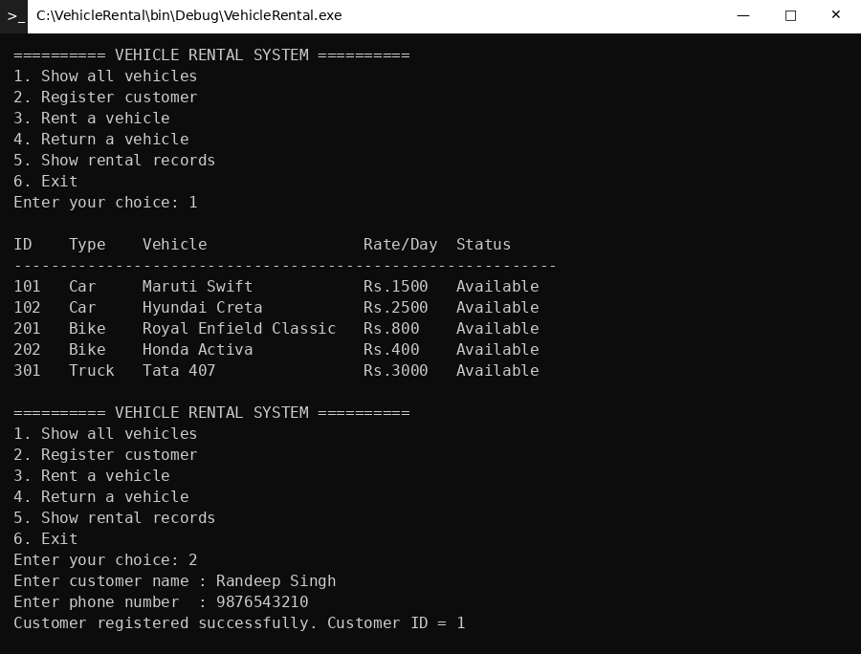
Output 1: Viewing all vehicles, registering a customer
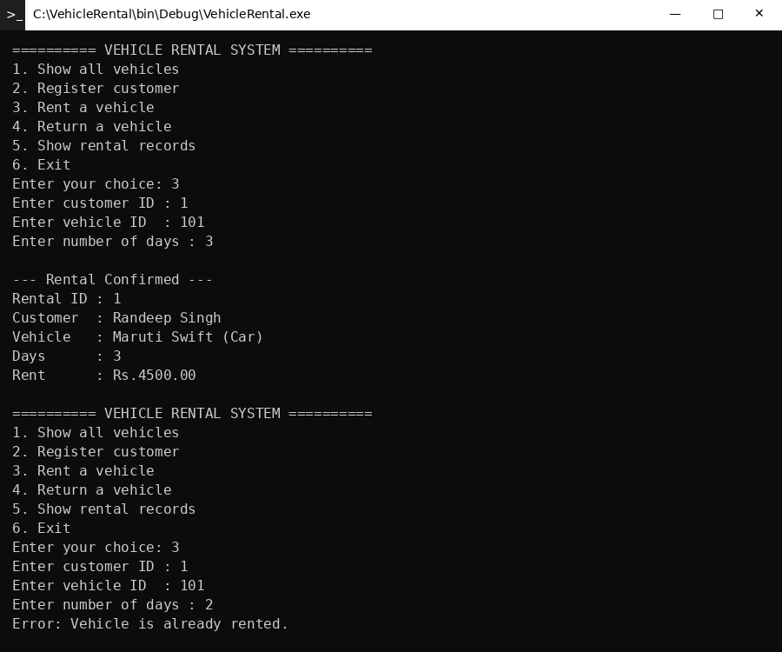
Output 2: Renting a vehicle, error handling (exceptions)
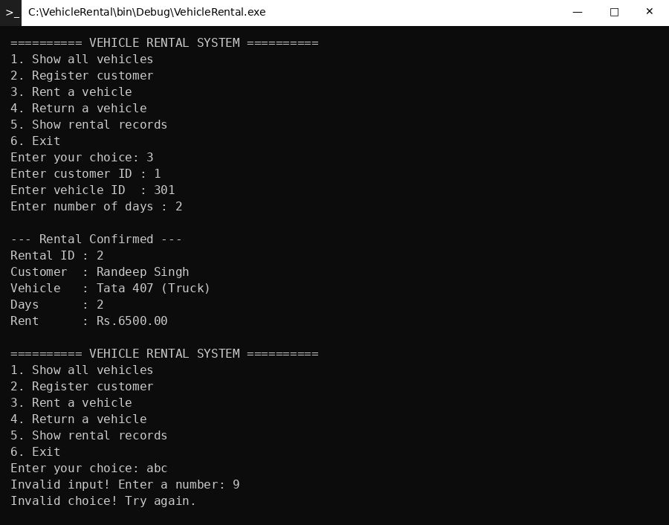
Output 3: Renting a vehicle, invalid input handling
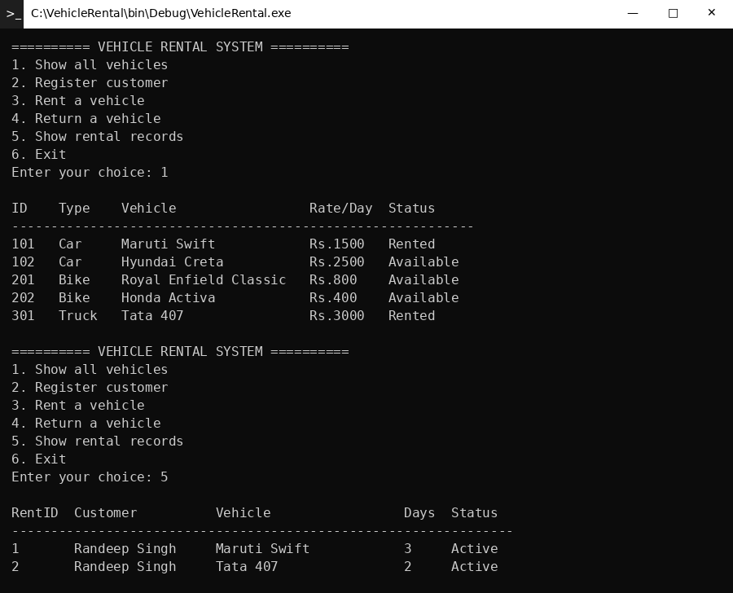
Output 4: Viewing all vehicles, showing rental records
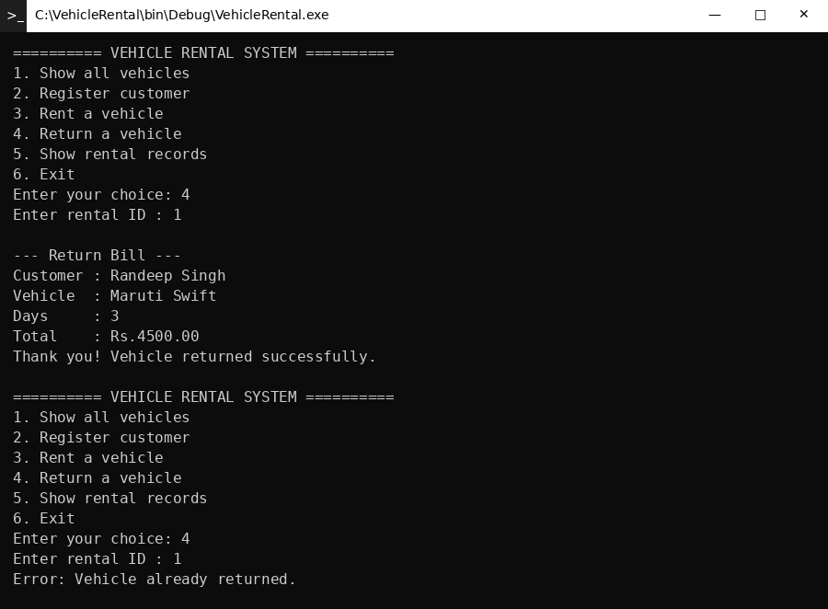
Output 5: Returning a vehicle and printing the bill, error handling (exceptions)
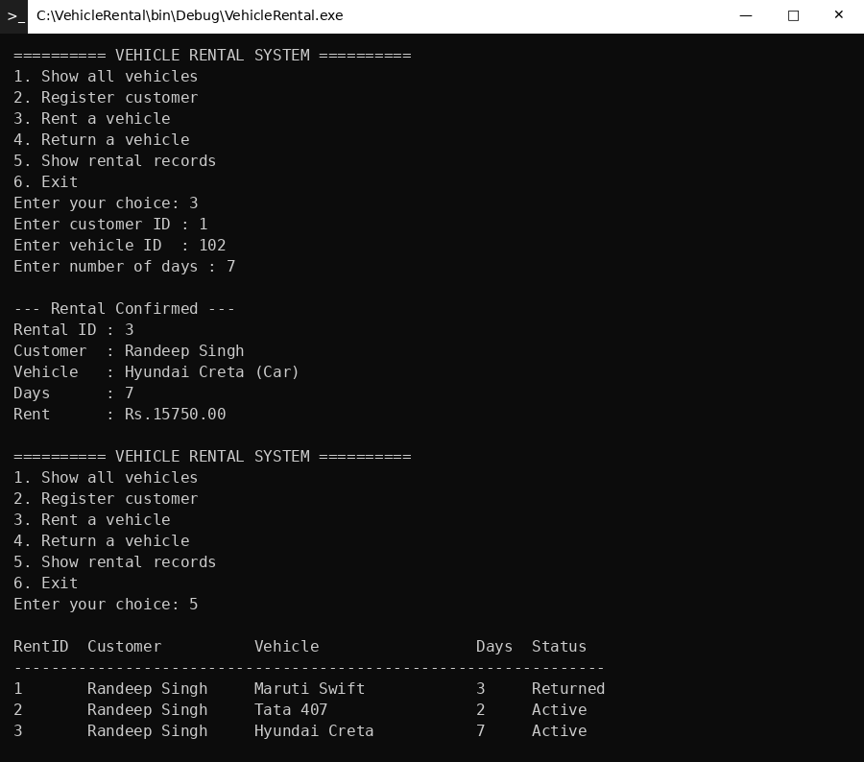
Output 6: Renting a vehicle, showing rental records
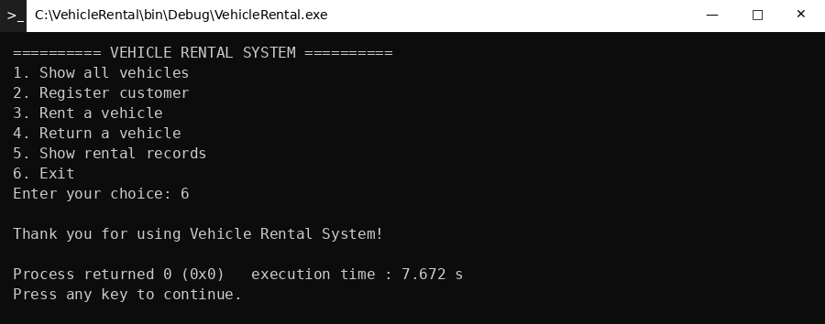
Output 7: Exiting the program

6. Conclusion
The Vehicle Rental System was designed and implemented successfully in C++ using Object Oriented Programming. The program lets the user view vehicles, register customers, rent and return vehicles, and see all rental records. The rent is calculated automatically and a vehicle cannot be rented twice at the same time.
Through this project the main OOP concepts were applied in a practical way: encapsulation protects the data, the abstract Vehicle class defines a common interface, the Car, Bike and Truck classes inherit from it, and polymorphism lets each vehicle calculate its rent in its own way. Exception handling and input validation make the program safe against wrong input.

Future Scope
- Store the data permanently in files or in a database so that it is not lost when the program closes.
- Add an admin login, late-return fines and a payment module.
- Add dates for the rental period and a search facility by vehicle type.
- Build a graphical user interface for easier use.

