Prepared By: Randeer silva

Rusada

**Plane spotter Application**

**Table of Contents**

**Introduction 1**

**Requirements 1**

**Configuration 1**

**Setup frontend application 1**

**Setup backend application 2**

**Appendix A: Git Repositories 2**

**Appendix B: User Interface 2**

**List View 3**

**Create View 3**

# Introduction

This application main purpose is to assist plane spotters and when designing that it’s designed with microservices architecture considering future extension of the application. So basically, it’s contains two applications.

1. **PlaneSpotter**

Web Api Project integrated with frontend.

Technologies: - Asp.net Core 5

1. **Plane-Spotters-App**

Frontend application which communicated with backend.

Technologies: - Angular 11

# Requirements

1. Visual Studio 2019 V16.6 Preview 1
2. .NET 5 Preview SDK
3. SQL Server Management Studio
4. Vs Code
5. Node latest version (<https://nodejs.org/en/>)

# Configuration

## Setup frontend application

**Step 01**

Clone from <https://github.com/Randeer04/Plane-Spotters-App.git>

**Step 02**

Open command prompt inside source folder and run npm install.

**Step 03**

Run ng serve

**Step 04**

Run following URL

<http://localhost:4200/sightings>

## Setup backend application

**Step 01**

Clone following repository

1. <https://github.com/Randeer04/PlaneSpotter.git>

**Step 02**

Run following script to restore database in your environment



**Step 03**

Open PlaneSpotter application with visual studio and configure appsettings.json with your SQL server settings.

**Step 04**

Run application.

# Appendix A: Git Repositories

<https://github.com/Randeer04/Plane-Spotters-App.git>

<https://github.com/Randeer04/PlaneSpotter.git>

# Appendix B: User Interface

## List View

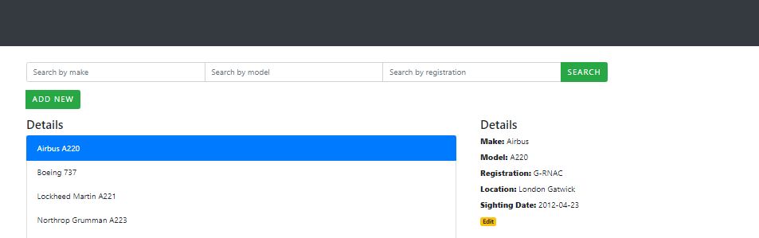

## Create View

