1. Input parking size lot ***NxN***. (N is even).
2. Generate parking spots data.
3. Classify the spots distance base on the formula.

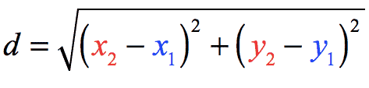

1. Input entrancing car’s destination.
2. Search the list for the available parking spot.
3. Output the first closest available parking spot.