SOUTHERN LUZON STATE UNIVERSITY
COLLEGE OF ENGINEERING
ELECTRICAL ENGINEERING DEPARTMENT

PREDICTION OF SOUTHERN LUZON STATE UNIVERSITY
ELECTRICAL ENGINEERING LICENSURE PERFORMANCE EXAM
BASED ON THE PAST INDIVIDUAL RATING OF STUDENTS AND
EXAMINEES' LICENSURE RATING USING RANDOM FOREST

Abitria, Von Jeferson U.
Anareta, Romell A.
Erandio, John Mark S.

Dr. Efren D. Villaverde
Professor

CHAPTER 1

THE PROBLEM AND ITS BACKGROUND

This chapter presents the introduction, background of the study, statement of the problem, scope and limitation/delimitation of the study, objectives of the study, and significance of the study
INTRODUCTION
In the Philippines, licensure examinations serve as a professional gateway, allowing graduates to practice in their chosen field. Passing a board exam often leads to better employment opportunities, higher income, and greater job security. Because of this, higher education institutions carry the responsibility of preparing students with the knowledge, skills, and competence needed to succeed. One way to assess the effectiveness of a program or curriculum is through the performance of its graduates in licensure examinations.
For Electrical Engineering students, the Registered Electrical Engineer (REE) licensure exam administered by the Professional Regulation Commission (PRC) determines their eligibility to practice as professional engineers. The exam consists of three major components: Mathematics (25%), Engineering Sciences and Allied Subjects (30%), and Electrical Engineering Professional Subjects (45%). To obtain the REE license, examinees must achieve an overall rating of at least 70%.
In recent years, however, the Electrical Engineering board examination performance of Southern Luzon State University has declined compared to the years before the pandemic. Studies show that academic performance, preparedness, and exposure to review programs strongly influence licensure outcomes. At SLSU, pre-board examinations are regularly conducted to support fourth-year students under the new curriculum, and these tests are known to be strong indicators of performance in the board exams.
To better understand the decline and develop a predictive tool that may support future interventions, this study explores the use of machine learning. Specifically, it utilizes the Random Forest algorithm to analyze student grades, pre-board results, and selected behavioral and institutional factors. Unlike complex deep learning methods, Random Forest is an interpretable, efficient, and easier-to-understand approach for educators. By identifying patterns between academic history and board exam performance, the model aims to provide meaningful insights that can help improve student preparation and institutional strategies.

Background of the study

In recent years, the growing availability of student performance data has opened opportunities for higher education institutions to adopt data-driven approaches in improving learning outcomes. Machine learning, particularly supervised learning models, is now widely used for forecasting academic success, identifying at-risk students, and supporting institutional decision-making. In the context of licensure examinations, predictive analytics enable schools to identify patterns in historical test results and academic records, thereby determining which factors have the strongest influence on board exam performance.
Although several machine learning models exist, Random Forest is particularly suitable for educational data due to its interpretability, accuracy, and ability to handle multiple variables at once. Unlike deep learning models that require large, complex datasets, Random Forest performs well even with limited but significant variables, such as grades, attendance, review participation, and subject performance. Its structure, composed of multiple decision trees, enables it to generate reliable predictions while also showing which student characteristics contribute the most to the likelihood of passing the exam.
This study aims not only to predict licensure outcomes but also to identify academic and institutional gaps that may be affecting recent declines in passing rates. This approach supports the university's commitment to continuous improvement and provides a scientific basis for enhancing curriculum delivery, review programs, and student support initiatives.

Statement of the problem
The Registered Electrical Engineer (REE) licensure examination serves as a crucial benchmark for Electrical Engineering graduates, as it determines their readiness to enter professional practice. In recent years, Southern Luzon State University has experienced fluctuations in its REE passing rates, prompting concerns about student preparedness and the overall effectiveness of current academic and support programs. To better understand these outcomes, this study analyzes REE performance data from the past three years and develops a predictive model using the Random Forest algorithm. The model is designed to automatically update based on the most recent three-year dataset, allowing it to reflect evolving trends in student performance and institutional practices.
This study seeks to determine how REE passing rates from 2022 to 2024 compare with previous years and what emerging patterns may be observed. It also examines the academic factors, as course grades, pre-board results, and curriculum components, that may strongly influence licensure outcomes. Additionally, the study explores how institutional elements, including teaching strategies, review programs, and learning resources, contribute to exam performance, as well as personal factors like study habits, motivation, and involvement in academic activities. Ultimately, the study investigates how the Random Forest model can use recent data to identify at-risk students and generate meaningful insights that can guide targeted interventions. Through these efforts, the study aims to support faculty, administrators, and students in enhancing preparation strategies and improving future REE licensure examination results.

Objectives of the study
The primary objective of this study is to develop and train a Random Forest model that can predict the likelihood of students passing the Registered Electrical Engineer (REE) licensure examination using historical data of Electrical Engineering students from Southern State University and historical data of examinees from the Professional Regulation Commission (PRC). The model will analyze academic, personal, and institutional data from the year 2022 to 2025 of examinees, providing actionable insights to improve student performance. The study aims to:

- To identify and model relevant features from the collected data that are hypothesized to significantly influence a student’s performance in the Registered Electrical Engineer (REE) licensure examination.
- To develop and train a Random Forest classification and regression model using processed historical data to predict the probability of an Electrical Engineering student passing the REE licensure examination.
- To evaluate and validate the performance of the developed Random Forest model using appropriate metrics and cross-validation techniques.
- To extract and analyze actionable insights and patterns from the model’s prediction to pinpoint areas of strength and weakness in the current Electrical Engineering curriculum and student support system for interventions

Significance of the study
This study is significant because it provides a data-driven approach to understanding and improving the performance of students taking the Registered Electrical Engineer (REE) licensure examination. By using the Random Forest machine learning algorithm, the research identifies patterns and factors in academic performance, pre-board results, and institutional support that may influence the likelihood of passing the exam. The findings and predictive tool aim to benefit multiple stakeholders in meaningful ways.
For students, the study serves as a guide to identify strengths and weaknesses in their academic preparation. By providing probabilistic predictions of REE outcomes, students can focus their efforts on areas that need improvement, enhance their study strategies, and better prepare for the licensure examination.
For faculty members, the research offers insights into which academic subjects, teaching methods, or pre-board practices have the greatest impact on student performance. This allows educators to adjust instructional approaches, provide targeted interventions, and design review activities that address common challenges faced by examinees.
For the institution, the predictive model supports evidence-based decision-making. It can help administrators identify trends in licensure performance, evaluate the effectiveness of existing curricula and review programs, and implement policies or support systems that enhance student readiness for the REE exam.
For future researchers, this study provides a foundation for further applications of machine learning in educational assessment and in predicting licensure exam scores. It demonstrates how historical academic and behavioral data can be leveraged to develop predictive models that improve understanding of student performance.

Scope and limitation
This study focuses on predicting the performance of students taking the Registered Electrical Engineer (REE) licensure examination using the Random Forest machine learning algorithm. It analyzes historical academic data, pre-board exam results, and selected personal and institutional factors of REE examinees from Southern Luzon State University over the past three years. The research aims to develop a predictive model and a user-friendly interface that allows faculty, administrators, and students to estimate the likelihood of passing the REE exam and to identify areas that may require improvement. The scope is limited to data that is consistently available, including subject grades, cumulative performance, pre-board scores, and other measurable indicators that can influence licensure success.
The quality and completeness of the historical data limit the study. Incomplete records, missing grades, or inconsistent reporting may affect the accuracy and reliability of the Random Forest model. The system also requires manual entry of new exam results, meaning that updates depend on the availability of data after each licensure cycle. Furthermore, the model cannot fully account for unforeseen personal factors, such as changes in motivation, study habits, or other individual circumstances. The predictions generated are probabilistic estimates, intended to guide students and faculty in identifying potential weaknesses and improving preparation strategies. Despite these limitations, the study provides valuable insights into patterns that influence REE performance and offers a practical, data-driven approach to support student readiness and institutional planning.

Definition of Terms
The following terms were defined to have a clear understanding for the readers used by the researchers to comprehend this study, hereby operationally defined.
Registered Electrical Engineer (REE is an individual who has passed the Registered Electrical Engineer licensure examination administered by the Professional Regulation Commission (PRC). In this study, the REE rating serves as the primary outcome variable used to evaluate the accuracy of the predictive model.
Machine Learning Algorithm is a computational method that enables a computer to learn patterns from data and make predictions or decisions without being explicitly programmed. In this study, it refers to using student performance data to predict REE outcomes.
Random Forest is a machine learning algorithm that combines multiple decision trees to improve predictive accuracy. It outputs the most likely result for classification tasks or the average value for regression tasks.
Academic Performance measures the indicators of a student’s success in coursework, including grades, cumulative averages, and pre-board exam results.
Cognitive Factors are the mental abilities and intellectual skills of SLSU Electrical Engineering examinees and how well they understand lessons, absorb information, solve problems, and make sense of complex concepts. These include abilities like memory, reasoning, problem-solving, and comprehension, all of which help students grasp engineering principles and handle challenging questions in the REE licensure exam.
Non-cognitive Factors refer to the personal and emotional qualities of examinees and how motivated they are, how they manage stress, their confidence, study habits, self-discipline, and determination. These traits influence how well students prepare for the exam, even though they are not directly tied to intelligence. When combined with their cognitive abilities, these factors give a fuller picture of each student and help explain why some succeed on the REE licensure exam while others struggle.
Institutional Factors, such as elements related to the university’s programs, resources, teaching methods, and review practices that may influence student performance in the REE exam.
Personal Factors are the characteristics or behaviors of students, such as study habits and engagement in review sessions, that may impact licensure exam outcomes.
UserFriendly Interface where a software tool or dashboard that allows users, such as students and faculty, to easily input data and obtain predictive results from the Random Forest model.
Prediction estimate generated by the Random Forest model indicating the likelihood of a student passing the REE licensure examination.
Board Exam Prediction uses historical academic performance data to forecast students' outcomes in the electrical engineering licensure examinations.
Data Cleaning involves preparing the collected datasets by removing errors, inconsistencies, and irrelevant information. This process includes handling missing or incomplete values, correcting incorrect entries, standardizing data formats, and eliminating duplicate records. Data cleaning ensures that the dataset is reliable, consistent, and suitable for accurate machine learning analysis.
Feature Selection is the process of identifying which academic variables (such as subject grades, overall averages, or specific performance indicators) have the greatest influence on licensure exam outcomes. This step enhances the model’s ability to learn meaningful patterns. By selecting the most significant features, the study ensures that the Random Forest algorithm focuses on variables that contribute most to predictive accuracy.
Model Development refers to the construction of the Random Forest algorithm using the processed and selected features. This step includes splitting the dataset into training and testing subsets, configuring model parameters, and training the algorithm to recognize patterns linking academic performance to licensure exam results. The model is iteratively refined to optimize learning and ensure generalizable predictive capability.
Model Training is within a given dataset. During training, the model analyzes the input variables and learns how these features relate to the output variable. In this phase, 80% of the dataset is fed to the model so it can adjust its structure and create decisions so that it will be used for prediction. refers to the process of teaching a machine learning algorithm to recognize patterns and relationships.
Model Testing is the process where a trained model is fed 20% of the dataset to evaluate how well the model performs on new and unseen data. It assesses the model’s accuracy, and it helps determine whether the model can correctly predict students' licensure exam performance based on their individual ratings.
Performance Evaluation involves assessing how well the trained Random Forest model predicts licensure exam outcomes. This is done by comparing the model’s predictions with actual historical exam results using metrics such as accuracy and precision. Determines the model’s effectiveness and reliability in forecasting examinees' future outcomes and validates its potential use for academic planning and decision making.

CHAPTER 2

REVIEW OF RELATED LITERATURE AND STUDIES

This chapter highlights the different related literature and research studies gathered from trusted books and online sources. Exploring information from various references helped the researchers gain a better and clearer understanding of the study’s focus. The knowledge gathered from these materials also became the basis for building the conceptual framework of the research. Overall, this chapter aims to provide meaningful insights and a stronger background on ideas and studies that are closely connected to the present study.
Related Literature

Machine Learning
Machine learning is one of the most important techniques of educational data mining, and can recognize implicit patterns in student data, as well as make predictions about a student's future learning performance. The analysis of raw educational data, such as student grades, attendance, and learning behavior, provides machine learning methods with the input data to extract applicable information.
Romero and Ventura (2020) emphasize that machine learning techniques enable educational institutions to identify students' weaknesses early, allowing instructors to provide targeted support. These techniques help transform raw educational data into meaningful insights that inform interventions and enhance student success.
According to Reddy (2025) highlights the growing importance of predicting student academic performance in higher education. His study demonstrates that algorithms such as Decision Trees, Random Forest, Support Vector Machines, and Logistic Regression can effectively analyze historical academic records, demographic information, and behavioral factors such as attendance and participation. By applying data preprocessing techniques including normalization, missing value imputation, and feature selection, these models can be trained and evaluated for accuracy, precision, recall, and F1 score. Reddy stresses that data-driven approaches improve prediction accuracy and enable institutions to implement timely support for at-risk students.
Yağcı (2022) conducted a study on undergraduate students in a Turkish Language class to predict final exam grades based on midterm scores, department, and faculty data. The study tested algorithms including Random Forest, Support Vector Machines, and Logistic Regression, with Random Forest performing most effectively. Using data from 1,854 students, the model achieved 70–75% accuracy. This research highlights the utility of machine learning in identifying students at risk of failing and guiding institutions to make informed decisions to enhance learning outcomes.
Khairy et al. (2024) explored the prediction of academic performance among first-year Computer Department students at Damietta University from 2016 to 2021. Using a dataset of 830 student records, the study compared five algorithms: Random Forest, Decision Tree, Naive Bayes, Neural Network, and K-Nearest Neighbours. Random Forest and Decision Tree models achieved the highest predictive accuracy, successfully identifying students requiring additional support. The study underscores the effectiveness of machine learning for proactive interventions to reduce failure rates.
Karim-Abdallah et al. (2025) conducted a systematic review of 60 studies published between 2018 and 2023 on the application of machine learning in predicting student performance. They identified Decision Trees, Random Forests, Artificial Neural Networks, Support Vector Machines, and Naïve Bayes as the most frequently used and effective algorithms. Key predictors of academic performance included students’ educational records, demographics, classroom participation, and exam scores. The review emphasizes that machine learning supports early interventions, personalized learning, and evidence-based decision-making, while also highlighting gaps in the literature for future research.
According to Girisha et al. (2024), data science and machine learning have become valuable tools in the education sector, especially for assessing and predicting student performance. Their study emphasizes that machine learning enables systems to learn from educational data and support decisions that identify low-performing or at-risk students. This approach helps institutions improve accreditation outcomes and allows teachers to better understand students’ difficulties. The review also notes that machine learning algorithms outperform traditional statistical techniques in predicting student performance because they can handle non-linear relationships and large, complex datasets. Researchers emphasize that Machine Learning not only predicts academic outcomes but also helps improve teaching strategies, optimize curricula, and evaluate institutional interventions.
Random Forest Algorithm
Random Forest is a popular machine learning algorithm used for classification and regression tasks, which works by combining the predictions from multiple decision trees in order to improve both accuracy and generalization. This makes it especially useful for working with large datasets with many variables and high complexity.
Schonlau and Zou (2020) highlight the versatility of Random Forest, demonstrating their application in predicting outcomes such as credit card defaults or the popularity of online news articles. They emphasize that the algorithm not only improves prediction accuracy but also provides interpretable insights into the importance of predictor variables, making it a valuable tool for data-driven decision-making in various fields, including education and academic performance prediction.
Prinyanka and Kumar D. (2020) explain that Random Forest employs random feature selection and bootstrap sampling to construct a “forest” of decision trees. This ensemble approach minimizes variance among individual trees, resulting in a more robust model that is less prone to overfitting. The method effectively combines multiple weak learners to produce a strong, reliable predictor.
Speiser et al. (2019) discuss the importance of variable selection in Random Forest modeling. Their study compared several variable selection methods using 311 publicly available classification datasets, evaluating prediction error rates, computation times, and accuracy metrics. They found that approaches such as Jiang’s method and the VSURF R package generally performed best, while varSelRF and Boruta were more efficient for datasets with many predictors. The study underscores that appropriate variable selection can improve model efficiency, reduce data collection efforts, and optimize computational performance when applying Random Forest to complex datasets.
In this study, the Random Forest algorithm was chosen for its ability to handle large and complex datasets with many variables and intricate relationships. Researchers favor this approach not only for its strong predictive accuracy but also for its robustness and the clarity it provides in understanding which factors influence outcomes. As a result, Random Forest proves to be a reliable and practical tool for predicting student academic performance and supporting data-driven decisions in educational settings.
Licensure Examination
Nebrida, Natividad, and Quidit (2024) examined the relationship between academic performance and licensing exam outcomes of Electrical Engineering (EE) and Mechanical Engineering (ME) graduates at Nueva Vizcaya State University over a five-year period. Using a quantitative descriptive-correlational approach with trend and path analysis, the study analyzed data from first-time licensure exam takers. Results indicated a significant correlation between performance in specific subjects and board exam success for both EE and ME graduates. Mathematical models, including linear, logistic regression, and discriminant equations, were developed to predict board ratings and probabilities of passing the exams. Path analysis further clarified the direct and indirect effects of academic achievement on licensure outcomes. The study highlights the predictive value of certain academic accomplishments and underscores the importance of focused curriculum design and targeted student support in engineering education programs.
Ucol (2024) examined how academic performance influences board exam outcomes among Civil Engineering graduates of Nueva Vizcaya State University from 2018 to 2022. The study aimed to identify which academic subjects best predict licensure exam success and how these insights can support curriculum enhancement. Using a descriptive research design, the researcher analyzed students’ grades in Mathematics, Hydraulics, and Design alongside their board exam ratings obtained from institutional records and the Professional Regulation Commission. Results showed that Hydraulics had a moderate positive relationship with board exam performance and significantly contributed to prediction models, while Math and Design displayed weaker or mixed correlations, suggesting the presence of other influencing factors. Regression analysis confirmed Hydraulics as a significant predictor of licensure outcomes, whereas Math and Design showed minimal or negative influence. With the model explaining 85.3% of the variance in board exam results, the study highlights the strong role of academic preparation and recommends strengthening Hydraulics instruction while reassessing the alignment of Math and Design courses with licensure exam competencies.
According to Tarun (2017), data mining classifiers can be effectively used to predict licensure examination performance and support decision-making through a Decision Support System (DSS). In the study, models were generated using WEKA and integrated into a DSS to guide interventions during review sessions. Key predictors of exam success included the reviewees’ General Weighted Average in General Education subjects, results from a Mock Board Exam, and the timing of self-review activities. The study demonstrates that data-driven models not only forecast licensure outcomes but also help educators and review coordinators implement targeted strategies to improve student performance.

Other Relevant Variables
Several studies have explored additional factors that influence academic performance and licensure examination outcomes beyond traditional academic indicators. Ali et al. (2025) highlighted the potential of predictive analytics and machine learning in identifying at-risk learners and providing targeted support. Their study, which focused on a one-year Certification Program in Emergency Medicine in Pakistan, compared regression trees and linear regression models to predict final exam performance. The models successfully identified students likely to perform poorly, allowing educators to provide additional support that improved their outcomes. The study highlights the practical value of data-driven approaches in enhancing educational performance, particularly in low-resource settings, while noting the importance of addressing issues such as algorithmic bias and overfitting.
Ballado‑Tan (2014) investigated the influence of academic performance, personal aspirations, attitudes, and study habits on the success of Accountancy graduates in the CPA licensure examination. The study found that consistent study habits and overall academic preparation significantly affect board exam success, emphasizing the role of disciplined study practices and a positive attitude toward learning in achieving licensure outcomes.
Romero, Valero-Amaro, Rubio, and Miranda (2024) examined how environmental conditions, particularly thermal comfort, affect academic performance in a technical college in southwestern Spain. The study revealed that classroom temperatures within the comfort range of 23–26 °C positively influenced students’ satisfaction and exam performance. Conversely, students experiencing thermal discomfort reported that environmental conditions were a primary barrier to success, even outweighing prior preparation. These findings highlight the importance of creating optimal learning environments to support both student well-being and academic achievement.
Mercado, Aruta, Morante, Gervacio, Alfarero, and Palompon (2025) identified several personal, academic, and economic barriers that impede success in the Licensure Examination for Teachers (LET). Factors such as financial difficulties, poor time management, test anxiety, and personal responsibilities were shown to hinder effective preparation, while weak academic foundations and overconfidence further contributed to exam failure. The study emphasizes that these combined challenges can significantly reduce graduates’ chances of passing licensure exams, highlighting the need for comprehensive support systems that address multiple dimensions of student readiness.
According to Al-Sheeb, Awad, and Al-Mahdi (2019), understanding the factors that influence engineering students’ success is essential for improving retention and preventing early dropout. Their study used the Knowledge, Attitudes, and Behavioral Skills (KAB) model to predict performance among 320 first-year engineering students, applying exploratory factor analysis, regression model selection, and ridge regression. Results showed that combining cognitive and non-cognitive factors improves prediction accuracy. The study emphasizes that students’ attitudes, behaviors, and self-perceived skills significantly affect academic outcomes, helping institutions identify at-risk students early and provide better support.

Related Studies

Local Studies
Several local studies have explored factors influencing academic performance and licensure examination outcomes of engineering students. Maaliw (2021) emphasized that graduates’ performance on licensure examinations serves as a key indicator of institutional effectiveness. Analyzing data from 500 Electronics Engineering graduates at Southern Luzon State University between 2014 and 2019, the study applied multiple machine learning algorithms and found that Random Forest achieved the highest predictive accuracy of 92.7%. By examining 33 variables, including verbal reasoning, reading comprehension, and course grades in mathematics and electrical subjects, the study identified significant predictors of board exam success. Maaliw highlighted that these data-driven insights can guide institutions in designing targeted programs and interventions to enhance student performance on professional licensure examinations.
Similarly, Alimario et al. (2023) investigated the diverse factors affecting the academic performance of Electrical Engineering students, such as academic-related variables, personal attributes, and contextual elements. The study demonstrated that deep feed-forward neural networks effectively captured complex patterns within the data, producing accurate predictions of exam outcomes. Findings revealed that exam performance is shaped by a combination of effective study habits, prior academic achievement, intrinsic motivation, and a supportive learning environment. Additional factors, including teaching quality, peer interactions, health, technology access, and individual characteristics, were also shown to significantly influence student success, underscoring the multifaceted nature of academic achievement and the importance of incorporating diverse variables into predictive modeling.
Nebrida, Natividad, and Quidit (2024) examined the relationship between academic performance and licensure exam outcomes of Electrical Engineering (EE) and Mechanical Engineering (ME) graduates at Nueva Vizcaya State University over a five-year period. Using a quantitative descriptive-correlational approach combined with trend and path analysis, the study analyzed data from first-time licensure exam takers. Results indicated a significant correlation between performance in specific subjects and board exam success for both EE and ME graduates. The study developed mathematical models, including linear, logistic regression, and discriminant equations, to predict board ratings and probabilities of passing the exams. Path analysis further clarified the direct and indirect effects of academic achievement on licensure outcomes, highlighting the predictive value of certain academic accomplishments and emphasizing the importance of targeted curriculum design and student support programs in engineering education.
Batoon and Cabral (2025) focused on predicting the board examination performance of engineering students using machine learning classification algorithms. The study considered academic and preparatory indicators, including general weighted average, pre-board scores, and participation in review programs. Among the models tested, logistic regression achieved the highest predictive accuracy (66.7%), followed closely by Naïve Bayes (66.1%). The findings emphasized the importance of pre-board performance and institutional review programs as predictors of board exam outcomes, demonstrating the potential of predictive analytics to improve educational strategies and student support systems. The study also suggested that including additional variables, such as psychological and behavioral factors, could further enhance the accuracy of prediction models.
Foreign Studies
Several foreign studies have explored the use of machine learning to predict student performance and academic outcomes. Brahim (2022) investigated the application of machine learning models to predict student performance during online learning activities in digital electronics education. The study collected data from students’ interactions in online lab sessions, including text editing, keystrokes, and time spent on each activity, alongside exam scores. A total of 86 statistical features were extracted and categorized by activity type, timing statistics, and peripheral activity count, with only the most influential features retained for model training. Five classifiers, Random Forest, Support Vector Machine, Naïve Bayes, Logistic Regression, and Multilayer Perceptron, were evaluated, with the Random Forest model achieving the highest classification accuracy at 97.4%. The study demonstrated the value of online engagement metrics and machine learning in accurately predicting student performance, offering insights for improving instructional strategies and student support in e-learning contexts.
Similarly, Sixhaxa, Jadhav, and Ajoodha (2022) examined how demographic, academic, and behavioral attributes influence student exam outcomes. Using Mutual Information for feature analysis and five machine learning classifiers—Gaussian Naïve Bayes, Support Vector Machine, Random Forest, K-Nearest Neighbour, and Logistic Regression, the study found that Support Vector Machine achieved the highest accuracy at 81.67%, followed by Random Forest at 78.33%. The findings highlighted the significant role of students’ behavioral patterns in academic performance and reinforced the utility of machine learning as a tool for early identification of at-risk learners.
Yağcı (2022) applied educational data mining and machine learning, including Random Forest, to predict undergraduate students’ final exam grades based on midterm scores, department, and faculty affiliation. The study achieved an accuracy of 70–75%, indicating that early academic performance can effectively forecast later success. These results emphasize the potential of predictive models in identifying students at risk and supporting timely interventions.
Lugoma, Zimbili, Ilunga, Mosia, and Abhishek (2025) focused on predicting student performance in a Structural Analysis 3 module at the University of South Africa using the Random Forest algorithm. Employing a supervised learning approach with assessment marks as features and final marks as labels, the study addressed class imbalance using the Synthetic Minority Oversampling Technique (SMOTE) and class weight adjustments. SMOTE improved overall accuracy by 3% and enhanced precision, recall, and F1-Score, particularly in predicting non-competent students. While RF-SMOTE outperformed the standard RF and RF with class weight adjustments, all three approaches were effective, demonstrating the utility of Random Forest combined with imbalance-handling techniques in academic prediction tasks.
Chen et al. (2024) developed and optimized a decision-tree–based predictive model to forecast students’ academic performance, achieving an average prediction accuracy of 93.11%. The study emphasized that such predictive models allow educators to identify students at risk of underperforming and implement timely interventions to improve learning outcomes. This research highlights the potential of machine learning tools to support educational planning and enhance student success.

- Conceptual Framework
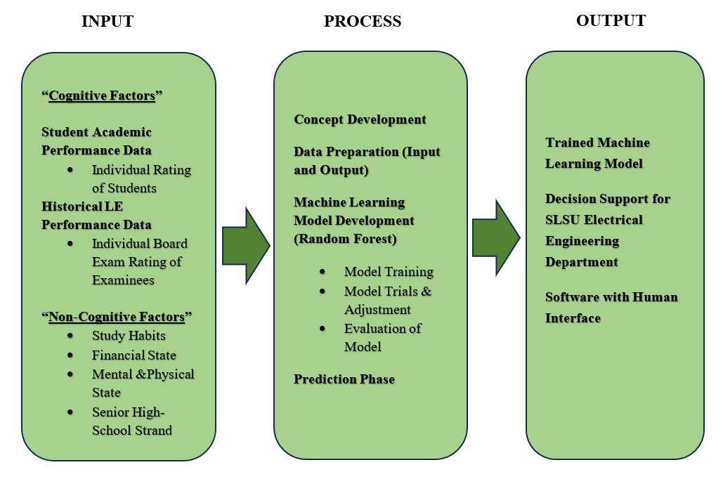
Figure 1. Conceptual Framework
The figure illustrates the study’s conceptual framework, which will systematically developed following an extensive review and analysis of existing literature. This framework integrates the most relevant concepts and findings to establish a comprehensive foundation for the present research.
The study’s input comprises all data needed to develop the prediction model for the licensure exam performance of electrical engineering students at Southern Luzon State University. These inputs include students' past academic performance, such as their grades in major EE subjects from first year to fourth year, and their pre-board exam results, which collectively serve as predictors of their readiness for the licensure exam.
In addition, historical licensure exam results of SLSU individuals who take the board exam are used to establish the relationship between college performance and board exam outcomes. Other relevant variables, such as their study habits, financial state, mental and physical state, and senior high school strand may also be considered. These inputs together will provide the raw data that the model will analyze to identify patterns and make predictions relevant to licensure exam success.
The process involves a series of data preparation and machine learning procedures to convert the collected input data into a meaningful prediction. The data needs to be clean and preprocessed to avoid and correct incomplete and inconsistent records to ensure data quality. Afterward, the Random Forest algorithm is applied to train and develop the predictive model. This machine learning method constructs multiple decision trees and aggregates their output, allowing it to learn complex patterns between individual academic ratings and individual licensure exam ratings results. The model is then evaluated using accuracy and error metrics to ensure reliability. After validation, the model is used to predict the licensure exam ratings of current or future students based on their academic performance data.
The output includes a trained machine learning model which can predict licensure exam rating for students, and provide an estimation of their expected performance in the Registered Electrical Engineering Licensure Examination. The machine learning model may also generate the likelihood or probability of passing the exam, giving students a clearer picture of their readiness for the board exam. Additionally, the model Random Forest identifies the most influential variables contributing to exam performance, which is valuable insights for educators and administrators. These results can help the EE department and university to strengthen academic interventions to be able to enhance review programs and support students who may be at risk, ultimately serving as a data-driven tool for improving student outcomes in the licensure exam.
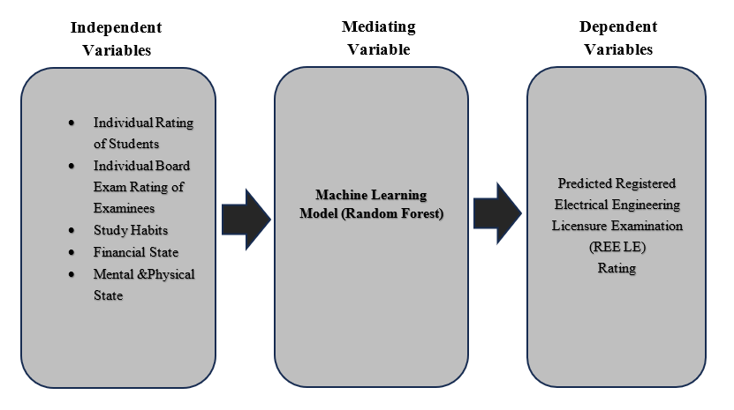
- Research Paradigm

Figure 2. Research Paradigm
- Experimental Research, Assumptions

This study employs a quantitative experimental research design using machine learning techniques to predict the licensure examination performance of Electrical Engineering students at Southern Luzon State University. The following assumptions were established to ensure validity, reliability, and consistency throughout the computational experiment:

1. Assumptions About the Data

1.1 Completeness of Academic Records
It is assumed that all students' academic records, including grades in Mathematics, Engineering Sciences and Allied Subjects, and Electrical Engineering Professional Subjects from first year to fourth year, are complete and accurately encoded.

1.2 Accuracy of Pre-Board and Licensure Results
The study assumes that the pre-board examination scores and PRC licensure results reflect the actual performance of the students and contain no discrepancies or erroneous entries.

1.3 Consistency of Curriculum and Grading Standards
The academic grading system and Subject Learning Outcomes (SLOs) implemented during the years included in the dataset (2022–2025) are assumed to be consistent enough for comparative analysis.

2. Assumptions About the Examinees

2.1 Academic Performance Represents Actual Knowledge
It is assumed that the academic grades and pre-board exam results genuinely represent the students' mastery of their subjects and are not influenced by cheating, grade inflation, or external factors.

2.2 Students' Effort During Assessments is Sincere
The study assumes that students exerted genuine effort during their pre-board examinations and coursework, ensuring that the collected performance data reflect real abilities and competencies.

3. Assumptions Related to the Machine Learning Experiment

3.1 Suitability of the Random Forest Algorithm
The Random Forest model is assumed to be appropriate for predicting licensure outcomes due to its ability to handle multiple variables, non-linear relationships, and noisy datasets.

3.2 Stability of Predictive Patterns
The historical relationships between academic performance and licensure examination results are assumed to be stable and representative, allowing the model to generalize future predictions reliably.

4. Assumptions Concerning Institutional and Personal Variables

4.1 Consistency of Academic Support and Review Programs
Institutional interventions such as faculty teaching methods, availability of learning resources, and review programs provided by the university are assumed to be consistently implemented throughout the examined years.

4.2 Personal Factors Are Accurately Reported
If student personal variables (e.g., study habits, motivation, financial concerns, mental readiness) are collected via survey, it is assumed that responses are truthful and free from exaggeration or underreporting.

5. Assumptions About the Application of the Predictive Model

5.1 User Inputs Will Be Accurate
It is assumed that faculty, administrators, and students who use the predictive system will input accurate academic data to ensure valid results.

5.2 The Model Will Be Used Responsibly
It is assumed that predictions generated by the system will be used only as a guide for academic intervention and not as a basis for discrimination, early labeling, or restrictive decision-making.

- Operational Definition of Variables

Independent Variables (Predictor Variables) refer to the academic, preparatory, cognitive, non-cognitive, and institutional indicators used as inputs to the predictive models.
- Academic Performance Indicators include the students’ total General Weighted Average (GWA) and subject-specific academic performance in Mathematics, Electrical Engineering (EE), and Engineering Sciences and Allied Subjects (ESAS) under the SLSU curriculum, particularly the integrative courses taken during the fourth year. These variables are expressed as numerical grades or percentage equivalents and serve as primary predictors of licensure examination performance.
- Pre-Board Examination Results refer to the students’ scores obtained from institutional pre-board or mock licensure examinations. The results are expressed as percentage scores and are used to represent the examinees’ level of readiness prior to taking the actual REE licensure examination.
- Survey-Based Factors have the variables derived from a structured questionnaire designed to measure performance-related factors affecting licensure examination outcomes. The survey includes the following domains: educational background, board examination preparation, cognitive factors, non-cognitive factors, and institutional factors. Responses for each domain are collected using Likert-scale items, aggregated, and normalized into percentage scores to ensure comparability and suitability for machine learning analysis. Some parts of the General information variables are excluded from the predictive models to minimize bias and retain only variables directly related to performance.
Dependent Variables (Target Variables) represent the outcomes predicted by the Random Forest models.
- Licensure Examination Outcome (Classification Target) refers to the examinee’s Registered Electrical Engineer (REE) licensure examination result, categorized as Pass or Fail based on the official Professional Regulation Commission (PRC) standards. This variable serves as the target output of the Random Forest classification model.
- Licensure Examination Rating (Regression Target) refers to the examinee’s overall PRC licensure examination rating, expressed as a percentage. It is used as the target output of the Random Forest regression model, which estimates the expected performance level of an examinee.

CHAPTER 3

METHODOLOGIES
The study will adopt a quantitative, predictive research design using machine learning, specifically the Random Forest algorithm, to estimate students’ likelihood of passing the licensure exam. The design will include systematic data collection, preprocessing, model development, and validation phases.

- Research Design
In this study, a predictive research design utilizing quantitative methods will apply machine learning with two predictive models using the Random Forest algorithm: a classification model and a regression model. The classification model aims to predict the licensure examination outcome of an examinee, categorized as either pass or fail, while the regression model estimates the overall Registered Electrical Engineer (REE) licensure examination rating expressed as a percentage.
The independent variables used in both models consist of students’ cumulative academic indicators, including total General Weighted Average (GWA), subject-specific performance in Mathematics, Electrical Engineering (EE), and Engineering Sciences and Allied Subjects (ESAS), and selected survey-based factors.
These survey-based factors include educational background, board examination preparation, cognitive factors, non-cognitive factors, and institutional factors, which were quantified and normalized into percentage scores to ensure consistency during model training. General information variables were intentionally excluded from the prediction process to minimize bias and retain only performance-related predictors. This structured variable framework supports a transparent and reliable machine learning approach for predicting licensure examination performance.

- Research Project Development

Preliminary Investigation/Conceptualization
Before starting the main research, an initial investigation will be conducted to understand the current performance of Electrical Engineering students at Southern Luzon State University in the REE licensure exam. This will involve looking at past data, including students' grades, pre-board exam results, and previous board exam outcomes from 2022 to 2025. From this initial review, several observations will be made:
- Board Exam Performance is Declining: Students' passing rates appeared to be declining in recent years, especially in key subjects like Mathematics, Engineering Sciences, and Electrical Engineering Professional Subjects.
- Academic Preparation Matters: Students' performance in their college courses influences how well they perform on the licensure exam.
- Cognitive, Non-cognitive, and Institutional Factors: Study habits, mental readiness, stress levels, review programs, and teaching methods may affect students' results.
Based on these observations, the study will be designed to create a predictive model using the Random Forest machine learning algorithm. This model will analyze students' academic performance, pre-board exam results, cognitive and non-cognitive factors, and institutional factors to predict the likelihood of passing the REE exam.
The conceptual framework will follow a straightforward flow: it will take student data as input, process it through the machine learning model, and produce predictions about licensure exam performance. This will allow users to view data-driven insights in an organized, visual, and easy-to-understand format.
Figure 3.1 Block Diagram of the Predictive System for REE Licensure Examination Performance
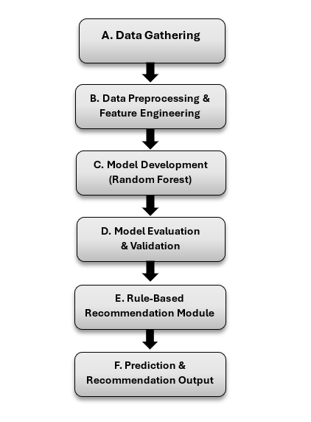
Figure 3.1 illustrates the overall block diagram of the predictive system developed for estimating Registered Electrical Engineer (REE) licensure examination performance. The system begins with the Data Gathering block, which collects academic records, pre-board examination results, and survey-based data from Electrical Engineering graduates. These inputs are then transmitted to the Data Preprocessing and Feature Engineering block, where data cleaning, handling of missing values, encoding of categorical variables, normalization, feature aggregation, and feature selection are performed to ensure data quality and suitability for machine learning analysis.
The processed dataset is subsequently fed into the Model Development block, which utilizes two Random Forest models: a classification model that predicts the likelihood of passing or failing the licensure examination and a regression model that estimates the expected PRC licensure examination rating. The predictive outputs are then assessed in the Model Evaluation and Validation block using appropriate performance metrics and cross-validation techniques to ensure accuracy, reliability, and generalizability of the models.
After validation, the results are passed to the Rule-Based Recommendation Module, which interprets the predicted outcomes using predefined logical rules to identify areas of academic strength and weakness. Finally, the system generates the Prediction and Recommendation Output, which presents the predicted licensure examination results and corresponding academic improvement recommendations through a web-based interface. This final output serves as the basis for evaluating the practical usefulness, clarity, and effectiveness of the predictive system in supporting examinees’ licensure preparation.

A. Data Gathering
The study collects data from two main sources to build a reliable prediction model: official PRC records and a structured survey administered to SLSU Electrical Engineering first-time examinees.
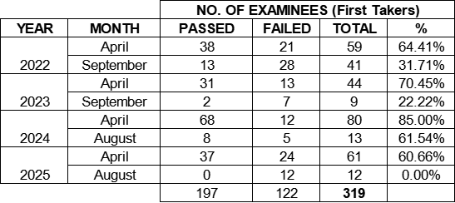
Table 1: Number of examinees starting in the year 2022 to 2025.

Only first takers from 2022 to 2025 will be included to ensure a consistent and accurate assessment of initial licensure performance. The PRC provides individual ratings for all three components of the REE exam.
• Mathematics (25%)
• Engineering Sciences and Allied Subjects – ESAS (30%)
• Electrical Engineering Professional Subjects (45%)
To complement these exam results, institutional academic records such as total generated weight average (GWA) grades and pre-board performance are gathered. A survey was conducted to capture additional variables that contribute to licensure readiness, including:
• Educational Background, Board Examination Preparation, Cognitive factors
(study habits, comprehension, academic preparedness)
• Non-cognitive factors
(motivation, anxiety, time management, confidence)
• Institutional factors
(quality of instruction, review program availability, learning resources)
All collected data are validated, organized, and prepared for analysis. With these datasets complete, the study will proceed to the next phase:
B. Data Preprocessing & Feature Engineering
Data preprocessing and feature engineering were conducted to ensure the quality, consistency, and suitability of the dataset for machine learning analysis. These procedures transformed raw academic records, licensure-related data, and survey responses into structured and meaningful inputs for model development. The preprocessing tasks were performed using a combination of Google Sheets for initial data organization and validation, and Google Colab for systematic data processing and machine learning implementation.
Handling of Missing Values.
Missing values were identified during the cleaning phase. For numerical variables such as GWA, subject grades, and pre-board examination scores, missing values were handled through appropriate imputation techniques, such as replacing missing entries with the mean or median of the corresponding variable. For survey-related responses, incomplete entries were either imputed based on the respondent’s available answers or excluded when necessary to preserve data integrity. These procedures were implemented primarily in Google Colab using Python-based data processing libraries.
Encoding of Categorical Variables.
Categorical variables, including survey responses and academic classifications, were transformed into numerical representations to facilitate machine learning processing. Label encoding and one-hot encoding techniques were applied depending on the nature of the variable, ensuring that categorical data were properly interpreted and executed in Google Colab using Python libraries to ensure compatibility with the Random Forest algorithm.
Likert-Scale Conversion and Feature Aggregation.
Survey responses measured using Likert-scale items were converted into numerical values and aggregated to represent composite scores for each survey domain, such as cognitive, non-cognitive, educational background, board examination preparation, and institutional factors. These aggregated scores were then transformed into percentage values to standardize the scale across respondents and improve comparability among features. Initial aggregation was performed in Google Sheets, while normalization and verification were conducted in Google Colab.

Feature Engineering and Selection.
Feature engineering techniques were applied to derive meaningful predictors from raw data, including the combination of related academic variables and normalization of feature values where applicable. Feature selection was then conducted using statistical analysis and model-based importance measures, such as permutation importance and information gain derived from the Random Forest models. This process identified the most relevant predictors, including academic grades, pre-board examination results, and survey-based factors, while removing redundant or less informative variables. The selected features enhanced model performance, reduced computational complexity, and improved interpretability. Feature selection procedures were implemented in Google Colab.
Correlation and Test Analysis
- Pearson Correlation Coefficient
Determine the coefficient of each input variable in the prediction of the performance rating of the EE licensure examination of SLSU.
The Pearson Correlation Coefficient is used to measure the strength and direction of the linear relationship between two continuous variables. This study helps determine whether variables such as GWA, cognitive factors, or institutional factors are significantly related to the EE licensure examination rating. It shows whether an increase or decrease in one variable is associated with an increase or decrease in another. The interpretation of the correlation coefficient is presented in the table. 2.0.
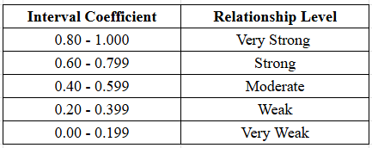
Table 2.0 Correlation Coefficient Interpretation

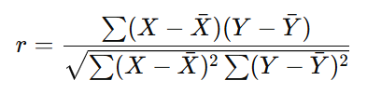
The Pearson Correlation Coefficient will be calculated using formula 1.0.
Eq. 1.0

Based on Equation 1.0, the r represents the Pearson correlation coefficient and presents the formula for determining the correlation between variables. In this equation, X represents the values of the independent variables, while Y represents the values of the dependent variable. The symbol X̄ denotes the mean (average) of the independent variable values, and Ȳ denotes the mean (average) of the dependent variable values. The symbol r indicates the strength and direction of the relationship between X and Y.

- Point-Biserial Correlation
The point-biserial correlation is used to measure the relationship between one continuous variable and one dichotomous (binary) variable. In this study, it can be used to determine whether variables such as GWA or average cognitive scores are significantly related to the EE licensure examination result (Pass = 1, Fail = 0). It helps identify whether differences in academic or personal factors are associated with passing or failing the board exam.
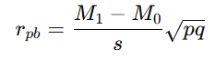
Eq. 1.1

Based on Formula 1.1, the M1 represents the mean score for the entire test of the group that received the positive binary value (1), while M0​ represents the mean score for the entire test of the group that received the negative binary value (0). Sn​ denotes the standard deviation of the entire test scores. Meanwhile, p refers to the proportion of cases in the “0” group, and q refers to the proportion of cases in the “1” group.

- Chi-Square Test
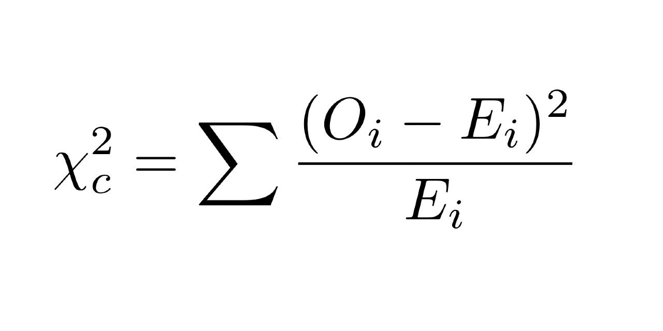
The Chi-Square test is a statistical method used to determine whether there is a significant association between two categorical variables. It evaluates whether the observed frequencies in each category differ from the frequencies that would be expected if there were no relationship between the variables. In research studies, the Chi-Square test is commonly used to test hypotheses about relationships or independence between variables, such as examining if non-cognitive factors are related to passing or failing the licensure examination.
Eq. 1.2

Based on Formula 1.2, c represents the degrees of freedom, O represents the observed value in each category, and E represents the expected value for that category.
Data Cleaning and Validation.
Initial data cleaning was performed in Google Sheets to identify and correct inconsistencies, duplicate entries, and out-of-range values in the dataset. Records with incomplete or invalid entries were reviewed, and entries with minimal missing information were retained to preserve the overall sample size. This step ensured that the dataset accurately represented the academic and survey profiles of the respondents.

Data Splitting
After data preprocessing and feature selection, the dataset was organized based on the year of examination to support both model development and post-deployment evaluation. Historical data from 2022 to 2024 were used for model development, while data from 2025 were reserved for post-deployment prediction and evaluation purposes. This temporal separation ensured that the models were trained using past data and evaluated using more recent, real-world data, thereby strengthening the assessment of model generalizability.

Within the 2022–2024 dataset, an 80:20 training–testing split was applied. The training subset was used to develop both the Random Forest classification and regression models, while the testing subset was used to evaluate initial model performance on unseen data. This approach allowed for internal validation during model development while maintaining an independent dataset for deployment-level evaluation.
After deployment, predictions generated for the 2025 examinees were compared with actual licensure examination results to reassess model performance. Following evaluation, the 2025 dataset may be incorporated into the existing training data and encoded using the same preprocessing and feature engineering procedures to update and retrain the models. The updated models are intended for use in predicting licensure examination performance of the upcoming 2026 examinees, ensuring that the system remains current and continuously improves over time.
All data splitting, encoding, and model updating procedures were implemented using Google Colab as part of the machine learning workflow.

C. Model Development
This part of the study is a critical stage as it transforms the preprocessed data into predictive models capable of estimating licensure examination performance. The Random Forest algorithm was selected as the primary machine learning technique due to its ability to handle complex, nonlinear relationships and multiple predictor variables without requiring strict statistical assumptions.
The Random Forest classification model was designed to predict whether an examinee is likely to pass or fail the Registered Electrical Engineer (REE) licensure examination. In parallel, a Random Forest regression model was developed to estimate the examinee’s overall PRC licensure examination rating, expressed as a percentage. Both models utilized the same set of predictor variables, including academic performance indicators, pre-board examination results, and aggregated survey-based factors.
Model training was conducted using the training dataset (80%), allowing the algorithm to learn patterns and relationships among the predictor variables and target outcomes. The models were implemented using Python-based machine learning libraries, particularly scikit-learn, with supporting libraries such as pandas and numpy for data handling and transformation. The development process was executed in Google Colab, which provided a cloud-based environment suitable for iterative experimentation and reproducibility. This dual-model approach ensured that the system could provide both categorical predictions and quantitative performance estimates, thereby enhancing the practical usefulness of the study.

D. Model Evaluation and Validation
Model evaluation and validation were conducted to assess the accuracy, reliability, and generalizability of the developed predictive models. Because the study employed both classification and regression approaches, separate evaluation criteria were applied to each model type.
For the classification model, performance was assessed using accuracy, precision, recall, and F1-score, supported by confusion matrix analysis to examine correct and incorrect predictions. These metrics collectively measured the model’s effectiveness in predicting licensure examination outcomes and its ability to correctly identify examinees at risk of failing.
For the regression model, predictive performance was evaluated using Mean Absolute Error (MAE), Root Mean Square Error (RMSE), and the coefficient of determination (R²). These metrics quantified the magnitude of prediction errors and the proportion of variance in licensure examination ratings explained by the model.
To ensure stability and prevent overfitting, k-fold cross-validation was applied to both models. Feature importance analysis derived from the Random Forest algorithm was also conducted to identify the most influential predictors affecting licensure examination performance.
All evaluation procedures were implemented in Google Colab using scikit-learn and visualization libraries such as matplotlib.

E. Rule-Based Recommendation Module
To enhance interpretability and practical applicability, a rule-based recommendation module was integrated into the predictive system. This module operates as a post-processing component that translates model predictions into meaningful academic recommendations.
The rule-based logic analyzes the outputs of the classification and regression models alongside key predictor variables, such as subject-level academic performance and survey-based factor scores. Based on predefined academic thresholds and identified areas of weakness, the module generates targeted recommendations aimed at improving licensure examination readiness.
The rule-based system was designed using transparent IF–THEN logical conditions, allowing recommendations to be easily understood by students, faculty, and administrators. The conceptual design of the rule logic was developed within the research framework, while its implementation was executed using Python programming in Google Colab.

F. Prediction & Recommendation Output
The final stage of the study focuses on generating, presenting, and evaluating predictive results and academic recommendations derived from the developed models. The system outputs include the predicted licensure examination outcome (pass or fail), the estimated PRC licensure examination rating, and personalized academic improvement recommendations generated through the rule-based recommendation module. These outputs are intended to support examinees in identifying areas requiring improvement prior to taking the Registered Electrical Engineer (REE) licensure examination.
To enhance usability, accessibility, and visualization of the predictive results, the trained classification and regression models were integrated into a web-based system. The system allows users to input their academic records and survey responses through an interactive interface, after which the data are processed using the trained Random Forest models. The predicted outcomes and corresponding recommendations are then displayed in a clear and user-friendly format to facilitate understanding and practical application of the results.
Following deployment, the web-based system also serves as a platform for post-deployment model evaluation using real-world data. Prediction records generated by the system are stored together with the corresponding input variables. Once actual licensure examination results become available, particularly for the 2025 PRC REE examinees, the predicted outcomes are aligned with the actual examination results to form a post-deployment evaluation dataset. This dataset enables the reassessment of model performance using the same evaluation metrics applied during the model development phase.
For the classification model, predicted pass or fail outcomes are compared with actual licensure results, and performance metrics such as accuracy, precision, recall, and F1-score are recalculated. For the regression model, predicted licensure ratings are compared with the actual PRC ratings of the 2025 examinees, and error-based metrics, including Mean Absolute Error (MAE), Root Mean Square Error (RMSE), and the coefficient of determination (R²), are recomputed. The recalculated metrics are then compared with baseline performance results obtained during initial testing and cross-validation to assess predictive consistency and model stability.
If notable performance degradation is observed, the system supports a feedback mechanism whereby newly collected data from the 2025 examinees may be incorporated into the training dataset. The models may then be retrained and revalidated following the same preprocessing, feature selection, and evaluation procedures described in this chapter before redeployment. This iterative evaluation and refinement process ensures that the predictive system remains accurate, reliable, and relevant over time.
Overall, the prediction and recommendation output module not only delivers actionable insights to users but also functions as a continuous evaluation mechanism that strengthens the credibility, sustainability, and real-world applicability of the proposed predictive system.

