De La Salle University

College of Engineering

Electronics and Communications Engineering

# 

# LBYEC4A — EK1

# 

# **Audio Denoising via Wavelet Transform**

Submitted by:

LARIZA, John Randell Q.

VERA CRUZ, John Ignatius M.

# 

Submitted to:

Ramon Stephen L. Ruiz

**ABSTRACT**

**Background:** When it comes to signal processing, noise is a problem since it can skew the information contained by the signal. It may be difficult or perhaps impossible to decode signals with this much noise. In signal processing, there are what we call filters which basically extract certain information or features from a signal. This project is focused on the utilization of wavelets in denoising audio signals via the use of MATLAB. Wavelets from different wavelet families were used in denoising or filtering an audio signal with an applied artificial gaussian noise. The wavelet filtered signal is then compared with the clean signal prior to it having gaussian noise, the comparison was done via cross correlation. Wavelets from different wavelet families, specifically; Coiflet, Symlet, and Daubechies were used and were then compared based on their denoising performances. Double wavelet filtering was also demonstrated wherein two successive wavelet transforms are applied to the audio to further filter noise from the signal. Cross correlation results showed that all the wavelet performances had been successful as they all have cross correlation values of over 95%.

**Keywords:** *Wavelet transform, MATLAB, Wavelet filtering, Coiflet, Symlet, Daubechies*

1. **INTRODUCTION**
   1. **Brief Background**

Signal quality can be significantly harmed by noise in a range of applications, including communication, data processing, and imaging. It is a ubiquitous and disruptive factor. It is an undesired addition to a signal that can be caused by ambient elements, electromagnetic interference, electrical components, and other things. Noise can significantly alter a signal, and can even mask the content or information behind the signal. Noise and distortion, which alter the signals and reduce their precision, are the greatest enemies of all audio transmissions. Noise impedes data transmission, particularly in telecommunications (Deliyski et al., 2005).

The main objective of this project is to improve the clarity of audio signals by removing noise. The software, MATLAB, offers numerous functions when it comes to signal processing. Various toolboxes by MATLAB were utilized in denoising audio signals including; the Wavelet Toolbox, the Communications Toolbox, and the Econometrics Toolbox. The researchers decided to tackle wavelet transform as means for denoising signals due to unique methods. As opposed to Fourier Transform, where it only creates a representation of a signal in the frequency domain, a wavelet transform creates a representation of the signal in both the frequency and the time domain making signal analysis more efficient (Zhang, 2019).

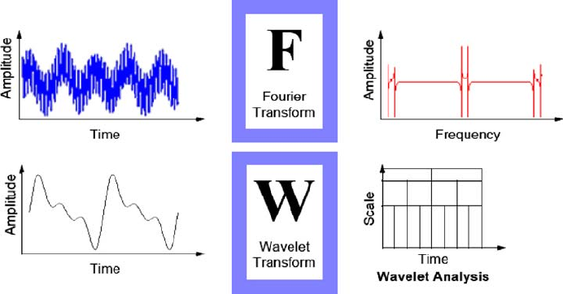

Figure 1: Fourier Transform and Wavelet Transform

The chosen wavelets for this project are; Coiflet5, Daubechies 9, and Symlet2. For Coiflet wavelets, these wavelets are orthogonal, and are widely used in signal processing due to their ability to accurately represent signals with smooth and rapid changes which is why they are especially useful for signal analysis that exhibit irregular and non-uniform structure, such as speech signals (Huang & Hsieh, 2002). Daubechies wavelets are wavelets that have the ability to maintain the quality of the signal while at the same time, providing high compression ratios (Vonesch, 2007). Symlet wavelets are also widely used in signal processing, and they may also be used for feature extraction, which focuses on identifying particular patterns or characteristics in a signal (Yadav et al., 2015). They are similar to Daubechies wavelets but a little better due to them having a slightly different shape allowing them to perform better with certain kinds of signals.

* 1. **Objectives**

The following were the objectives of the project:

* To produce a significantly denoised audio signal via wavelet transforms.
* To utilize correlation functions to compare performances of different wavelet transforms.
* To rule out which wavelet or combination of wavelets perform best in audio denoising.

1. **THEORETICAL CONSIDERATION**

**Wavelet Transforms:**

Signal processing, image compression, and pattern recognition all benefit from the use of wavelet transforms, a potent mathematical technique. A mathematical operation known as a wavelet transform breaks down a signal into a series of wavelets, which are localized oscillations that have a finite energy. The wavelet change gives a more effective method for investigating signals than the customary Fourier change, which deteriorates a sign into a progression of sinusoidal capabilities. Wavelet transforms are well-suited for analyzing signals with localized features, such as image edges or sharp changes in a time series, which is one of their main advantages (Burrus, 2015). Wavelet changes likewise give a more reduced portrayal or representation of a signal, when contrasted with the Fourier change, which requires an enormous number of sinusoidal functions to address a signal completely.

**Coiflet Wavelets:**

Signal processing tasks like image compression, denoising, and feature extraction all make use of the coiflet wavelet, a type of wavelet function. The Coiflet wavelet function is suitable for numerous practical applications due to its desirable properties of orthogonality, symmetry, compact support, and high vanishing moments. Numerous signal processing applications have utilized coiflet wavelets (Wei, 1998). For instance, they have been utilized in picture pressure calculations like the EZW calculation and the SPIHT calculation. Denoising techniques like the wavelet shrinkage method and the Bayesian wavelet shrinkage method have also made use of them. In addition, applications for feature extraction like texture analysis and shape analysis have made use of Coiflet wavelets.

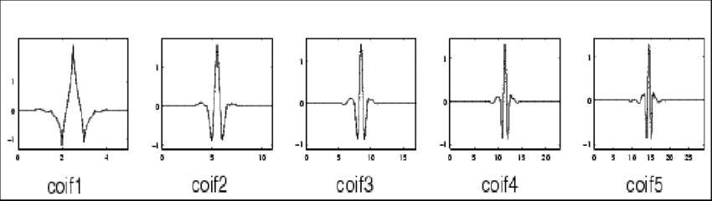

Figure 2: Coiflet wavelets

**Daubechies Wavelets:**

In signal processing, image compression, and other related fields, the orthogonal wavelets in the Daubechies wavelet family are frequently utilized. Daubechies wavelets' ability to efficiently and accurately approximate signals with few coefficients is one of their main advantages (Ma et al., 2003). This property has made them popular in image and signal compression algorithms, where reducing the number of coefficients is crucial to efficient storage and transmission. The idea of multiresolution examination, which licenses signs to be dissected at different scales and goals, fills in as the establishment for the Daubechies wavelets.

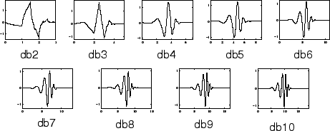

Figure 3: Daubechies wavelets

**Symlet Wavelets:**

In digital signal processing, symlet wavelets are used for data compression, noise reduction, and feature extraction. They are derived from Daubechies wavelets, which are a group of symmetrical wavelets with compact support. The Symlet wavelet family can better represent signals with smoother variations because it is designed to have more vanishing moments than the Daubechies family. Each member of the Symlet wavelet family has a different number of vanishing moments, ranging from 2 to 10. Among the many applications of symlet wavelets are biomedical signal analysis, speech recognition, and image processing (Awal et al., 2014).

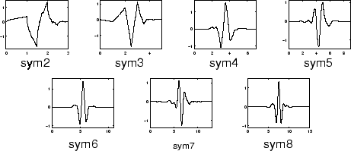

Figure 4: Symlet wavelets

1. **METHODOLOGY**
2. **Project Design**

This project only uses the software MATLAB. For the program to work, three toolboxes must be installed; the Communications Toolbox, the Econometric Toolbox, and the Wavelet Toolbox. The Communications Toolbox is mainly utilized for signal processing in communications applications involving equalization, waveform generation, and many more. The Econometric Toolbox is useful for the cross correlation part of this project where the performances of different wavelet transforms are compared. The Wavelet Toolbox is the most important as it provides a comprehensive set of tools for utilizing wavelet transforms to analyze and process signals. This toolbox is not only used in audio processing but also image processing and feature extraction as well.

The wavelets used are all orthogonal wavelets, and not biorthogonal. This is because biorthogonal wavelets perform better in denoising images and not audio. The specific wavelets chosen were; Coiflet5, Daubechies 9, and Symlet2. The Coiflet5 was chosen because a study from 2012 shows that the Coiflet5 performs best in denoising signals affiliated with music involving 2048 samples (Verma et al., 2012). Another study in 2012 demonstrates the performances of both Coiflet 5 and Daubechies 9 which concludes that they both showed best performances and results in audio denoising; which is why Daubechies 9 was the 2nd chosen wavelet to be used and tested in this project. In another study in 2017, the Symlet 2 wavelet, as well as two more wavelets (Daubechies 8 and Haar) were proven to be best performing in audio processing (Thiruvengatanadhan, 2017). These studies helped the researchers decide which wavelets to be used for testing in this project.

1. **Implementation**

When the necessary software and toolboxes are installed, the code may already be executed. The program starts with an audioread() function which allows the user to input an audio file into MATLAB. After the audio signal was inputted, next is to add an artificial white gaussian noise to that audio using awgn() function. The user shall input a preferred SNR value for the gaussian noise to be added. The lower the SNR, the noisier the audio signal is. Next is to use the audiowrite() function to create a new file for the artificially noised signal.

The second part of the program is the main wavelet integration onto the signal. The value for alpha is a tuning parameter for the penalty term according to MATLAB. The representation of the wavelet packet of the denoised signal sparsity will depend on the alpha value since the sparsity grows with it. In this project, the alpha value is set to 2. The “keepapp” option basically specifies whether or not the approximation coefficients (coefficients at the highest level of the decomposition tree) should be retained in the filtered or denoised signal.

For the first wavelet, the Coiflet 5 wavelet is used. Using “wname”, the wavelet is introduced and the decomposition level is set as well. The decomposition level chosen for all the wavelets in this experiment is 10. The wpdec() function performs the wavelet packet decomposition of the signal, using the specified wavelet and decomposition level. The resulting decomposition tree is stored in the tobj1 variable. Next is to use the wpcoef() function which extracts the wavelet coefficients at level 2 (same level applied in all the wavelets to be tested) of the decomposition tree, which correspond to the detail coefficients. These coefficients are stored in the det1 variable. Next is to use both the median() and the wpbmpen() functions to estimate a threshold for the detail coefficients. The median function calculates the median absolute value of the detail coefficients, and the wpbmpen function uses this value to calculate a threshold based on a Bayesian method. The threshold is stored in the thr1 variable. Lastly, the wpdencmp() function performs a wavelet packet denoising of the signal using the threshold thr1 and the option 's' to shrink the detail coefficients that are larger than the threshold. The 'nobest' option specifies that the denoised signal should be reconstructed using the same decomposition tree as the original signal, and the 'keepapp' option specifies that the approximation coefficients (the coefficients at the highest level of the decomposition tree) should be retained in the denoised signal. The main denoising of the signal is done in the function wpdencmp(), and this denoised signal is stored in the “xdcoif5” variable.

For denoising the signal with the Daubechies 9 and the Symlet2 wavelets, the same exact procedure performed in Coiflet5 denoising is followed, just in different variables. The functions to be used remain the same.

The next part of the program is to apply two-stage wavelet-based denoising on audio signals. The first test involves the use of Symlet2 wavelet to filter the Coiflet5 denoised signal which was performed previously. The filtering using Symlet2 wavelet follows the same procedure once again performed in the previous steps. The same functions and the same decomposition levels are used. The Daubechies9 filtering for the Coiflet5 denoised signal, and the Daubechies9 filtering for the Symlet2 denoised signal follows the same procedure performed in the previous steps as well.

The next part would involve the use of cross correlation techniques in MATLAB. A “z” vector is defined which has a range of -20 to 20 with a step size of 1. By using the crosscorr() function in MATLAB, the filtered signals will then be compared with the original clean audio signal that was inputted by the user at the very beginning of the project. There are a total of 6 filtered signals; Coif5 Filtered Signal, Sym2 Filtered Signal, Db9 Filtered Signal, Sym2 Filtered Coif5 Filtered Signal, Db9 Filtered Coif5 Filtered Signal, and lastly, Db9 Filtered Sym2 Filtered Signal. The cross correlation of these signals with the original clean audio signal will then be plotted to see and compare their performances in denoising the original signal.

1. **RESULTS**

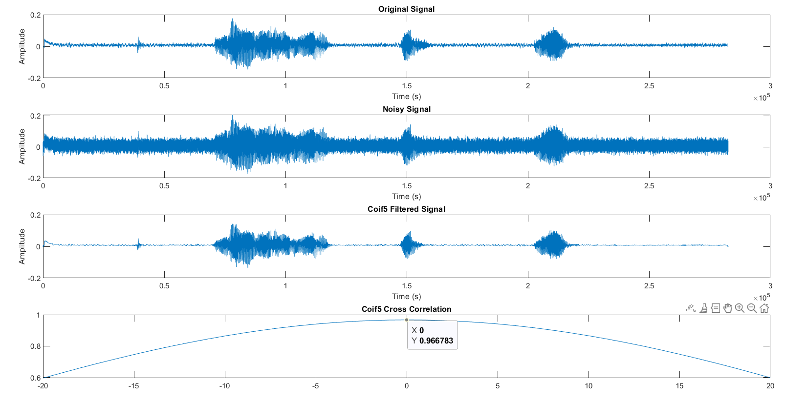

In the figures above, the time domain graphs for the Original Signal, Noisy Signal, and the Coif5 Filtered signal are shown. The cross correlation results between the Coiflet 5 Filtered Signal and the Original Signal is around 96.67% or 0.966783 to be exact.

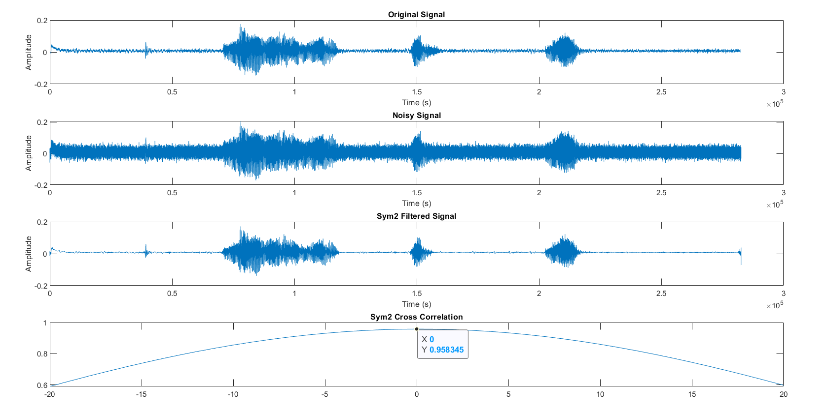

In the figures above, the time domain graphs for the Original Signal, Noisy Signal, and the Sym2 Filtered signal are shown. The cross correlation results between the Symlet 2 Filtered Signal and the Original Signal is around 95.83% or 0.958345 to be exact.

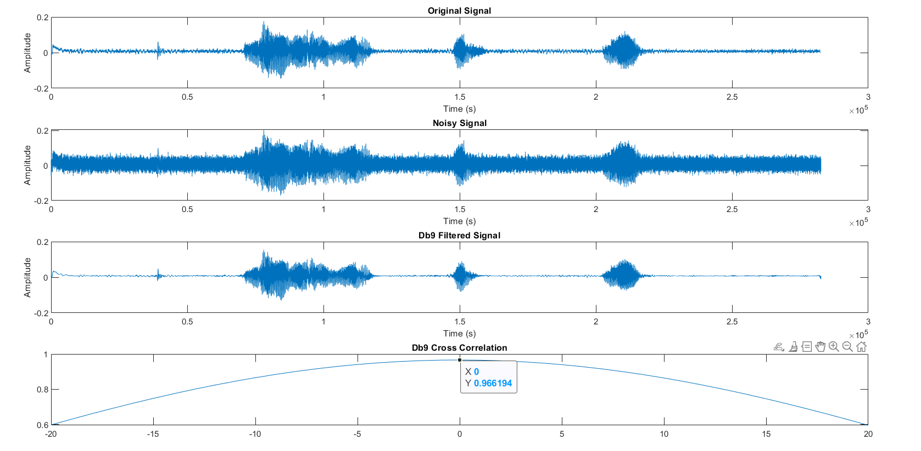

In the figures above, the time domain graphs for the Original Signal, Noisy Signal, and the Db9 Filtered signal are shown. The cross correlation results between the Daubechies 9 Filtered Signal and the Original Signal is around 96.61% or 0.966194 to be exact.

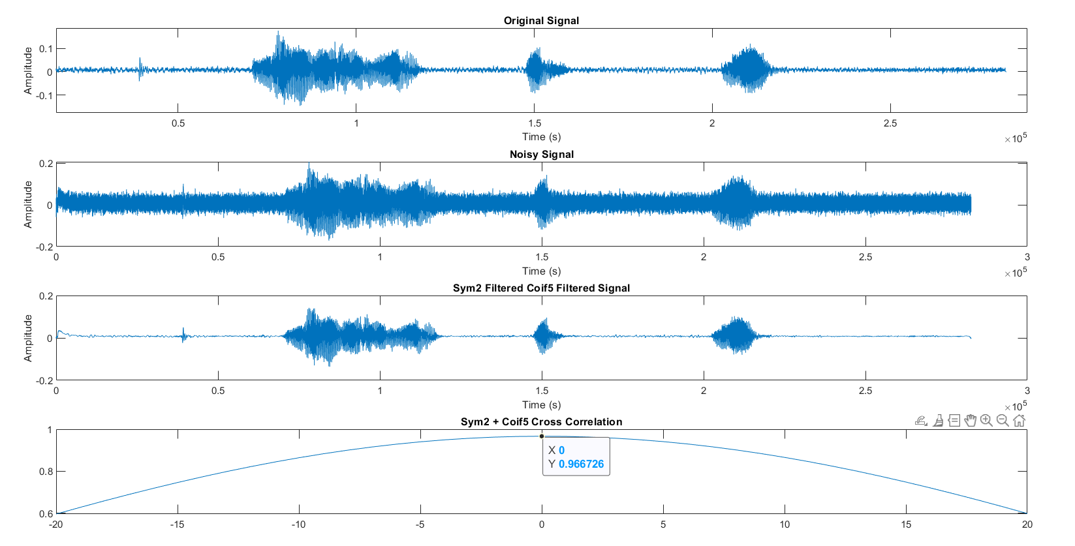

In the figures above, the time domain graphs for the Original Signal, Noisy Signal, and the Symlet 2 Filtered Coiflet 5 Filtered signal are shown. The cross correlation results between the Symlet 2 Filtered Coiflet 5 Filtered Signal and the Original Signal is around 96.67% or 0.966726 to be exact.

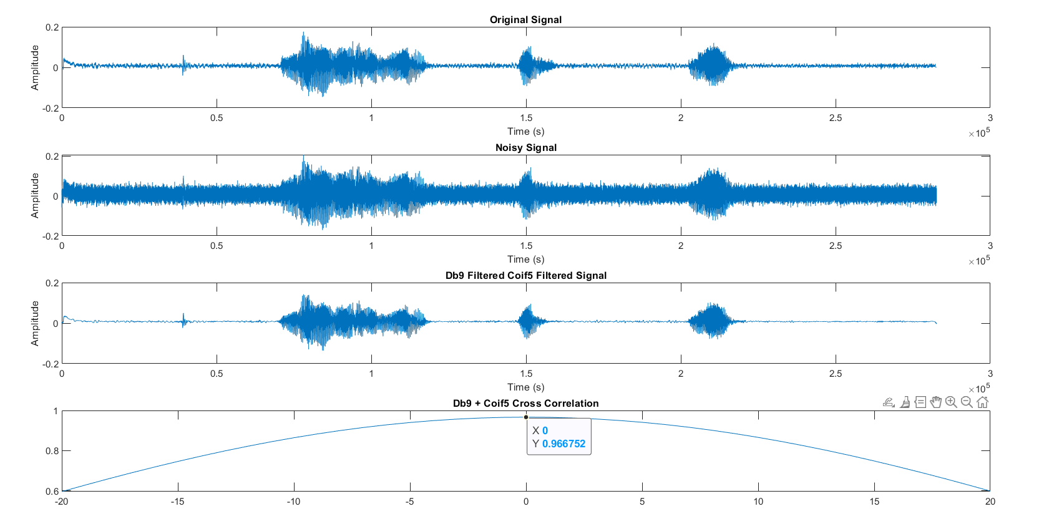

In the figures above, the time domain graphs for the Original Signal, Noisy Signal, and the Daubechies 9 Filtered Coif5 Filtered signal are shown. The cross correlation results between the Daubechies 9 Filtered Coiflet 5 Filtered Signal and the Original Signal is around 96.67% or 0.966752 to be exact.

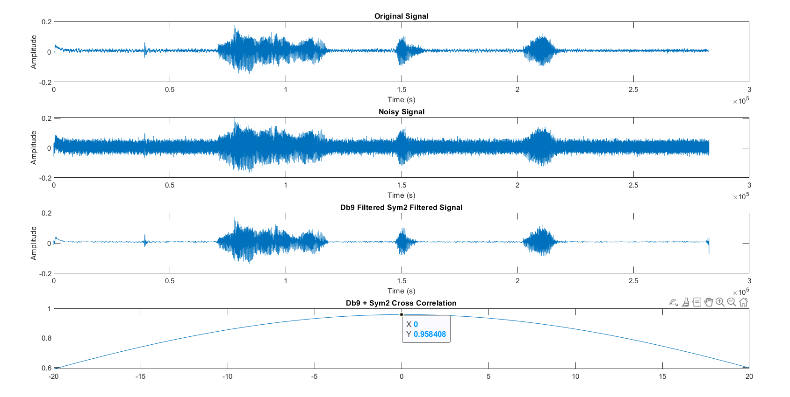

In the figures above, the time domain graphs for the Original Signal, Noisy Signal, and the Db9 Filtered Sym2 Filtered signal are shown. The cross correlation results between the Db9 Filtered Sym2 Filtered signal and the Original Signal is around 95.84% or 0.958408 to be exact.

1. **DISCUSSION**

It was able to demonstrate through the cross-correlation graphs how successfully the various wavelet transforms had reduced the original signal's Gaussian noise. As the cross-correlation approaches 0 along the x-axis, the cross-correlation for any wavelet transform in this paper was close to 1 in magnitude. At t=0, there is practically next to zero time shift between the two signs and with a cross-connection of roughly 1 implies that the original signal and the wavelet denoised signal are almost indistinguishable from one another. This indicates that, despite the wavelet Symlet 2 having the lowest cross-correlation magnitude at 0.958345, or 95.83%, the original signal has been fairly close to being retrieved from the noisy signal. Based on the graphs above, the Coiflet 5 wavelet performed best. The cross correlation result between the Coiflet 5 Filtered signal and the Original signal is at 0.966783 or 96.67% making it the best performing wavelet used in this experiment.

For the two-stage wavelet-based denoising, it is shown in the graphs that single wavelet denoising performs better than the two-stage wavelet denoising. This is due to the fact that applying another wavelet filter to the already wavelet filtered signal basically introduces another layer of processing that could alter or modify the signal itself. The second wavelet filter may have certain characteristics and parameters that would end up either suppressing or amplifying certain frequencies of the signal. Additional filtering may have introduced additional distortions into the signal which made the similarity worse to the original signal. Over-filtering can also be the effect of the two-stage wavelet-based denoising which leads to a slight loss of information that decreases the overall quality of the signal. However, the cross correlation results of the two-stage wavelet-based denoising are still good as all of them have cross correlation results of 95% and above.

1. **CONCLUSION**

The use of MATLAB wavelets for denoising audio signals was investigated in this project. The purpose of this research was to find specific details or characteristics in a signal that had been modified and tainted by artificial Gaussian noise. Based on their denoising capabilities, the performance of wavelets from the Coiflet, Symlet, and Daubechies wavelet families was compared. Double wavelet filtering, in which the audio signal undergoes two successive wavelet transformations to further reduce noise, was also demonstrated. Cross-correlation was used to compare the denoised signals to the clean signal. With cross-correlation values greater than 95%, all wavelet performances were successful. The cross correlation result between the Coiflet 5 Filtered signal and the Original signal is at 0.966783 or 96.67% making it the best performing wavelet used in this experiment. All the objectives have been met. Results show that doubling the filter on a noisy signal does not always yield the best results as it can also alter the features and the characteristics of the signal being filtered. In general, this study provides insight into the performance of various wavelet families for this application and demonstrates the effectiveness of wavelet filtering for denoising audio signals.

1. **AUTHORS CONTRIBUTIONS**

**LARIZA, John Randell** - IPO Model (shown in the video presentation)

**VERA CRUZ, John Ignatius** - Abstract, Introduction, Theoretical Consideration, Methodology, Data and Results, Discussion, Conclusion, and Poster

1. **REFERENCES**

Zhang, D., & Zhang, D. (2019). Wavelet transform. *Fundamentals of Image Data Mining: Analysis, Features, Classification and Retrieval*, 35-44.

Deliyski, D. D., Shaw, H. S., & Evans, M. K. (2005). Adverse effects of environmental noise on acoustic voice quality measurements. Journal of Voice, 19(1), 15-28.

Huang, S. J., & Hsieh, C. T. (2002). Coiflet wavelet transform applied to inspect power system disturbance-generated signals. IEEE Transactions on Aerospace and Electronic Systems, 38(1), 204-210.

Vonesch, C., Blu, T., & Unser, M. (2007). Generalized Daubechies wavelet families. IEEE Transactions on Signal Processing, 55(9), 4415-4429.

Yadav, A. K., Roy, R., Kumar, A. P., Kumar, C. S., & Dhakad, S. K. (2015, August). De-noising of ultrasound image using discrete wavelet transform by symlet wavelet and filters. In 2015 International Conference on Advances in Computing, Communications and Informatics (ICACCI) (pp. 1204-1208). IEEE.

Verma, N., & Verma, A. K. (2012, December). Real time adaptive denoising of musical signals in wavelet domain. In 2012 Nirma University International Conference on Engineering (NUiCONE) (pp. 1-5). IEEE.

Burrus, C. S. (2015). Wavelets and wavelet transforms.

Wei, D. (1998). Coiflet-type wavelets: theory, design, and applications. The University of Texas at Austin.

Ma, J., Xue, J., Yang, S., & He, Z. (2003). A study of the construction and application of a Daubechies wavelet-based beam element. Finite Elements in Analysis and Design, 39(10), 965-975.

Awal, M. A., Mostafa, S. S., Ahmad, M., & Rashid, M. A. (2014). An adaptive level dependent wavelet thresholding for ECG denoising. Biocybernetics and biomedical engineering, 34(4), 238-249.

Thiruvengatanadhan, R. (2017). Speech/Music Classification using Discrete Wavelet Transform and Linear Discriminate Analysis. Advances in Computational Sciences and Technology, 10(11), 3205-3209.

Dixit, A., & Majumdar, S. (2013). Comparative analysis of coiflet and daubechies wavelets using global threshold for image denoising. International Journal of Advances in Engineering & Technology, 6(5), 2247.