人物：

1  Emily Lee   Financial auditor

A woman without pretence，solved the problem of stike and determined that Frank was the murderer.

女主角，调查项目经理的死因，以及财务虛高问题，调查古晋项目账户问题，开始来到古晋，发现发票虚高，想要去工地去实地考察。后和弗立波一起去的，解决了罢工间题。和 peter 处理了发票问题，发现了肖恩的罪行，开始怀疑德里克和肖因合作，但是发现德里克无权对金钱问题做出决定，后怀疑弗立波，但是塞琳娜的揭发，让埃米利确定凶手是弗兰克

investigates the cause of death of the project manager and the problem of false high finance. She investigates the account of the Kuching project. She begins to come to Kuching and finds that the invoice is falsely high. She wants to go to the construction site for on-the-spot investigation. Later, he went with freibo and solved the problem of strike. After dealing with the invoice with Peter and discovering Sean's crime, they began to suspect Derek and Sean of cooperating. However, they found that Derek had no right to make a decision on the money issue, and then they suspected freibo. However, Selena's disclosure made Emily determine that Frank was the murderer  
2 Frank Churchill  [ˈtʃɜːtʃɪl]  Chief financial officer

murderer, force the subcontractor to donate money to charity and transfer the money to his pocket.

坏人，凶手。杀了肖恩，并将肖恩的钱全部转到自己的账户。让弗立波在所有发票签上名字，但不让他去管财务中的事情，为了栽赃弗立波和肖恩合作，强迫分包商将钱捐给慈善机构，然后将钱转到自己腰包，最后杀了肖恩独吞了钱，最后因为书中的签名以及塞琳娜的揭发暴露。

Bad guys, murderers. Kill Sean and transfer all his money to his account. He asked freibo to sign his name on all the invoices, but he was not allowed to take care of the financial affairs. In order to plant freibo and Sean's cooperation, he forced the subcontractor to donate money to charity, and then transferred the money to his own pocket. Finally, he killed Sean and swallowed the money. Finally, because of the signature in the book and Selena's exposure. frank lied to Selena about her feelings  
3 Fllippo Gimino   Technical project manager

Go to construction site with Emily, solve the strike problem and had some transactions with a subcontractor, was suspected of being a murderer at first

肖恩处理财务问题，弗立波处理技术问题，但他在每个发票中都签了名，但是在埃米莉问他的时候，他说是弗兰克要求的，他根本不了解。性格比较暴躁，认为埃米莉天真，刚开始被怀疑成凶手，后向埃米莉道歉并和她一起去马来西亚的工地调查，和一个分包商有一些交易，不知道该不该相信埃米莉，后因为被埃米莉发现后怀疑成凶手。

freibo handled the technical problems, but he signed every invoice. When Emily asked him, he said that Frank asked for it, and he didn't understand it at all. He is rather irascible [ɪˈræsəbl] and thinks Emily is naive. At first, he was suspected of being a murderer. Later, he apologized to Emily and went to the construction site in Malaysia with her to investigate. He had some transactions with a subcontractor. He didn't know whether to trust Emily. Later, he was suspected of being a murderer after Emily found out。

4 Selina Hargreaves  [ˈhɑrˌgrivz]  Personal assistant to Frank

Expose Frank through the signature she found in his book.  
坏人的助手，最后因为弗兰克对她不太好了，揭发了弗兰克，给了埃米莉一本书，教弗兰克用互联网

The bad guy's assistant finally exposed frank and gave Emily a book to teach Frank how to use the Internet because Frank was not nice to her

5 Peter Esterhazy   Assistant commercial manager

solved the invoice problem, and found some problems that Sean cooperated with the subcontractor to import the money into his own pocket through charity

感谢弗立波和埃米莉解决罢工问题，替埃米莉向赛琳娜要发票和埃米莉一起处理了发票问题，并发现了一些问题：肖恩与分包商合作通过慈善机构将钱导入到自己腰包

Thanks to freibo and Emily for solving the strike problem, asking for the invoice from Selena for Emily, and together with Emily, they solved the invoice problem, and found some problems that Sean cooperated with the subcontractor to import the money into his own pocket through charity

6 Derek [ˈderɪk] Poole   Project site manager

Have capacity in his field, but does not respect woman. He called Emily sweet.

可能能力还行但是人品不行，有点不要脸，调戏埃米莉，一直盯着她的腿看，并且叫她甜心，埃米莉让他将发票打包发她，他说为了你什么都可以工人罢工，想让弗兰克补办清洁仪式。

he may be able, but his character is not good. he is a bit shameless. he flirts with Emily, keeps staring at her legs, and calls her sweetheart. Emily asks him to pack the invoice and send it to her. He says that workers can go on strike for your sake, and wants Frank to do a cleaning ceremony.  
7 Sean McCabe [məˈkeɪb]  commercial project manager

死在了马来西亚的一家酒店房间中。喝了一杯就死了，死前想离婚。和弗兰克合作强迫分包商将钱转入慈善机构后导入自己腰包，后备弗兰克在酒中下毒，杀了他并将账户中的钱全部转走。

Died in a hotel room in Malaysia. He died after drinking a cup. He wanted a divorce before he died. Cooperate with Frank to force the subcontractor to transfer the money to charity and then import it into his own pocket. Backup Frank poisoned the wine, killed him and transferred all the money in his account.

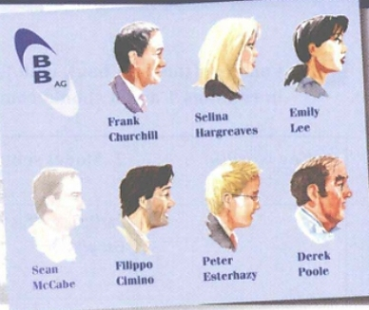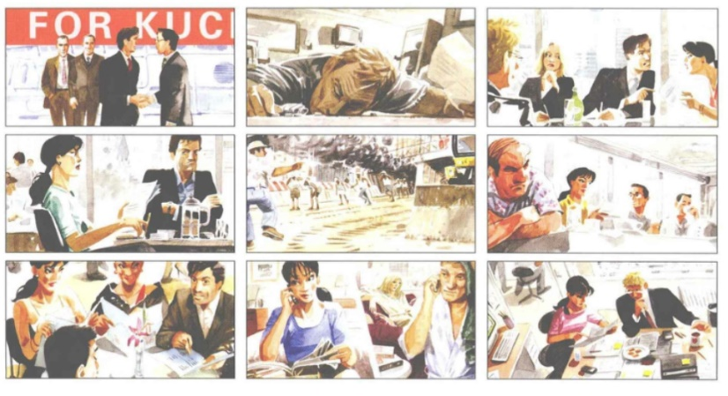

一

警察发现Sean McCabe服用过量安眠药晕倒在他的房间，当时Frank Churchill也住在这几个酒店，并对此事深表遗憾。他向Emily写邮件告知她：他已经接管了该项目的财务管理，想让她从纽约来柏林检查该项目，与工作人员交谈并写报告，可以让peter做助理。

The police found that Sean McCabe had fainted in his room after taking an overdose of sleeping pills. Frank Churchill was also staying in these hotels at that time, and expressed deep regret over the matter. He emailed Emily that he had taken over the financial management of the project and wanted her to come from New York to Berlin to inspect the project, talk to the staff and write a report. Peter could be an assistant.

二

肖恩在喝完酒后离奇死亡，然后有一个人走进房间，将一张纸放在肖恩手中后走了。

Sean died strangely after drinking. Then a man came into the room, put a piece of paper in Sean's hand and left.

三

Filippo Cimino , Emily Lee , Frank Churchill and Peter Esterhazy are meeting in Berlin to discuss the project status after Sean McCabe ’ s death . Selina Hargreaves is there to write the minutes ( the meeting report ).

四

暴躁的Filippo认为Emily 有点天真，认为最重要的问题是先把项目完成而不是调查肖恩死亡事件，说话咄出逼人，他说他只负责技术问题，不管财务问题，当埃米莉问为什么一些虚高的发票有他和肖恩的签名，他说是弗兰克让他这么做的，但是对于财务问题啥都不知道。

The irascible Filippo thinks Emily is a little naive. He thinks that the most important issue is to complete the project first rather than investigate Sean's death. He is aggressive. He says that he is only responsible for technical issues, regardless of financial issues. When Emily asks why some falsely high invoices have his signature with Sean, he says Frank asked him to do so, but he doesn't know anything about financial issues.

五

古晋工地发生火灾，被工人发现并很快扑灭，起火原因是一个分包商将废纸扔的到处都是，另一个分包商没有清理就开始电气工作

A fire broke out at Kuching construction site, which was discovered and put out by workers. The cause of the fire was that one subcontractor threw waste paper everywhere, and the other subcontractor started electrical work without cleaning it up

六

 KEC 、 CCM 、德里克（猥琐男）、弗立波，埃米莉一起讨论如何将项目提前完工。最后的解决方案是加钱，让工人们加班。

KEC, CCM, Derek (obscene man), freibo and Emily discuss how to complete the project ahead of schedule. The final solution is to pay more and let the workers work overtime.

七

弗立波请埃米莉吃饭，（中餐），中途弗立波离开和一个分包商秘密打电话，以为没有被埃米莉发现，其实被埃米莉发现了，并被埃米莉发现有个棕色大信封，于是此时被埃米莉误认为是弗立波和肖恩合作，从分包商那里获利。

Freibo invited Emily to dinner (Chinese food). In the middle of the meal, freibo left and made a secret phone call with a subcontractor. He thought that Emily hadn't found out. In fact, Emily found out that there was a big brown envelope. At this time, Emily mistook freibo and Sean for cooperation and made profits from the subcontractor.

八

艾米莉发现了弗利波和其中一个分包商拨打秘密电话，于是向Frank报告，并发现弗利波有个棕色大信封，Frank命令艾米莉必须将棕色大信封找到。

Emily found that freibo and one of the subcontractors had made a secret phone call, so she reported to frank and found that freibo had a big brown envelope. Frank ordered Emily to find the big brown envelope.

九

艾米莉和皮特整理发票问题，发现了肖恩使如何和分包商合作的。

Emily and Pete sorted out the invoice and found out how Shawn worked with the subcontractor.

6号探病

Detailed information about the injury or illness:

Inquiring about hospital bills, insurance issues

They may inquire about the patient's condition in a friendly manner

Chinese people also respect the individual's privacy regarding medical expenses and other personal matters

8号上下楼

is regarded as a sign of respect and concern for her safety and comfort.

China : but men often give way to women and pay attention to their safety and comfort.

2号护身符

银行吃了吗

介绍用全名

使用名字：使用对方的名字是最常见的方式。例如，如果对方名字是John Smith，你可以简单地说"Hi, John!"（嗨，约翰！）。

使用称呼：如果你不确定对方的名字，或者对方有一个特定的职称或称呼，可以使用相应的称呼来称呼他们。例如，如果对方是一位医生，你可以称呼他们为"Doctor"（医生）。

使用尊称：在某些文化中，使用尊称来称呼对方是一种常见的方式。例如，在英国，你可以使用"Sir"（先生）来称呼男性，或者"Madam"（夫人）来称呼女性。

使用代词：如果你已经与对方建立了一定的关系，可以使用代词来称呼对方，如"you"（你）或"he/she"（他/她）

中西方文化在Small Talk（闲聊）方面存在一些差异。以下是一些常见的区别：

主题选择：在西方，常见的Small Talk话题包括天气、体育、电影、音乐、假期等轻松的话题。人们会分享个人的兴趣爱好和经历。在中国文化中，Small Talk通常涉及更加个人化的话题，如家庭、工作、教育等。人们可能更倾向于讨论与自身生活和经历更相关的话题。

直接与间接性：西方文化中的Small Talk通常更加直接和直截了当。人们会直接提出问题或分享个人意见。而在中国文化中，人们可能更喜欢使用间接的方式进行交流，通过暗示或更含蓄的表达来传达意思。

空间和个人隐私：在西方文化中，人们更注重个人空间和隐私。他们可能会保持一定的距离，不会过于接近或打扰他人。在中国文化中，人们可能更容易接近他人，展示更多的亲密和热情。