Touchstone 3: Visual Design and Responsive Layout

Name | Rand Al Hirake
Course | Introduction to Web Development
Date | 09/13/26
Selected Client | North Star Bakery

Section 1: GitHub Link
Paste the GitHub Repository Link: https://github.com/Randhirake/north-star-bakery
Working Preview Link: https://randhirake.github.io/north-star-bakery/

Section 2: Design Explanation

Respond to each prompt below. Focus on explaining your design decisions.

Your responses should reference specific elements from your website. General descriptions without examples may receive reduced credit.

Note: Your design should use 2 to 4 colors and no more than 2 font families, applied consistently across all pages.

Client Alignment

Explain how your design choices support your selected client’s goals and audience. Include at least one specific example from your website.

North Star Bakery is a small, neighborhood bakery, so the design leans warm and handmade rather than sleek or corporate. The Playfair Display headings and soft cream-and-brown palette give the site the feel of a hand-lettered bakery sign, while short, friendly copy (“Stop in, say hello”) keeps the tone personal. On the home page, the “What We're Known For” and “Hours & Location” sections are presented as separate cream-bordered cards so visitors can scan the most important facts — what the bakery makes and when it's open — without reading dense paragraphs. This supports the client's goal of feeling like a trusted, everyday neighborhood spot that's easy to find and easy to get to know.

Color Palette
The main colors are cream (FFF8F0), brown (6B3E26), peach (D88C5A), and charcoal (2F2A26). List the 2 to 4 main colors you used (you may include hex codes). Explain how these colors support your client’s tone and ensure readability. Include one example of where you applied these colors.
I used four main colors: cream (FFF8F0) for the page background, brown (6B3E26) for the header, footer, and headings, peach (D88C5A) for buttons, links, and accent text, and charcoal (2F2A26) for body copy. The warm cream and brown evoke crust and baked goods, which fits a bakery's tone, while charcoal-on-cream keeps paragraph text at strong contrast for readability. Peach is reserved for things that need to stand out, such as the “Send Request” button on the Contact page and the price text in the product cards, so visitors' eyes are drawn to calls to action and pricing without the page feeling cluttered.

Typography

Identify the font or font pair you used. Explain how your choices support readability and create visual hierarchy. Include one example of how you used font size, weight, or style.

I used a two-font pairing: Playfair Display, a serif display font, for all headings (h1–h3), and Nunito Sans, a clean sans-serif, for body text, labels, and navigation. The serif headings give the site a bakery-sign, handcrafted feel and create clear visual hierarchy against the plainer body text, while Nunito Sans keeps paragraphs, form labels, and ingredient lists easy to read at normal size. For example, on the Products page each item name (like “Cinnamon Swirl Babka”) is set in bold Playfair Display at a larger size than its description, so visitors can scan product names quickly before reading the details underneath.

Responsive Design

Describe how your layout adapts across screen sizes. Include at least one specific example of a layout, spacing, or content change.

The layout was built mobile-first: the base CSS stacks the header logo above a single-column nav, and all sections, product cards, and form fields display in one column with generous spacing for small screens. A single media query at 800px then switches the layout for larger screens — the header becomes a horizontal row with the nav links inline, and the product grid on the Products page changes from a stacked list to a three-item flex row using flex-wrap, so Breads, Pastries, and Cakes display side by side once there's room. The contact form's field sets also switch from full-width stacked fields to a two-column wrapped layout above 800px, keeping the form compact on desktop without making it cramped on mobile.

Design Challenge

Describe one design challenge you encountered. Explain how you addressed it and what change you made.

The biggest challenge was the product cards: on mobile, a horizontal three-across layout made each card too narrow and squeezed the pricing text awkwardly, but a single stacked column on desktop left too much empty white space on either side of the container. I addressed this by making. product-grid a column-direction flex container by default (mobile-first) and only switching it to flex-direction: row with flex-wrap and flex: 1 1 30% inside the 800px media query, so each card gets roughly a third of the row's width and wraps naturally to a new line when there isn't room for a fourth card. This kept the cards readable and evenly sized at every screen width I tested.

Section 3: Submission Checklist
☐ Updated HTML files~
`
☐ Working preview link
☐ Consistent color palette (2–4 colors)
☐ Consistent typography (1–2 fonts)
☐ Styles applied across all pages
☐ Flexbox used in layout
☐ At least one media query
☐ Readable text with sufficient contrast
☐ Completed design explanation

Section 4: Screenshot
Include one screenshot of your website that demonstrates a design decision you described above.
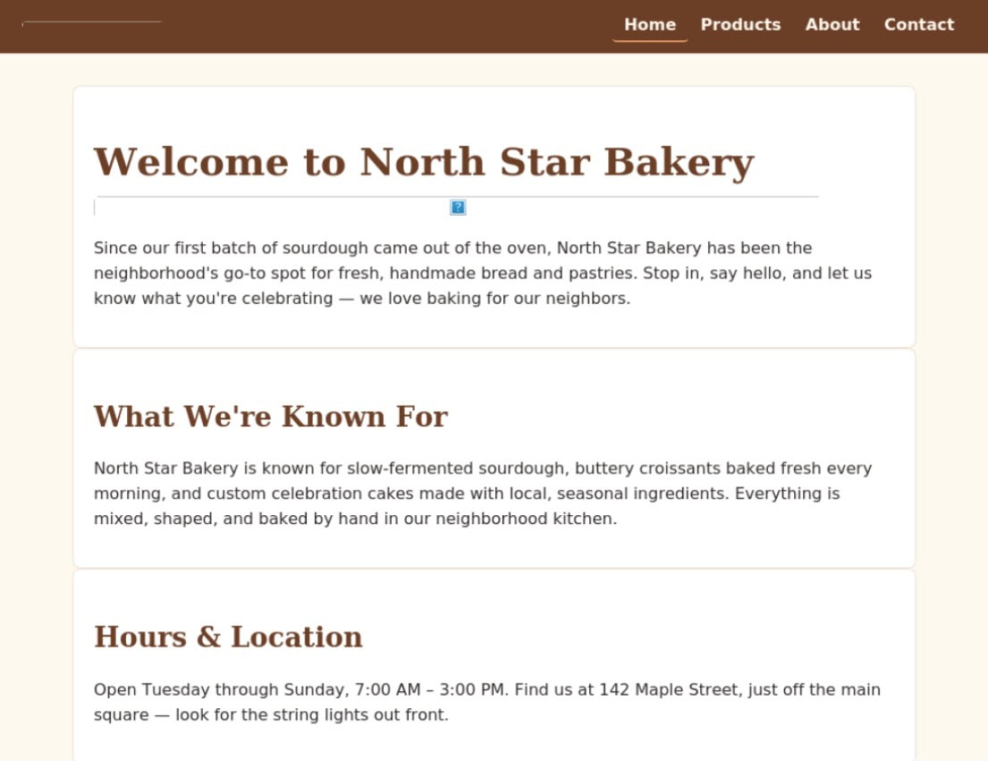

Home page (index.html): the brown header/footer, cream page background, peach accents, and Playfair Display headings demonstrate the color palette and typography described above

Section 5: Final Review
☐ All pages display correctly
☐ Navigation works across all pages
☐ Layout adjusts across screen sizes
☐ Design is consistent and readable

