Touchstone 4 Template
Interactivity and Client-Side Data
Name: | Rand Al Hirake
Course: | Introduction to Web Development
Date: | September 14, 2026
Selected Client: | North Star Bakery

Important: Continue using the same client and website from Touchstone Task 2 and Touchstone 3. Submit this completed template as your single Touchstone file. Your linked project must contain the updated HTML, CSS, and JavaScript files.

Section 1: Project Link
Paste the URL to your public GitHub repository for this project. The repository should include all updated HTML, CSS, and JavaScript files required for this Touchstone.
Working Project Link: | https://randhirake.github.io/north-star-bakery/
Repository Link (if different): | (same as above) https://github.com/Randhirake/north-star-bakery

Section 2: Implementation Explanation
Respond to every prompt below. Each response should be 2–4 sentences, refer to a specific element or behavior from your project, and explain how the implementation works. Reference your screenshots where requested.
Feature Purpose
Explain what your interactive feature helps users do and how it supports your client’s goals or audience. Identify the page where the feature appears and describe the user need it addresses.
Reference Screenshot 1 in your response.
Response:
The interactive feature is a "My Favorites" tracker on the Products page. Each bread, pastry, and cake card has an "Add to Favorites" button, and a summary box at the top of the page lists everything the visitor has favorited. This addresses a real need for a small bakery: customers often browse the full menu but want to remember a shortlist of items to order or ask about when they call or visit, and this feature lets them build that list without writing anything down.

User Interaction
Describe how a user interacts with the feature step by step. Explain what JavaScript changes on the page after the user clicks, selects, or enters information.
Include the key action and the visible result.
Response:
When a visitor clicks "☆ Add to Favorites" on any product card, JavaScript immediately changes that button to "★ Favorited" with a filled peach background, and the item's name is added to the "My Favorites" list at the top of the page. Clicking an already-favorited button removes it from the list and reverts the button back to its original outline style. The "My Favorites" box also switches between showing the placeholder text "You haven't added any favorites yet." and a bulleted list, depending on whether anything is currently favorited.

Form Validation
Identify at least two JavaScript validation checks you added to your form. Explain how invalid submission is prevented and how feedback appears near the relevant fields so users can correct their entries.
Reference Screenshot 2 and quote or summarize at least one error message.
Response:
The Contact page form includes two JavaScript validation checks: a required-field check on the Name input, and an email format check on the Email input using a regular expression that confirms the value contains an "@" and a domain. If either check fails, event.preventDefault() stops the form from submitting and a red error message appears directly beneath the relevant field, for example "Please enter a valid email address (example: name@example.com)." for an invalid or missing email. Because the script only re-validates the specific field the visitor is fixing, they can correct one mistake without losing anything they already typed in the other fields.

Data Storage
State whether you used localStorage or sessionStorage. Explain what data is stored, when it is saved, and when it is loaded again. Describe how this improves the user experience.
Reference Screenshot 3 and identify the restored or remembered data.
Response:
The favorites feature uses localStorage, since a visitor's favorite items should still be there if they close the browser and come back another day, not just for the current tab session. Favorites are saved every time a button is clicked (inside toggleFavorite(), which calls localStorage.setItem() with the updated data), and they are loaded back on page load (inside initFavoriteButtons(), which calls localStorage.getItem() to restore the saved state to each button and to the summary list). As a smaller second example, the Contact page also uses sessionStorage to remember the visitor's selected "Request Type" for the rest of that browsing session, so if they leave the form and come back to it, their choice is still selected.

Technical Design
Explain how functions organize your JavaScript and how arrays or objects manage data. Name at least one function and one array or object, then describe what each does in your implementation.
For Advanced performance, the rubric expects at least two arrays or at least two objects.
Response:
The JavaScript is broken into small, single-purpose functions rather than one large block, including getFavorites(), saveFavorites(), toggleFavorite(), updateFavoriteButton(), renderFavoritesSummary(), and initFavoriteButtons() for the favorites feature, plus separate functions for validation (isValidEmail(), setFieldError(), validateContactForm()) and for the Contact page's remembered selection (initRequestTypeMemory()). Data is organized using two different structures: a PRODUCTS array of objects (each object holding a product's id, name, and category) that acts as the JavaScript's own source of truth for product names, and a favorites object that stores each favorited product's id as a key mapped to true or false, which localStorage saves as JSON.

Challenges Encountered
Describe one specific problem you encountered while building or testing the feature, validation, or storage. Explain what was not working, how you identified the cause, and what change fixed it.
Focus on a real implementation decision rather than a general statement.
Response:
The main challenge was deciding how the favorites list should know each product's display name. My first version read the name back out of the button's data attribute in the DOM, which worked but tied the JavaScript tightly to the exact HTML structure of the page. While testing, I realized this would break if the page markup ever changed, so I refactored the code to keep a separate PRODUCTS array of objects in script.js as the single source of truth for product names, and updated renderFavoritesSummary() to look names up from that array instead of the DOM. This made the code more reliable and easier to test on its own.

Section 3: Technical and Submission Checklist
Check each item after testing your project.
☒ One meaningful JavaScript feature responds to a click, selection, or user input.
☒ The feature updates the page dynamically and clearly supports the client’s goals.
☒ JavaScript is organized into multiple functions rather than one large block.
☒ At least one array or object is used to manage data.
☒ For Advanced performance, at least two arrays or at least two objects are used.
☒ At least two JavaScript validation checks are implemented.
☒ Invalid form submission is prevented.
☒ Clear validation feedback appears near the relevant fields.
☒ Users can correct errors without losing the information they already entered.
☒ localStorage or sessionStorage saves at least one meaningful piece of data.
☒ Stored data is loaded when the relevant page opens or reloads.
☒ All previous HTML, CSS, navigation, media, and form functionality still works.
☒ The working project link is included and opens without requiring sign-in.
☒ All six explanation sections are complete and use project-specific examples.
☒ At least three screenshots and captions are included below.

Section 4: Screenshots
Insert at least three clear screenshots. Crop each image so the relevant feature is easy to see, and add a short caption that explains what the screenshot proves.
Screenshot 1: Interactive Feature in Use
Show the feature after a user action and the resulting dynamic update on the page.
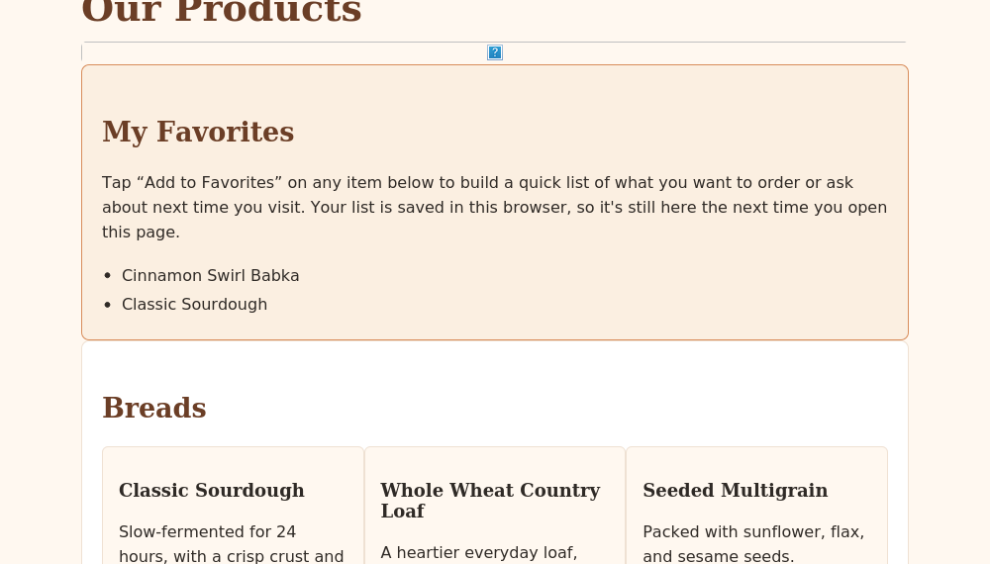
Caption: Screenshot 1: After clicking “Add to Favorites” on Classic Sourdough and Cinnamon Swirl Babka, both buttons switch to the filled “★ Favorited” state and the My Favorites summary box updates dynamically to list both items.
Screenshot 2: Form Validation Feedback
Show at least two validation messages displayed near the relevant fields while submission is prevented.
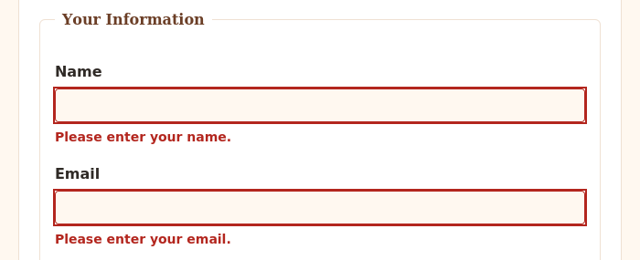
Caption: Screenshot 2: Submitting the Contact form with the Name and Email fields empty is blocked, and red error messages (“Please enter your name.” and “Please enter your email.”) appear directly beneath each invalid field.
Screenshot 3: Browser Storage Working
Show data restored after a refresh or return visit, such as a remembered selection, saved favorite, or pre-filled field.
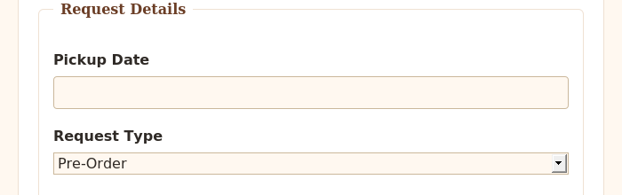
Caption: Screenshot 3: On a return visit to the Contact page during the same browser session, the Request Type dropdown is automatically restored to “Pre-Order” — the value the visitor selected earlier — using sessionStorage.

Section 5: Final Review
☒ The interactive feature works as expected after repeated testing.
☒ The page updates dynamically when the user takes the intended action.
☒ Validation prevents invalid submission and messages appear near fields.
☒ Valid form entries can proceed without unnecessary errors.
☒ Stored data saves and reloads correctly after refreshing or reopening the page.
☒ No JavaScript errors appear in the browser console during normal use.
☒ Navigation and relative file paths work across all pages.
☒ The project remains readable and usable at mobile and desktop widths.
☒ The submitted link and all screenshots match the final version of the project.

Section 1: GitHub Repository
Paste the URL to your public GitHub repository for this project. The repository should include all updated HTML, CSS, and JavaScript files required for this Touchstone.
Repository URL:
https://github.com/Randhirake/north-star-bakery

Updated Final Review Items
- ☒ Public GitHub repository link included
- ☒ Repository opens without requiring login
- ☒ Repository contains all updated HTML, CSS, and JavaScript files
- ☒ Interactive feature works as expected
- ☒ Form validation prevents invalid submission
- ☒ Feedback appears near the relevant fields
- ☒ Stored data persists correctly
- ☒ Previous HTML and CSS functionality remains intact

