**The Business problem**

**A grocery store in California (US) wants to expand its business and manage it dynamically as well as they want to have accurate monthly sales forecast. We've been asked to provide analytical support to make decisions about store formats, inventory planning and sales forecast.**

**Task 1: Store Format for Existing Stores**

The company currently has 85 grocery stores and is planning to open 10 new stores at the beginning of the year. Currently, all stores use the same store format for selling their products. Up until now, the company has treated all stores similarly, shipping the same amount of product to each store. This is beginning to cause problems as stores are suffering from product surpluses in some product categories and shortages in others.



**Task 2: Store Format for New Stores**

The grocery store chain has 10 new stores opening up at the beginning of the year. The company wants to determine which store format each of the new stores should have. However, we don’t have sales data for these new stores yet, so we’ll have to determine the format using each of the new store’s demographic data.



**Task 3: Forecasting**

Fresh produce has a short life span, and due to increasing costs, the company wants to have an accurate monthly sales forecast.

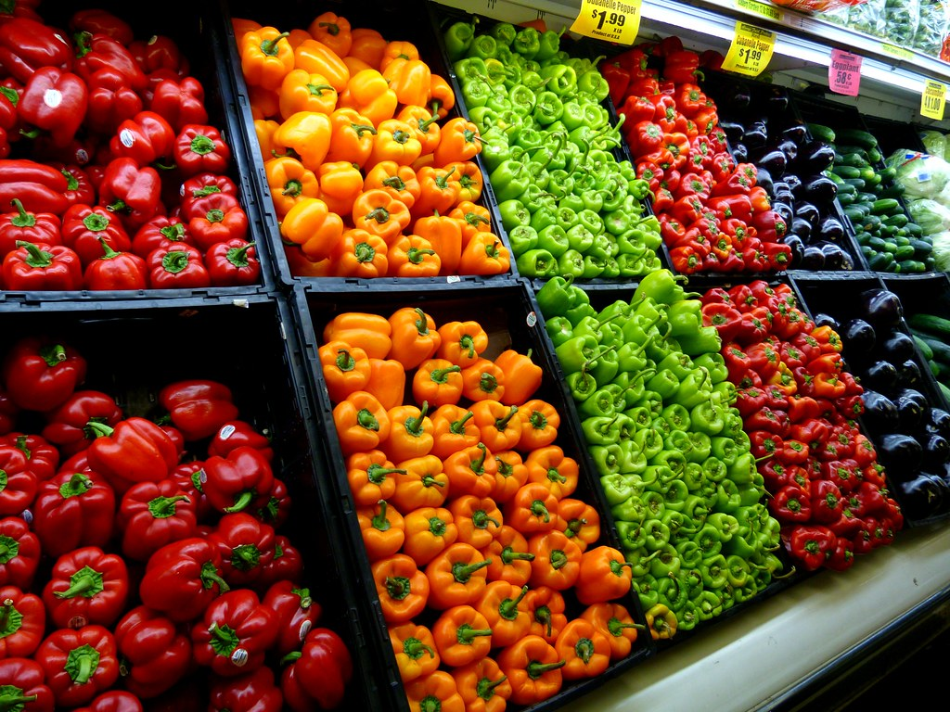

**Data Given by the Company**

* *StoreSalesData.csv* - This file contains sales by product category for all existing stores for 2012, 2013, and 2014.
* *StoreInformation.csv* - This file contains location data for each of the stores.
* *StoreDemographicData.csv* - This file contains demographic data for the areas surrounding each of the existing stores and locations for new stores

**Bird eye view on how we have planned to use our data science expertise to solve this complex business problem.**

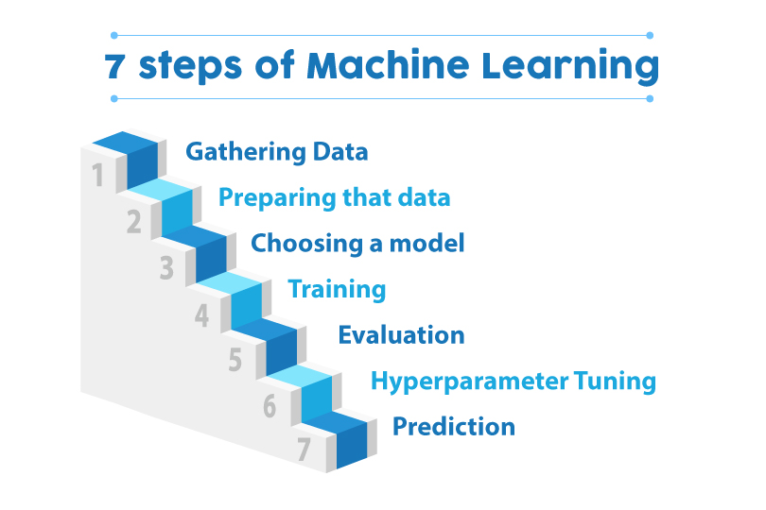

**1) We have decided to use exploratory data analysis and Cluster Machine learning model to Segment Existing Stores.**

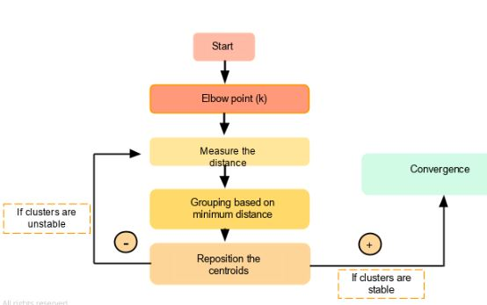

**2) In order to get the store format of new stores we have decided to use classification machine learning model on existing stores and apply that on the new stores.**

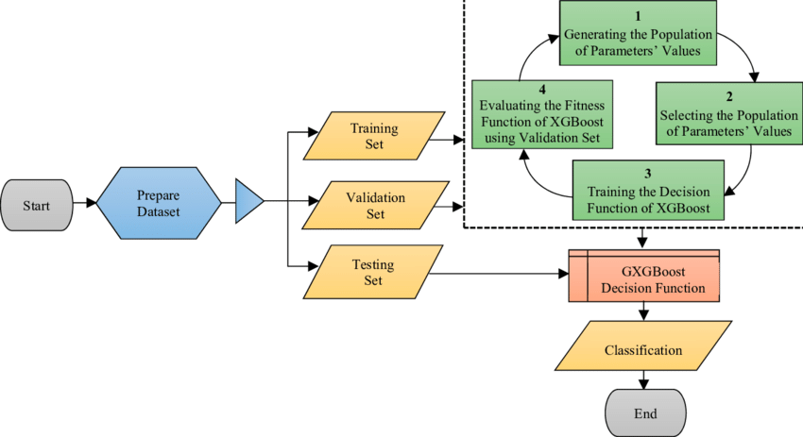

**3) To get the monthly sales forecast of new and existing stores we will use forecasting machine learning model on the monthly sales data.**

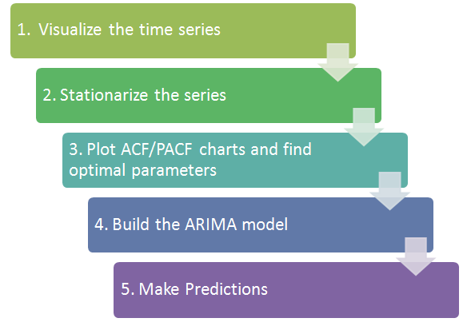

**Once we will Solve the problem we will create a interactive website where we will explain how we manage to solve a very complex business problem with explanatory data visualization.**

