Source ID: 78893799

Source Title: IEICE Electronics Express

Current Issue URL: <https://www.ieice.org/publications/elex/index.html?current=1>

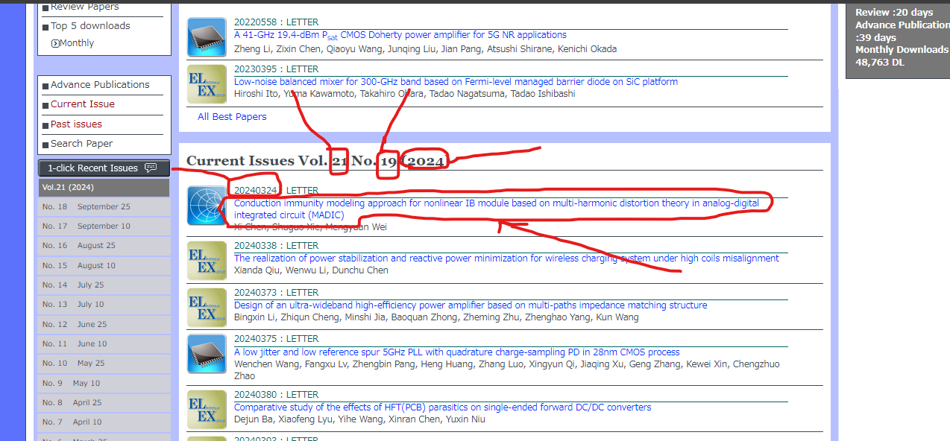

**Click on Title**

**Article number**

**Volume**

**Issue**

**Year**

**DOI**

**Title**

**PDF**

