|  |  |
| --- | --- |
| 320888999 | http://zgspxb.cnjournals.org/zgspxben/home?id=20230331105127001&name=English |

Go to the website using the based url.You will get web page like below

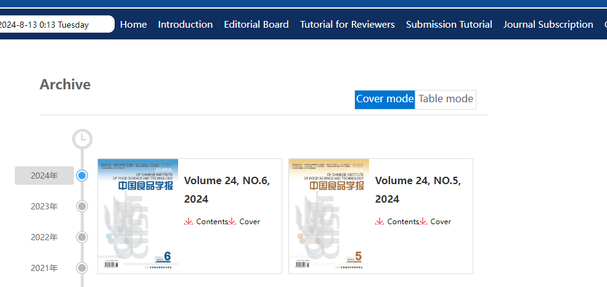

Select the latest issue from here

You will get current issue page like below.

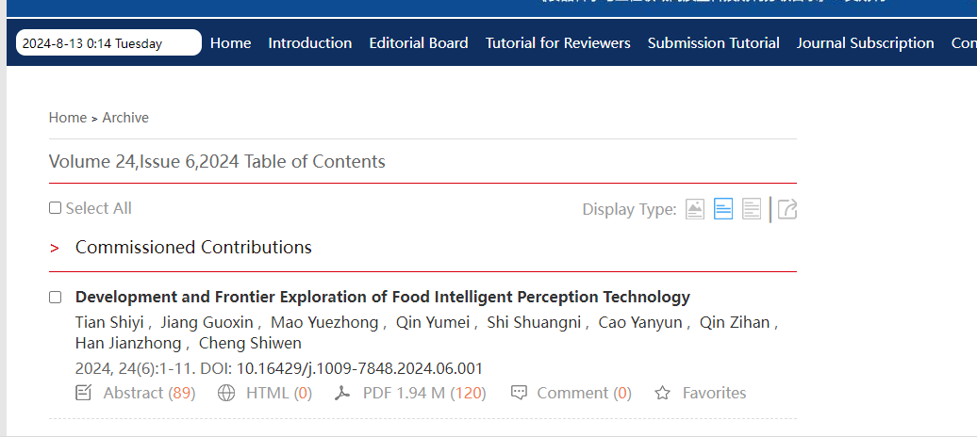

doi

Article Title

Click here to download

Page range

Issue

Year

Volume

Need both non roman and English tocs.