|  |  |
| --- | --- |
| 295935599 | https://revista.spemd.pt/issues |

Go to the website using the based URL,you will get latest issue page like below

Capture Volume

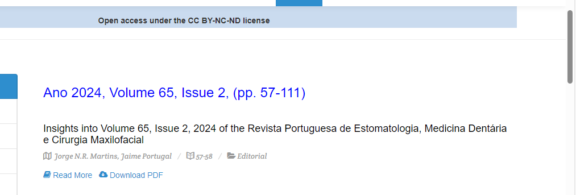

Capture and click article title

Capture issue

Capture Year

After clicking article title you will get article page like below

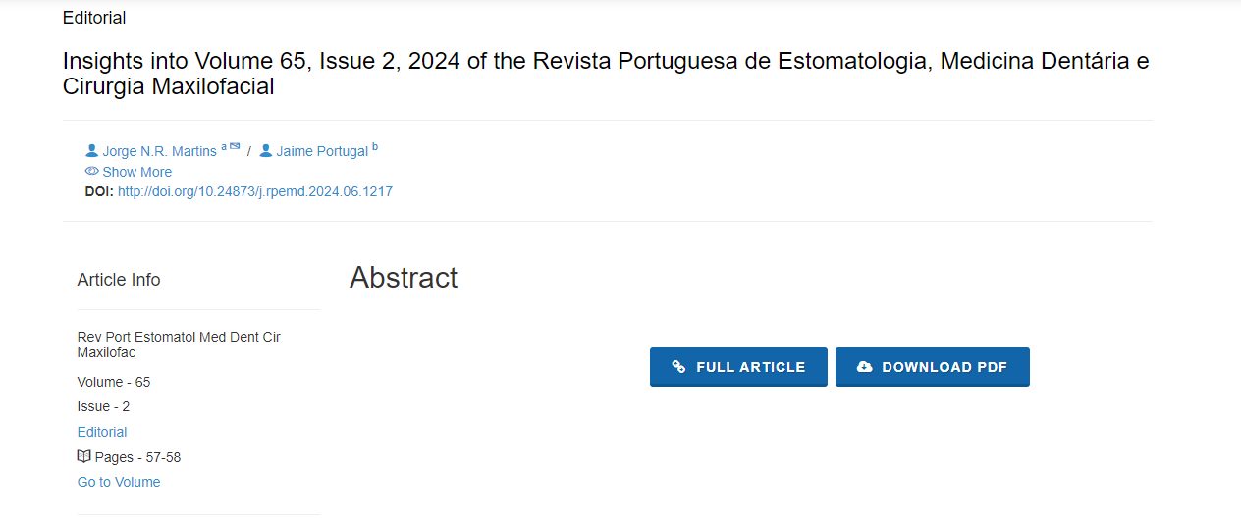

Click here to download pdf

Page range

DOI