Source ID - 76893999

Source Title - Journal of the College of Physicians and Surgeons Pakistan

Agreement URL - <https://www.jcpsp.pk/>

Year

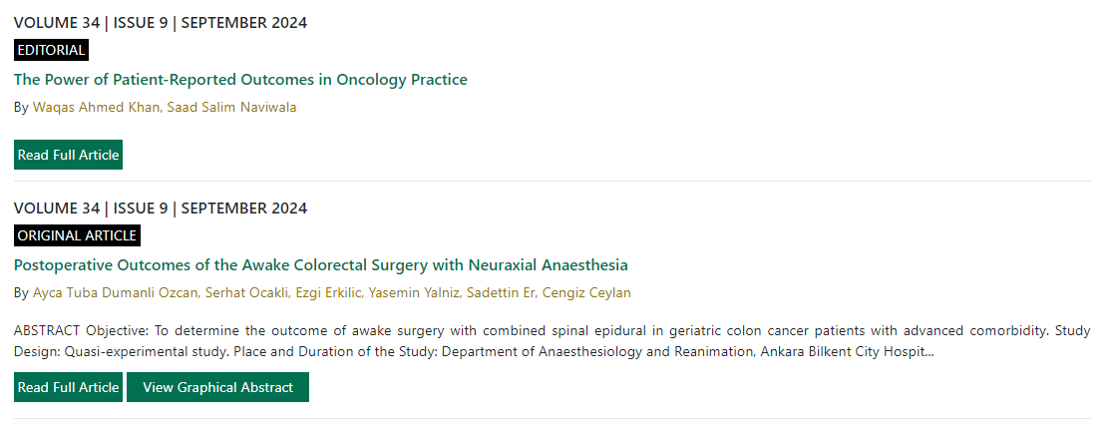

Volume

Issue

Month

Click read full article to capture meta data

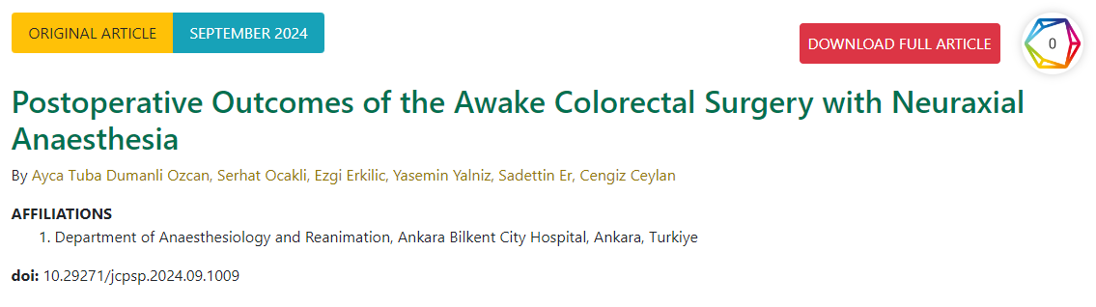

DOI number

Article title

Click to download PDF