Source ID - 76980999

Source Title - Medical Science Monitor

Agreement URL - <http://www.medscimonit.com/medscimonit/>

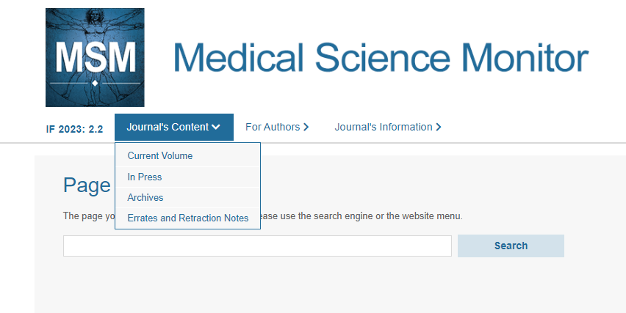

Volume

Click current volume from the journal content dropdown

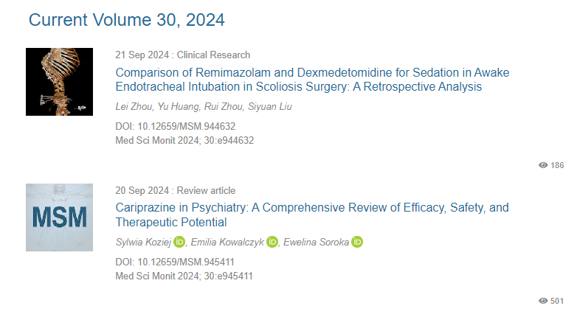

year

Click article title to capture meta data

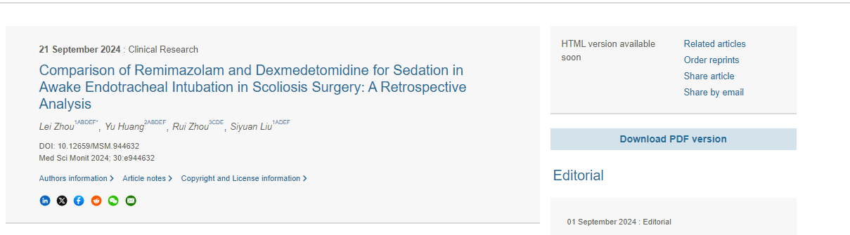

Click to download PDF

DOI number

Identifier

Article title