Source ID - 77339199

Source title - Diqiu Kexue - Zhongguo Dizhi Daxue Xuebao/Earth Science - Journal of China University of Geosciences

Agreement URL - <http://www.earth-science.net/index.htm>

NOTE – Chinese TOC should be captured.

DO not select the English version of the website as it will browse to a different journal.



Click to search

Click the latest number from the dropdown

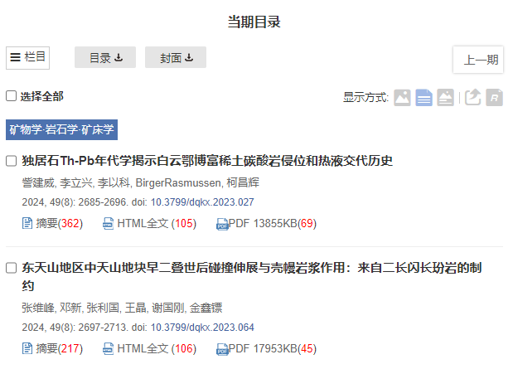

Click article title to capture meta data

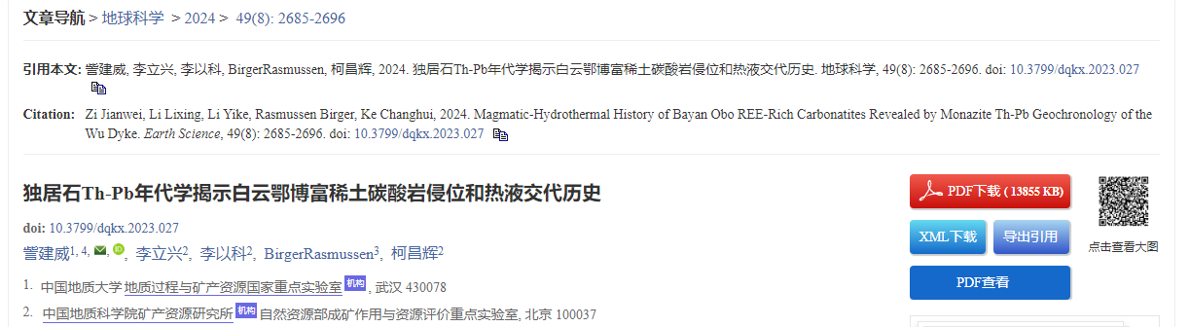

Click to download XML

Click to download PDF

DOI number

Volume issue

Page range

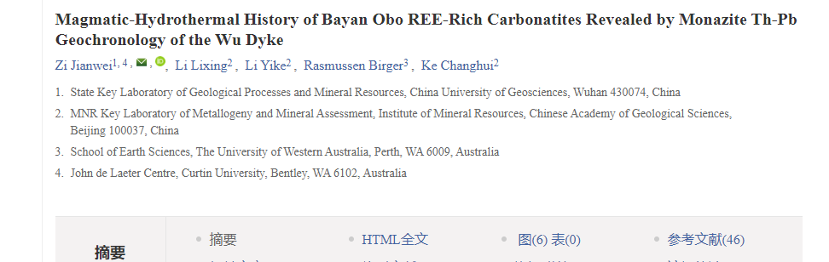

Article title