Source ID - 77603399

Source Title - Yanshilixue Yu Gongcheng Xuebao/Chinese Journal of Rock Mechanics and Engineering

Agreement URL - <http://rockmech.whrsm.ac.cn/CN/volumn/home.shtml>

NOTE – English and Chinese TOC should be captured.

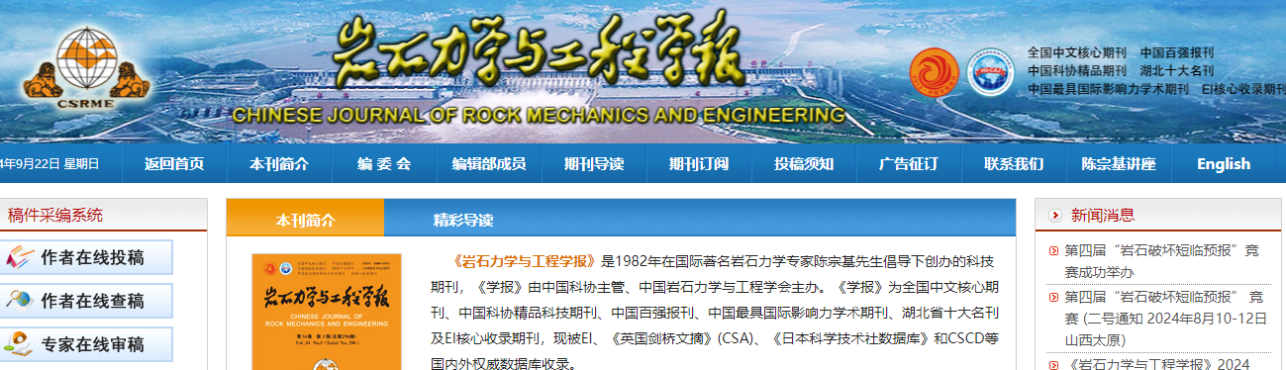

Click English to browse English translation

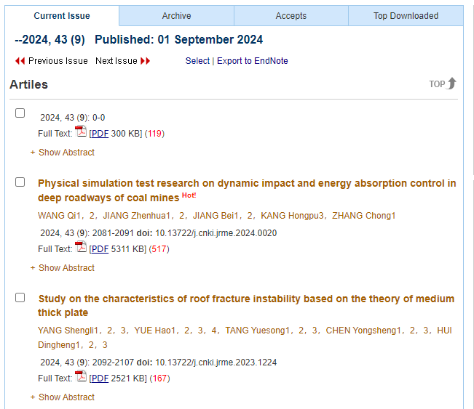

Volume issue and year

Click article title to capture meta data

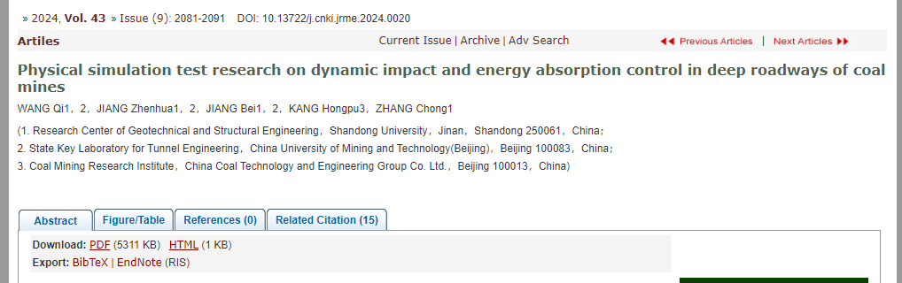

Click to download PDF

Page range

DOI number

Article title