Source ID - 77875499

Source Title - Hedongli Gongcheng/Nuclear Power Engineering

Agreement URL - <http://hdlgc.xml-journal.net/archive_list.htm>

NOTE – English and Chinese TOC should be captured.

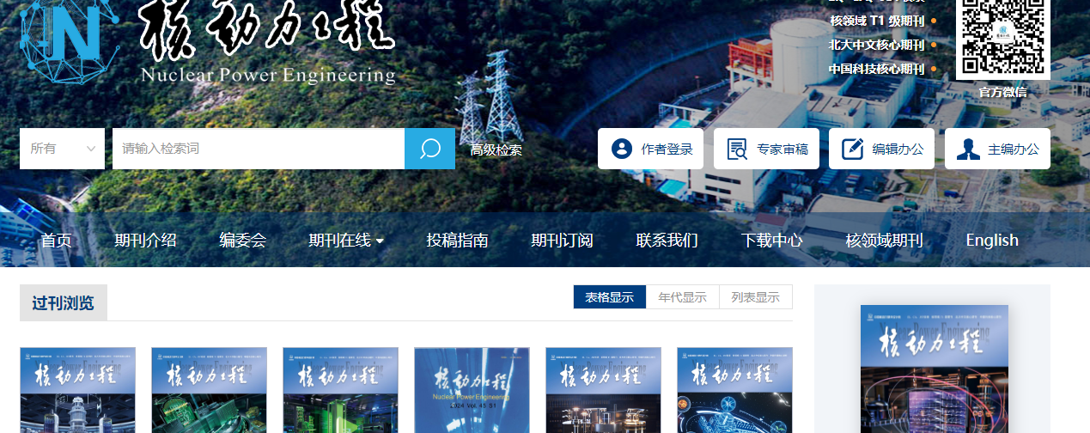

Click English to browse English translation of the website

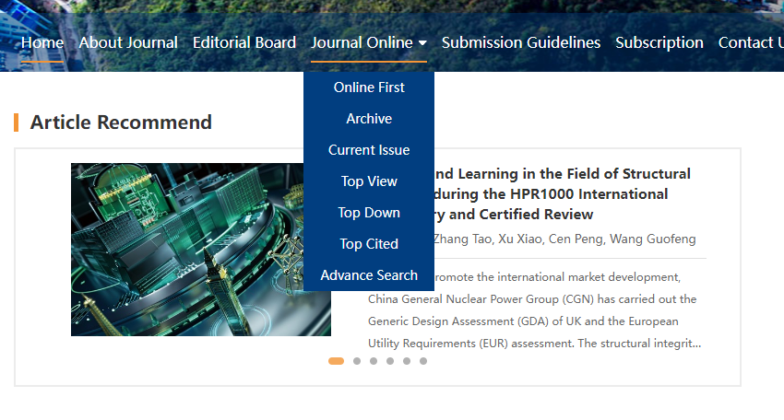

Click current issue to browse current issue

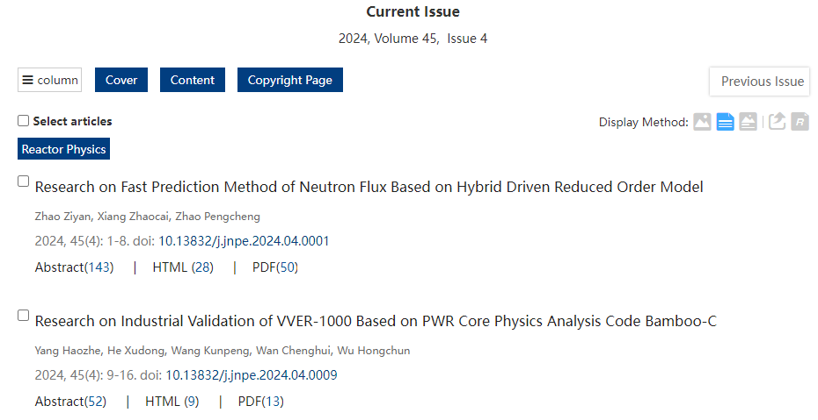

Volume issue and year

Page range

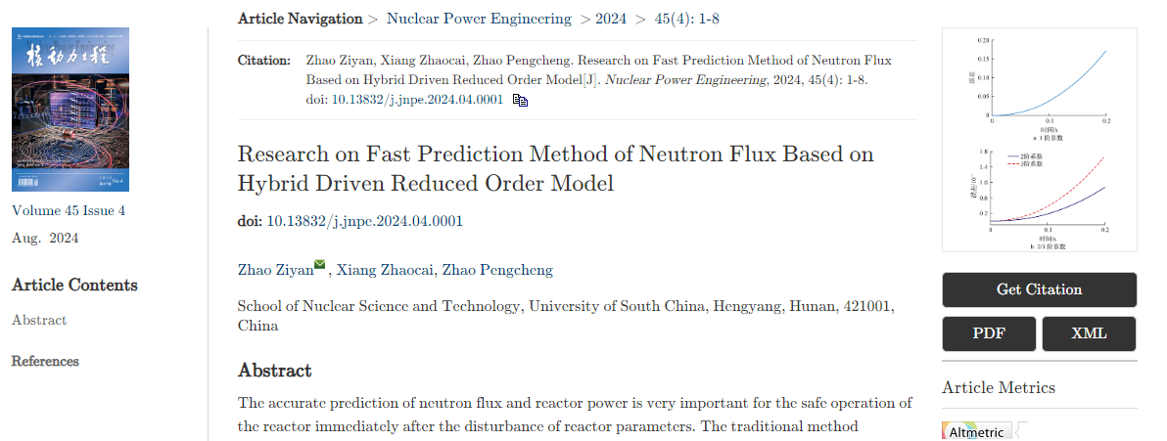

Click to download XML

Click to download PDF

Article title

Volume issue month and year

DOI number