Source ID – 941587506

Source Title - PASOS Revista de Turismo y Patrimonio Cultural

URL - http://ojsull.webs.ull.es/index.php/Revista/about

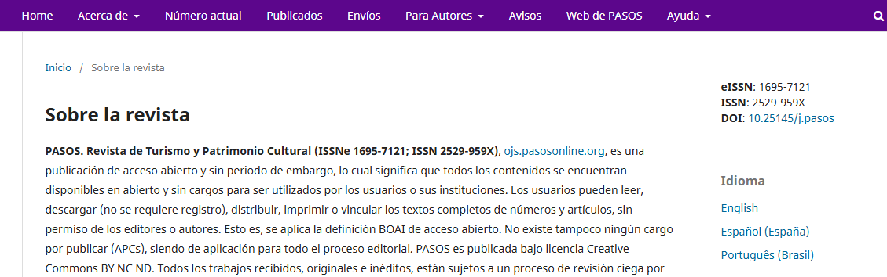

Select English

Select current issue.

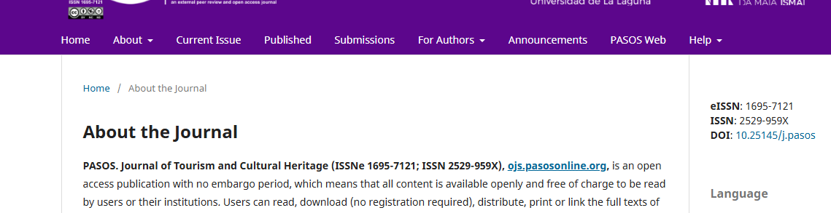

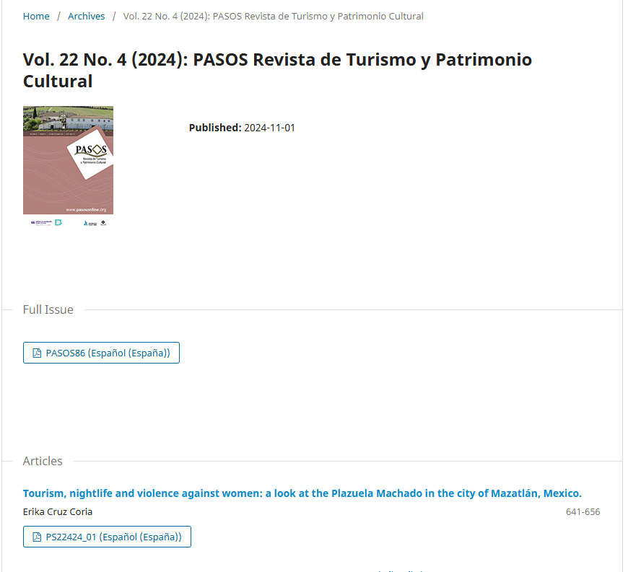

PDF

Volume

Issue

Year

Article title

Page range

Click the article title and proceed to the next page to get the DOI.

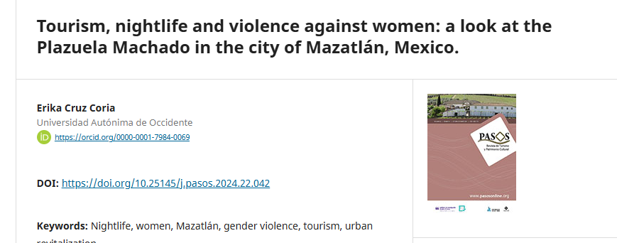

DOI