654587226

Base URL:

**agreement URL :** https://www.tj.kyushu-u.ac.jp/evergreen/

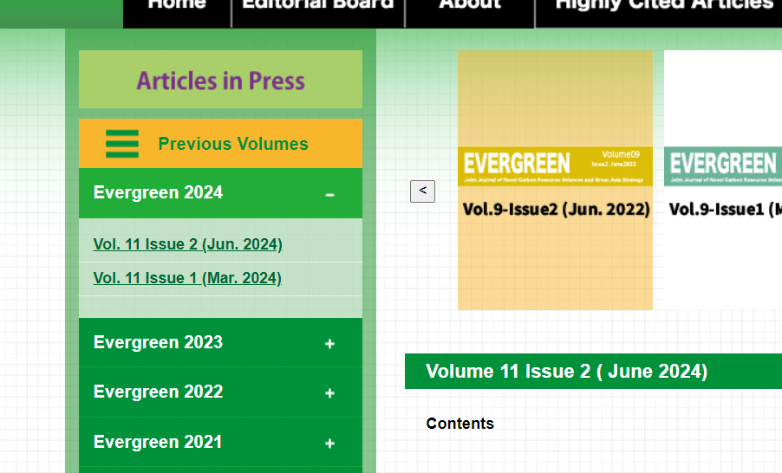

**Select the current issue**

* **All required articles will be listed here.**

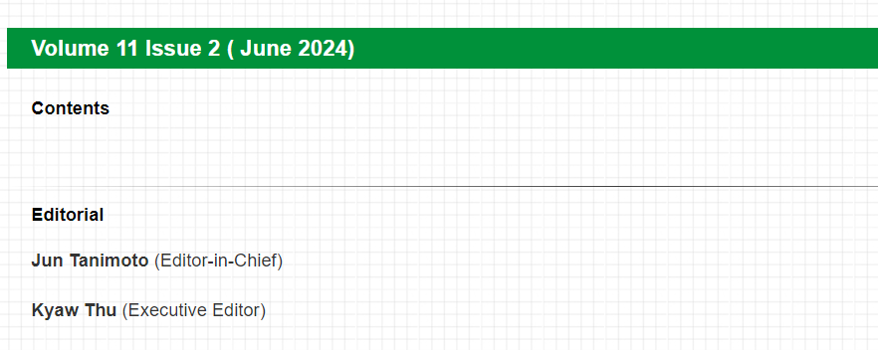

**Year**

**Volume**

**Issue**

**Month**

* Meta data can be captured as below.

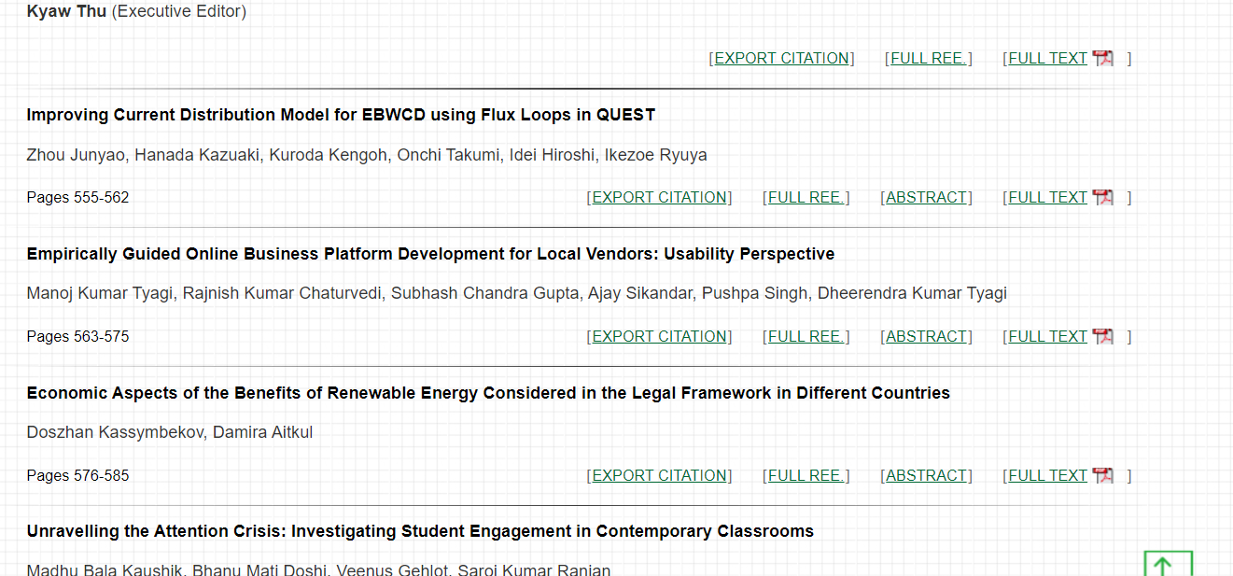

**Article Name**

**Page range**

**Download pdf from here**