|  |  |
| --- | --- |
| 310167599 | https://bg.cherkasgu.press/en/archive.html |
| 923277205 | https://ijmil.cherkasgu.press/en/archive.html |
|  |  |

Note above url based website are having same structure

Capture issue

Click here to go to article list

Always current issue will be display in first

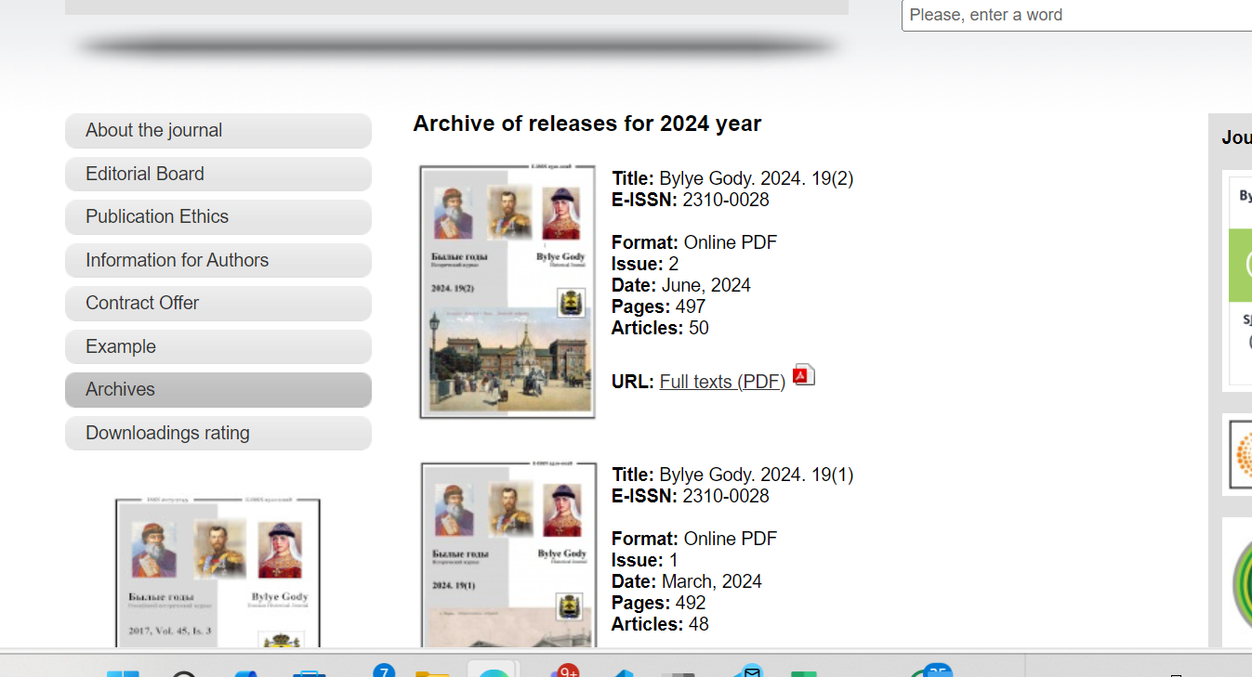

Capture volume

Download pdf from here

Month

Date

Year

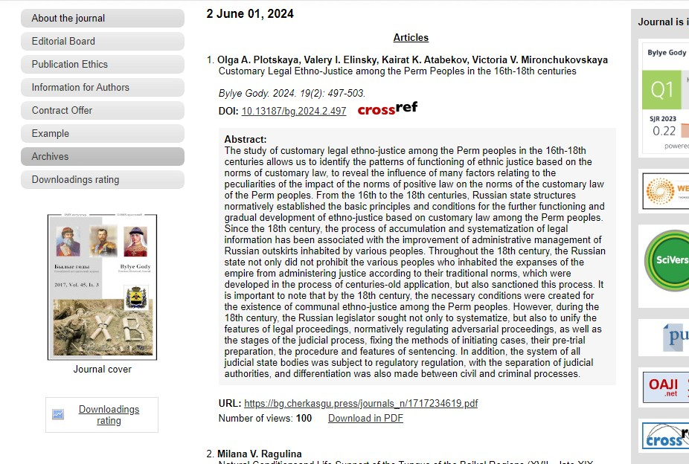

Article Name

DOI Number

Page Range