SID: 77396799

Base URL: <https://www.informatica.si/index.php/informatica>

Click on the Current in order to go to the current issue.

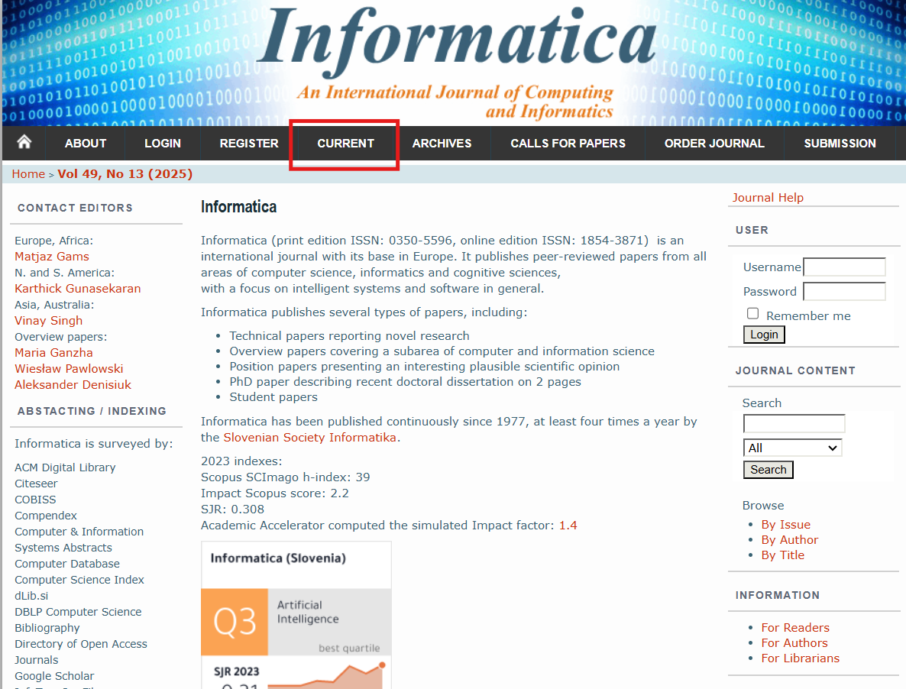

Click on Table of contents as shown:

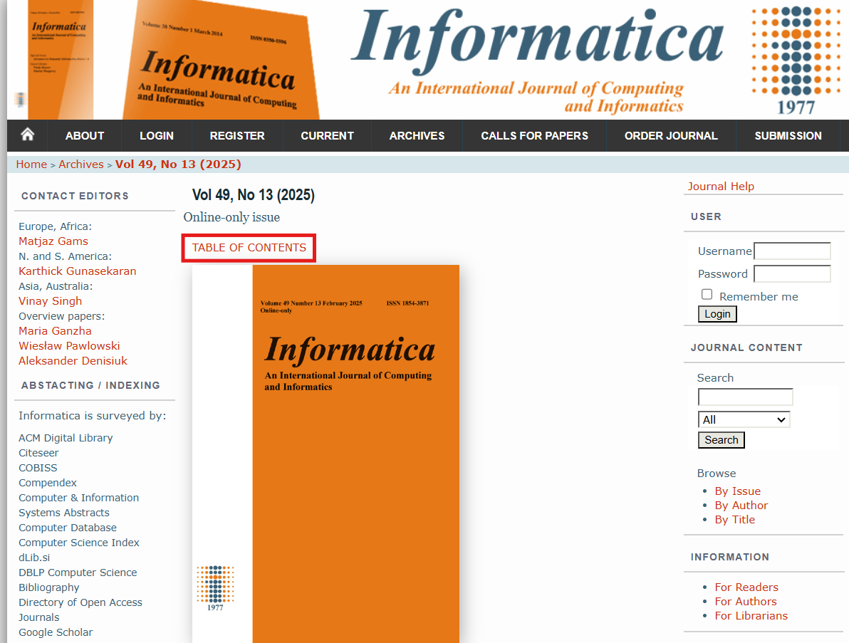

Capture the volume, issue and year from here:

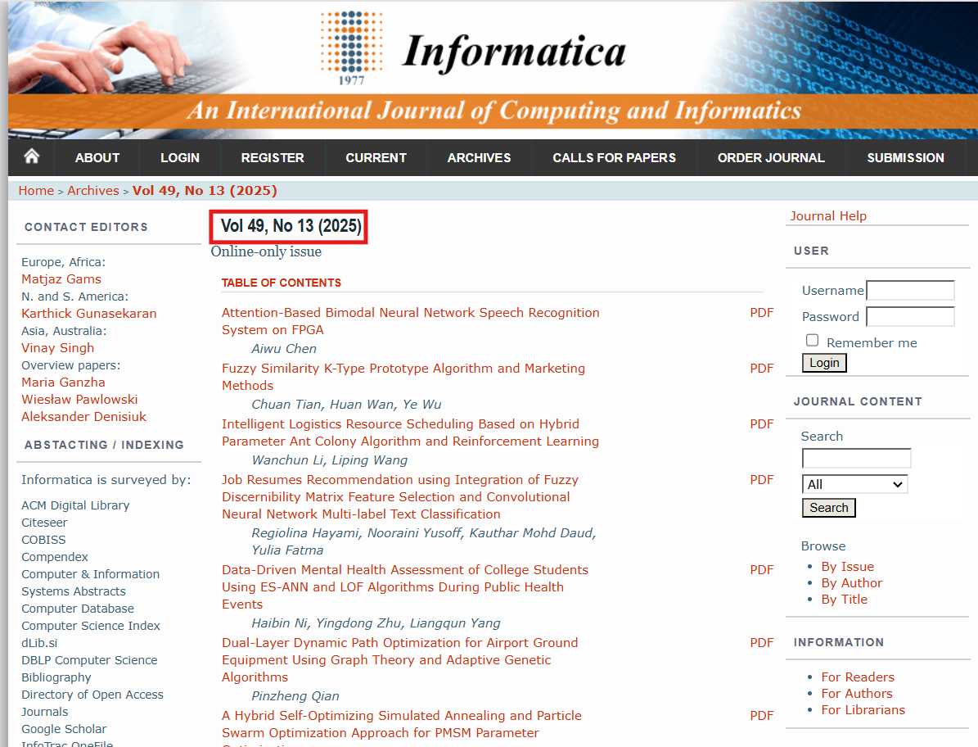

Click an article to go inside:

You can capture the title and DOI from here as shown below: 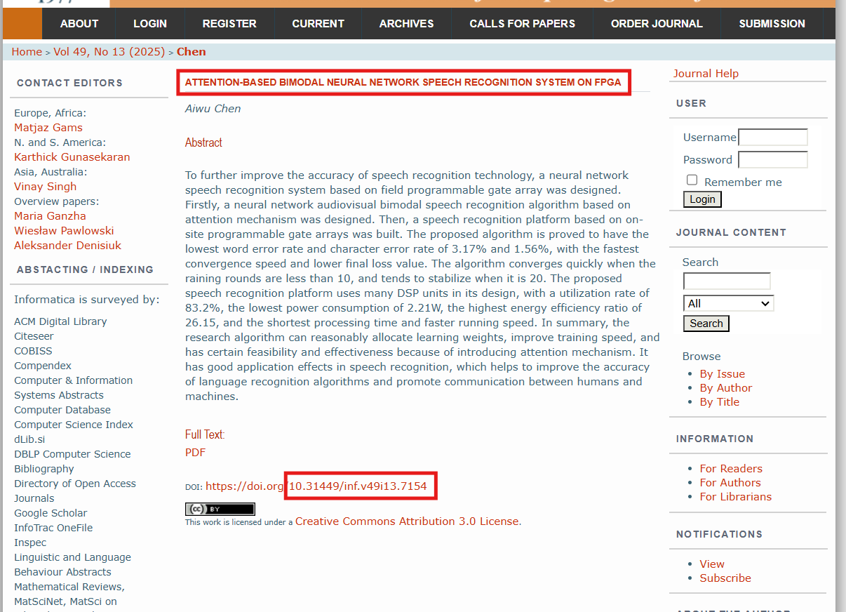

After that click on PDF:

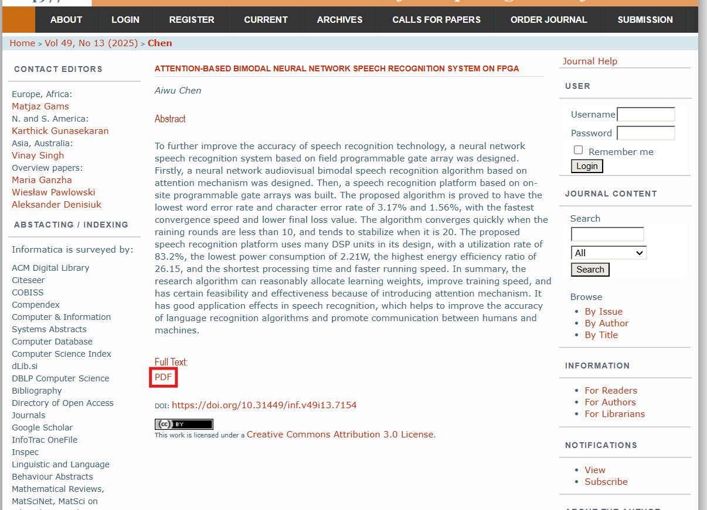

Capture the page range from here: 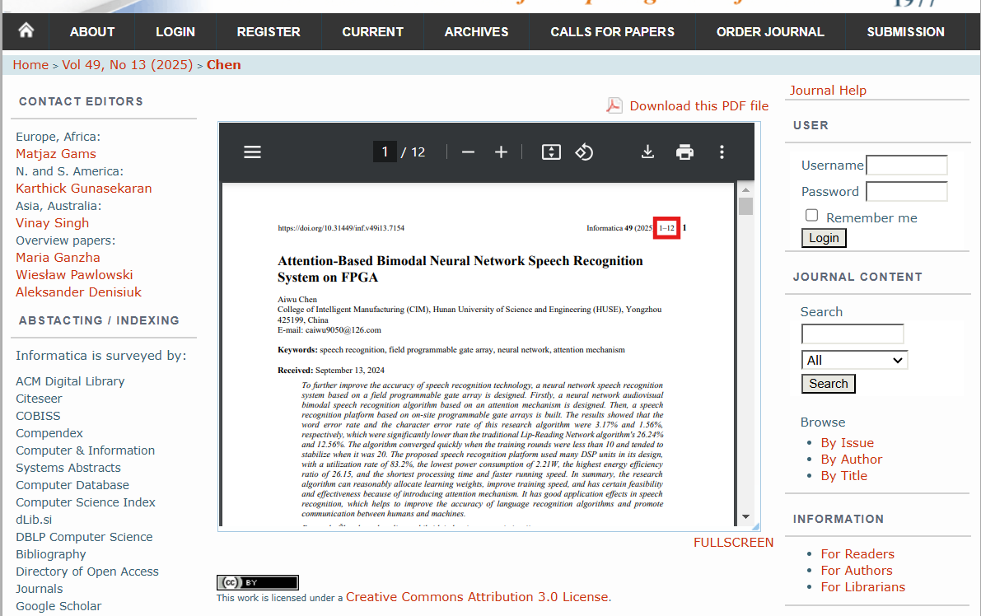

Repeat this process till the last article.