**SID - 943988028**

**Source URL - https://jelectrochem.xmu.edu.cn/journal/**

**1)Go to the website using the baed url you will drect to current issue page.**

**Scroll down you can see current issue like below.**

2)Capture volume

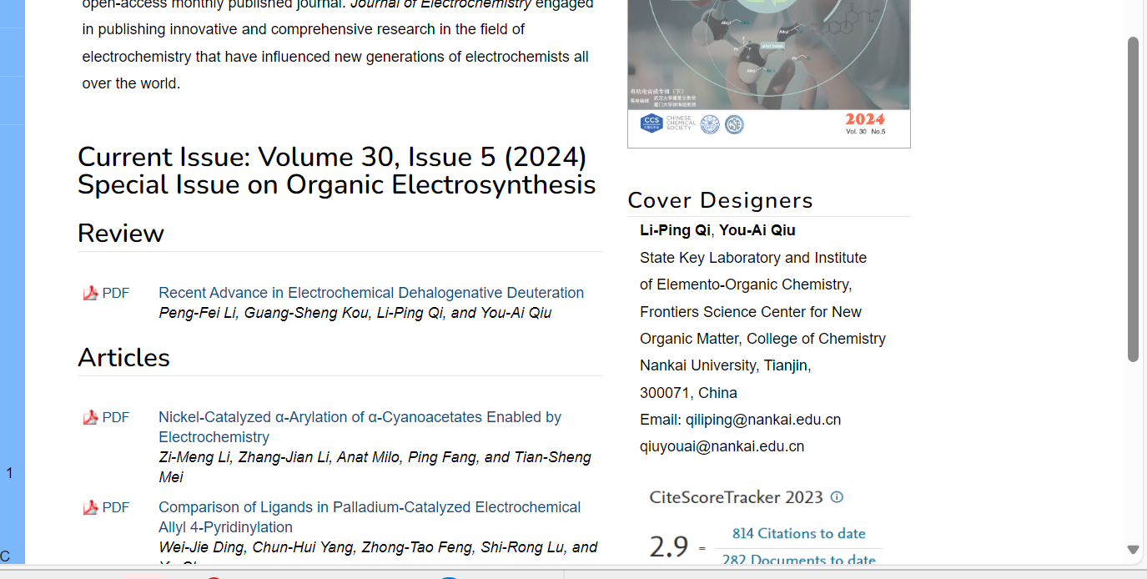

4)Capture article title and click

2)Capture year

3)Capture issue

**You will direct to article page.**

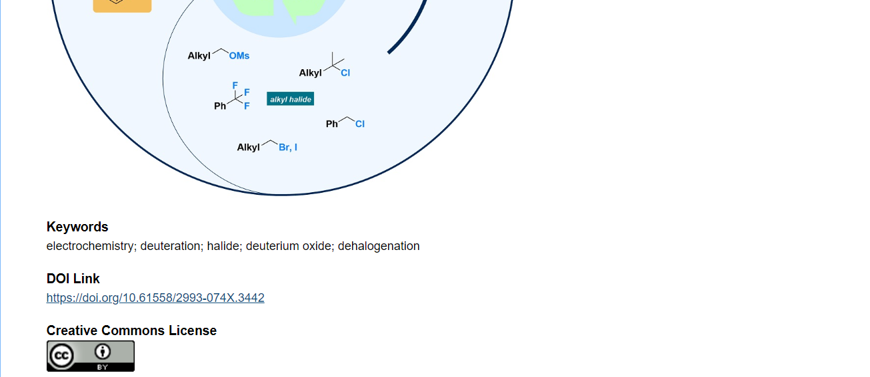

5)Capture doi

**Download pdf**

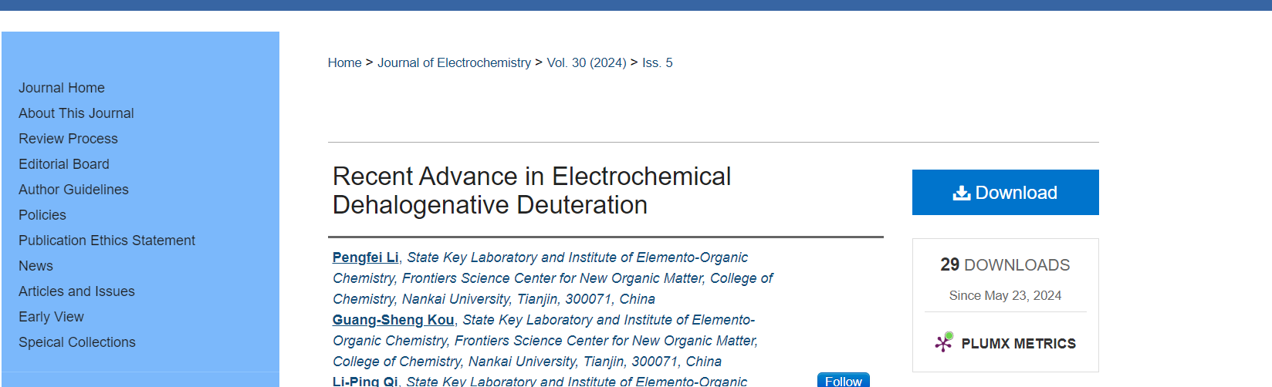

6)Click here to download