300363299

Base URL:

**Agreement URL:**

|  |
| --- |
| https://innovareacademics.in/journals.php |

**Source URL:**

http://innovareacademics.in/journals/index.php/ijcpr

* Use the source URL because it’s difficult find the correct journal with using the agreement URL.
* Select the issue from the issue list.

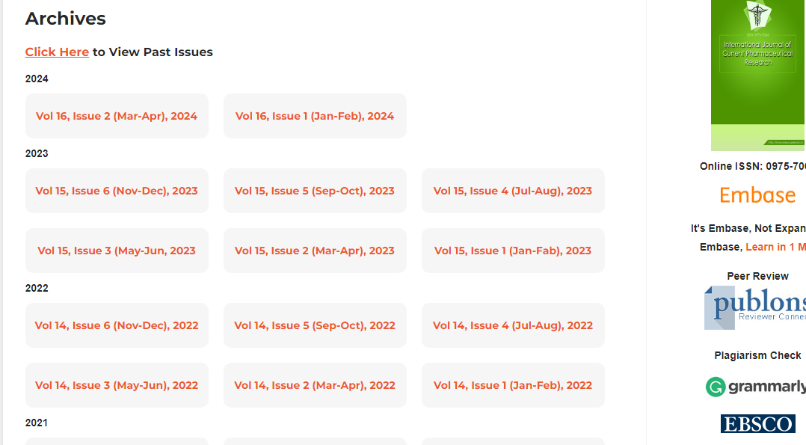

**Select the Current issue from here.**

* After selecting the issue content will appear here.

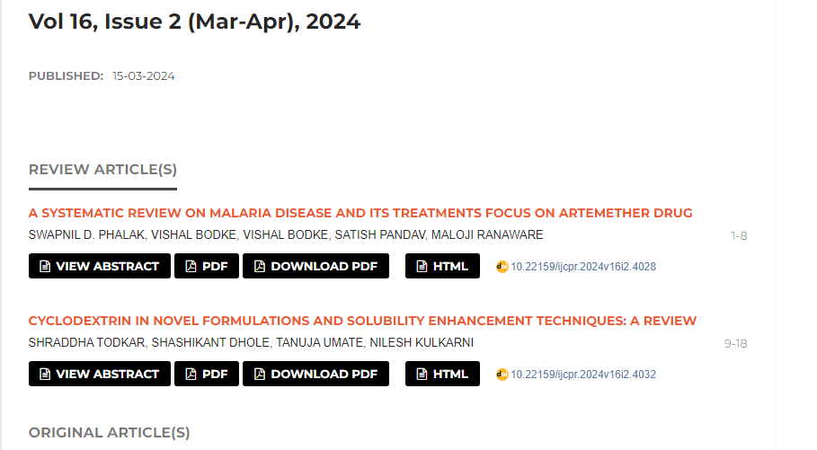

Title

Page range

* All required articles will be listed here

**Year**



**DOI**

**Then click here to download the pdf**

**Volume, issue**