**77875099**

Agreement url:   
http://www.mtkxjs.com.cn/en/issue

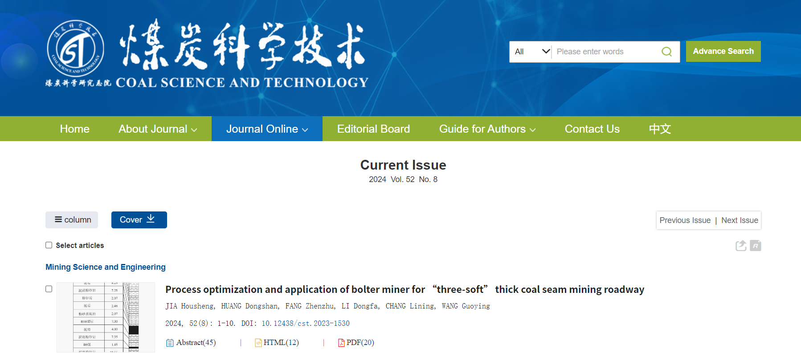

Current issue

DOI

Page range

Publication year, Month, volume, issue

Download the pdf

English title

* **In here both English and Chinese toc needs to be captured**