**925313428**

Base URL:

Agreement URL: http://www.ijettjournal.org/archive

Go to the website using the based url You will get crchive Then select the current issue from the list and click

2)Select current issue

You will direct to the current issue page like below

5)Capture issue

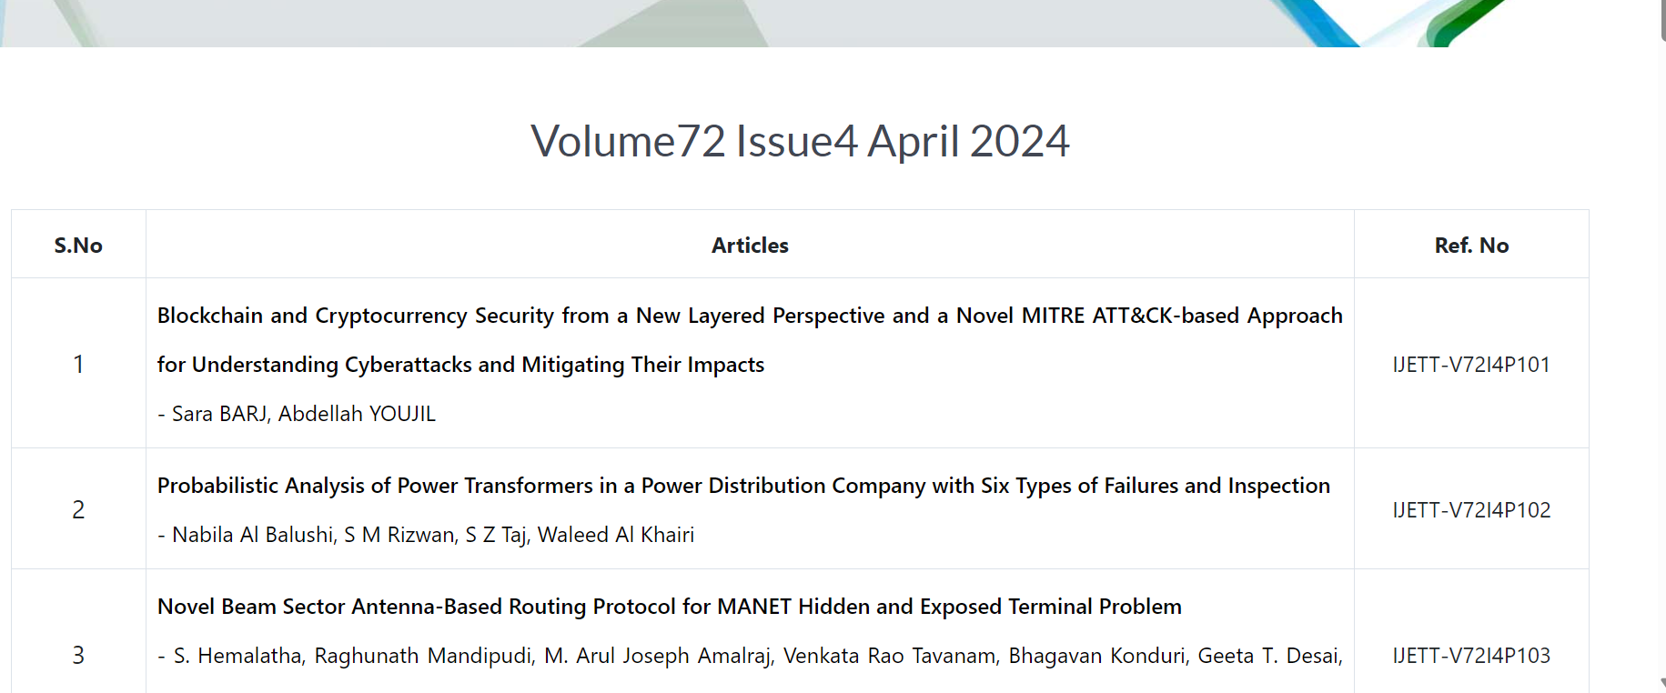

5)Capture article title and click

6)Capture month

4)Capture year

3)Capture volume

You will direct to the article page like below.

Title

Volume and issue number & year

Click on download to open the pdf

Doi

Click on the title and open the page to get the URL.

Download the pdf