Source ID: **657092805**

Source Title: **Journal of Ayub Medical College**

Agreement URL: <https://jamc.ayubmed.edu.pk/jamc/index.php/jamc/issue/archive>

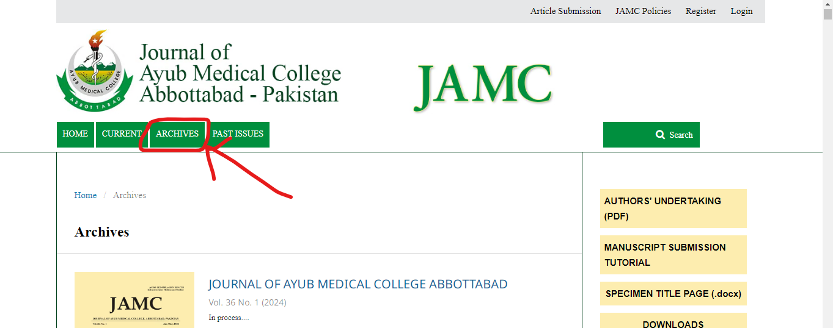

**Click ‘ARCHIVES’**

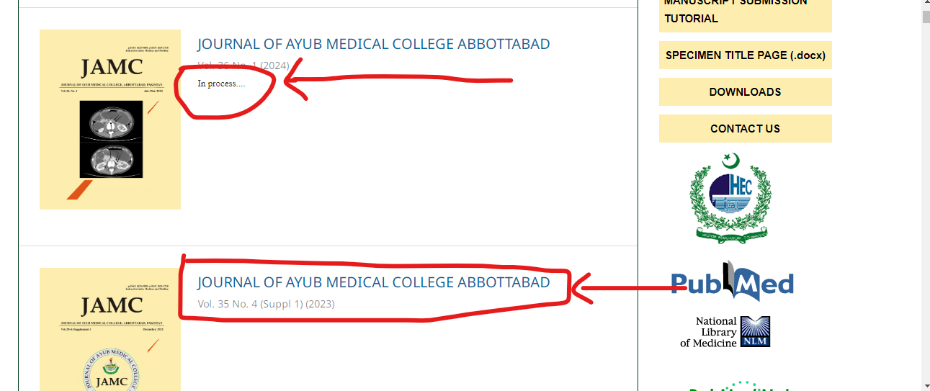

**Select latest available issue**

**\*\*\*Skip ‘In process’ issues & Current Issue**

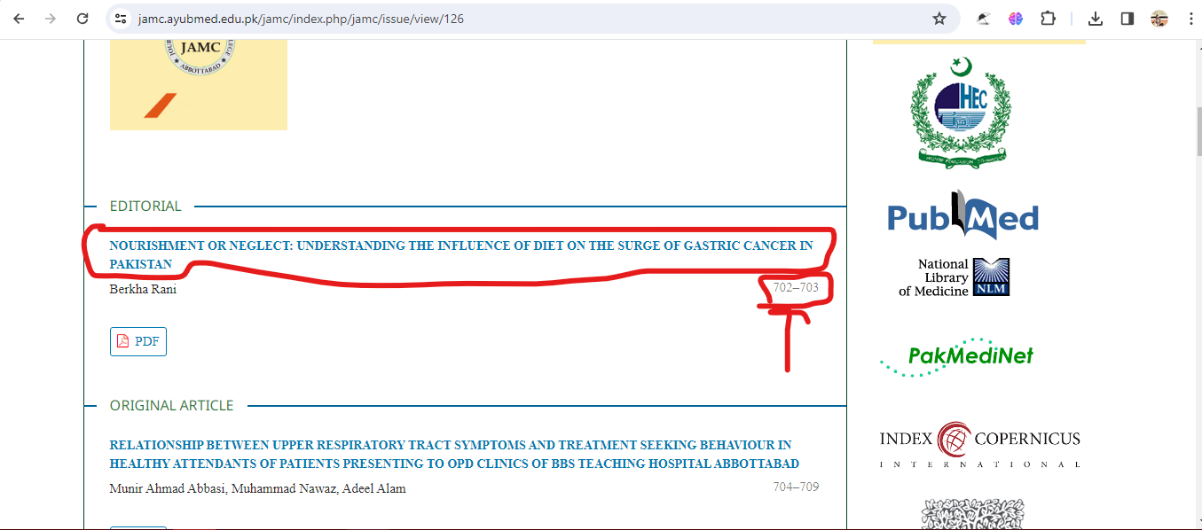

**Volume, Issue, Supplement & year**

**Page range**

**Click on Title**

**DOI ( For some issues DOI isn’t available in Web site)**

**Title**

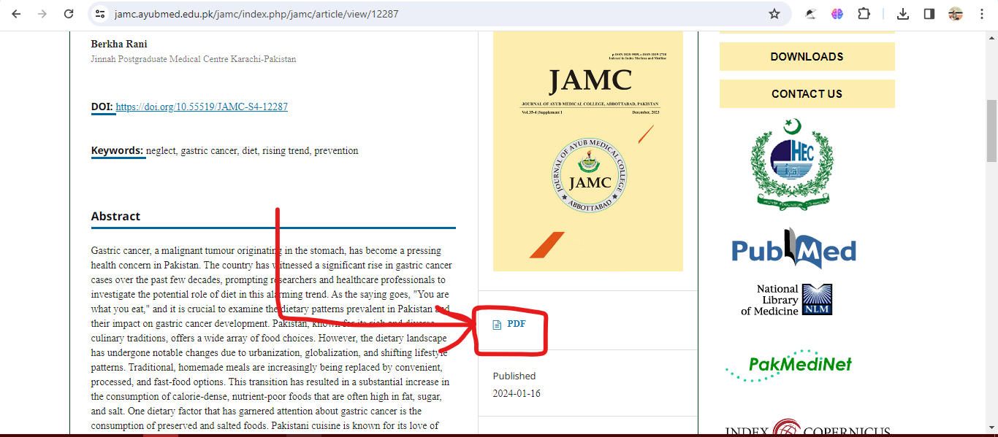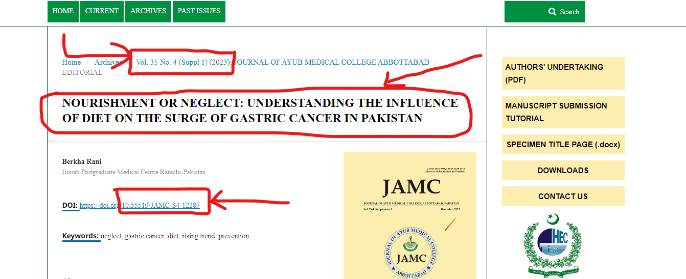

**Scroll down & Click here to access PDF**

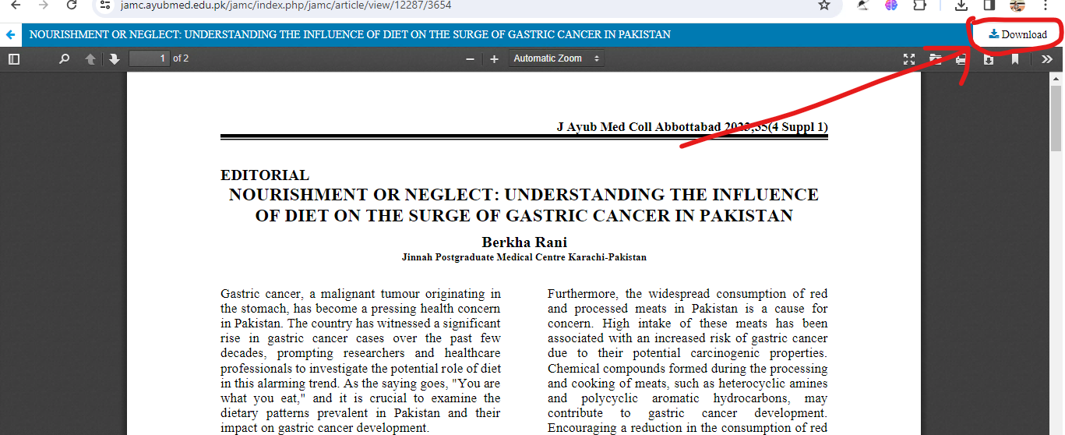

**Click here to download PDF**

*** Please note, in some cases current issue will release before publishing PDFs. Therefore we can’t process that issue until PDFs are available.