Source ID - 942267985

Source Title - Visnyk Universitetu Imeni Alfreda Nobelya. Seriya: Filologichni Nauki

Agreement URL - phil.duan.edu.ua/index.php/uk/

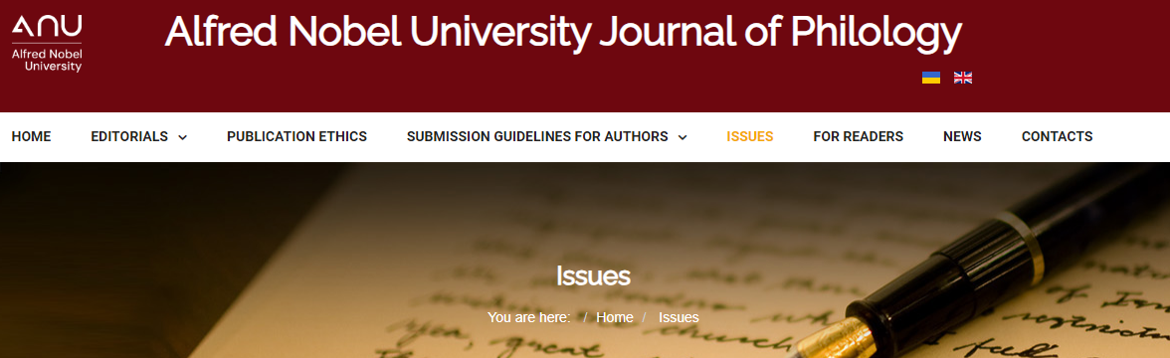

Click to browse issue list

Click the latest issue

Article title

Year

Issue

DOI

PDF