Source ID - 79733799

Select English for the English translation of the website

Month(Please capture and convert in to word

Year

Issue number and Year

Issue number and Year

Click article title to capture meta data

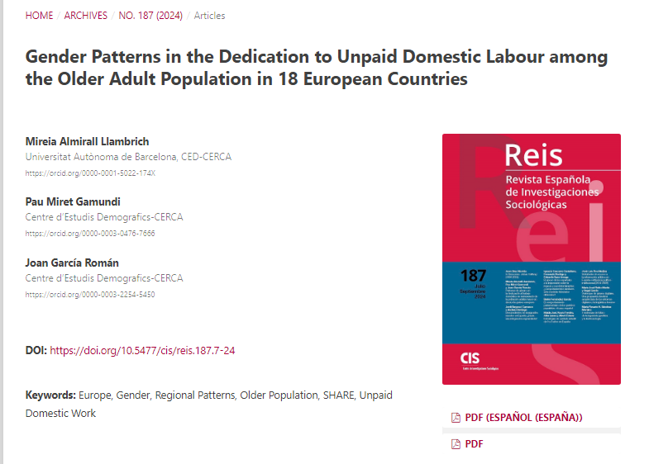

Article title

Click to download PDF

Page range

DOI number

Please note user needs to verify month from pdf if different.