**77888499**

**Base URL:**

**Agreement URL:** http://jeit.ac.cn



**Click the online journal drop down and select current issue.**

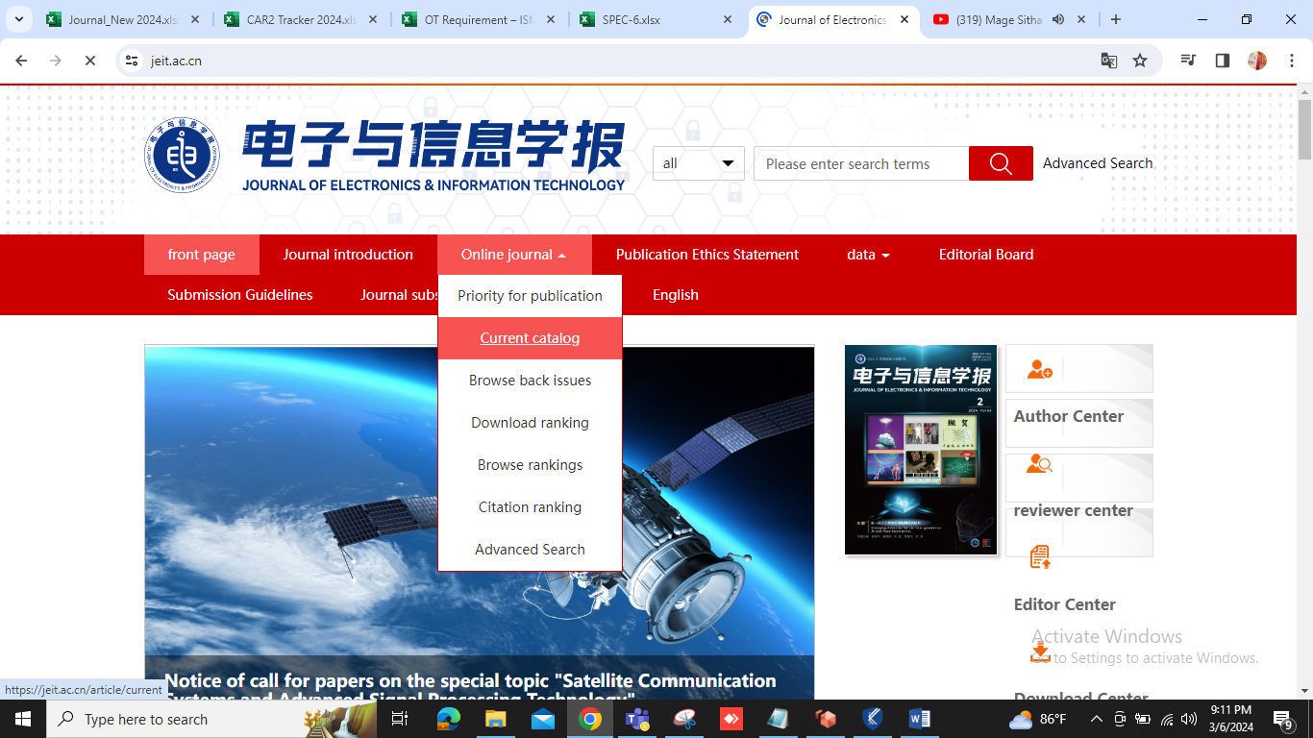

**Select the current issues**



**After selecting volume issue all required articles will be listed here.**

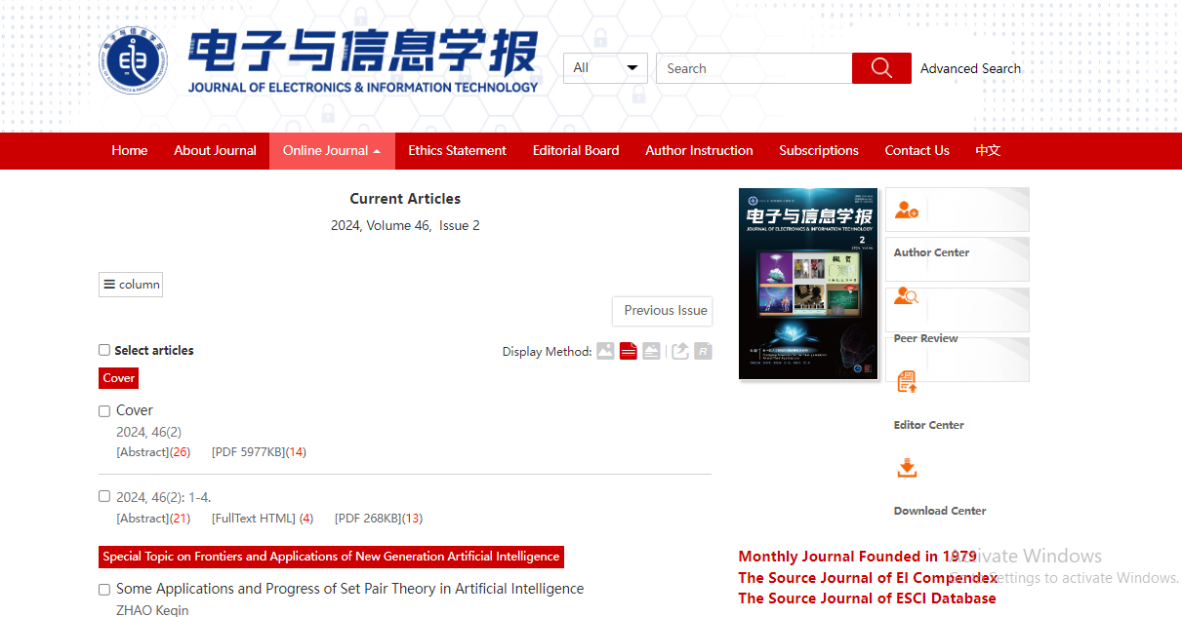

**Click the article name to open the article info page to download the PDF.**

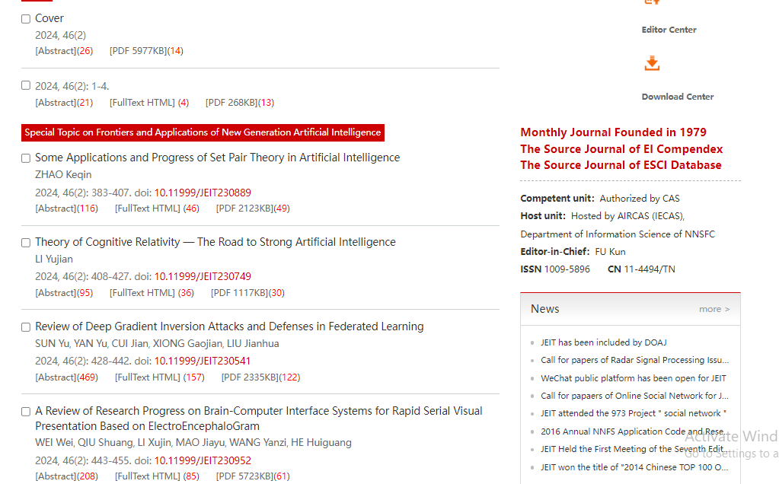



**Article names**

**Apply following step to download the PDF.**



**Download the PDF file.**

**Select the PDF file.**

**Meta data can be captured as below.**

* **Month, Date, Year**
* **Volume and issue**

**Volume issue**

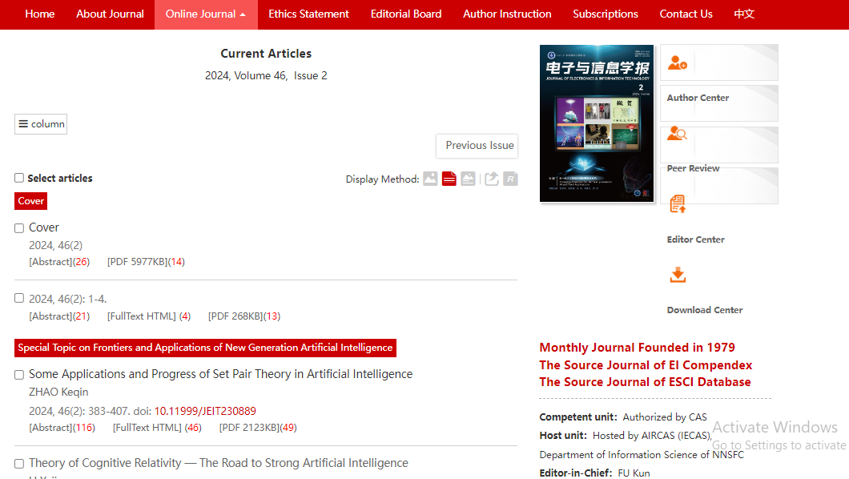

**Date Month Year**

* DOI
* Page Range

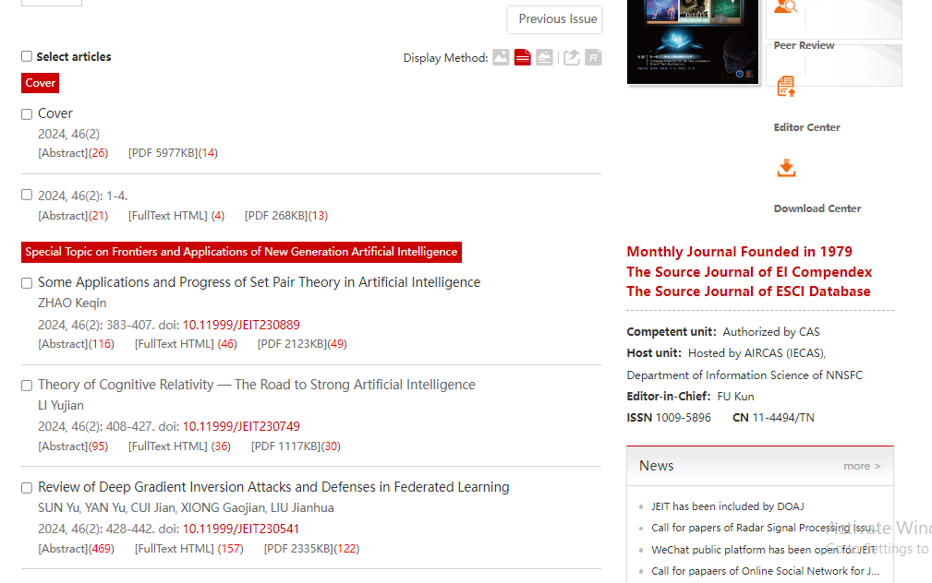

**DOI**

**Page Range**

* In here both English and non roman toc needs to be captured so choose language option from website language conversion . then go to the Table of content page right click and save as pdf and merge in to one.