943736833

Go

to the website using the url.

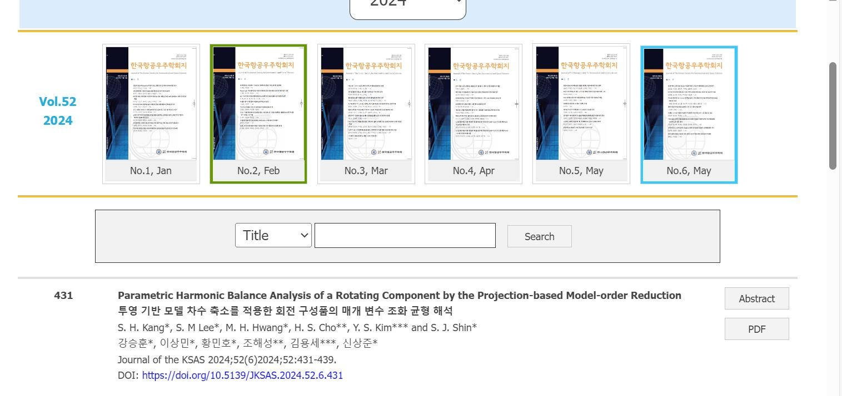

month

Issue

Volume



Year

Click here

DOI

Page

range



Clcik

here

to

download pdf

<http://eng.jksas.or.kr/sub/sub4_03.asp>

* In here both English and non roman toc needs to be captured so choose language option from website language conversion . then go to the Table of content page right click and save as pdf and merge in to one.