**951527209**

Base URL:

**https://sjdlyj.ecnu.edu.cn/EN/article/showOldVolumn.do**

* Select the issue from the issue list.

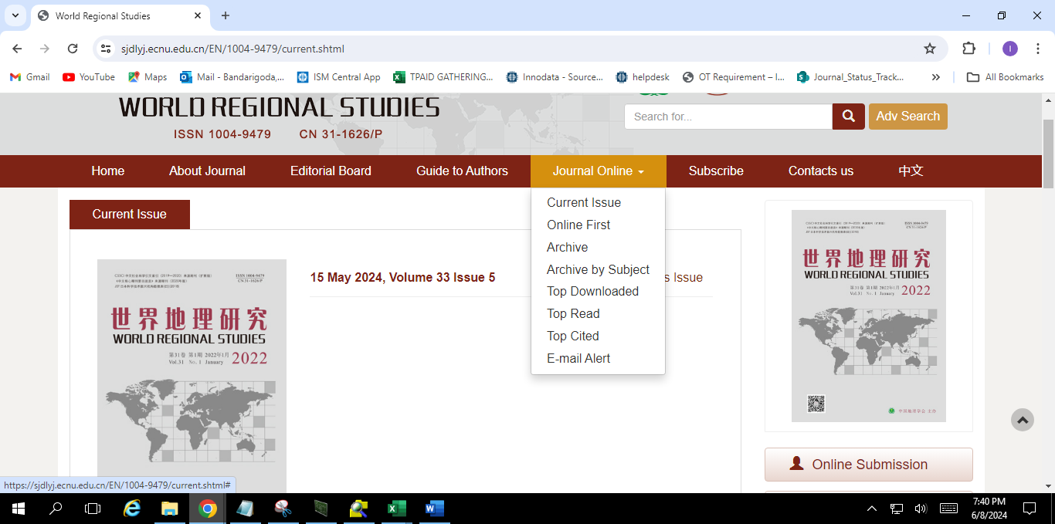

**Select the Current issue from here.**

* Meta data can be captured as below.

**Volume, issue, Month, Date and Year**

**Page Range**

**DOI**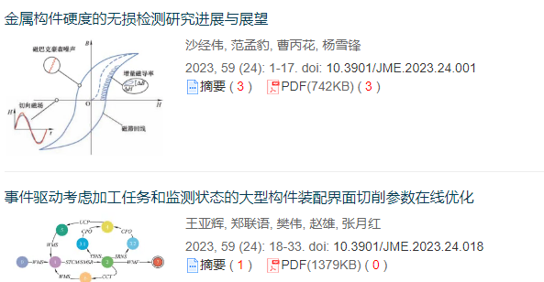

**Article Name**

**Click here to download the pdf**