**944268100**

Base URL:

|  |
| --- |
|  |

**Agreement URL:**

<https://revistaseug.ugr.es/index.php/acfs/issue/archive>

Choose the English from website language translation

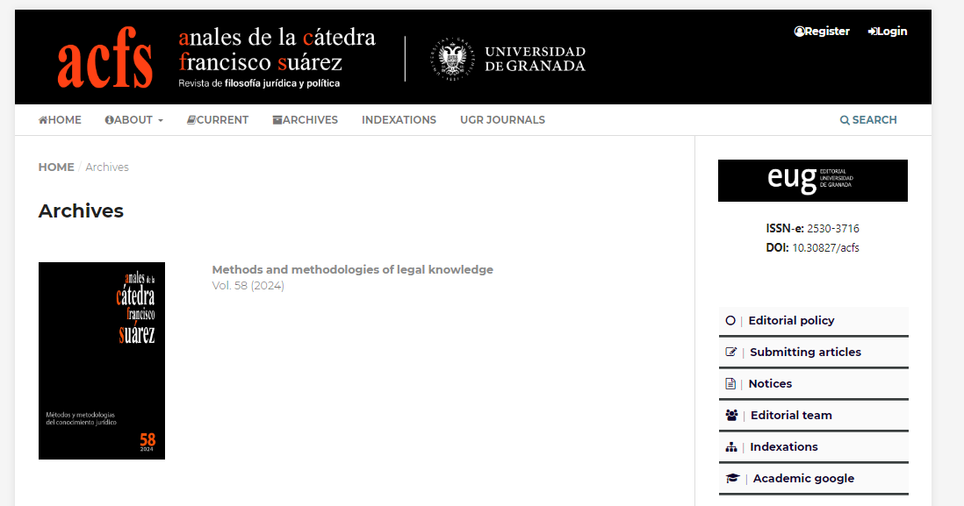

**Select the Current issue from here.**

* After selecting the issue content will appear here.

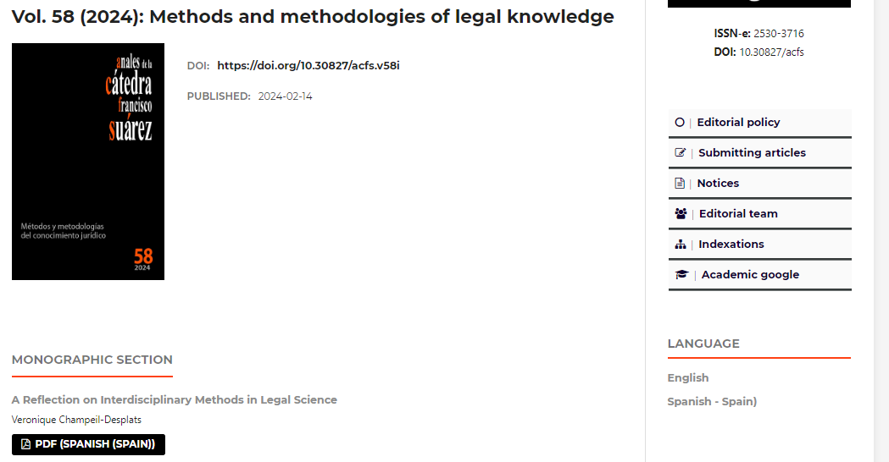

**Year**

**Volume**

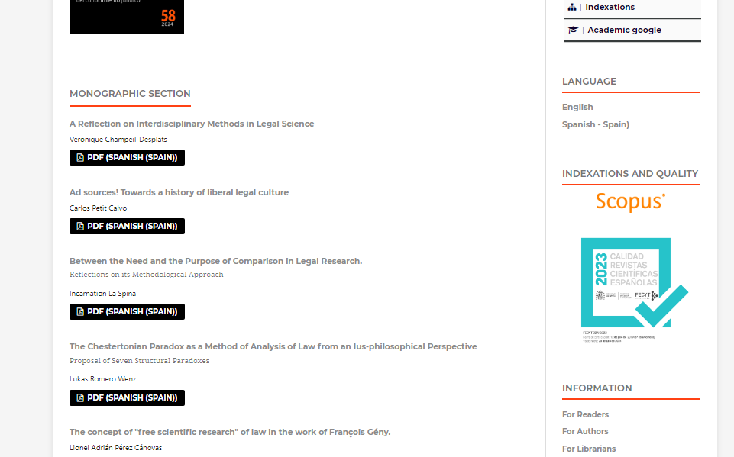

**Capture and click**

* All required articles will be listed here

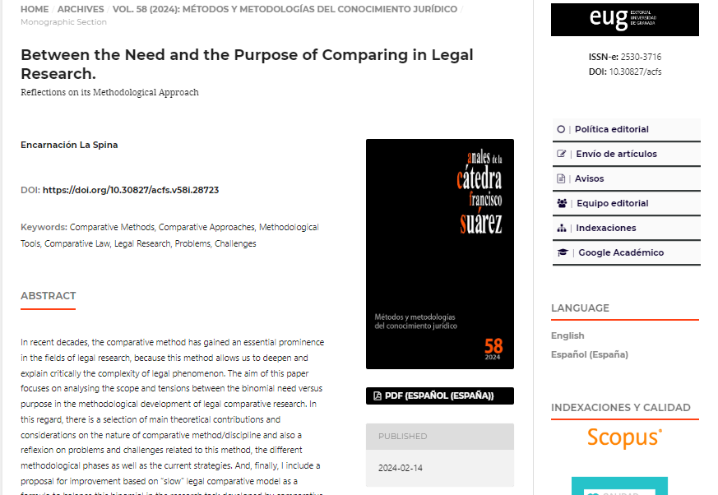

**DOI**

**Then click here to download the pdf**